# 媒体信号处理基础-实验报告1

学号： 3170105728 姓名：林昭炜

## 实验内容及要求

实验工具：MATLAB 2018a

实验内容：

1. 生成值在[0-255]之间的随机信号序列，长度50；
2. 利用MATLAB对信号进行无损差分编码，然后解码；
3. 利用MATLAB对信号进行有损差分编码，然后解码；
4. 在图中展示原信号和两种解码还原的信号；

## 关键代码及注释

1. %config
2. cnt = 50; %number of signals
3. sig_max = 255; %maximum signal range
4. %code
5. x = 1:1:cnt;
6. signal = randi(sig_max, [1, cnt]);
7. %encode & decode
8. pcm_e = pcm_encode(cnt, signal);
9. pcm_d = pcm_decode(cnt, pcm_e);
10. dpcm_e = dpcm_encode(cnt, signal);
11. dpcm_d = dpcm_decode(cnt, dpcm_e);
12. plot(x, signal, '*', x, pcm_d, x, dpcm_d);
13. legend('orginal sig', 'pcm', 'dpcm');
14. function pcm_e = pcm_encode( cnt, data )
15. pcm_e = zeros(1, cnt);
16. pcm_e(1) = data(1);
17. pcm_e(2) = data(2) - data(1);
18. for i=3:cnt
19. project = floor(0.5 * (data(i-2) + data(i-1)));
20. pcm_e(i) = data(i) - project;
21. end
22. end
23. function pcm_d = pcm_decode( cnt, data )
24. pcm_d = zeros(1, cnt);
25. pcm_d(1) = data(1);
26. pcm_d(2) = data(2) + data(1);
27. for i=3:cnt
28. project = floor(0.5 * (pcm_d(i-2) + pcm_d(i-1)));
29. pcm_d(i) = project + data(i);
30. end
31. end
32. function dpcm_e = dpcm_encode( cnt, data )
33. dpcm_e = zeros(1, cnt);
34. prev1 = data(1);
35. dpcm_e(1) = prev1;
36. e = data(2) - prev1;
37. dpcm_e(2) = 16*floor((255+e)/16)-256+8;
38. prev2 = prev1 + dpcm_e(2);
39. for i=3:cnt
40. project = floor((prev1 + prev2) * 0.5);
41. prev1 = prev2;
42. e = data(i) - project;
43. dpcm_e(i) = 16*floor((255+e)/16)-256+8;
44. prev2 = project + dpcm_e(i);
45. end
46. end
47. function dpcm_d = dpcm_decode( cnt, data )
48. dpcm_d = zeros(1, cnt);
49. dpcm_d(1) = data(1);
50. dpcm_d(2) = data(2) + data(1);
51. for i=3:cnt
52. project = floor(0.5 * (dpcm_d(i-2) + dpcm_d(i-1)));
53. dpcm_d(i) = project + data(i);
54. end
55. end

## 实验结果及分析

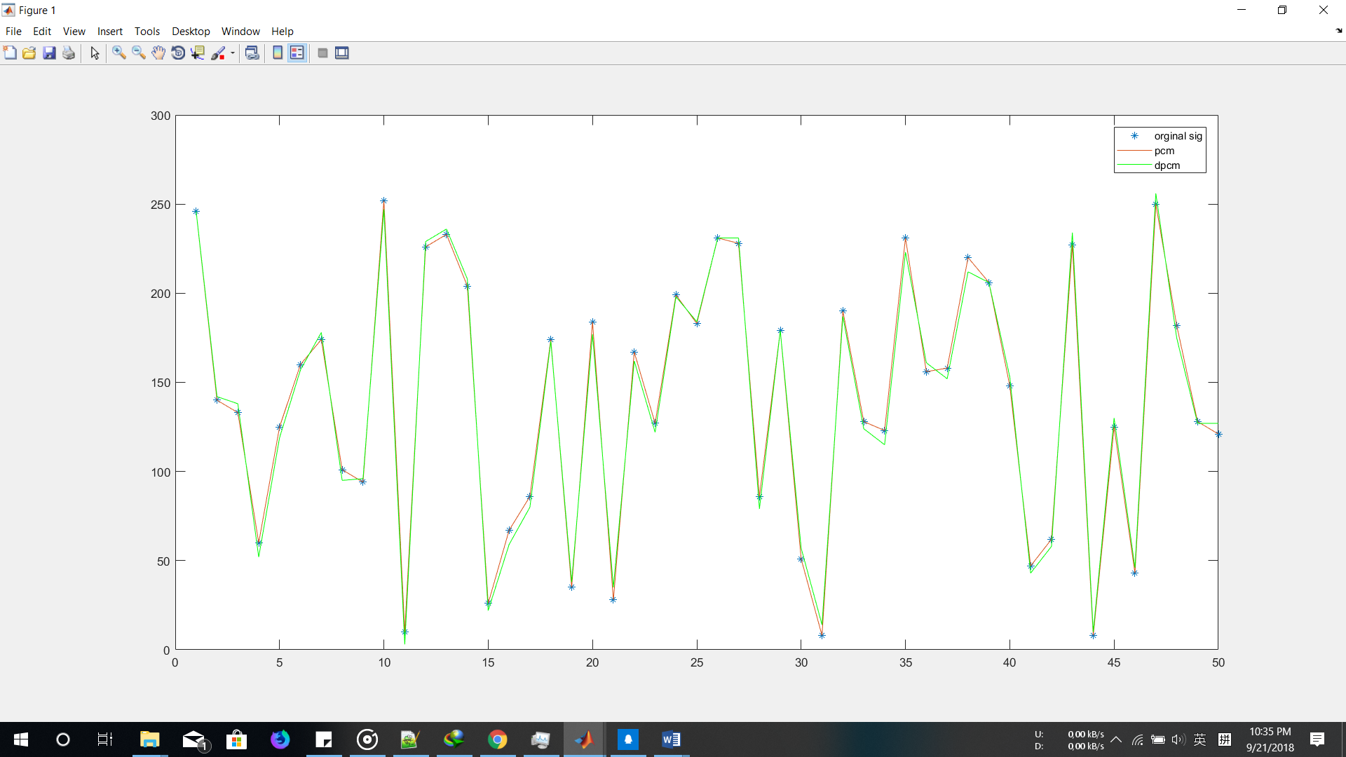

‘*’原始信号

‘red’pcm

‘green’dpcm