总代码
import base64

# ==================== 工具函数 ====================

def hamming_distance(s1: bytes, s2: bytes) -> int:
"""计算两个字节串的汉明距离（不同比特位数）"""
xor_bytes = bytes(a ^ b for a, b in zip(s1, s2))
distance = sum(bin(byte).count('1') for byte in xor_bytes)
return distance

def score_english(text: str) -> float:
"""根据字符频率给英文文本打分，用于识别最像英文的明文"""
char_freq = {
'a': 0.08167, 'b': 0.01492, 'c': 0.02782, 'd': 0.04253,
'e': 0.12702, 'f': 0.02228, 'g': 0.02015, 'h': 0.06094,
'i': 0.06966, 'j': 0.00153, 'k': 0.00772, 'l': 0.04025,
'm': 0.02406, 'n': 0.06749, 'o': 0.07507, 'p': 0.01929,
'q': 0.00095, 'r': 0.05987, 's': 0.06327, 't': 0.09056,
'u': 0.02758, 'v': 0.00978, 'w': 0.02360, 'x': 0.00150,
'y': 0.01974, 'z': 0.00074, ' ': 0.13000
}
score = 0.0
for c in text.lower():
if c in char_freq:
score += char_freq[c]
elif not c.isprintable():
score -= 0.5 # 不可打印字符扣分
return score

def break_single_byte_xor(ciphertext: bytes):
"""破解单字节异或，返回 (密钥整数, 明文bytes, 评分)"""
best_score = -float('inf')
best_key = 0
best_plain = b''

for key in range(256):
plain = bytes(b ^ key for b in ciphertext)
try:
text = plain.decode('ascii')
s = score_english(text)
if s > best_score:
best_score = s
best_key = key
best_plain = plain
except UnicodeDecodeError:
continue # 跳过无法解码为ASCII的密钥

return best_key, best_plain, best_score

# ==================== 核心破解逻辑 ====================

def guess_keysize(ciphertext: bytes, min_size=2, max_size=40, num_blocks=4):
"""
推测最可能的密钥长度。
对每个长度，取密文前 num_blocks 个块，计算两两之间的归一化汉明距离。
返回距离最小的前 3 个候选长度。
"""
distances = []

for keysize in range(min_size, max_size + 1):
# 确保密文足够长以取 num_blocks 个块
if len(ciphertext) < keysize * num_blocks:
continue

blocks = [ciphertext[i * keysize:(i + 1) * keysize] for i in range(num_blocks)]
total_dist = 0
pair_count = 0

for i in range(len(blocks)):
for j in range(i + 1, len(blocks)):
total_dist += hamming_distance(blocks[i], blocks[j])
pair_count += 1

# 归一化：平均距离除以密钥长度
normalized_dist = (total_dist / pair_count) / keysize
distances.append((keysize, normalized_dist))

# 按距离从小到大排序
distances.sort(key=lambda x: x[1])
# 返回前3个最可能的密钥长度
return [keysize for keysize, _ in distances[:3]]

def crack_repeating_key_xor(ciphertext: bytes, keysize: int):
"""
根据给定的密钥长度破解重复密钥异或。
1. 将密文按密钥长度分块。
2. 转置分块：把每个块的第一个字节组成新块，第二个字节组成新块……
3. 对每个转置块用单字节异或破解，得到密钥的一个字节。
4. 拼接密钥并解密全文。
"""
# 1. 分块
blocks = [ciphertext[i:i + keysize] for i in range(0, len(ciphertext), keysize)]

# 2. 转置并破解每个位置的密钥字节
key = []
for i in range(keysize):
# 取出每个块的第 i 个字节，组成新的“单字节异或密文”
transposed_block = bytes(block[i] for block in blocks if i < len(block))
# 破解这个单字节异或块
key_byte, _, _ = break_single_byte_xor(transposed_block)
key.append(key_byte)

key_bytes = bytes(key)

# 3. 用得到的密钥解密全文
plaintext = bytes(
ciphertext[i] ^ key_bytes[i % len(key_bytes)]
for i in range(len(ciphertext))
)

return key_bytes, plaintext

# ==================== 主程序 ====================

def main():
# 1. 读取并解码 Base64 密文文件
try:
with open("6.txt", "r") as f:
b64_data = f.read().replace('\n', '') # 去掉换行符
ciphertext = base64.b64decode(b64_data)
except FileNotFoundError:
print("错误：找不到文件 6.txt，请确保它与本脚本在同一目录下。")
return

print("已加载密文，长度：{} 字节".format(len(ciphertext)))

# 2. 推测密钥长度
print("\n正在推测密钥长度...")
candidates = guess_keysize(ciphertext)
print("最佳候选密钥长度：", candidates)

# 3. 依次尝试每个候选长度
for keysize in candidates:
print(f"\n===== 尝试密钥长度: {keysize} =====")
key_bytes, plaintext = crack_repeating_key_xor(ciphertext, keysize)

try:
key_str = key_bytes.decode('ascii')
plain_str = plaintext.decode('ascii')

print(f"密钥: {key_str}")
print("-" * 40)
print(plain_str[:500]) # 打印前500个字符作为预览
print("-" * 40)

except UnicodeDecodeError:
print(f"密钥长度 {keysize} 解密结果含不可解码字节，跳过。")

if __name__ == "__main__":
main()
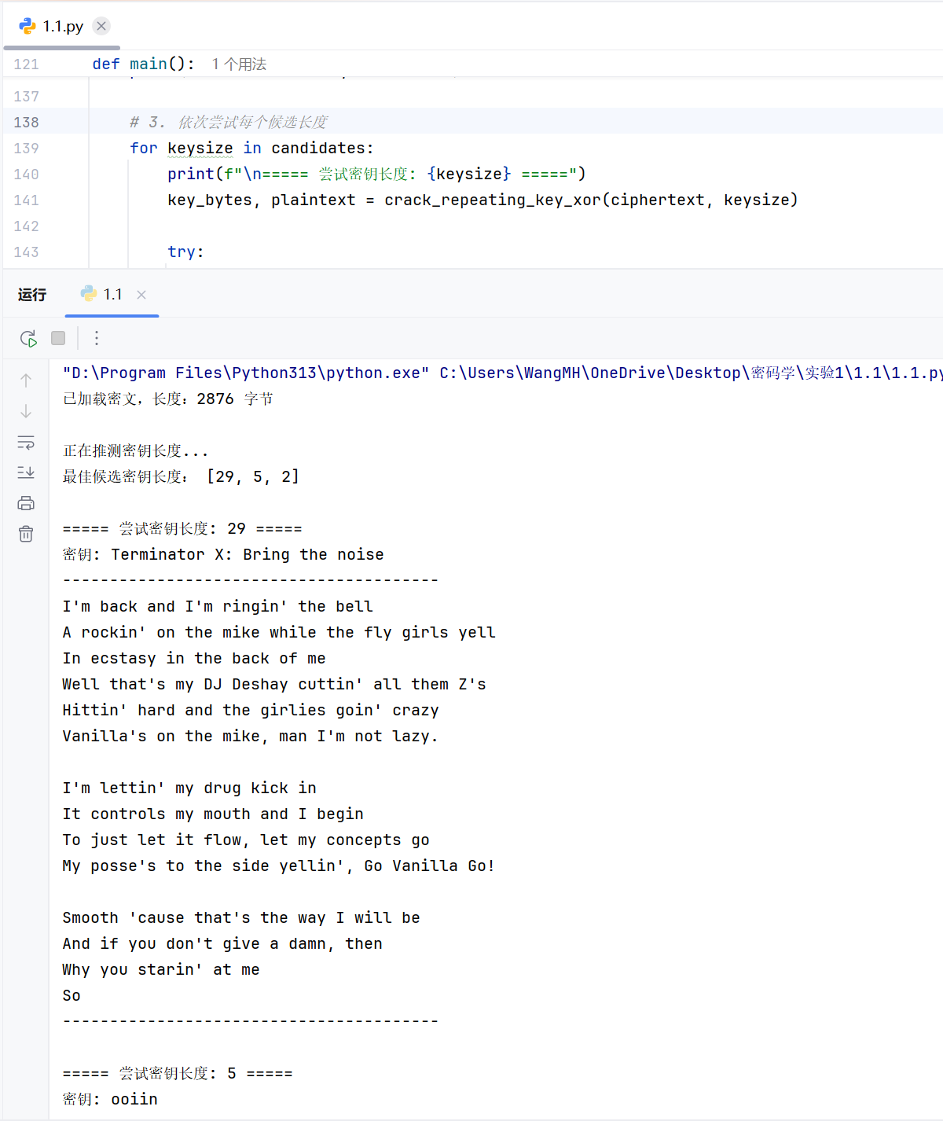
第一步：验证汉明距离函数
def hamming_distance(s1: bytes, s2: bytes) -> int:
"""计算两个字节串的汉明距离（不同比特位数）"""
xor_bytes = bytes(a ^ b for a, b in zip(s1, s2))
distance = sum(bin(byte).count('1') for byte in xor_bytes)
return distance

# 验证
s1 = b"this is a test"
s2 = b"wokka wokka!!!"
print(hamming_distance(s1, s2)) # 必须是 37
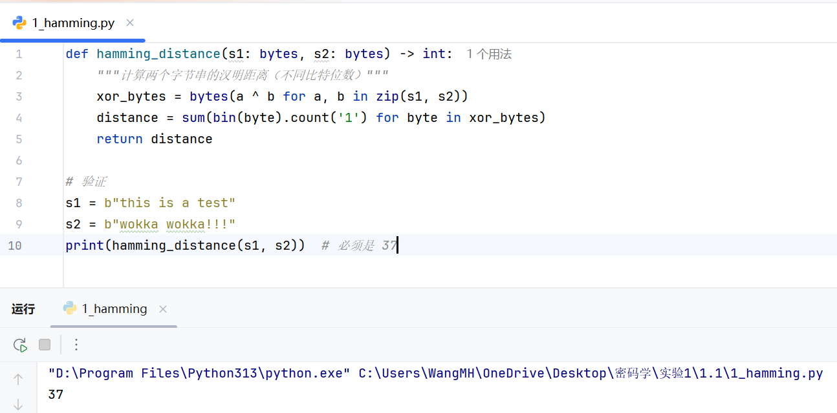
第二步：验证单字节异或破解函数（第一组第3题）
def score_english(text: str) -> float:
"""根据字符频率给英文文本打分"""
char_freq = {
'a': 0.08167, 'b': 0.01492, 'c': 0.02782, 'd': 0.04253,
'e': 0.12702, 'f': 0.02228, 'g': 0.02015, 'h': 0.06094,
'i': 0.06966, 'j': 0.00153, 'k': 0.00772, 'l': 0.04025,
'm': 0.02406, 'n': 0.06749, 'o': 0.07507, 'p': 0.01929,
'q': 0.00095, 'r': 0.05987, 's': 0.06327, 't': 0.09056,
'u': 0.02758, 'v': 0.00978, 'w': 0.02360, 'x': 0.00150,
'y': 0.01974, 'z': 0.00074, ' ': 0.13000
}
score = 0.0
for c in text.lower():
if c in char_freq:
score += char_freq[c]
elif not c.isprintable():
score -= 0.5
return score

def break_single_byte_xor(ciphertext: bytes):
"""破解单字节异或，返回 (密钥整数, 明文bytes, 评分)"""
best_score = -float('inf')
best_key = 0
best_plain = b''

for key in range(256):
plain = bytes(b ^ key for b in ciphertext)
try:
text = plain.decode('ascii')
s = score_english(text)
if s > best_score:
best_score = s
best_key = key
best_plain = plain
except:
continue

return best_key, best_plain, best_score

# 用第3题的密文验证
hex_str = "1b37373331363f78151b7f2b783431333d78397828372d363c78373e783a393b3736"
ciphertext = bytes.fromhex(hex_str)
key, plain, score = break_single_byte_xor(ciphertext)
print(f"密钥: {key} ({chr(key)})")
print(f"明文: {plain.decode()}")

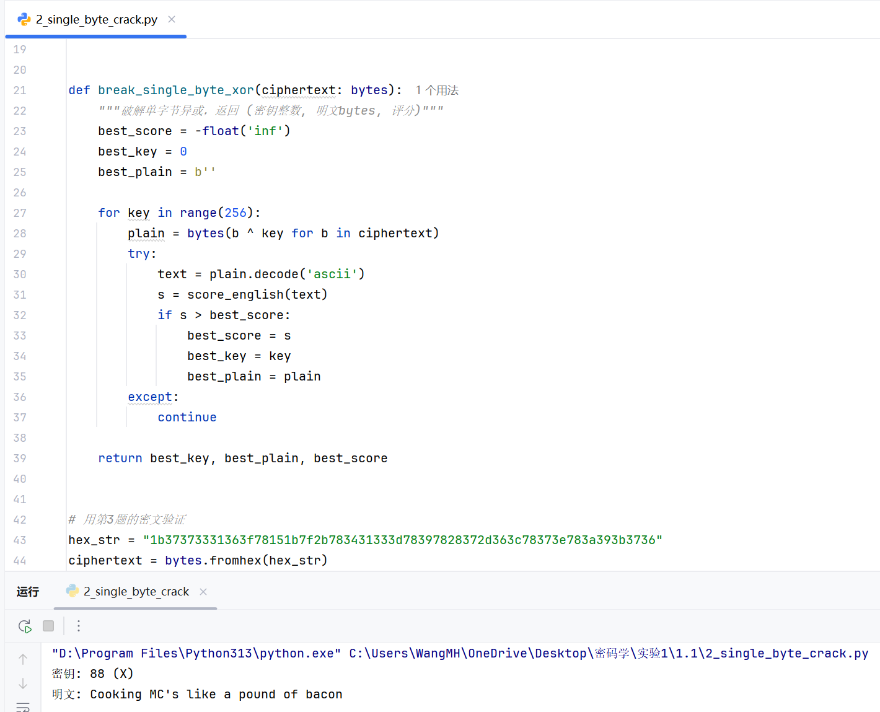
第三步：推测密钥长度（算出归一化汉明距离最小的几个候选）
import base64
# 把第一步的 hamming_distance 函数复制过来
def hamming_distance(s1: bytes, s2: bytes) -> int:
xor_bytes = bytes(a ^ b for a, b in zip(s1, s2))
return sum(bin(byte).count('1') for byte in xor_bytes)

# 读取并解码文件
with open("6.txt", "r") as f:
b64_data = f.read().replace('\n', '')
ciphertext = base64.b64decode(b64_data)

def guess_keysize(ct: bytes, min_size=2, max_size=40):
distances = []
for keysize in range(min_size, max_size + 1):
# 取前4个块
blocks = [ct[i*keysize:(i+1)*keysize] for i in range(4)]
total = 0
pairs = 0
for i in range(len(blocks)):
for j in range(i+1, len(blocks)):
total += hamming_distance(blocks[i], blocks[j])
pairs += 1
normalized = (total / pairs) / keysize
distances.append((keysize, normalized))
distances.sort(key=lambda x: x[1])
return distances[:5] # 多输出几个看看

candidates = guess_keysize(ciphertext)
print("候选密钥长度（长度，归一化距离）：")
for ks, dist in candidates:
print(f" {ks}: {dist:.4f}")
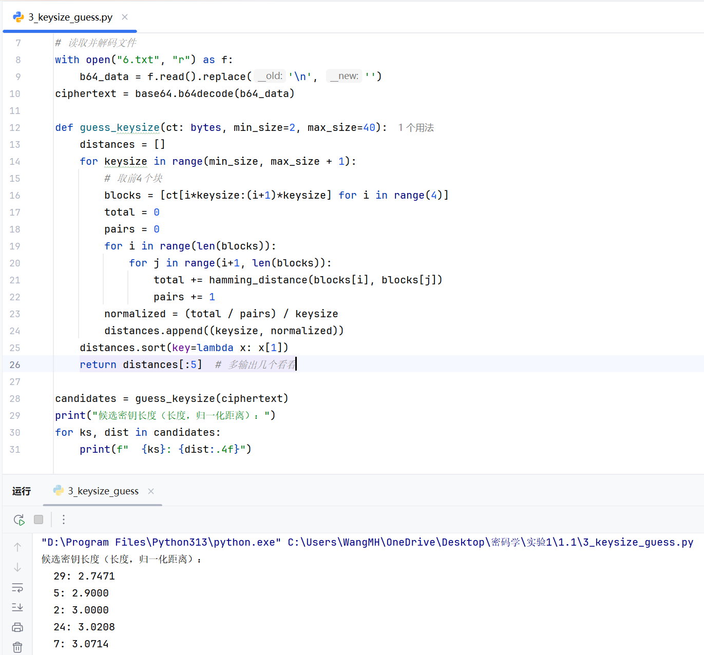
第四步：破解密文（用最优密钥长度）
import base64

# ---------- 复制所有前面验证过的函数 ----------
def hamming_distance(s1: bytes, s2: bytes) -> int:
xor_bytes = bytes(a ^ b for a, b in zip(s1, s2))
return sum(bin(byte).count('1') for byte in xor_bytes)

def score_english(text: str) -> float:
char_freq = {
'a': 0.08167, 'b': 0.01492, 'c': 0.02782, 'd': 0.04253,
'e': 0.12702, 'f': 0.02228, 'g': 0.02015, 'h': 0.06094,
'i': 0.06966, 'j': 0.00153, 'k': 0.00772, 'l': 0.04025,
'm': 0.02406, 'n': 0.06749, 'o': 0.07507, 'p': 0.01929,
'q': 0.00095, 'r': 0.05987, 's': 0.06327, 't': 0.09056,
'u': 0.02758, 'v': 0.00978, 'w': 0.02360, 'x': 0.00150,
'y': 0.01974, 'z': 0.00074, ' ': 0.13000
}
score = 0.0
for c in text.lower():
if c in char_freq:
score += char_freq[c]
elif not c.isprintable():
score -= 0.5
return score

def break_single_byte_xor(ciphertext: bytes):
best_score = -float('inf')
best_key = 0
best_plain = b''
for key in range(256):
plain = bytes(b ^ key for b in ciphertext)
try:
text = plain.decode('ascii')
s = score_english(text)
if s > best_score:
best_score = s
best_key = key
best_plain = plain
except:
continue
return best_key, best_plain, best_score

# --------------------------------------------

# 读取密文
with open("6.txt", "r") as f:
b64_data = f.read().replace('\n', '')
ciphertext = base64.b64decode(b64_data)

def crack_with_keysize(ct: bytes, keysize: int):
"""根据密钥长度破解重复密钥异或"""
# 分块
blocks = [ct[i:i + keysize] for i in range(0, len(ct), keysize)]

# 转置并破解每个位置的密钥字节
key = []
for i in range(keysize):
transposed = bytes(block[i] for block in blocks if i < len(block))
key_byte, _, _ = break_single_byte_xor(transposed)
key.append(key_byte)

key_bytes = bytes(key)

# 解密全文
plaintext = bytes(ct[i] ^ key_bytes[i % len(key_bytes)] for i in range(len(ct)))
return key_bytes, plaintext

# 用第三步找到的最佳候选长度尝试（例如 29）
key, plaintext = crack_with_keysize(ciphertext, 29)
print("密钥:", key.decode('ascii'))
print("=" * 60)
print(plaintext.decode('ascii'))
