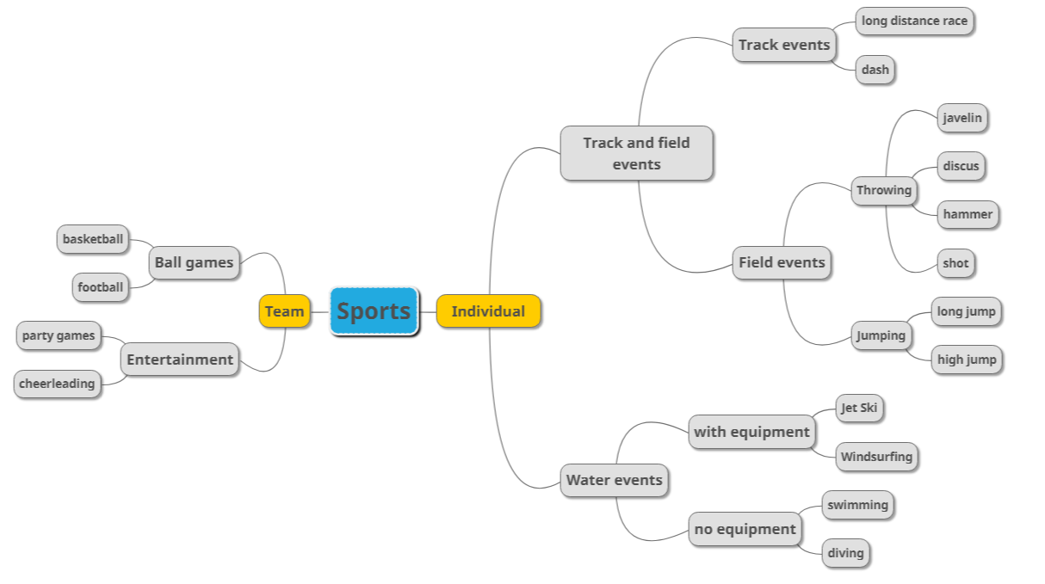

Sports may be divided into two main types, individual sports and tram sports. /stage 1

A team sport includes any sport where individuals are organized into opposing teams which compete to win. [1] It may consist of ball games and entertainment sports. Ball games, involving some type of ball or similar object, are very popular nowadays, such as basketball and football. Entertainment sports, which of common examples are party games and cheerleading, is a type of spectacle which presents an ostensibly competitive event using a high level of theatrical flourish and extravagant presentation, with the purpose of entertaining an audience. [2]

Individual sports can be divided into track and field events and water events. Track and field events, also known as athletics, is a sport which includes athletic contests established on the skills of running, jumping, and throwing, and it can be grouped into track events and field events. Track events are the general term for the running and walking events on the track. Long distance race and dash are the most two popular items of track events. Field events are the general term for jumping and throwing competitions in the specified areas of track and field, so it contains jumping and throwing. The throwing events consist of javelin, discus, hammer and shot, and high jump and long jump are examples of jumping.

Water events represent all sports related to water, which are composed of events with equipment and events without equipment. Water events with equipment require high professional skills, such as jet ski and windsurfing. Water events without equipment are more common to daily life, both swimming and diving are common types of it. /Stage 2

**References**

[1] Sport, ComeOn. "Sports Tours and tournaments in France and Europe - ComeOn Sport". ComeOnSport. Retrieved 21 October 2018.

[2] Journal of Olympic History, Volume 16, issue 2, "Avery Brundage and his vision of the Olympic Games during the 'Unsettling' Years 1938-1952", by John Lucas

118037920085

林许亚伦