*The following two questions can be solved by brute force. Try to figure out these two questions by using stacks or other advanced methods. Submit your solution on OJ.*

*Yalun Lin Hsu (xuylin@sjtu.edu.cn) is responsible for this homework.*

Q1: Buckets effect

As Buckets effect reveals, the capacity of a bucket depends on the shortest board. This is a theory in 3D, an now consider a similar problem in 2D.

Given a string of integers, each integer is non-negative, and each integer represents the height of a board which of the width is 1. Compute the capacity of buckets based on Buckets effect.

E.g.

**Input**: 0,1,0,1,2,1,3,2

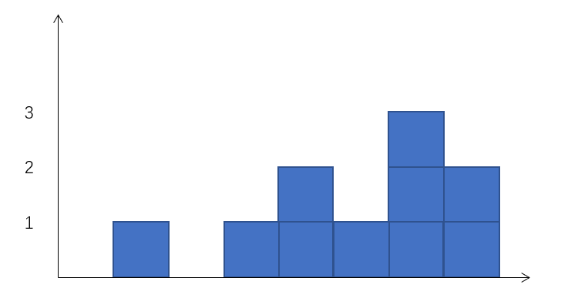

The above is the corresponding graph of **Input**. You can get the capacity quickly by observing .Obviously, the **output** is 2.

**Output**: 2

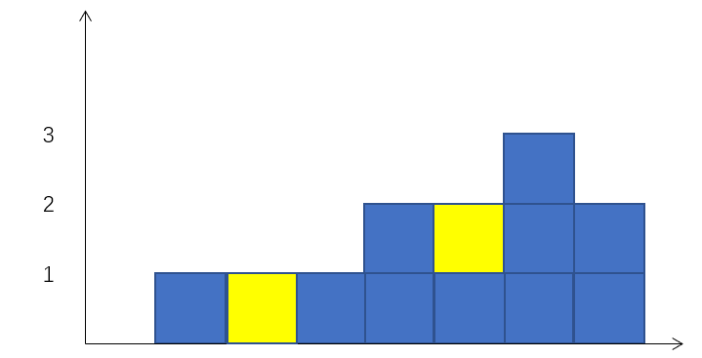

Q2: Cut the cake

You want to give your friend a cake, but the shape of the cake you own is too strange. So, you decide to cut the cake based on the following requirements:

* The cake you cut must be rectangular
* You only give your friend one cake, the rest will be thrown away;
* The larger of the cake you cut is, the better.

Now, cut the cake and compute the area the cake you cut.

In this problem, the cake can be represented by a string of integers. Each integer is non-negative, and each integer represents the height of a cake bar which of the width is 1.

E.g.

**Input**: 1,1,2,3,3,2,2,1

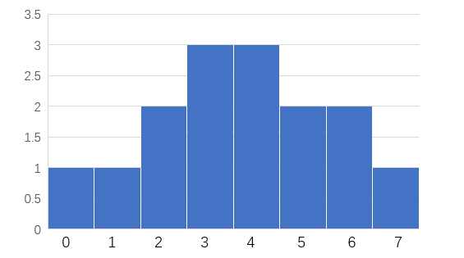

The above is the corresponding cake of **Input**. You can get the max rectangular cake quickly by observing. Obviously, the **output** is10.

**Output**: 10

