Buckets effect

As Buckets effect reveals, the capacity of a bucket depends on the shortest board. This is a theory in 3D, an now consider a similar problem in 2D.

Given a string of integers, each integer is non-negative, and each integer represents the height of a board which of the width is 1. Compute the capacity of buckets based on Buckets effect.

E.g.

**Input**: 0,1,0,1,2,1,3,2

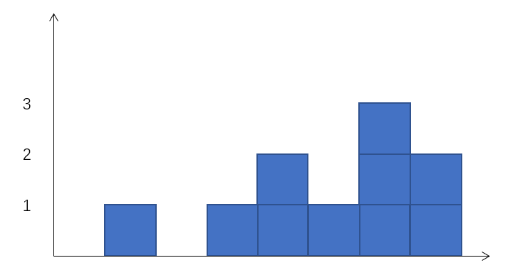

The above is the corresponding graph of **Input**. You can get the capacity quickly by observing .Obviously, the **output** is 2.

**Output**: 2

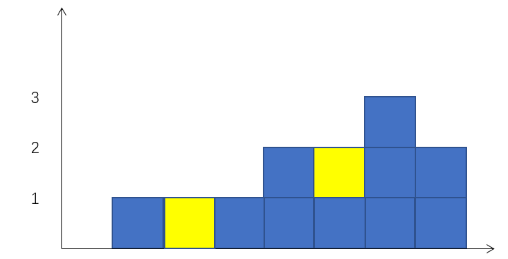

Cut the cake

You want to give your friend a cake, but the shape of the cake you own is too strange. So, you decide to cut the cake based on the following requirements:

* The cake you cut must be rectangular
* You only give your friend one cake, the rest will be thrown away;
* The larger of the cake is, the better.

Now, cut the cake and compute the area the cake you cut.

In this problem, the cake can be represented by a string of integers. Each integer is non-negative, and each integer represents the height of a cake bar which of the width is 1.

E.g.

**Input**: 1,2,3,4,5,3,3,2

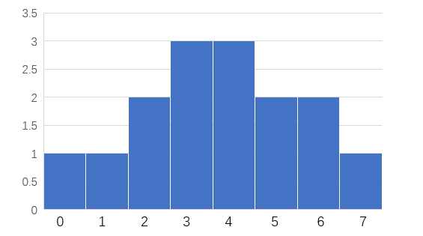

The above is the corresponding cake of **Input**. You can get the max rectangular cake quickly by observing. Obviously, the **output** is10.

**Output**: 10

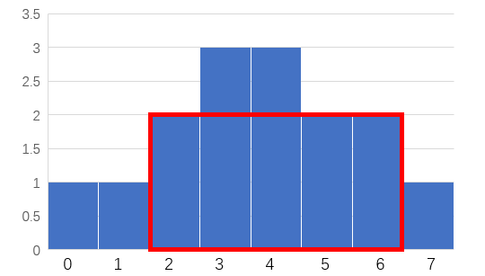

Yalun Lin Hsu (xuylin@sjtu.edu.cn) is responsible for this homework.