**SE232, Autumn 2018**

**Lab 1: Calculator**

**Assigned: Sept. 28**

**Due: Oct. 17**

*Hsuyalun Lin (xuylin@sjtu.edu.cn) is responsible for this lab.*

**Introduction:**

In lab1, we will implement a calculator with the help of the textbook. For details, reference the sixth and seventh chapters. Complete the additional functions on the sample of the textbook.

**Requirements:**

1. Implement and run the sample program (6.9) in the course and understand the structure and function of the program.

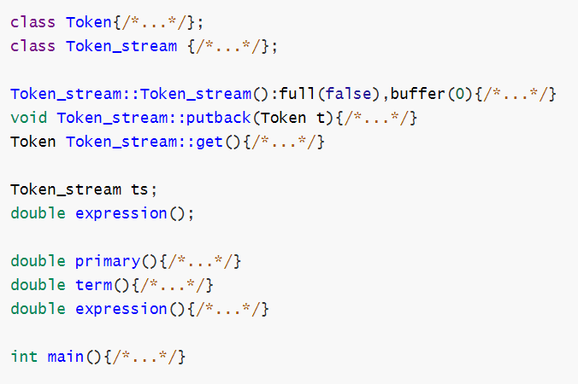

1. Your file’s name should be named ***{Your Student ID}.cpp***. Your file can read the content of ***input.txt*** and generate the result ***output.txt*** in the same subdirectory.
2. (**basic**) Implement and run the *calculator* sample program (7.3-7.6) and complete the *calculate* function, which will be able to:
   1. Cope with error message;
   2. Implement error recovery;
   3. Cope with negative number;
   4. Cope with modular operation(%);
3. (**advanced**)Modify the program, which will be able to:
   1. Cope with factorial operation(!). Note the operator precedence and 0!=1;
   2. Implement a key word *ANS(The initial value is 0)*, which can store the last calculation result. For example, the content of *input.txt* is，

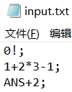

And the *output.txt* will be,

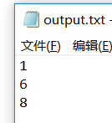

**Evaluation**

1. Cheaters will receive 0 point.
2. Basic function has 16 test cases; advanced function has 10. For each test case a fixed score (5) is assigned such that the scores for each task summed to 130. This score is awarded to the program yielding a correct result for the case; otherwise no score is awarded. There are some test cases in ***lab1_input.txt*** and corresponding results in ***lab1_output.txt.*** Please comply with the format of ***input.txt*** and ***output.txt*** in ***lab1_input.txt*** and ***lab1_output.txt***. If your format of ***output.txt*** is not specific with the requirement, you will get 0 point.
3. Code comments and code style have 20 points.

Reference: [Google C++ Style Guide](https://google.github.io/styleguide/cppguide.html)