Figures Draft

Xinyi Lin

3/26/2021

## Figure A

confusion matrix

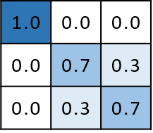

Figure A-1

#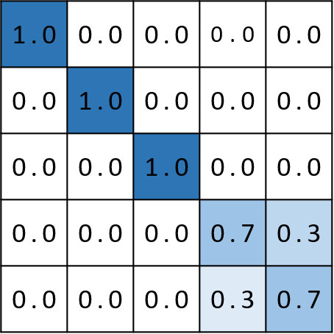

## Fig A-2

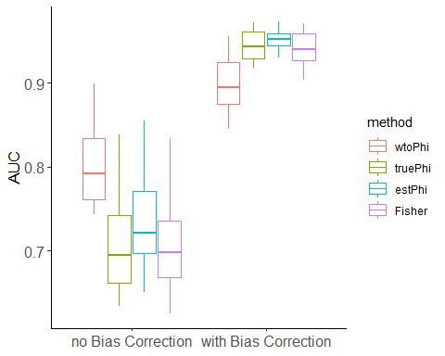

## Saving 5 x 4 in image

Plots -Supplementary1

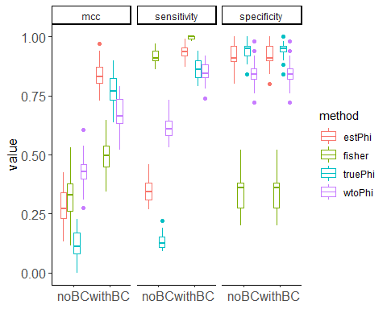

## Saving 5 x 4 in image

## Figure B

### Different number of replicates

## [1] "D:/Data/DCATS/simulation/replicates2&2_K8_con100_splatter1500&2500.RData"  
## [2] "D:/Data/DCATS/simulation/replicates3&3_K8_con100_splatter1500&2500.RData"  
## [3] "D:/Data/DCATS/simulation/replicates4&4_K8_con100_splatter1500&2500.RData"

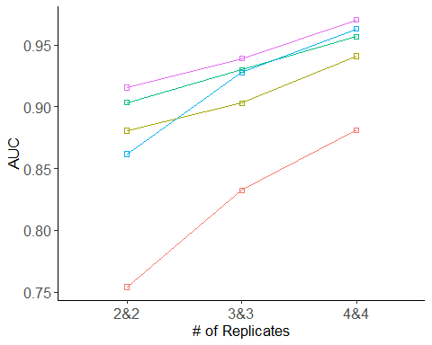

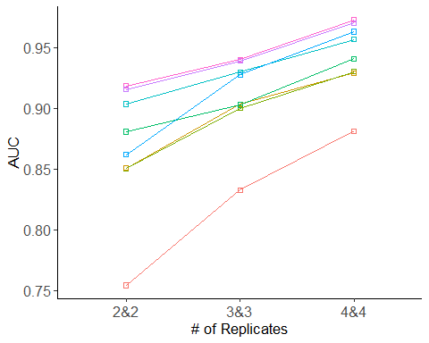

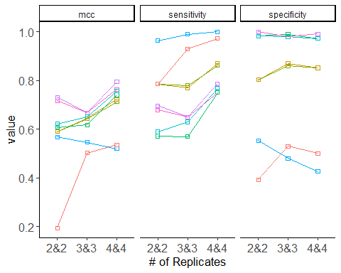

Try to use heatmap

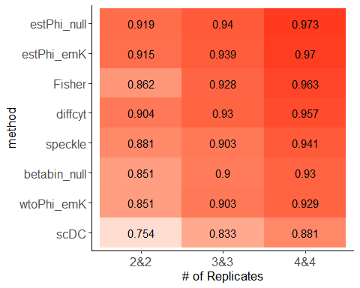

|  |  |  |  |  |  |  |  |
| --- | --- | --- | --- | --- | --- | --- | --- |
| method | mcc | prauc | auc | sensitivity | specificity | F1 | replicates |
| estPhi_null | 0.717 | 0.9465702 | 0.919 | 0.679 | 1.000 | 0.809 | 2&2 |
| estPhi_emK | 0.731 | 0.9448016 | 0.915 | 0.696 | 1.000 | 0.821 | 2&2 |
| diffcyt | 0.621 | 0.9432465 | 0.904 | 0.589 | 0.982 | 0.733 | 2&2 |
| speckle | 0.607 | 0.9327113 | 0.881 | 0.571 | 0.982 | 0.719 | 2&2 |
| Fisher | 0.568 | 0.9473168 | 0.862 | 0.964 | 0.554 | 0.800 | 2&2 |
| betabin_null | 0.589 | 0.8631795 | 0.851 | 0.786 | 0.804 | 0.793 | 2&2 |
| wtoPhi_emK | 0.589 | 0.8644719 | 0.851 | 0.786 | 0.804 | 0.793 | 2&2 |
| scDC | 0.194 | 0.8236680 | 0.754 | 0.786 | 0.393 | 0.657 | 2&2 |
| estPhi_null | 0.667 | 0.9551089 | 0.940 | 0.650 | 0.980 | 0.778 | 3&3 |
| estPhi_emK | 0.667 | 0.9534368 | 0.939 | 0.650 | 0.980 | 0.778 | 3&3 |
| diffcyt | 0.651 | 0.9461967 | 0.930 | 0.630 | 0.980 | 0.764 | 3&3 |
| Fisher | 0.546 | 0.9444653 | 0.928 | 0.990 | 0.480 | 0.789 | 3&3 |
| wtoPhi_emK | 0.643 | 0.9093621 | 0.903 | 0.770 | 0.870 | 0.811 | 3&3 |
| speckle | 0.617 | 0.9406593 | 0.903 | 0.570 | 0.990 | 0.722 | 3&3 |
| betabin_null | 0.642 | 0.9052562 | 0.900 | 0.780 | 0.860 | 0.812 | 3&3 |
| scDC | 0.502 | 0.8360728 | 0.833 | 0.930 | 0.530 | 0.775 | 3&3 |
| estPhi_null | 0.763 | 0.9828727 | 0.973 | 0.750 | 0.991 | 0.853 | 4&4 |
| estPhi_emK | 0.794 | 0.9804525 | 0.970 | 0.787 | 0.991 | 0.876 | 4&4 |
| Fisher | 0.520 | 0.9755557 | 0.963 | 1.000 | 0.426 | 0.777 | 4&4 |
| diffcyt | 0.757 | 0.9694612 | 0.957 | 0.769 | 0.972 | 0.856 | 4&4 |
| speckle | 0.741 | 0.9707739 | 0.941 | 0.750 | 0.972 | 0.844 | 4&4 |
| betabin_null | 0.713 | 0.9390602 | 0.930 | 0.861 | 0.852 | 0.857 | 4&4 |
| wtoPhi_emK | 0.722 | 0.9369762 | 0.929 | 0.870 | 0.852 | 0.862 | 4&4 |
| scDC | 0.536 | 0.8666093 | 0.881 | 0.972 | 0.500 | 0.787 | 4&4 |

### Different number of cell types

## [1] "D:/Data/DCATS/simulation/replicates3&3_K10_con100_splatter1500&2500.RData"  
## [2] "D:/Data/DCATS/simulation/replicates3&3_K12_con100_splatter1500&2500.RData"  
## [3] "D:/Data/DCATS/simulation/replicates3&3_K8_con100_splatter1500&2500.RData"

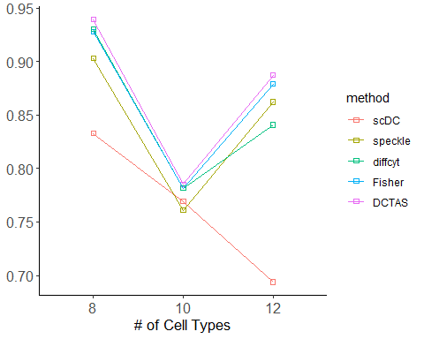

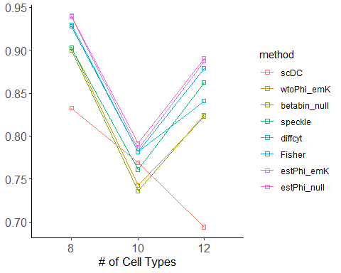

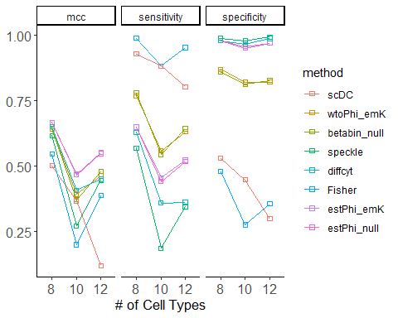

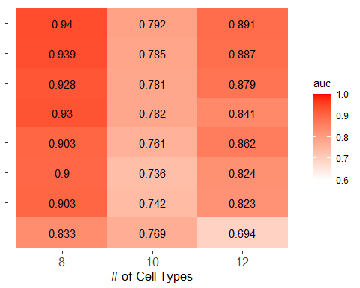

|  |  |  |  |  |  |  |  |
| --- | --- | --- | --- | --- | --- | --- | --- |
| method | mcc | prauc | auc | sensitivity | specificity | F1 | clustersN |
| estPhi_null | 0.667 | 0.9551089 | 0.940 | 0.650 | 0.980 | 0.778 | 8 |
| estPhi_emK | 0.667 | 0.9534368 | 0.939 | 0.650 | 0.980 | 0.778 | 8 |
| diffcyt | 0.651 | 0.9461967 | 0.930 | 0.630 | 0.980 | 0.764 | 8 |
| Fisher | 0.546 | 0.9444653 | 0.928 | 0.990 | 0.480 | 0.789 | 8 |
| wtoPhi_emK | 0.643 | 0.9093621 | 0.903 | 0.770 | 0.870 | 0.811 | 8 |
| speckle | 0.617 | 0.9406593 | 0.903 | 0.570 | 0.990 | 0.722 | 8 |
| betabin_null | 0.642 | 0.9052562 | 0.900 | 0.780 | 0.860 | 0.812 | 8 |
| scDC | 0.502 | 0.8360728 | 0.833 | 0.930 | 0.530 | 0.775 | 8 |
| estPhi_null | 0.467 | 0.8365756 | 0.792 | 0.441 | 0.959 | 0.595 | 10 |
| estPhi_emK | 0.469 | 0.8292339 | 0.785 | 0.455 | 0.952 | 0.606 | 10 |
| diffcyt | 0.408 | 0.8150702 | 0.782 | 0.359 | 0.966 | 0.515 | 10 |
| Fisher | 0.200 | 0.8250965 | 0.781 | 0.883 | 0.276 | 0.677 | 10 |
| scDC | 0.368 | 0.7822137 | 0.769 | 0.883 | 0.448 | 0.725 | 10 |
| speckle | 0.272 | 0.7968132 | 0.761 | 0.186 | 0.979 | 0.309 | 10 |
| wtoPhi_emK | 0.393 | 0.7619896 | 0.742 | 0.559 | 0.821 | 0.643 | 10 |
| betabin_null | 0.372 | 0.7608120 | 0.736 | 0.545 | 0.814 | 0.629 | 10 |
| estPhi_null | 0.548 | 0.9107310 | 0.891 | 0.517 | 0.971 | 0.669 | 12 |
| estPhi_emK | 0.553 | 0.9072372 | 0.887 | 0.523 | 0.971 | 0.674 | 12 |
| Fisher | 0.387 | 0.9068303 | 0.879 | 0.954 | 0.356 | 0.735 | 12 |
| speckle | 0.446 | 0.8876361 | 0.862 | 0.345 | 0.994 | 0.511 | 12 |
| diffcyt | 0.450 | 0.8661504 | 0.841 | 0.362 | 0.989 | 0.527 | 12 |
| betabin_null | 0.479 | 0.8130057 | 0.824 | 0.644 | 0.828 | 0.709 | 12 |
| wtoPhi_emK | 0.462 | 0.8093367 | 0.823 | 0.632 | 0.822 | 0.698 | 12 |
| scDC | 0.120 | 0.7358992 | 0.694 | 0.805 | 0.299 | 0.642 | 12 |

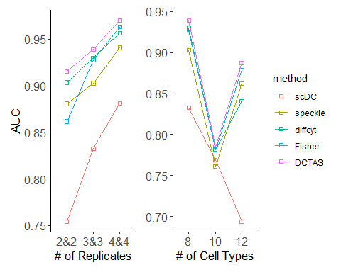

## Saving 5 x 4 in image

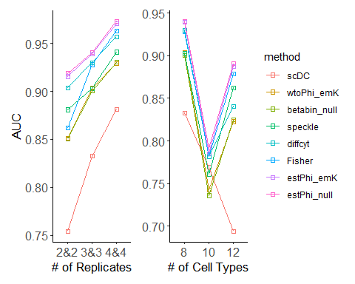

## Saving 5 x 4 in image

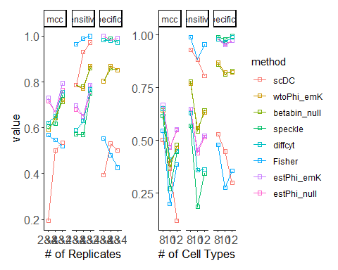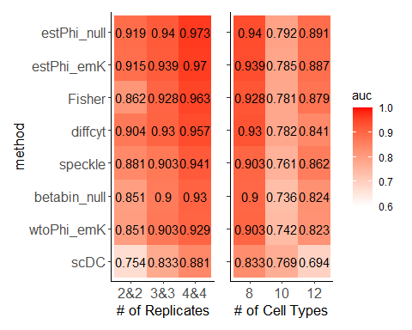

## Saving 5 x 4 in image

## Figure b2

## method mcc prauc auc sensitivity specificity  
## 1 betabin_null 0.5733863 0.8809883 0.8671596 0.5862069 0.9482759  
## 2 estPhi_null 0.5036394 0.8700736 0.8564209 0.4568966 0.9741379  
## 3 wtoPhi_emSVM 0.5621463 0.8846705 0.8810939 0.5862069 0.9396552  
## 4 truePhi_emSVM 0.5259851 0.8905426 0.8700580 0.5000000 0.9655172  
## 5 estPhi_emSVM 0.5454660 0.8859926 0.8701323 0.5086207 0.9741379  
## 6 wtoPhi_emT 0.5805774 0.8687486 0.8662678 0.5948276 0.9482759  
## 7 truePhi_emT 0.5518358 0.8367326 0.8274747 0.5603448 0.9482759  
## 8 estPhi_emT 0.4967951 0.8377223 0.8274376 0.5086207 0.9396552  
## 9 wtoPhi_emU 0.5662000 0.8812007 0.8849584 0.5775862 0.9482759  
## 10 truePhi_emU 0.5662000 0.8749339 0.8566439 0.5775862 0.9482759  
## 11 estPhi_emU 0.5733863 0.8686933 0.8556406 0.5862069 0.9482759  
## 12 wtoPhi_emK 0.5733863 0.8826828 0.8742197 0.5862069 0.9482759  
## 13 truePhi_emK 0.5541176 0.8964568 0.8690175 0.5344828 0.9655172  
## 14 estPhi_emK 0.5524096 0.8921725 0.8677170 0.5172414 0.9741379  
## 15 wtoPhi_fullK 0.5590170 0.8812782 0.8748142 0.5689655 0.9482759  
## 16 wtoPhi_fullU 0.5733863 0.8769965 0.8819857 0.5862069 0.9482759  
## 17 wtoPhi_fullT 0.5847639 0.8686648 0.8702066 0.5862069 0.9568966  
## 18 wtoPhi_fullSVM 0.5621463 0.8799010 0.8754831 0.5862069 0.9396552  
## 19 estPhi_fullK 0.5036394 0.8693720 0.8474658 0.4568966 0.9741379  
## 20 estPhi_fullU 0.5036394 0.8682730 0.8467227 0.4568966 0.9741379  
## 21 estPhi_fullT 0.4906137 0.8557816 0.8407773 0.4568966 0.9655172  
## 22 estPhi_fullSVM 0.5106387 0.8697633 0.8476516 0.4655172 0.9741379  
## 23 truePhi_fullK 0.5118745 0.8763387 0.8495095 0.4827586 0.9655172  
## 24 truePhi_fullU 0.5118745 0.8765133 0.8493980 0.4827586 0.9655172  
## 25 truePhi_fullT 0.5048021 0.8554554 0.8425981 0.4741379 0.9655172  
## 26 truePhi_fullSVM 0.5118745 0.8768702 0.8503641 0.4827586 0.9655172  
## 27 fisher 0.4487927 0.8607657 0.8521477 0.9568966 0.4224138  
## 28 scDC 0.2047784 0.6662115 0.6473692 0.7241379 0.4741379  
## 29 speckle 0.3006093 0.8381494 0.8256540 0.2068966 0.9827586  
## 30 diffcyt 0.3500000 0.8520617 0.8351665 0.2586207 0.9827586  
## 31 betabin_null 0.1567208 0.6085271 0.5919293 0.2413793 0.8793103  
## 32 estPhi_null 0.2150033 0.6520804 0.6066810 0.1465517 0.9741379  
## 33 wtoPhi_emSVM 0.1469044 0.6090284 0.5914090 0.2327586 0.8793103  
## 34 truePhi_emSVM 0.2547623 0.6588641 0.6103597 0.1810345 0.9741379  
## 35 estPhi_emSVM 0.2451951 0.6555264 0.6101367 0.1724138 0.9741379  
## 36 wtoPhi_emT 0.1921057 0.6073416 0.5873960 0.2500000 0.8965517  
## 37 truePhi_emT 0.1798422 0.6196201 0.5685568 0.1896552 0.9310345  
## 38 estPhi_emT 0.1587768 0.6125224 0.5661787 0.1724138 0.9310345  
## 39 wtoPhi_emU 0.1759198 0.6123192 0.5965740 0.2586207 0.8793103  
## 40 truePhi_emU 0.2651044 0.6706782 0.6226219 0.2672414 0.9310345  
## 41 estPhi_emU 0.2681332 0.6654254 0.6225104 0.2413793 0.9482759  
## 42 wtoPhi_emK 0.1663896 0.6069906 0.5907402 0.2500000 0.8793103  
## 43 truePhi_emK 0.2641183 0.6560696 0.6086133 0.1896552 0.9741379  
## 44 estPhi_emK 0.2547623 0.6550453 0.6087619 0.1810345 0.9741379  
## 45 wtoPhi_fullK 0.1567208 0.6072367 0.5898112 0.2413793 0.8793103  
## 46 wtoPhi_fullU 0.1597524 0.6073984 0.5907773 0.2327586 0.8879310  
## 47 wtoPhi_fullT 0.1695051 0.6069719 0.5839402 0.2413793 0.8879310  
## 48 wtoPhi_fullSVM 0.1695051 0.6044043 0.5964997 0.2413793 0.8879310  
## 49 estPhi_fullK 0.2150033 0.6503677 0.6061608 0.1465517 0.9741379  
## 50 estPhi_fullU 0.2043510 0.6524287 0.6091335 0.1379310 0.9741379  
## 51 estPhi_fullT 0.2150033 0.6516998 0.6042658 0.1465517 0.9741379  
## 52 estPhi_fullSVM 0.2150033 0.6525184 0.6088362 0.1465517 0.9741379  
## 53 truePhi_fullK 0.2353960 0.6516215 0.6067182 0.1637931 0.9741379  
## 54 truePhi_fullU 0.2253411 0.6495701 0.6065696 0.1551724 0.9741379  
## 55 truePhi_fullT 0.2353960 0.6502154 0.6048231 0.1637931 0.9741379  
## 56 truePhi_fullSVM 0.2353960 0.6526499 0.6087619 0.1637931 0.9741379  
## 57 betabin_null NaN 1.0000000 NaN 0.2198276 NaN  
## 58 estPhi_null NaN 1.0000000 NaN 0.1250000 NaN  
## 59 wtoPhi_emSVM NaN 1.0000000 NaN 0.2198276 NaN  
## 60 truePhi_emSVM NaN 1.0000000 NaN 0.1551724 NaN  
## 61 estPhi_emSVM NaN 1.0000000 NaN 0.1336207 NaN  
## 62 wtoPhi_emT NaN 1.0000000 NaN 0.2327586 NaN  
## 63 truePhi_emT NaN 1.0000000 NaN 0.2284483 NaN  
## 64 estPhi_emT NaN 1.0000000 NaN 0.2068966 NaN  
## 65 wtoPhi_emU NaN 1.0000000 NaN 0.2241379 NaN  
## 66 truePhi_emU NaN 1.0000000 NaN 0.2413793 NaN  
## 67 estPhi_emU NaN 1.0000000 NaN 0.2241379 NaN  
## 68 wtoPhi_emK NaN 1.0000000 NaN 0.2241379 NaN  
## 69 truePhi_emK NaN 1.0000000 NaN 0.1637931 NaN  
## 70 estPhi_emK NaN 1.0000000 NaN 0.1465517 NaN  
## 71 wtoPhi_fullK NaN 1.0000000 NaN 0.2155172 NaN  
## 72 wtoPhi_fullU NaN 1.0000000 NaN 0.2155172 NaN  
## 73 wtoPhi_fullT NaN 1.0000000 NaN 0.2155172 NaN  
## 74 wtoPhi_fullSVM NaN 1.0000000 NaN 0.2155172 NaN  
## 75 estPhi_fullK NaN 1.0000000 NaN 0.1250000 NaN  
## 76 estPhi_fullU NaN 1.0000000 NaN 0.1293103 NaN  
## 77 estPhi_fullT NaN 1.0000000 NaN 0.1206897 NaN  
## 78 estPhi_fullSVM NaN 1.0000000 NaN 0.1336207 NaN  
## 79 truePhi_fullK NaN 1.0000000 NaN 0.1465517 NaN  
## 80 truePhi_fullU NaN 1.0000000 NaN 0.1465517 NaN  
## 81 truePhi_fullT NaN 1.0000000 NaN 0.1422414 NaN  
## 82 truePhi_fullSVM NaN 1.0000000 NaN 0.1551724 NaN  
## F1 factor  
## 1 0.7157895 condition  
## 2 0.6162791 condition  
## 3 0.7120419 condition  
## 4 0.6516854 condition  
## 5 0.6629213 condition  
## 6 0.7225131 condition  
## 7 0.6951872 condition  
## 8 0.6483516 condition  
## 9 0.7089947 condition  
## 10 0.7089947 condition  
## 11 0.7157895 condition  
## 12 0.7157895 condition  
## 13 0.6813187 condition  
## 14 0.6703911 condition  
## 15 0.7021277 condition  
## 16 0.7157895 condition  
## 17 0.7195767 condition  
## 18 0.7120419 condition  
## 19 0.6162791 condition  
## 20 0.6162791 condition  
## 21 0.6127168 condition  
## 22 0.6242775 condition  
## 23 0.6363636 condition  
## 24 0.6363636 condition  
## 25 0.6285714 condition  
## 26 0.6363636 condition  
## 27 0.7551020 condition  
## 28 0.6436782 condition  
## 29 0.3380282 condition  
## 30 0.4054054 condition  
## 31 0.3544304 age  
## 32 0.2500000 age  
## 33 0.3439490 age  
## 34 0.3000000 age  
## 35 0.2877698 age  
## 36 0.3694268 age  
## 37 0.3013699 age  
## 38 0.2777778 age  
## 39 0.3750000 age  
## 40 0.4000000 age  
## 41 0.3733333 age  
## 42 0.3647799 age  
## 43 0.3120567 age  
## 44 0.3000000 age  
## 45 0.3544304 age  
## 46 0.3461538 age  
## 47 0.3566879 age  
## 48 0.3566879 age  
## 49 0.2500000 age  
## 50 0.2370370 age  
## 51 0.2500000 age  
## 52 0.2500000 age  
## 53 0.2753623 age  
## 54 0.2627737 age  
## 55 0.2753623 age  
## 56 0.2753623 age  
## 57 0.3604240 gender  
## 58 0.2222222 gender  
## 59 0.3604240 gender  
## 60 0.2686567 gender  
## 61 0.2357414 gender  
## 62 0.3776224 gender  
## 63 0.3719298 gender  
## 64 0.3428571 gender  
## 65 0.3661972 gender  
## 66 0.3888889 gender  
## 67 0.3661972 gender  
## 68 0.3661972 gender  
## 69 0.2814815 gender  
## 70 0.2556391 gender  
## 71 0.3546099 gender  
## 72 0.3546099 gender  
## 73 0.3546099 gender  
## 74 0.3546099 gender  
## 75 0.2222222 gender  
## 76 0.2290076 gender  
## 77 0.2153846 gender  
## 78 0.2357414 gender  
## 79 0.2556391 gender  
## 80 0.2556391 gender  
## 81 0.2490566 gender  
## 82 0.2686567 gender

## method mcc prauc auc sensitivity specificity F1  
## 1 wtoPhi_emK 0.1663896 0.6069906 0.5907402 0.2500000 0.8793103 0.3647799  
## 2 betabin_null 0.1567208 0.6085271 0.5919293 0.2413793 0.8793103 0.3544304  
## 3 estPhi_emK 0.2547623 0.6550453 0.6087619 0.1810345 0.9741379 0.3000000  
## 4 estPhi_null 0.2150033 0.6520804 0.6066810 0.1465517 0.9741379 0.2500000  
## 5 fisher 0.4487927 0.8607657 0.8521477 0.9568966 0.4224138 0.7551020  
## 6 betabin_null 0.5733863 0.8809883 0.8671596 0.5862069 0.9482759 0.7157895  
## 7 wtoPhi_emK 0.5733863 0.8826828 0.8742197 0.5862069 0.9482759 0.7157895  
## 8 estPhi_emK 0.5524096 0.8921725 0.8677170 0.5172414 0.9741379 0.6703911  
## 9 scDC 0.2047784 0.6662115 0.6473692 0.7241379 0.4741379 0.6436782  
## 10 estPhi_null 0.5036394 0.8700736 0.8564209 0.4568966 0.9741379 0.6162791  
## 11 diffcyt 0.3500000 0.8520617 0.8351665 0.2586207 0.9827586 0.4054054  
## 12 speckle 0.3006093 0.8381494 0.8256540 0.2068966 0.9827586 0.3380282  
## 13 wtoPhi_emK NaN 1.0000000 NaN 0.2241379 NaN 0.3661972  
## 14 betabin_null NaN 1.0000000 NaN 0.2198276 NaN 0.3604240  
## 15 estPhi_emK NaN 1.0000000 NaN 0.1465517 NaN 0.2556391  
## 16 estPhi_null NaN 1.0000000 NaN 0.1250000 NaN 0.2222222  
## factor  
## 1 age  
## 2 age  
## 3 age  
## 4 age  
## 5 condition  
## 6 condition  
## 7 condition  
## 8 condition  
## 9 condition  
## 10 condition  
## 11 condition  
## 12 condition  
## 13 gender  
## 14 gender  
## 15 gender  
## 16 gender

## real-world data 1 - Experiment 7

The ‘group’ column started with ‘B’ is the indicators of replicates

## batch barcode condition clusterRes x  
## 1 B1 AAACATACCACAAC Control Enterocyte.Progenitor Enterocyte.Progenitor  
## 2 B1 AAACGCACGAGGAC Control Stem Stem  
## 3 B1 AAACGCACTAGCCA Control Stem Stem  
## 4 B1 AAACGCACTGTCCC Control Stem Stem  
## 5 B1 AAACTTGACCACCT Control Enterocyte.Progenitor Enterocyte.Progenitor  
## 6 B1 AAAGATCTACCTTT Control Enterocyte.Progenitor Enterocyte.Progenitor

## batch barcode condition clusterRes   
## Length:9842 Length:9842 Length:9842 Length:9842   
## Class :character Class :character Class :character Class :character   
## Mode :character Mode :character Mode :character Mode :character   
## x   
## Length:9842   
## Class :character   
## Mode :character

## `summarise()` has grouped output by 'batch'. You can override using the `.groups` argument.

## # A tibble: 10 x 3  
## # Groups: batch [10]  
## batch condition n  
## <chr> <chr> <int>  
## 1 B1 Control 840  
## 2 B10 Salmonella 950  
## 3 B2 Control 200  
## 4 B3 Control 1258  
## 5 B4 Control 942  
## 6 B5 Hpoly.Day3 1490  
## 7 B6 Hpoly.Day3 631  
## 8 B7 Hpoly.Day10 1169  
## 9 B8 Hpoly.Day10 1542  
## 10 B9 Salmonella 820

## `summarise()` has grouped output by 'batch', 'condition'. You can override using the `.groups` argument.

## `summarise()` has grouped output by 'condition'. You can override using the `.groups` argument.

## Bin width defaults to 1/30 of the range of the data. Pick better value with `binwidth`.  
## Bin width defaults to 1/30 of the range of the data. Pick better value with `binwidth`.

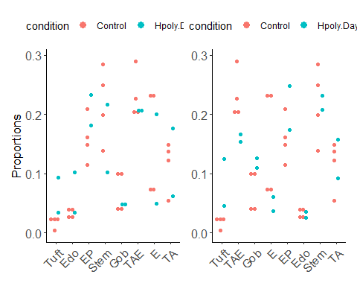

## Saving 5 x 4 in image  
## Bin width defaults to 1/30 of the range of the data. Pick better value with `binwidth`.  
## Bin width defaults to 1/30 of the range of the data. Pick better value with `binwidth`.

|  |  |  |  |  |  |  |  |  |
| --- | --- | --- | --- | --- | --- | --- | --- | --- |
|  | Tuft | Endocrine | Enterocyte.Progenitor | Stem | Goblet | TA.Early | Enterocyte | TA |
| truth | P | N | N | N | N | N | N | N |
| DCATS | * | n.s. | n.s. | n.s. | n.s. | n.s. | n.s. | n.s. |
| fisher | *** | *** | *** | ** | *** | *** | *** | n.s. |
| scDC | * | n.s. | n.s. | ** | *** | *** | *** | n.s. |
| speckle | n.s. | n.s. | n.s. | n.s. | n.s. | n.s. | n.s. | n.s. |

|  |  |  |  |  |  |  |  |  |
| --- | --- | --- | --- | --- | --- | --- | --- | --- |
|  | Tuft | TA.Early | Goblet | Enterocyte | Enterocyte.Progenitor | Endocrine | Stem | TA |
| truth | P | P | P | P | N | N | N | N |
| DCATS | ** | n.s. | n.s. | *** | n.s. | n.s. | n.s. | n.s. |
| fisher | *** | *** | *** | *** | *** | n.s. | n.s. | n.s. |
| scDC | *** | n.s. | ** | *** | n.s. | ** | n.s. | n.s. |
| speckle | n.s. | n.s. | n.s. | n.s. | n.s. | n.s. | n.s. | n.s. |

|  |  |  |  |  |  |  |  |  |
| --- | --- | --- | --- | --- | --- | --- | --- | --- |
|  | Enterocyte | Stem | TA | TA.Early | Enterocyte.Progenitor | Tuft | Goblet | Endocrine |
| truth | P | P | P | P | N | N | N | N |
| DCATS | *** | * | n.s. | n.s. | n.s. | n.s. | n.s. | n.s. |
| fisher | *** | *** | *** | *** | *** | n.s. | n.s. | n.s. |
| scDC | ** | * | n.s. | n.s. | n.s. | * | n.s. | n.s. |
| speckle | *** | * | n.s. | n.s. | n.s. | n.s. | n.s. | n.s. |

## real-world data2

## cell tsne1 tsne2 ind condition cluster clusterRes  
## 1 AAACATACAATGCC-1 -4.277833 -19.294709 107 ctrl 5 CD4 T cells  
## 2 AAACATACATTTCC-1 -27.640373 14.966629 1016 ctrl 9 CD14+ Monocytes  
## 3 AAACATACCAGAAA-1 -27.493646 28.924885 1256 ctrl 9 CD14+ Monocytes  
## 4 AAACATACCAGCTA-1 -28.132584 24.925484 1256 ctrl 9 CD14+ Monocytes  
## 5 AAACATACCATGCA-1 -10.468194 -5.984389 1488 ctrl 3 CD4 T cells  
## 6 AAACATACCTCGCT-1 -24.367997 20.429285 1256 ctrl 9 CD14+ Monocytes  
## multiplets  
## 1 doublet  
## 2 singlet  
## 3 singlet  
## 4 doublet  
## 5 singlet  
## 6 singlet

## `summarise()` has grouped output by 'condition'. You can override using the `.groups` argument.

## # A tibble: 16 x 3  
## # Groups: condition [2]  
## condition clusterRes n  
## <chr> <chr> <int>  
## 1 ctrl B cells 1488  
## 2 ctrl CD14+ Monocytes 3365  
## 3 ctrl CD4 T cells 6005  
## 4 ctrl CD8 T cells 1409  
## 5 ctrl Dendritic cells 227  
## 6 ctrl FCGR3A+ Monocytes 906  
## 7 ctrl Megakaryocytes 166  
## 8 ctrl NK cells 1051  
## 9 stim B cells 1392  
## 10 stim CD14+ Monocytes 3082  
## 11 stim CD4 T cells 6028  
## 12 stim CD8 T cells 1225  
## 13 stim Dendritic cells 245  
## 14 stim FCGR3A+ Monocytes 1008  
## 15 stim Megakaryocytes 180  
## 16 stim NK cells 1279

## # A tibble: 0 x 2  
## # ... with 2 variables: cell <chr>, n <int>

## BARCODE RD.TOTL RD.PASS RD.UNIQ N.SNP BEST SNG.1ST  
## 1 AAACATACAATGCC-1 5799 280 269 185 DBL-107-1244-0.500 107  
## 2 AAACATACATTTCC-1 5466 592 501 236 SNG-1016 1016  
## 3 AAACATACCAGAAA-1 4337 330 300 154 SNG-1256 1256  
## 4 AAACATACCAGCTA-1 7120 418 338 179 DBL-1256-1244-0.500 1256  
## 5 AAACATACCATGCA-1 2422 86 76 54 SNG-1488 1488  
## 6 AAACATACCTCGCT-1 5312 561 497 207 SNG-1256 1256  
## SNG.LLK1 SNG.2ND SNG.LLK2 SNG.LLK0 DBL.1ST DBL.2ND ALPHA LLK12  
## 1 -78.5388 1244 -92.3864 -75.9878 107 1244 0.5 -62.8745  
## 2 -61.8525 1256 -193.3940 -135.9317 1016 1256 0.5 -93.0213  
## 3 -50.6213 1015 -100.6965 -67.2587 101 1256 0.5 -64.5022  
## 4 -70.2734 1244 -110.3962 -82.1916 1256 1244 0.5 -67.3787  
## 5 -16.1294 1015 -31.7146 -27.0167 1015 1488 0.5 -18.5646  
## 6 -66.3586 1015 -180.3066 -115.0556 1256 101 0.5 -101.4645  
## LLK1 LLK2 LLK10 LLK20 LLK00 PRB.DBL PRB.SNG1  
## 1 -78.5388 -92.3864 -88.6649 -94.1498 -77.4107 1.00e+00 1  
## 2 -61.8525 -193.3940 -103.2284 -168.3927 -132.6010 4.15e-15 1  
## 3 -107.8190 -50.6213 -111.3319 -64.5022 -72.4244 1.95e-07 1  
## 4 -70.2734 -110.3962 -80.3745 -103.1706 -85.1143 7.21e-01 1  
## 5 -31.7146 -16.1294 -30.2045 -22.5295 -28.2980 1.28e-02 1  
## 6 -66.3586 -190.9367 -101.4645 -194.9529 -124.2197 8.42e-17 1

## BARCODE RD.TOTL RD.PASS RD.UNIQ N.SNP BEST SNG.1ST SNG.LLK1  
## 1 AAACATACCAAGCT-1 2491 239 228 141 SNG-101 101 -31.2822  
## 2 AAACATACCCCTAC-1 3747 282 274 173 SNG-1488 1488 -37.4261  
## 3 AAACATACCCGTAA-1 2844 144 133 108 SNG-1244 1244 -35.0043  
## 4 AAACATACCCTCGT-1 3575 199 189 115 SNG-1488 1488 -31.5489  
## 5 AAACATACGAGGTG-1 2649 170 158 99 SNG-1488 1488 -33.2782  
## 6 AAACATACGCGAAG-1 9874 880 822 345 SNG-101 101 -139.7810  
## SNG.2ND SNG.LLK2 SNG.LLK0 DBL.1ST DBL.2ND ALPHA LLK12 LLK1  
## 1 1015 -81.3393 -59.5871 101 1015 0.5 -47.8026 -31.2822  
## 2 1256 -104.7874 -74.9247 1256 1488 0.5 -53.8991 -104.7874  
## 3 1488 -61.5604 -51.6974 1488 1244 0.5 -36.9775 -61.5604  
## 4 1244 -79.8040 -57.9696 1256 1488 0.5 -42.8116 -83.5802  
## 5 1244 -66.4966 -48.9522 101 1488 0.5 -36.4330 -75.8228  
## 6 1256 -266.4763 -170.1924 101 1488 0.5 -154.9333 -139.7810  
## LLK2 LLK10 LLK20 LLK00 PRB.DBL PRB.SNG1  
## 1 -81.3393 -32.1591 -47.8026 -64.9647 1.07e-08 1  
## 2 -37.4261 -101.7666 -64.5707 -79.2115 1.00e-08 1  
## 3 -35.0043 -72.6479 -50.8297 -52.6835 2.03e-02 1  
## 4 -31.5489 -80.4661 -49.8506 -58.0733 2.38e-06 1  
## 5 -33.2782 -72.2344 -36.4330 -48.3017 8.06e-03 1  
## 6 -273.8806 -136.9040 -154.9333 -175.5614 3.82e-08 1

## cell batch  
## 1 AAACATACATTTCC-1 SNG-1016  
## 2 AAACATACCAGAAA-1 SNG-1256  
## 3 AAACATACCATGCA-1 SNG-1488  
## 4 AAACATACCTCGCT-1 SNG-1256  
## 5 AAACATACCTGGTA-1 SNG-1039  
## 6 AAACATACGATGAA-1 SNG-1488

## `summarise()` has grouped output by 'condition', 'clusterRes'. You can override using the `.groups` argument.

## Bin width defaults to 1/30 of the range of the data. Pick better value with `binwidth`.

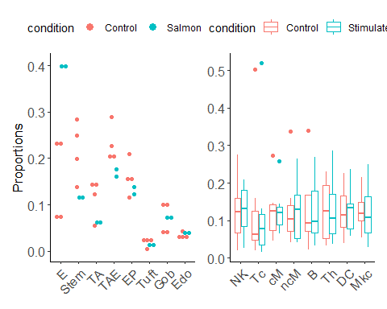

## Saving 5 x 4 in image  
## Bin width defaults to 1/30 of the range of the data. Pick better value with `binwidth`.

|  |  |  |  |  |  |  |  |  |
| --- | --- | --- | --- | --- | --- | --- | --- | --- |
|  | B cells | CD14+ Monocytes | CD4 T cells | CD8 T cells | Dendritic cells | FCGR3A+ Monocytes | Megakaryocytes | NK cells |
| truth | N | N | N | N | N | N | N | N |
| DCATS | n.s. | n.s. | n.s. | n.s. | n.s. | n.s. | n.s. | n.s. |
| fisher | n.s. | *** | n.s. | *** | n.s. | *** | n.s. | *** |
| scDC | *** | n.s. | n.s. | n.s. | n.s. | * | n.s. | ** |
| speckle | n.s. | n.s. | n.s. | n.s. | n.s. | n.s. | n.s. | n.s. |