Figure Draft - Three plots version

Xinyi Lin

3/12/2022

## Bias Correction validation

Supplementary figures

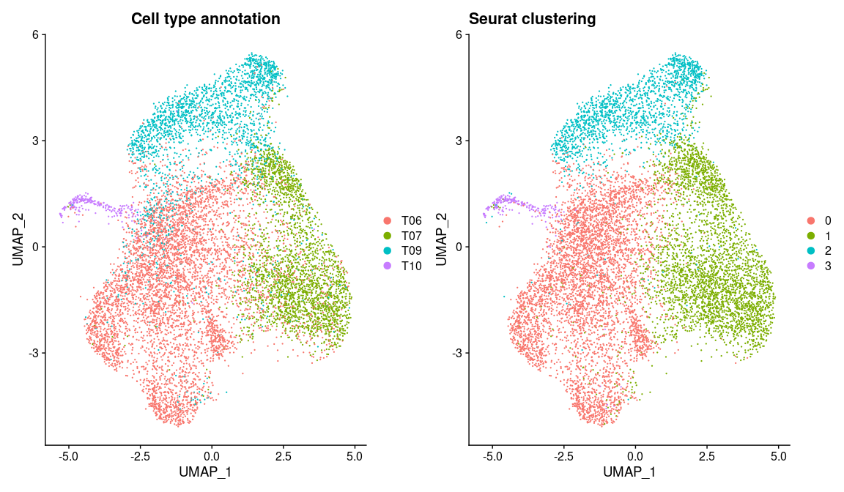

## T06 T07 T09 T10  
## true_proportion 0.5176000 0.2473000 0.2124000 0.022700000  
## cur_proportion 0.4757000 0.3378000 0.1654000 0.021100000  
## bs_true_proportion 0.5175566 0.2473243 0.2124182 0.022700893  
## bs_knn_proportion 0.5359492 0.2801164 0.1633053 0.020629093  
## bs_svm_proportion 0.5544828 0.2795524 0.1575926 0.008372169

## .  
## rmse_cur 1.810000e-01  
## rmse_true_bs 8.672239e-05  
## rmse_svm_bs 1.382705e-01  
## rmse_knn_bs 1.023313e-01

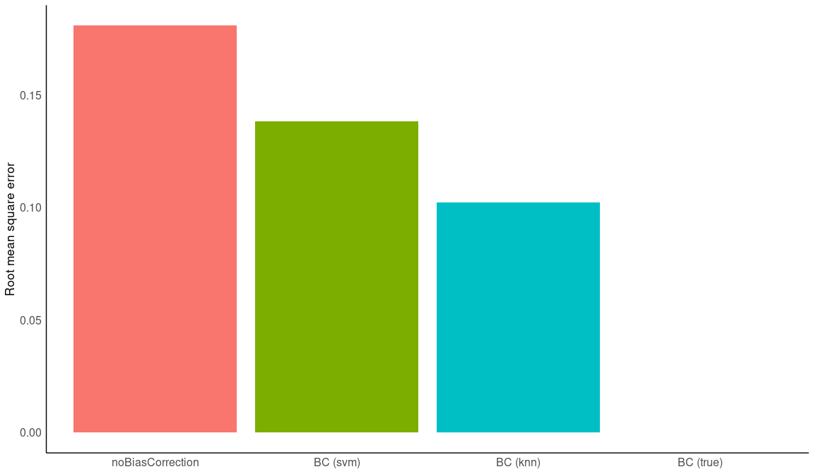

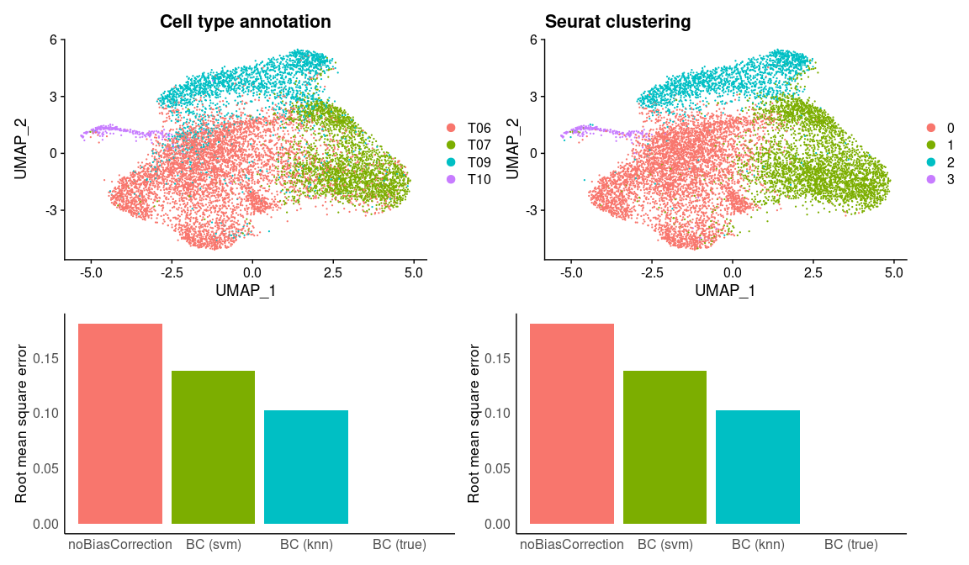

## Saving 12 x 7 in image

### Figure 1 - B

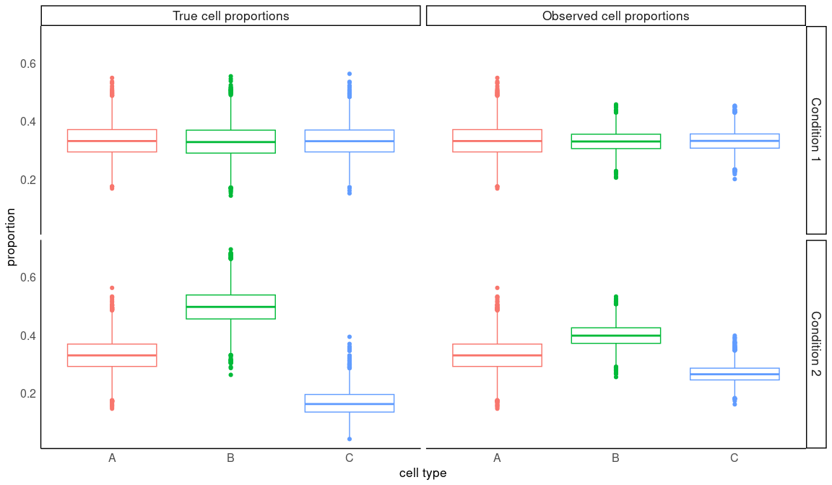

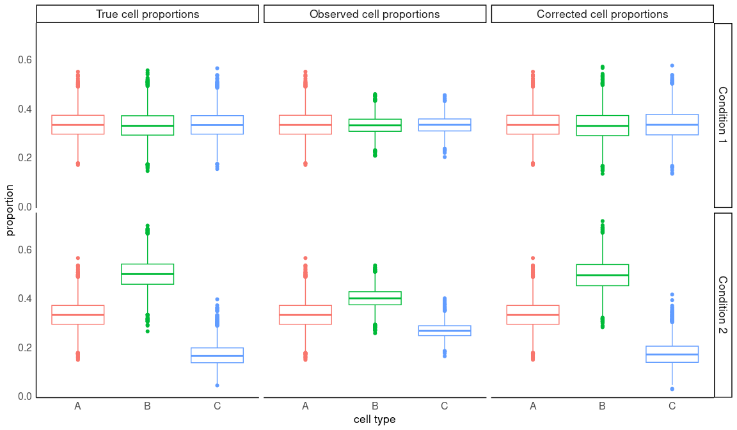

## Saving 12 x 7 in image

### Figure 2 - C

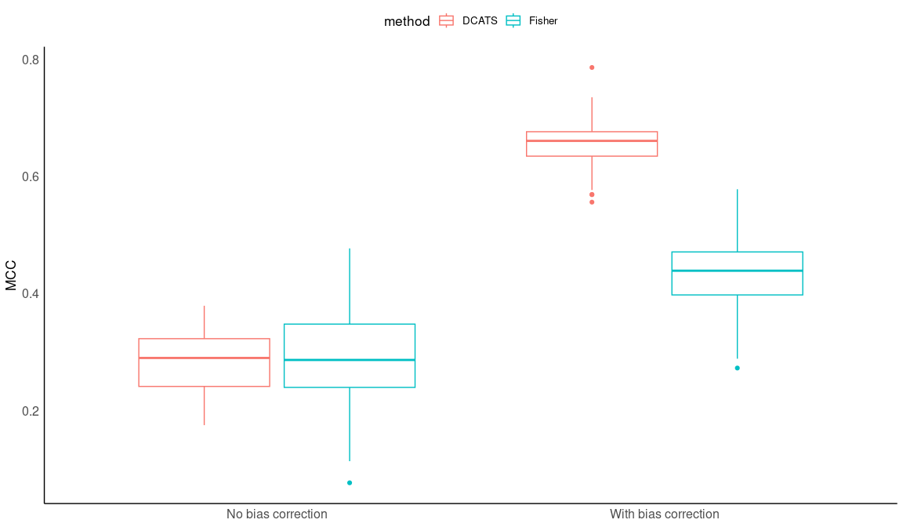

## Saving 12 x 7 in image

Simulation 1: Supplementary Plots

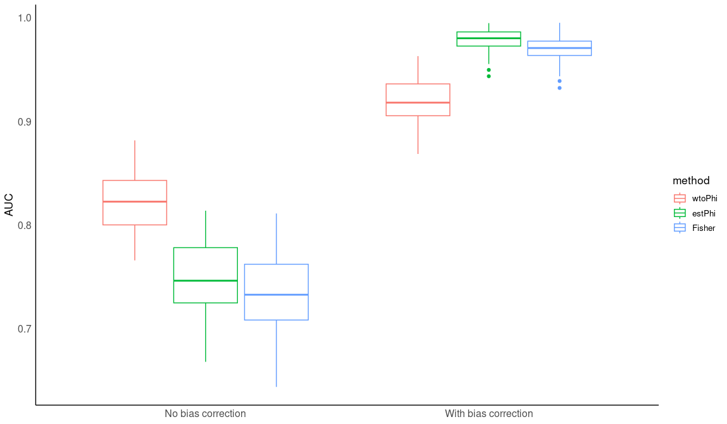

## Saving 12 x 7 in image

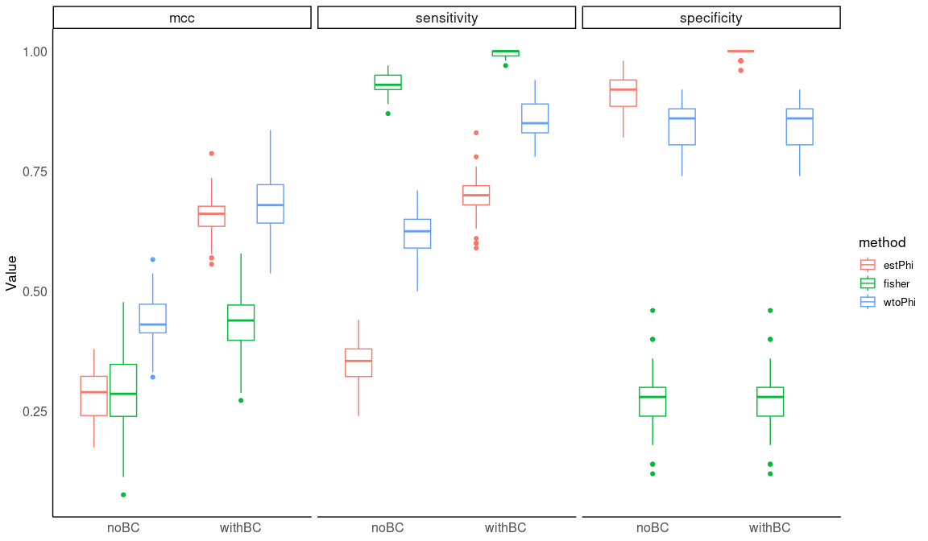

## Saving 12 x 7 in image

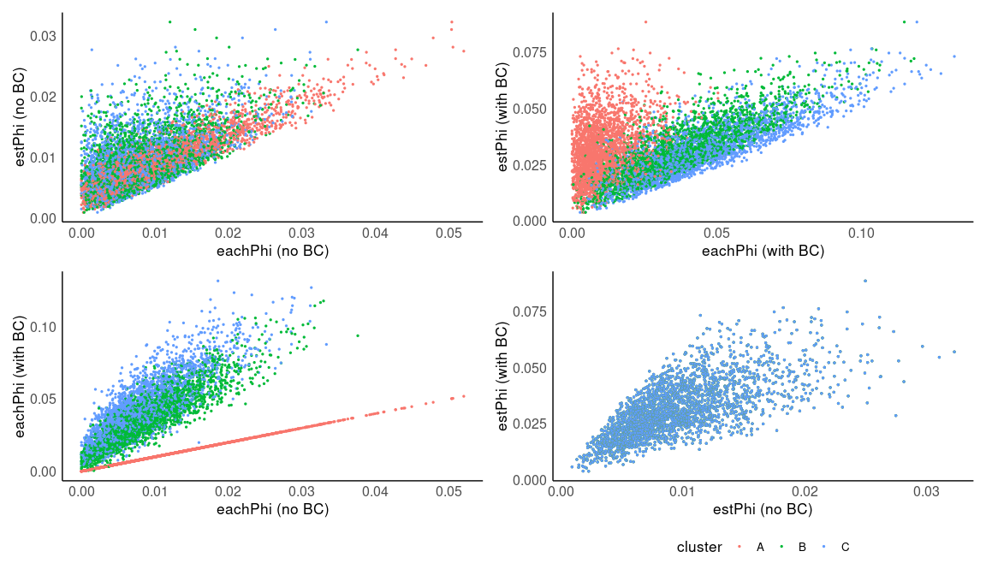

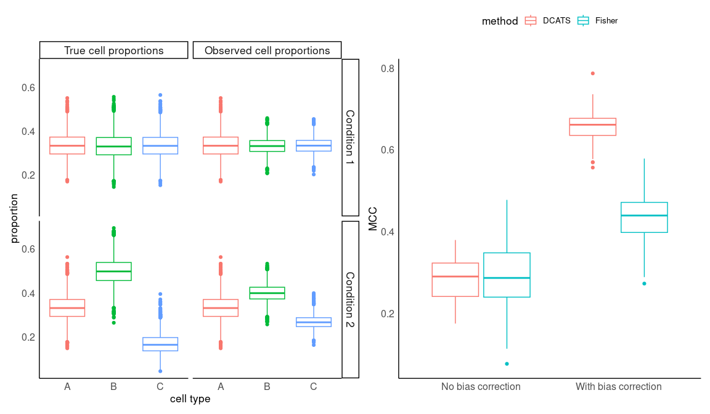

## Figure 2

### Figure 2-A

The Distribution of cell pool

## Centering and scaling data matrix

## PC_ 1   
## Positive: Gene862, Gene593, Gene473, Gene94, Gene511, Gene508, Gene724, Gene830, Gene623, Gene584   
## Gene662, Gene396, Gene439, Gene214, Gene524, Gene714, Gene285, Gene485, Gene395, Gene19   
## Gene840, Gene191, Gene676, Gene88, Gene418, Gene111, Gene569, Gene713, Gene179, Gene434   
## Negative: Gene754, Gene241, Gene650, Gene117, Gene705, Gene244, Gene665, Gene971, Gene864, Gene443   
## Gene734, Gene540, Gene908, Gene280, Gene378, Gene369, Gene456, Gene136, Gene26, Gene401   
## Gene159, Gene267, Gene594, Gene965, Gene559, Gene174, Gene322, Gene703, Gene148, Gene935   
## PC_ 2   
## Positive: Gene273, Gene88, Gene327, Gene713, Gene173, Gene981, Gene397, Gene60, Gene349, Gene724   
## Gene356, Gene511, Gene24, Gene150, Gene14, Gene624, Gene373, Gene418, Gene161, Gene819   
## Gene57, Gene126, Gene817, Gene142, Gene214, Gene763, Gene485, Gene191, Gene46, Gene345   
## Negative: Gene171, Gene260, Gene138, Gene36, Gene189, Gene444, Gene68, Gene743, Gene93, Gene145   
## Gene806, Gene883, Gene809, Gene799, Gene726, Gene507, Gene170, Gene672, Gene896, Gene83   
## Gene147, Gene117, Gene53, Gene715, Gene867, Gene184, Gene673, Gene778, Gene125, Gene810   
## PC_ 3   
## Positive: Gene655, Gene94, Gene171, Gene3, Gene241, Gene479, Gene624, Gene179, Gene833, Gene521   
## Gene883, Gene362, Gene513, Gene862, Gene951, Gene593, Gene830, Gene524, Gene391, Gene714   
## Gene797, Gene402, Gene419, Gene902, Gene600, Gene118, Gene584, Gene569, Gene865, Gene235   
## Negative: Gene754, Gene679, Gene458, Gene155, Gene27, Gene531, Gene220, Gene309, Gene208, Gene731   
## Gene298, Gene300, Gene614, Gene953, Gene782, Gene819, Gene428, Gene510, Gene566, Gene420   
## Gene765, Gene791, Gene730, Gene810, Gene255, Gene565, Gene393, Gene170, Gene68, Gene715   
## PC_ 4   
## Positive: Gene521, Gene475, Gene525, Gene877, Gene888, Gene397, Gene431, Gene655, Gene651, Gene219   
## Gene85, Gene171, Gene235, Gene575, Gene970, Gene34, Gene860, Gene552, Gene201, Gene402   
## Gene780, Gene236, Gene839, Gene557, Gene301, Gene955, Gene36, Gene736, Gene349, Gene638   
## Negative: Gene214, Gene593, Gene862, Gene623, Gene662, Gene27, Gene569, Gene138, Gene473, Gene99   
## Gene511, Gene666, Gene395, Gene560, Gene676, Gene444, Gene809, Gene743, Gene510, Gene713   
## Gene425, Gene132, Gene398, Gene19, Gene723, Gene798, Gene787, Gene439, Gene94, Gene640   
## PC_ 5   
## Positive: Gene166, Gene624, Gene179, Gene557, Gene970, Gene552, Gene993, Gene909, Gene663, Gene301   
## Gene623, Gene575, Gene799, Gene586, Gene797, Gene508, Gene548, Gene402, Gene877, Gene754   
## Gene830, Gene521, Gene235, Gene234, Gene213, Gene374, Gene404, Gene633, Gene19, Gene736   
## Negative: Gene14, Gene425, Gene362, Gene619, Gene444, Gene713, Gene439, Gene511, Gene70, Gene241   
## Gene6, Gene546, Gene184, Gene31, Gene946, Gene216, Gene781, Gene169, Gene593, Gene676   
## Gene651, Gene142, Gene775, Gene914, Gene67, Gene273, Gene351, Gene714, Gene640, Gene340

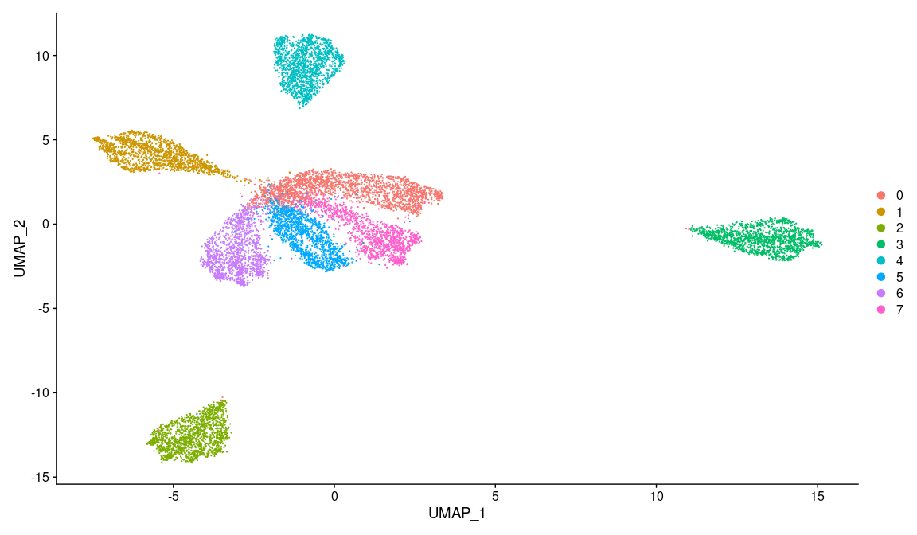

## Centering and scaling data matrix

## PC_ 1   
## Positive: Gene623, Gene412, Gene469, Gene313, Gene433, Gene400, Gene198, Gene589, Gene464, Gene973   
## Gene151, Gene251, Gene654, Gene340, Gene317, Gene56, Gene102, Gene524, Gene392, Gene872   
## Gene344, Gene766, Gene748, Gene980, Gene303, Gene873, Gene811, Gene652, Gene155, Gene485   
## Negative: Gene605, Gene650, Gene746, Gene143, Gene110, Gene153, Gene409, Gene620, Gene714, Gene460   
## Gene755, Gene615, Gene475, Gene370, Gene936, Gene65, Gene950, Gene335, Gene3, Gene921   
## Gene164, Gene328, Gene195, Gene985, Gene821, Gene818, Gene849, Gene793, Gene859, Gene140   
## PC_ 2   
## Positive: Gene413, Gene418, Gene579, Gene479, Gene373, Gene605, Gene513, Gene190, Gene559, Gene388   
## Gene601, Gene560, Gene660, Gene816, Gene522, Gene24, Gene203, Gene542, Gene746, Gene912   
## Gene566, Gene98, Gene5, Gene438, Gene241, Gene186, Gene914, Gene672, Gene270, Gene322   
## Negative: Gene258, Gene339, Gene735, Gene469, Gene503, Gene384, Gene820, Gene595, Gene833, Gene556   
## Gene675, Gene617, Gene168, Gene259, Gene96, Gene470, Gene491, Gene84, Gene42, Gene589   
## Gene607, Gene488, Gene321, Gene649, Gene313, Gene552, Gene276, Gene608, Gene347, Gene919   
## PC_ 3   
## Positive: Gene746, Gene820, Gene842, Gene373, Gene215, Gene96, Gene927, Gene800, Gene648, Gene739   
## Gene20, Gene46, Gene773, Gene913, Gene402, Gene74, Gene86, Gene349, Gene672, Gene347   
## Gene42, Gene203, Gene99, Gene689, Gene291, Gene605, Gene844, Gene237, Gene932, Gene14   
## Negative: Gene524, Gene627, Gene544, Gene464, Gene23, Gene510, Gene384, Gene251, Gene623, Gene400   
## Gene155, Gene872, Gene313, Gene781, Gene875, Gene809, Gene38, Gene340, Gene366, Gene56   
## Gene642, Gene595, Gene469, Gene315, Gene344, Gene992, Gene973, Gene490, Gene589, Gene127   
## PC_ 4   
## Positive: Gene731, Gene807, Gene608, Gene811, Gene385, Gene274, Gene402, Gene513, Gene356, Gene12   
## Gene234, Gene809, Gene158, Gene510, Gene508, Gene315, Gene362, Gene118, Gene616, Gene11   
## Gene958, Gene339, Gene544, Gene443, Gene605, Gene961, Gene266, Gene938, Gene276, Gene384   
## Negative: Gene689, Gene866, Gene67, Gene533, Gene746, Gene219, Gene552, Gene584, Gene564, Gene941   
## Gene267, Gene350, Gene595, Gene695, Gene503, Gene777, Gene148, Gene326, Gene934, Gene854   
## Gene613, Gene59, Gene617, Gene290, Gene883, Gene344, Gene711, Gene488, Gene352, Gene56   
## PC_ 5   
## Positive: Gene464, Gene158, Gene927, Gene265, Gene64, Gene173, Gene362, Gene230, Gene690, Gene739   
## Gene258, Gene424, Gene412, Gene508, Gene668, Gene902, Gene259, Gene349, Gene672, Gene954   
## Gene664, Gene236, Gene99, Gene938, Gene653, Gene523, Gene597, Gene400, Gene560, Gene695   
## Negative: Gene627, Gene148, Gene42, Gene267, Gene438, Gene644, Gene270, Gene103, Gene912, Gene347   
## Gene777, Gene126, Gene800, Gene957, Gene813, Gene911, Gene131, Gene809, Gene384, Gene839   
## Gene987, Gene59, Gene84, Gene1, Gene276, Gene607, Gene262, Gene434, Gene658, Gene117

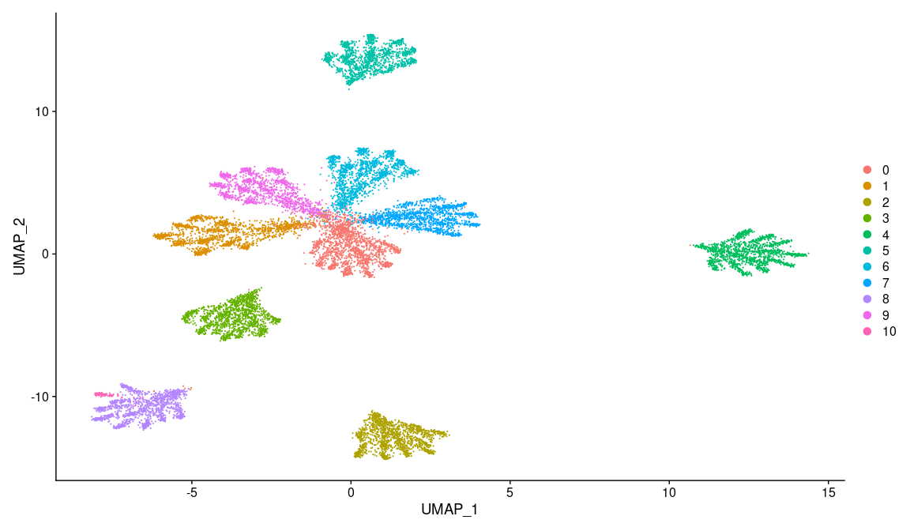

## Centering and scaling data matrix

## PC_ 1   
## Positive: Gene422, Gene948, Gene338, Gene23, Gene233, Gene837, Gene895, Gene131, Gene387, Gene552   
## Gene209, Gene428, Gene740, Gene396, Gene366, Gene835, Gene554, Gene149, Gene269, Gene516   
## Gene488, Gene522, Gene670, Gene571, Gene560, Gene189, Gene65, Gene700, Gene937, Gene866   
## Negative: Gene958, Gene216, Gene810, Gene868, Gene452, Gene870, Gene563, Gene44, Gene820, Gene925   
## Gene329, Gene848, Gene767, Gene972, Gene660, Gene311, Gene377, Gene156, Gene207, Gene323   
## Gene721, Gene507, Gene161, Gene604, Gene953, Gene126, Gene712, Gene673, Gene626, Gene580   
## PC_ 2   
## Positive: Gene675, Gene736, Gene393, Gene777, Gene255, Gene799, Gene66, Gene925, Gene441, Gene661   
## Gene966, Gene881, Gene665, Gene847, Gene15, Gene580, Gene360, Gene44, Gene180, Gene502   
## Gene600, Gene685, Gene712, Gene208, Gene867, Gene819, Gene26, Gene869, Gene519, Gene323   
## Negative: Gene21, Gene972, Gene197, Gene500, Gene95, Gene56, Gene821, Gene745, Gene725, Gene642   
## Gene127, Gene813, Gene784, Gene362, Gene790, Gene960, Gene43, Gene341, Gene927, Gene911   
## Gene493, Gene126, Gene602, Gene803, Gene588, Gene673, Gene351, Gene576, Gene399, Gene344   
## PC_ 3   
## Positive: Gene222, Gene56, Gene989, Gene957, Gene639, Gene526, Gene311, Gene143, Gene799, Gene215   
## Gene671, Gene238, Gene74, Gene328, Gene966, Gene815, Gene917, Gene409, Gene1000, Gene932   
## Gene165, Gene860, Gene347, Gene704, Gene717, Gene275, Gene707, Gene721, Gene9, Gene290   
## Negative: Gene339, Gene216, Gene608, Gene870, Gene287, Gene728, Gene803, Gene952, Gene995, Gene436   
## Gene227, Gene745, Gene137, Gene797, Gene360, Gene911, Gene661, Gene810, Gene859, Gene443   
## Gene407, Gene766, Gene993, Gene252, Gene887, Gene505, Gene434, Gene316, Gene566, Gene820   
## PC_ 4   
## Positive: Gene632, Gene573, Gene874, Gene809, Gene381, Gene762, Gene526, Gene191, Gene804, Gene213   
## Gene790, Gene174, Gene593, Gene3, Gene838, Gene248, Gene783, Gene382, Gene881, Gene991   
## Gene889, Gene813, Gene333, Gene7, Gene328, Gene193, Gene394, Gene710, Gene237, Gene857   
## Negative: Gene215, Gene584, Gene887, Gene284, Gene681, Gene310, Gene409, Gene777, Gene74, Gene350   
## Gene230, Gene239, Gene406, Gene21, Gene956, Gene377, Gene80, Gene252, Gene664, Gene338   
## Gene391, Gene110, Gene534, Gene363, Gene495, Gene900, Gene407, Gene316, Gene810, Gene431   
## PC_ 5   
## Positive: Gene790, Gene733, Gene1000, Gene948, Gene328, Gene534, Gene495, Gene143, Gene848, Gene953   
## Gene884, Gene56, Gene7, Gene476, Gene275, Gene791, Gene341, Gene717, Gene844, Gene878   
## Gene641, Gene347, Gene839, Gene689, Gene870, Gene206, Gene424, Gene287, Gene116, Gene314   
## Negative: Gene129, Gene582, Gene207, Gene744, Gene246, Gene707, Gene858, Gene137, Gene125, Gene665   
## Gene778, Gene682, Gene350, Gene538, Gene711, Gene905, Gene952, Gene200, Gene960, Gene322   
## Gene580, Gene979, Gene321, Gene21, Gene589, Gene987, Gene838, Gene83, Gene503, Gene851

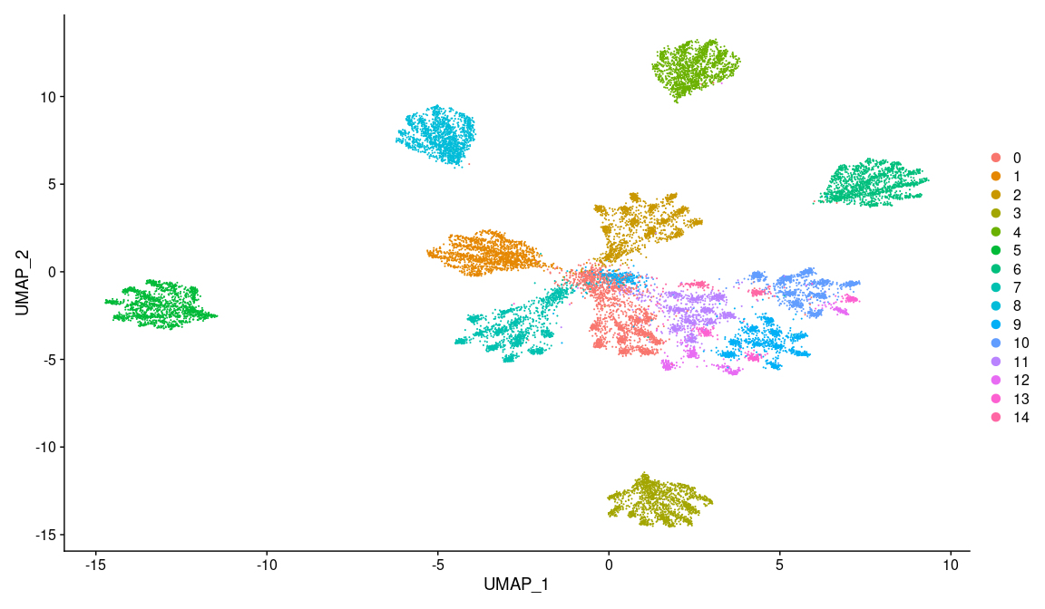

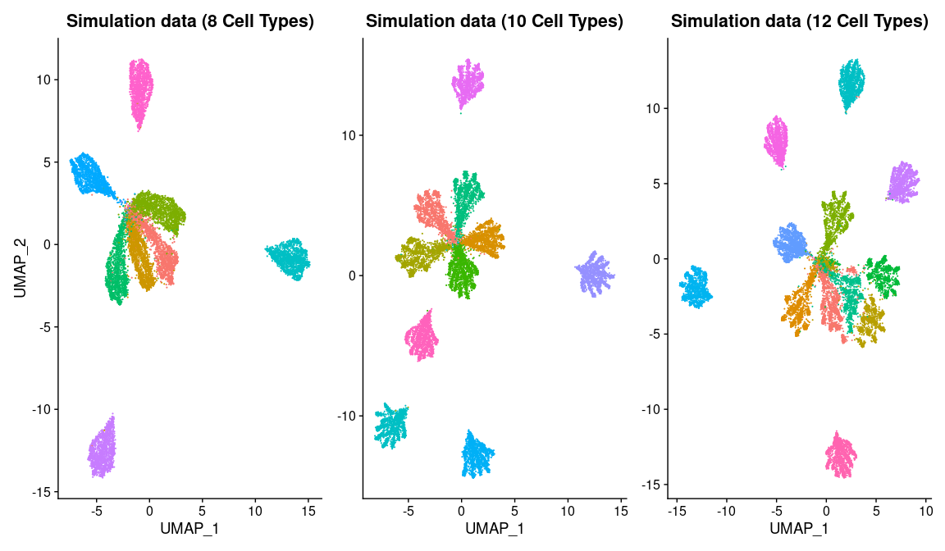

Draw the proportion of different cell types and ROC curves

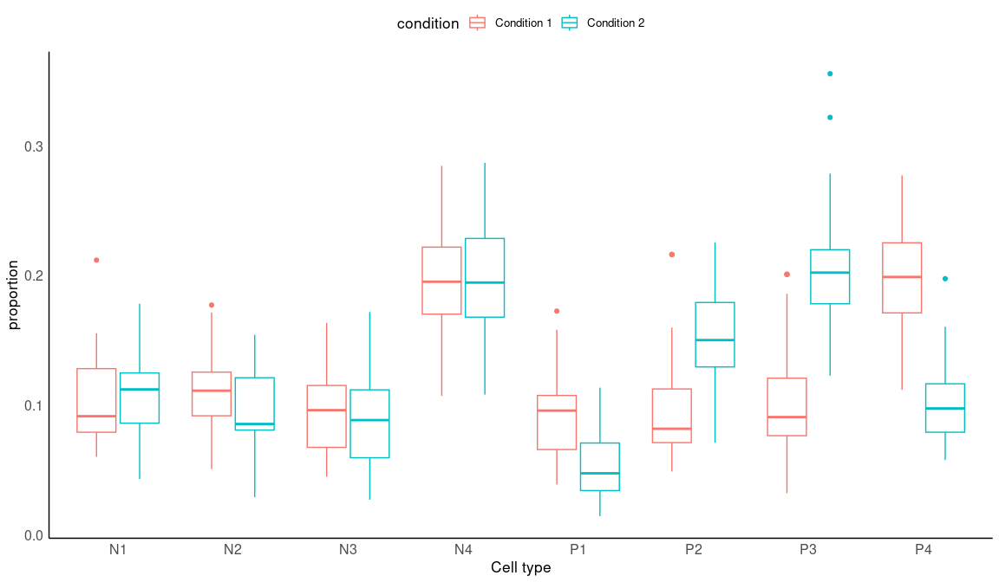

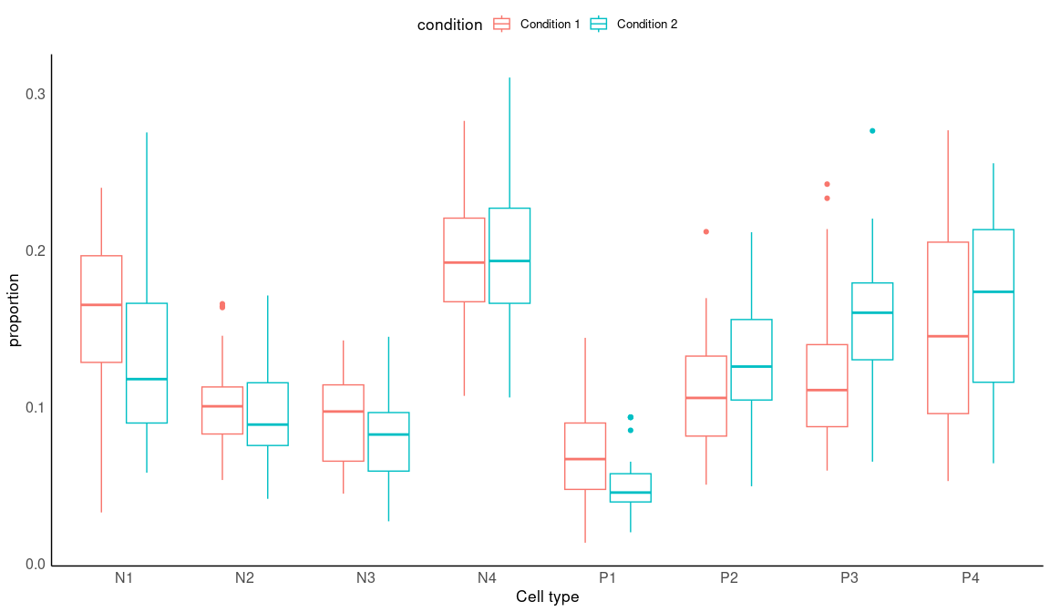

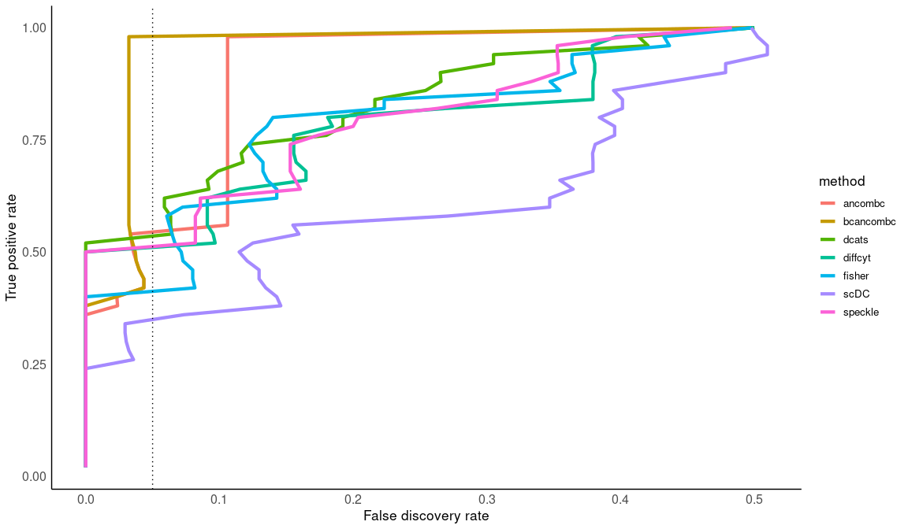

### Figure 2-B

#### Different numbers of replicates

## [1] "/storage/holab/linxy/DCATS/simulation/current/replicates2&2_K8_con100_splatter3000&3000para.RData"  
## [2] "/storage/holab/linxy/DCATS/simulation/current/replicates3&3_K8_con100_splatter3000&3000para.RData"  
## [3] "/storage/holab/linxy/DCATS/simulation/current/replicates4&4_K8_con100_splatter3000&3000para.RData"

## Warning in if (!is.na(oper[[idx]])) {: the condition has length > 1 and only the  
## first element will be used

## Warning in if (!is.na(oper[[idx]])) {: the condition has length > 1 and only the  
## first element will be used

## Warning in if (!is.na(oper[[idx]])) {: the condition has length > 1 and only the  
## first element will be used

## Warning in if (!is.na(oper[[idx]])) {: the condition has length > 1 and only the  
## first element will be used

## Warning in if (!is.na(oper[[idx]])) {: the condition has length > 1 and only the  
## first element will be used

## Warning in if (!is.na(oper[[idx]])) {: the condition has length > 1 and only the  
## first element will be used

## Warning in if (!is.na(oper[[idx]])) {: the condition has length > 1 and only the  
## first element will be used

## Warning in if (!is.na(oper[[idx]])) {: the condition has length > 1 and only the  
## first element will be used

## Warning in if (!is.na(oper[[idx]])) {: the condition has length > 1 and only the  
## first element will be used

## Warning in if (!is.na(oper[[idx]])) {: the condition has length > 1 and only the  
## first element will be used

## Warning in if (!is.na(oper[[idx]])) {: the condition has length > 1 and only the  
## first element will be used

## Warning in if (!is.na(oper[[idx]])) {: the condition has length > 1 and only the  
## first element will be used

## Warning in if (!is.na(oper[[idx]])) {: the condition has length > 1 and only the  
## first element will be used

## Warning in if (!is.na(oper[[idx]])) {: the condition has length > 1 and only the  
## first element will be used

## Warning in if (!is.na(oper[[idx]])) {: the condition has length > 1 and only the  
## first element will be used

## Warning in if (!is.na(oper[[idx]])) {: the condition has length > 1 and only the  
## first element will be used

## Warning in if (!is.na(oper[[idx]])) {: the condition has length > 1 and only the  
## first element will be used

## Warning in if (!is.na(oper[[idx]])) {: the condition has length > 1 and only the  
## first element will be used

## Warning in if (!is.na(oper[[idx]])) {: the condition has length > 1 and only the  
## first element will be used

## Warning in if (!is.na(oper[[idx]])) {: the condition has length > 1 and only the  
## first element will be used

## Warning in if (!is.na(oper[[idx]])) {: the condition has length > 1 and only the  
## first element will be used

## Warning in if (!is.na(oper[[idx]])) {: the condition has length > 1 and only the  
## first element will be used

## Warning in if (!is.na(oper[[idx]])) {: the condition has length > 1 and only the  
## first element will be used

## Warning in if (!is.na(oper[[idx]])) {: the condition has length > 1 and only the  
## first element will be used

## Warning in if (!is.na(oper[[idx]])) {: the condition has length > 1 and only the  
## first element will be used

## Warning in if (!is.na(oper[[idx]])) {: the condition has length > 1 and only the  
## first element will be used

## Warning in if (!is.na(oper[[idx]])) {: the condition has length > 1 and only the  
## first element will be used

## Warning in if (!is.na(oper[[idx]])) {: the condition has length > 1 and only the  
## first element will be used

## Warning in if (!is.na(oper[[idx]])) {: the condition has length > 1 and only the  
## first element will be used

## Warning in if (!is.na(oper[[idx]])) {: the condition has length > 1 and only the  
## first element will be used

## Warning in if (!is.na(oper[[idx]])) {: the condition has length > 1 and only the  
## first element will be used

## Warning in if (!is.na(oper[[idx]])) {: the condition has length > 1 and only the  
## first element will be used

## Warning in if (!is.na(oper[[idx]])) {: the condition has length > 1 and only the  
## first element will be used

## Warning in if (!is.na(oper[[idx]])) {: the condition has length > 1 and only the  
## first element will be used

## Warning in if (!is.na(oper[[idx]])) {: the condition has length > 1 and only the  
## first element will be used

## Warning in if (!is.na(oper[[idx]])) {: the condition has length > 1 and only the  
## first element will be used

## Warning in if (!is.na(oper[[idx]])) {: the condition has length > 1 and only the  
## first element will be used

## Warning in if (!is.na(oper[[idx]])) {: the condition has length > 1 and only the  
## first element will be used

## Warning in if (!is.na(oper[[idx]])) {: the condition has length > 1 and only the  
## first element will be used

## Warning in if (!is.na(oper[[idx]])) {: the condition has length > 1 and only the  
## first element will be used

## Warning in if (!is.na(oper[[idx]])) {: the condition has length > 1 and only the  
## first element will be used

## Warning in if (!is.na(oper[[idx]])) {: the condition has length > 1 and only the  
## first element will be used

## Warning in if (!is.na(oper[[idx]])) {: the condition has length > 1 and only the  
## first element will be used

## Warning in if (!is.na(oper[[idx]])) {: the condition has length > 1 and only the  
## first element will be used

## Warning in if (!is.na(oper[[idx]])) {: the condition has length > 1 and only the  
## first element will be used

## Warning in if (!is.na(oper[[idx]])) {: the condition has length > 1 and only the  
## first element will be used

## Warning in if (!is.na(oper[[idx]])) {: the condition has length > 1 and only the  
## first element will be used

## Warning in if (!is.na(oper[[idx]])) {: the condition has length > 1 and only the  
## first element will be used

## Warning in if (!is.na(oper[[idx]])) {: the condition has length > 1 and only the  
## first element will be used

## Warning in if (!is.na(oper[[idx]])) {: the condition has length > 1 and only the  
## first element will be used

## Warning in if (!is.na(oper[[idx]])) {: the condition has length > 1 and only the  
## first element will be used

## Warning in if (!is.na(oper[[idx]])) {: the condition has length > 1 and only the  
## first element will be used

## Warning in if (!is.na(oper[[idx]])) {: the condition has length > 1 and only the  
## first element will be used

## Warning in if (!is.na(oper[[idx]])) {: the condition has length > 1 and only the  
## first element will be used

## Warning in if (!is.na(oper[[idx]])) {: the condition has length > 1 and only the  
## first element will be used

## Warning in if (!is.na(oper[[idx]])) {: the condition has length > 1 and only the  
## first element will be used

## Warning in if (!is.na(oper[[idx]])) {: the condition has length > 1 and only the  
## first element will be used

## Warning in if (!is.na(oper[[idx]])) {: the condition has length > 1 and only the  
## first element will be used

## Warning in if (!is.na(oper[[idx]])) {: the condition has length > 1 and only the  
## first element will be used

## Warning in if (!is.na(oper[[idx]])) {: the condition has length > 1 and only the  
## first element will be used

## Warning in if (!is.na(oper[[idx]])) {: the condition has length > 1 and only the  
## first element will be used

## Warning in if (!is.na(oper[[idx]])) {: the condition has length > 1 and only the  
## first element will be used

## Warning in if (!is.na(oper[[idx]])) {: the condition has length > 1 and only the  
## first element will be used

## Warning in if (!is.na(oper[[idx]])) {: the condition has length > 1 and only the  
## first element will be used

## Warning in if (!is.na(oper[[idx]])) {: the condition has length > 1 and only the  
## first element will be used

## Warning in if (!is.na(oper[[idx]])) {: the condition has length > 1 and only the  
## first element will be used

## Warning in if (!is.na(oper[[idx]])) {: the condition has length > 1 and only the  
## first element will be used

## Warning in if (!is.na(oper[[idx]])) {: the condition has length > 1 and only the  
## first element will be used

## Warning in if (!is.na(oper[[idx]])) {: the condition has length > 1 and only the  
## first element will be used

## Warning in if (!is.na(oper[[idx]])) {: the condition has length > 1 and only the  
## first element will be used

## Warning in if (!is.na(oper[[idx]])) {: the condition has length > 1 and only the  
## first element will be used

## Warning in if (!is.na(oper[[idx]])) {: the condition has length > 1 and only the  
## first element will be used

## Warning in if (!is.na(oper[[idx]])) {: the condition has length > 1 and only the  
## first element will be used

## Warning in if (!is.na(oper[[idx]])) {: the condition has length > 1 and only the  
## first element will be used

## Warning in if (!is.na(oper[[idx]])) {: the condition has length > 1 and only the  
## first element will be used

## Warning in if (!is.na(oper[[idx]])) {: the condition has length > 1 and only the  
## first element will be used

## Warning in if (!is.na(oper[[idx]])) {: the condition has length > 1 and only the  
## first element will be used

## Warning in if (!is.na(oper[[idx]])) {: the condition has length > 1 and only the  
## first element will be used

## Warning in if (!is.na(oper[[idx]])) {: the condition has length > 1 and only the  
## first element will be used

## Warning in if (!is.na(oper[[idx]])) {: the condition has length > 1 and only the  
## first element will be used

## Warning in if (!is.na(oper[[idx]])) {: the condition has length > 1 and only the  
## first element will be used

## Warning in if (!is.na(oper[[idx]])) {: the condition has length > 1 and only the  
## first element will be used

## Warning in if (!is.na(oper[[idx]])) {: the condition has length > 1 and only the  
## first element will be used

## Warning in if (!is.na(oper[[idx]])) {: the condition has length > 1 and only the  
## first element will be used

## Warning in if (!is.na(oper[[idx]])) {: the condition has length > 1 and only the  
## first element will be used

## Warning in if (!is.na(oper[[idx]])) {: the condition has length > 1 and only the  
## first element will be used

## Warning in if (!is.na(oper[[idx]])) {: the condition has length > 1 and only the  
## first element will be used

## Warning in if (!is.na(oper[[idx]])) {: the condition has length > 1 and only the  
## first element will be used

## Warning in if (!is.na(oper[[idx]])) {: the condition has length > 1 and only the  
## first element will be used

## Warning in if (!is.na(oper[[idx]])) {: the condition has length > 1 and only the  
## first element will be used

## Warning in if (!is.na(oper[[idx]])) {: the condition has length > 1 and only the  
## first element will be used

## Warning in if (!is.na(oper[[idx]])) {: the condition has length > 1 and only the  
## first element will be used

## Warning in if (!is.na(oper[[idx]])) {: the condition has length > 1 and only the  
## first element will be used

## Warning in if (!is.na(oper[[idx]])) {: the condition has length > 1 and only the  
## first element will be used

## Warning in if (!is.na(oper[[idx]])) {: the condition has length > 1 and only the  
## first element will be used

## Warning in if (!is.na(oper[[idx]])) {: the condition has length > 1 and only the  
## first element will be used

## Warning in if (!is.na(oper[[idx]])) {: the condition has length > 1 and only the  
## first element will be used

## Warning in if (!is.na(oper[[idx]])) {: the condition has length > 1 and only the  
## first element will be used

## Warning in if (!is.na(oper[[idx]])) {: the condition has length > 1 and only the  
## first element will be used

## Warning in if (!is.na(oper[[idx]])) {: the condition has length > 1 and only the  
## first element will be used

## Warning in if (!is.na(oper[[idx]])) {: the condition has length > 1 and only the  
## first element will be used

## Warning in if (!is.na(oper[[idx]])) {: the condition has length > 1 and only the  
## first element will be used

## Warning in if (!is.na(oper[[idx]])) {: the condition has length > 1 and only the  
## first element will be used

## Warning in if (!is.na(oper[[idx]])) {: the condition has length > 1 and only the  
## first element will be used

## Warning in if (!is.na(oper[[idx]])) {: the condition has length > 1 and only the  
## first element will be used

## Warning in if (!is.na(oper[[idx]])) {: the condition has length > 1 and only the  
## first element will be used

## Warning in if (!is.na(oper[[idx]])) {: the condition has length > 1 and only the  
## first element will be used

## Warning in if (!is.na(oper[[idx]])) {: the condition has length > 1 and only the  
## first element will be used

## Warning in if (!is.na(oper[[idx]])) {: the condition has length > 1 and only the  
## first element will be used

## Warning in if (!is.na(oper[[idx]])) {: the condition has length > 1 and only the  
## first element will be used

## Warning in if (!is.na(oper[[idx]])) {: the condition has length > 1 and only the  
## first element will be used

## Warning in if (!is.na(oper[[idx]])) {: the condition has length > 1 and only the  
## first element will be used

## Warning in if (!is.na(oper[[idx]])) {: the condition has length > 1 and only the  
## first element will be used

## Warning in if (!is.na(oper[[idx]])) {: the condition has length > 1 and only the  
## first element will be used

## Warning in if (!is.na(oper[[idx]])) {: the condition has length > 1 and only the  
## first element will be used

## Warning in if (!is.na(oper[[idx]])) {: the condition has length > 1 and only the  
## first element will be used

## Warning in if (!is.na(oper[[idx]])) {: the condition has length > 1 and only the  
## first element will be used

## Warning in if (!is.na(oper[[idx]])) {: the condition has length > 1 and only the  
## first element will be used

## Warning in if (!is.na(oper[[idx]])) {: the condition has length > 1 and only the  
## first element will be used

## Warning in if (!is.na(oper[[idx]])) {: the condition has length > 1 and only the  
## first element will be used

## Warning in if (!is.na(oper[[idx]])) {: the condition has length > 1 and only the  
## first element will be used

## Warning in if (!is.na(oper[[idx]])) {: the condition has length > 1 and only the  
## first element will be used

## Warning in if (!is.na(oper[[idx]])) {: the condition has length > 1 and only the  
## first element will be used

## Warning in if (!is.na(oper[[idx]])) {: the condition has length > 1 and only the  
## first element will be used

## Warning in if (!is.na(oper[[idx]])) {: the condition has length > 1 and only the  
## first element will be used

## Warning in if (!is.na(oper[[idx]])) {: the condition has length > 1 and only the  
## first element will be used

## Warning in if (!is.na(oper[[idx]])) {: the condition has length > 1 and only the  
## first element will be used

## Warning in if (!is.na(oper[[idx]])) {: the condition has length > 1 and only the  
## first element will be used

## Warning in if (!is.na(oper[[idx]])) {: the condition has length > 1 and only the  
## first element will be used

## Warning in if (!is.na(oper[[idx]])) {: the condition has length > 1 and only the  
## first element will be used

## Warning in if (!is.na(oper[[idx]])) {: the condition has length > 1 and only the  
## first element will be used

## Warning in if (!is.na(oper[[idx]])) {: the condition has length > 1 and only the  
## first element will be used

## Warning in if (!is.na(oper[[idx]])) {: the condition has length > 1 and only the  
## first element will be used

## Warning in if (!is.na(oper[[idx]])) {: the condition has length > 1 and only the  
## first element will be used

## Warning in if (!is.na(oper[[idx]])) {: the condition has length > 1 and only the  
## first element will be used

## Warning in if (!is.na(oper[[idx]])) {: the condition has length > 1 and only the  
## first element will be used

## Warning in if (!is.na(oper[[idx]])) {: the condition has length > 1 and only the  
## first element will be used

## Warning in if (!is.na(oper[[idx]])) {: the condition has length > 1 and only the  
## first element will be used

## Warning in if (!is.na(oper[[idx]])) {: the condition has length > 1 and only the  
## first element will be used

## Warning in if (!is.na(oper[[idx]])) {: the condition has length > 1 and only the  
## first element will be used

## Warning in if (!is.na(oper[[idx]])) {: the condition has length > 1 and only the  
## first element will be used

## Warning in if (!is.na(oper[[idx]])) {: the condition has length > 1 and only the  
## first element will be used

## Warning in if (!is.na(oper[[idx]])) {: the condition has length > 1 and only the  
## first element will be used

## Warning in if (!is.na(oper[[idx]])) {: the condition has length > 1 and only the  
## first element will be used

## Warning in if (!is.na(oper[[idx]])) {: the condition has length > 1 and only the  
## first element will be used

## Warning in if (!is.na(oper[[idx]])) {: the condition has length > 1 and only the  
## first element will be used

## Warning in if (!is.na(oper[[idx]])) {: the condition has length > 1 and only the  
## first element will be used

## Warning in if (!is.na(oper[[idx]])) {: the condition has length > 1 and only the  
## first element will be used

## Warning in if (!is.na(oper[[idx]])) {: the condition has length > 1 and only the  
## first element will be used

## Warning in if (!is.na(oper[[idx]])) {: the condition has length > 1 and only the  
## first element will be used

## Warning in if (!is.na(oper[[idx]])) {: the condition has length > 1 and only the  
## first element will be used

## Warning in if (!is.na(oper[[idx]])) {: the condition has length > 1 and only the  
## first element will be used

## Warning in if (!is.na(oper[[idx]])) {: the condition has length > 1 and only the  
## first element will be used

## Warning in if (!is.na(oper[[idx]])) {: the condition has length > 1 and only the  
## first element will be used

## Warning in if (!is.na(oper[[idx]])) {: the condition has length > 1 and only the  
## first element will be used

## Warning in if (!is.na(oper[[idx]])) {: the condition has length > 1 and only the  
## first element will be used

## Warning in if (!is.na(oper[[idx]])) {: the condition has length > 1 and only the  
## first element will be used

## Warning in if (!is.na(oper[[idx]])) {: the condition has length > 1 and only the  
## first element will be used

## Warning in if (!is.na(oper[[idx]])) {: the condition has length > 1 and only the  
## first element will be used

## Warning in if (!is.na(oper[[idx]])) {: the condition has length > 1 and only the  
## first element will be used

## Warning in if (!is.na(oper[[idx]])) {: the condition has length > 1 and only the  
## first element will be used

## Warning in if (!is.na(oper[[idx]])) {: the condition has length > 1 and only the  
## first element will be used

## Warning in if (!is.na(oper[[idx]])) {: the condition has length > 1 and only the  
## first element will be used

## Warning in if (!is.na(oper[[idx]])) {: the condition has length > 1 and only the  
## first element will be used

## Warning in if (!is.na(oper[[idx]])) {: the condition has length > 1 and only the  
## first element will be used

## Warning in if (!is.na(oper[[idx]])) {: the condition has length > 1 and only the  
## first element will be used

## Warning in if (!is.na(oper[[idx]])) {: the condition has length > 1 and only the  
## first element will be used

## Warning in if (!is.na(oper[[idx]])) {: the condition has length > 1 and only the  
## first element will be used

## method mcc auc sensitivity specificity F1 replicates  
## 1 estPhi_emK 0.462 0.760 0.527 0.902 0.648 2&2  
## 2 estPhi_wtoEM 0.458 0.751 0.509 0.911 0.637 2&2  
## 3 estPhi_emU 0.451 0.743 0.598 0.839 0.680 2&2  
## 4 fisher 0.181 0.733 0.848 0.304 0.667 2&2  
## 5 diffcyt 0.318 0.733 0.339 0.920 0.478 2&2  
## 6 wtoPhi_emK 0.340 0.723 0.688 0.652 0.675 2&2  
## 7 speckle 0.325 0.716 0.286 0.955 0.430 2&2  
## 8 wtoPhi_wtoEM 0.340 0.715 0.688 0.652 0.675 2&2  
## 9 scDC 0.142 0.653 0.732 0.402 0.628 2&2  
## 10 ancombc_knn 0.157 0.651 0.188 0.920 0.296 2&2  
## 11 ancombc 0.173 0.643 0.161 0.946 0.265 2&2  
## 12 milo 0.211 0.613 0.366 0.821 0.474 2&2  
## 13 wtoPhi_emK 0.612 0.882 0.824 0.787 0.809 3&3  
## 14 wtoPhi_wtoEM 0.602 0.878 0.815 0.787 0.804 3&3  
## 15 estPhi_emK 0.630 0.872 0.685 0.926 0.779 3&3  
## 16 speckle 0.517 0.860 0.509 0.954 0.655 3&3  
## 17 estPhi_emU 0.622 0.856 0.713 0.898 0.786 3&3  
## 18 estPhi_wtoEM 0.622 0.851 0.676 0.926 0.772 3&3  
## 19 diffcyt 0.504 0.848 0.509 0.944 0.651 3&3  
## 20 fisher 0.321 0.843 0.972 0.250 0.714 3&3  
## 21 ancombc 0.447 0.747 0.333 1.000 0.500 3&3  
## 22 milo 0.382 0.742 0.630 0.750 0.670 3&3  
## 23 ancombc_knn 0.455 0.733 0.343 1.000 0.510 3&3  
## 24 scDC 0.229 0.724 0.861 0.333 0.681 3&3  
## 25 estPhi_emK 0.710 0.873 0.759 0.940 0.834 4&4  
## 26 estPhi_emU 0.684 0.873 0.793 0.888 0.833 4&4  
## 27 estPhi_wtoEM 0.665 0.868 0.707 0.940 0.800 4&4  
## 28 speckle 0.665 0.866 0.741 0.914 0.811 4&4  
## 29 diffcyt 0.665 0.862 0.741 0.914 0.811 4&4  
## 30 fisher 0.233 0.862 0.922 0.250 0.690 4&4  
## 31 wtoPhi_emK 0.569 0.836 0.802 0.767 0.788 4&4  
## 32 wtoPhi_wtoEM 0.569 0.834 0.802 0.767 0.788 4&4  
## 33 scDC 0.319 0.832 0.888 0.388 0.710 4&4  
## 34 ancombc 0.373 0.804 0.284 0.983 0.437 4&4  
## 35 ancombc_knn 0.342 0.787 0.250 0.983 0.395 4&4  
## 36 milo 0.279 0.675 0.569 0.707 0.611 4&4

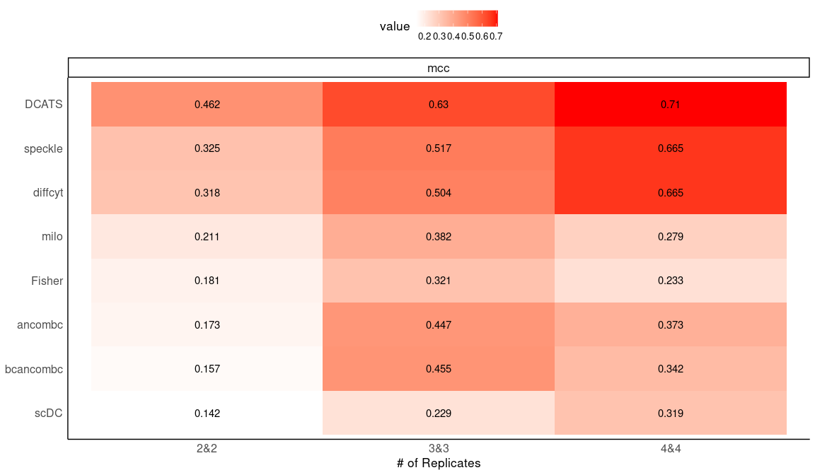

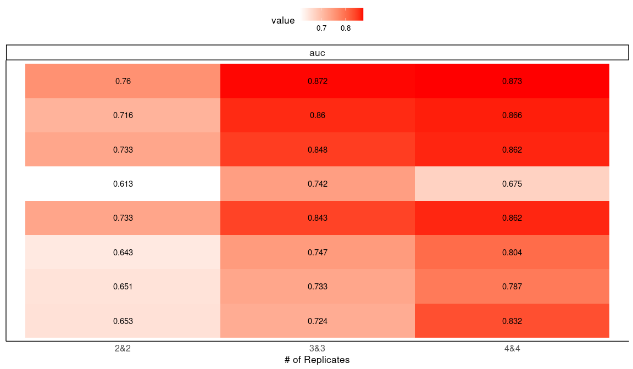

Simulation 2: Supplementary Plots

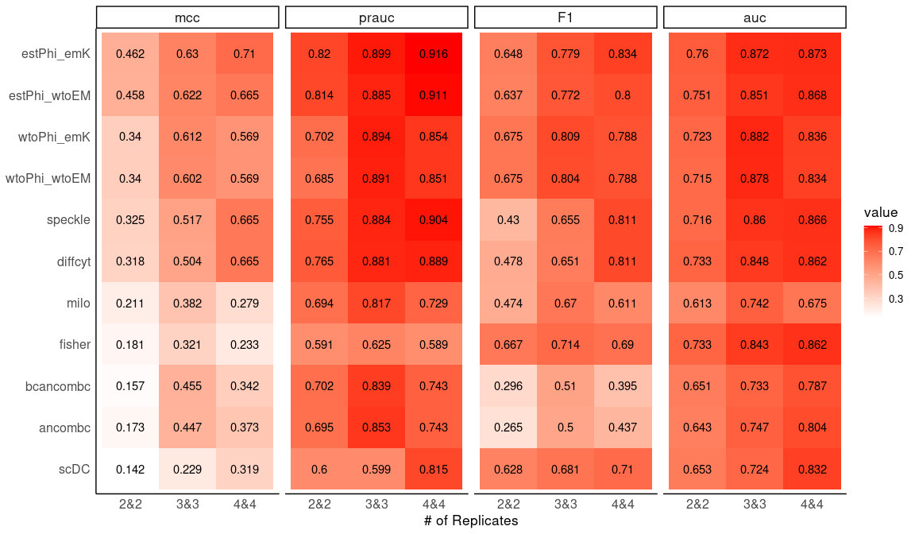

Details of statistics value

|  |  |  |  |  |  |  |  |  |
| --- | --- | --- | --- | --- | --- | --- | --- | --- |
| method | mcc | auc | prauc | sensitivity | specificity | precision | F1 | replicates |
| estPhi_emK | 0.462 | 0.760 | 0.820 | 0.527 | 0.902 | 0.843 | 0.648 | 2&2 |
| estPhi_wtoEM | 0.458 | 0.751 | 0.814 | 0.509 | 0.911 | 0.851 | 0.637 | 2&2 |
| diffcyt | 0.318 | 0.733 | 0.765 | 0.339 | 0.920 | 0.809 | 0.478 | 2&2 |
| fisher | 0.181 | 0.733 | 0.591 | 0.848 | 0.304 | 0.549 | 0.667 | 2&2 |
| wtoPhi_emK | 0.340 | 0.723 | 0.702 | 0.688 | 0.652 | 0.664 | 0.675 | 2&2 |
| speckle | 0.325 | 0.716 | 0.755 | 0.286 | 0.955 | 0.865 | 0.430 | 2&2 |
| wtoPhi_wtoEM | 0.340 | 0.715 | 0.685 | 0.688 | 0.652 | 0.664 | 0.675 | 2&2 |
| scDC | 0.142 | 0.653 | 0.600 | 0.732 | 0.402 | 0.550 | 0.628 | 2&2 |
| bcancombc | 0.157 | 0.651 | 0.702 | 0.188 | 0.920 | 0.700 | 0.296 | 2&2 |
| ancombc | 0.173 | 0.643 | 0.695 | 0.161 | 0.946 | 0.750 | 0.265 | 2&2 |
| milo | 0.211 | 0.613 | 0.694 | 0.366 | 0.821 | 0.672 | 0.474 | 2&2 |
| wtoPhi_emK | 0.612 | 0.882 | 0.894 | 0.824 | 0.787 | 0.795 | 0.809 | 3&3 |
| wtoPhi_wtoEM | 0.602 | 0.878 | 0.891 | 0.815 | 0.787 | 0.793 | 0.804 | 3&3 |
| estPhi_emK | 0.630 | 0.872 | 0.899 | 0.685 | 0.926 | 0.902 | 0.779 | 3&3 |
| speckle | 0.517 | 0.860 | 0.884 | 0.509 | 0.954 | 0.917 | 0.655 | 3&3 |
| estPhi_wtoEM | 0.622 | 0.851 | 0.885 | 0.676 | 0.926 | 0.901 | 0.772 | 3&3 |
| diffcyt | 0.504 | 0.848 | 0.881 | 0.509 | 0.944 | 0.902 | 0.651 | 3&3 |
| fisher | 0.321 | 0.843 | 0.625 | 0.972 | 0.250 | 0.565 | 0.714 | 3&3 |
| ancombc | 0.447 | 0.747 | 0.853 | 0.333 | 1.000 | 1.000 | 0.500 | 3&3 |
| milo | 0.382 | 0.742 | 0.817 | 0.630 | 0.750 | 0.716 | 0.670 | 3&3 |
| bcancombc | 0.455 | 0.733 | 0.839 | 0.343 | 1.000 | 1.000 | 0.510 | 3&3 |
| scDC | 0.229 | 0.724 | 0.599 | 0.861 | 0.333 | 0.564 | 0.681 | 3&3 |
| estPhi_emK | 0.710 | 0.873 | 0.916 | 0.759 | 0.940 | 0.926 | 0.834 | 4&4 |
| estPhi_wtoEM | 0.665 | 0.868 | 0.911 | 0.707 | 0.940 | 0.921 | 0.800 | 4&4 |
| speckle | 0.665 | 0.866 | 0.904 | 0.741 | 0.914 | 0.896 | 0.811 | 4&4 |
| diffcyt | 0.665 | 0.862 | 0.889 | 0.741 | 0.914 | 0.896 | 0.811 | 4&4 |
| fisher | 0.233 | 0.862 | 0.589 | 0.922 | 0.250 | 0.552 | 0.690 | 4&4 |
| wtoPhi_emK | 0.569 | 0.836 | 0.854 | 0.802 | 0.767 | 0.775 | 0.788 | 4&4 |
| wtoPhi_wtoEM | 0.569 | 0.834 | 0.851 | 0.802 | 0.767 | 0.775 | 0.788 | 4&4 |
| scDC | 0.319 | 0.832 | 0.815 | 0.888 | 0.388 | 0.592 | 0.710 | 4&4 |
| ancombc | 0.373 | 0.804 | 0.743 | 0.284 | 0.983 | 0.943 | 0.437 | 4&4 |
| bcancombc | 0.342 | 0.787 | 0.743 | 0.250 | 0.983 | 0.935 | 0.395 | 4&4 |
| milo | 0.279 | 0.675 | 0.729 | 0.569 | 0.707 | 0.660 | 0.611 | 4&4 |

nhoods level

## method mcc auc sensitivity specificity F1 replicates prauc  
## 1 fisher 0.340 0.7157843 0.470 0.846 0.579 2&2 0.716  
## 2 wtoPhi_emU 0.332 0.7096903 0.496 0.818 0.592 2&2 0.710  
## 3 wtoPhi_wtoEM 0.338 0.7095942 0.436 0.870 0.557 2&2 0.710  
## 4 milo 0.295 0.6937905 0.295 0.933 0.434 2&2 0.694  
## 5 estPhi_wtoEM 0.125 0.6895417 0.080 0.976 0.146 2&2 0.690  
## 6 estPhi_emU 0.148 0.6875149 0.129 0.955 0.219 2&2 0.688  
## 7 speckle NaN 0.6173524 0.000 1.000 0.000 2&2 0.617  
## 8 milo 0.379 0.7439506 0.352 0.950 0.502 3&3 0.744  
## 9 fisher 0.394 0.7403612 0.452 0.899 0.581 3&3 0.740  
## 10 wtoPhi_wtoEM 0.401 0.7393887 0.444 0.909 0.577 3&3 0.739  
## 11 wtoPhi_emU 0.383 0.7361322 0.514 0.847 0.613 3&3 0.736  
## 12 estPhi_wtoEM 0.175 0.7009994 0.135 0.963 0.230 3&3 0.701  
## 13 estPhi_emU 0.212 0.6994401 0.233 0.920 0.354 3&3 0.699  
## 14 speckle 0.016 0.6428572 0.001 1.000 0.001 3&3 0.643  
## 15 fisher 0.398 0.7535549 0.430 0.916 0.567 4&4 0.754  
## 16 wtoPhi_wtoEM 0.391 0.7493532 0.425 0.914 0.561 4&4 0.749  
## 17 wtoPhi_emU 0.391 0.7465912 0.441 0.904 0.572 4&4 0.747  
## 18 milo 0.321 0.7364727 0.324 0.930 0.463 4&4 0.736  
## 19 estPhi_wtoEM 0.262 0.7304013 0.217 0.958 0.344 4&4 0.730  
## 20 estPhi_emU 0.262 0.7279494 0.232 0.950 0.361 4&4 0.728  
## 21 speckle 0.066 0.6503482 0.010 0.999 0.020 4&4 0.650

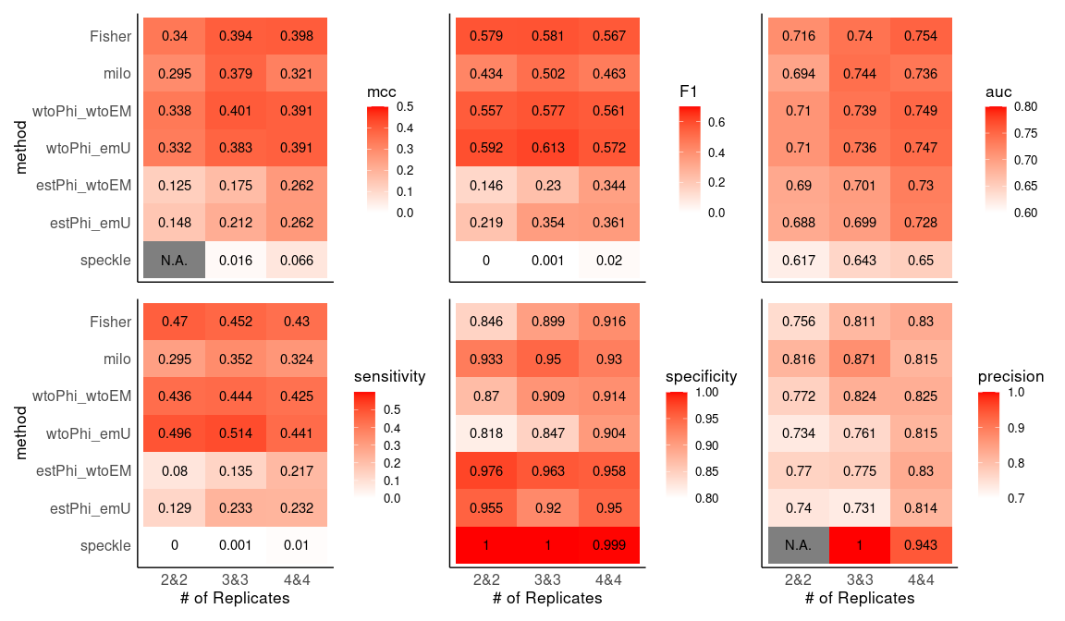

#### Different numbers of clusters

## [1] "/storage/holab/linxy/DCATS/simulation/current/replicates3&3_K10_con100_splatter3000&3000para.RData"  
## [2] "/storage/holab/linxy/DCATS/simulation/current/replicates3&3_K12_con100_splatter3000&3000para.RData"  
## [3] "/storage/holab/linxy/DCATS/simulation/current/replicates3&3_K8_con100_splatter3000&3000para.RData"

## method mcc auc sensitivity specificity F1 clustersN  
## 1 wtoPhi_emK 0.612 0.882 0.824 0.787 0.809 8  
## 2 betabin_null 0.602 0.878 0.815 0.787 0.804 8  
## 3 estPhi_emK 0.630 0.872 0.685 0.926 0.779 8  
## 4 speckle 0.517 0.860 0.509 0.954 0.655 8  
## 5 estPhi_null 0.622 0.851 0.676 0.926 0.772 8  
## 6 diffcyt 0.504 0.848 0.509 0.944 0.651 8  
## 7 fisher 0.321 0.843 0.972 0.250 0.714 8  
## 8 milo 0.382 0.742 0.630 0.750 0.670 8  
## 9 scDC 0.229 0.724 0.861 0.333 0.681 8  
## 10 estPhi_null 0.799 0.954 0.807 0.980 0.883 10  
## 11 estPhi_emK 0.799 0.954 0.807 0.980 0.883 10  
## 12 fisher 0.363 0.949 1.000 0.233 0.723 10  
## 13 diffcyt 0.669 0.929 0.673 0.967 0.789 10  
## 14 speckle 0.623 0.928 0.607 0.973 0.743 10  
## 15 betabin_null 0.694 0.911 0.820 0.873 0.842 10  
## 16 wtoPhi_emK 0.681 0.911 0.820 0.860 0.837 10  
## 17 milo 0.415 0.767 0.660 0.753 0.692 10  
## 18 scDC 0.034 0.741 0.967 0.047 0.662 10  
## 19 estPhi_null 0.603 0.885 0.628 0.944 0.746 12  
## 20 estPhi_emK 0.589 0.884 0.628 0.933 0.741 12  
## 21 betabin_null 0.684 0.878 0.822 0.861 0.839 12  
## 22 fisher 0.220 0.878 0.950 0.194 0.690 12  
## 23 wtoPhi_emK 0.656 0.877 0.817 0.839 0.826 12  
## 24 speckle 0.463 0.872 0.400 0.978 0.562 12  
## 25 diffcyt 0.470 0.862 0.450 0.956 0.602 12  
## 26 scDC 0.088 0.696 0.889 0.172 0.654 12  
## 27 milo 0.301 0.652 0.422 0.850 0.537 12

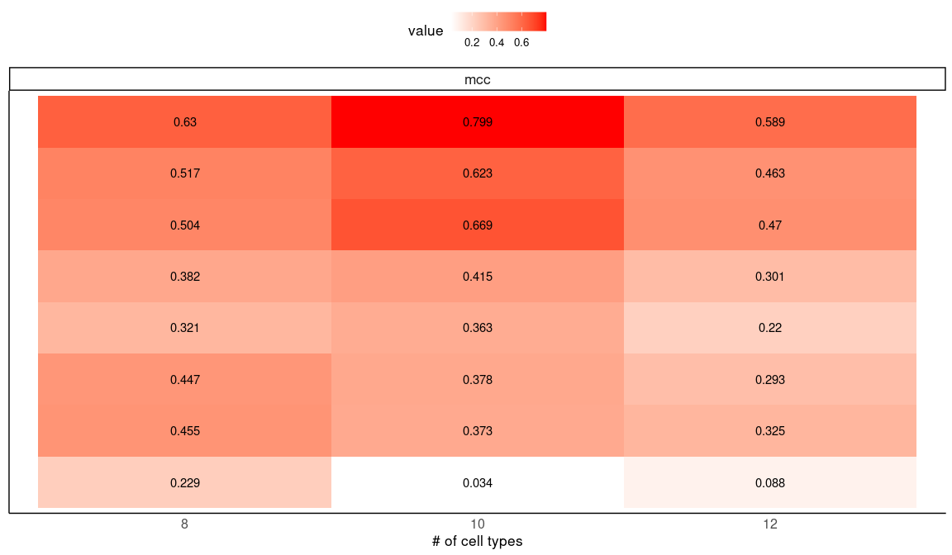

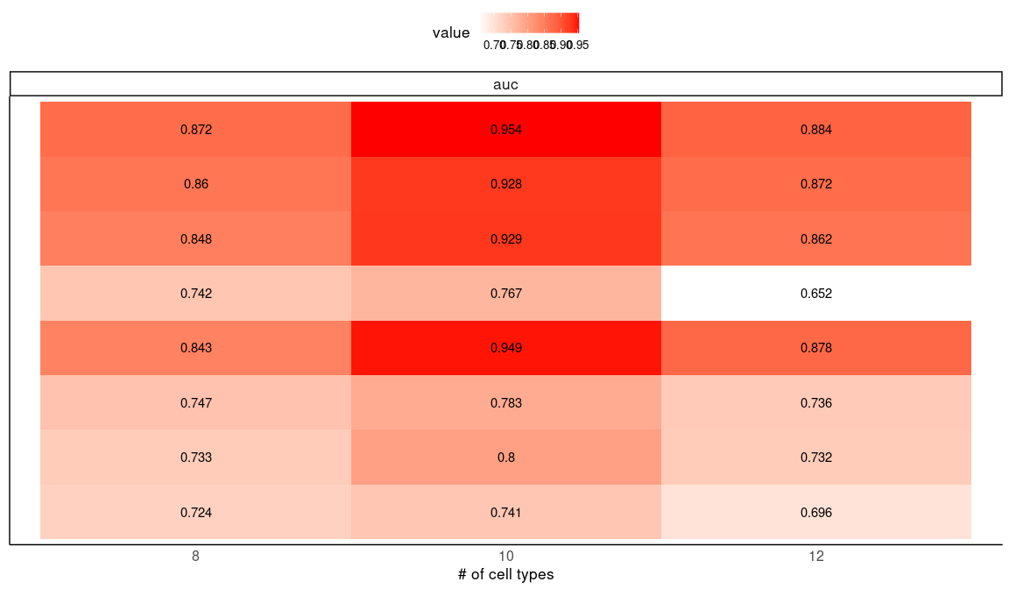

Simulation 2: Supplementary Plot

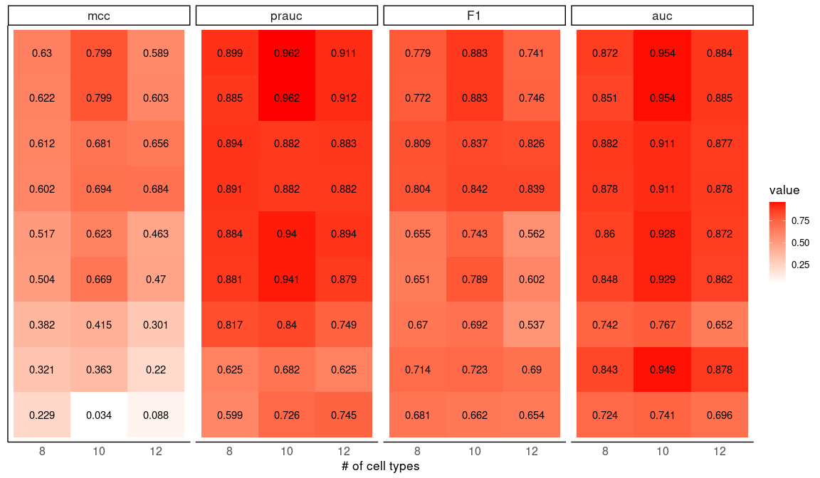

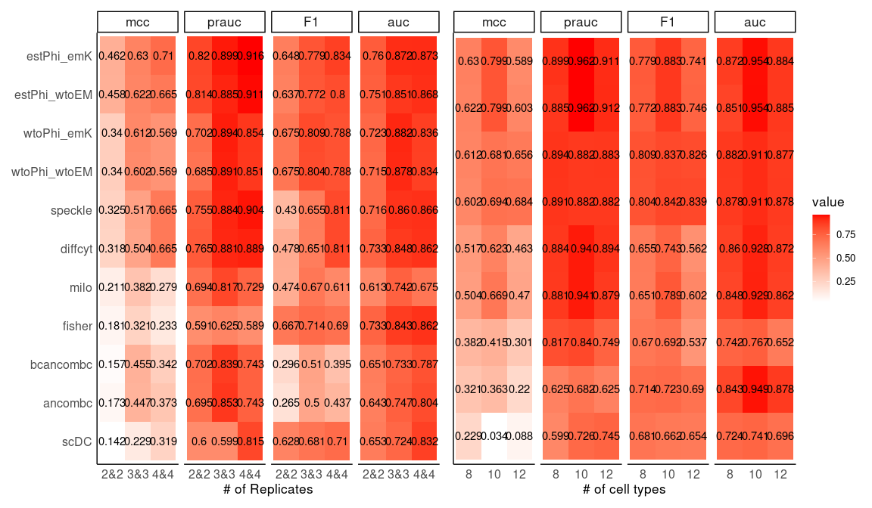

Details of statistics value

|  |  |  |  |  |  |  |  |  |
| --- | --- | --- | --- | --- | --- | --- | --- | --- |
| method | mcc | auc | prauc | sensitivity | specificity | precision | F1 | clustersN |
| wtoPhi_emK | 0.612 | 0.882 | 0.894 | 0.824 | 0.787 | 0.795 | 0.809 | 8 |
| wtoPhi_wtoEM | 0.602 | 0.878 | 0.891 | 0.815 | 0.787 | 0.793 | 0.804 | 8 |
| estPhi_emK | 0.630 | 0.872 | 0.899 | 0.685 | 0.926 | 0.902 | 0.779 | 8 |
| speckle | 0.517 | 0.860 | 0.884 | 0.509 | 0.954 | 0.917 | 0.655 | 8 |
| estPhi_wtoEM | 0.622 | 0.851 | 0.885 | 0.676 | 0.926 | 0.901 | 0.772 | 8 |
| diffcyt | 0.504 | 0.848 | 0.881 | 0.509 | 0.944 | 0.902 | 0.651 | 8 |
| fisher | 0.321 | 0.843 | 0.625 | 0.972 | 0.250 | 0.565 | 0.714 | 8 |
| ancombc | 0.447 | 0.747 | 0.853 | 0.333 | 1.000 | 1.000 | 0.500 | 8 |
| milo | 0.382 | 0.742 | 0.817 | 0.630 | 0.750 | 0.716 | 0.670 | 8 |
| bcancombc | 0.455 | 0.733 | 0.839 | 0.343 | 1.000 | 1.000 | 0.510 | 8 |
| scDC | 0.229 | 0.724 | 0.599 | 0.861 | 0.333 | 0.564 | 0.681 | 8 |
| estPhi_wtoEM | 0.799 | 0.954 | 0.962 | 0.807 | 0.980 | 0.976 | 0.883 | 10 |
| estPhi_emK | 0.799 | 0.954 | 0.962 | 0.807 | 0.980 | 0.976 | 0.883 | 10 |
| fisher | 0.363 | 0.949 | 0.682 | 1.000 | 0.233 | 0.566 | 0.723 | 10 |
| diffcyt | 0.669 | 0.929 | 0.941 | 0.673 | 0.967 | 0.953 | 0.789 | 10 |
| speckle | 0.623 | 0.928 | 0.940 | 0.607 | 0.973 | 0.958 | 0.743 | 10 |
| wtoPhi_wtoEM | 0.694 | 0.911 | 0.882 | 0.820 | 0.873 | 0.866 | 0.842 | 10 |
| wtoPhi_emK | 0.681 | 0.911 | 0.882 | 0.820 | 0.860 | 0.854 | 0.837 | 10 |
| bcancombc | 0.373 | 0.800 | 0.857 | 0.260 | 0.993 | 0.975 | 0.411 | 10 |
| ancombc | 0.378 | 0.783 | 0.857 | 0.267 | 0.993 | 0.976 | 0.419 | 10 |
| milo | 0.415 | 0.767 | 0.840 | 0.660 | 0.753 | 0.728 | 0.692 | 10 |
| scDC | 0.034 | 0.741 | 0.726 | 0.967 | 0.047 | 0.503 | 0.662 | 10 |
| estPhi_wtoEM | 0.603 | 0.885 | 0.912 | 0.628 | 0.944 | 0.919 | 0.746 | 12 |
| estPhi_emK | 0.589 | 0.884 | 0.911 | 0.628 | 0.933 | 0.904 | 0.741 | 12 |
| wtoPhi_wtoEM | 0.684 | 0.878 | 0.882 | 0.822 | 0.861 | 0.855 | 0.839 | 12 |
| fisher | 0.220 | 0.878 | 0.625 | 0.950 | 0.194 | 0.541 | 0.690 | 12 |
| wtoPhi_emK | 0.656 | 0.877 | 0.883 | 0.817 | 0.839 | 0.835 | 0.826 | 12 |
| speckle | 0.463 | 0.872 | 0.894 | 0.400 | 0.978 | 0.947 | 0.562 | 12 |
| diffcyt | 0.470 | 0.862 | 0.879 | 0.450 | 0.956 | 0.910 | 0.602 | 12 |
| ancombc | 0.293 | 0.736 | 0.754 | 0.172 | 0.994 | 0.969 | 0.292 | 12 |
| bcancombc | 0.325 | 0.732 | 0.842 | 0.206 | 0.994 | 0.974 | 0.339 | 12 |
| scDC | 0.088 | 0.696 | 0.745 | 0.889 | 0.172 | 0.518 | 0.654 | 12 |
| milo | 0.301 | 0.652 | 0.749 | 0.422 | 0.850 | 0.738 | 0.537 | 12 |

nhoods level

## method mcc auc sensitivity specificity F1 clustersN prauc  
## 1 milo 0.379 0.7439506 0.352 0.950 0.502 8 0.744  
## 2 fisher 0.394 0.7403612 0.452 0.899 0.581 8 0.740  
## 3 wtoPhi_wtoEM 0.401 0.7393887 0.444 0.909 0.577 8 0.739  
## 4 wtoPhi_emU 0.383 0.7361322 0.514 0.847 0.613 8 0.736  
## 5 estPhi_wtoEM 0.175 0.7009994 0.135 0.963 0.230 8 0.701  
## 6 estPhi_emU 0.212 0.6994401 0.233 0.920 0.354 8 0.699  
## 7 speckle 0.016 0.6428572 0.001 1.000 0.001 8 0.643  
## 8 fisher 0.378 0.7419091 0.451 0.890 0.579 10 0.742  
## 9 wtoPhi_wtoEM 0.355 0.7336701 0.413 0.898 0.546 10 0.734  
## 10 milo 0.339 0.7330529 0.306 0.953 0.453 10 0.733  
## 11 wtoPhi_emU 0.359 0.7301010 0.477 0.856 0.589 10 0.730  
## 12 estPhi_wtoEM 0.120 0.7064403 0.059 0.986 0.111 10 0.706  
## 13 estPhi_emU 0.173 0.6985041 0.121 0.971 0.210 10 0.699  
## 14 speckle 0.037 0.6383595 0.003 1.000 0.007 10 0.638  
## 15 fisher 0.307 0.6987307 0.412 0.865 0.538 12 0.699  
## 16 milo 0.246 0.6924343 0.198 0.964 0.321 12 0.692  
## 17 wtoPhi_wtoEM 0.296 0.6910424 0.372 0.885 0.505 12 0.691  
## 18 wtoPhi_emU 0.297 0.6891288 0.422 0.849 0.543 12 0.689  
## 19 estPhi_wtoEM 0.132 0.6670580 0.088 0.974 0.159 12 0.667  
## 20 estPhi_emU 0.178 0.6589271 0.151 0.956 0.254 12 0.659  
## 21 speckle 0.023 0.6143789 0.002 1.000 0.003 12 0.614

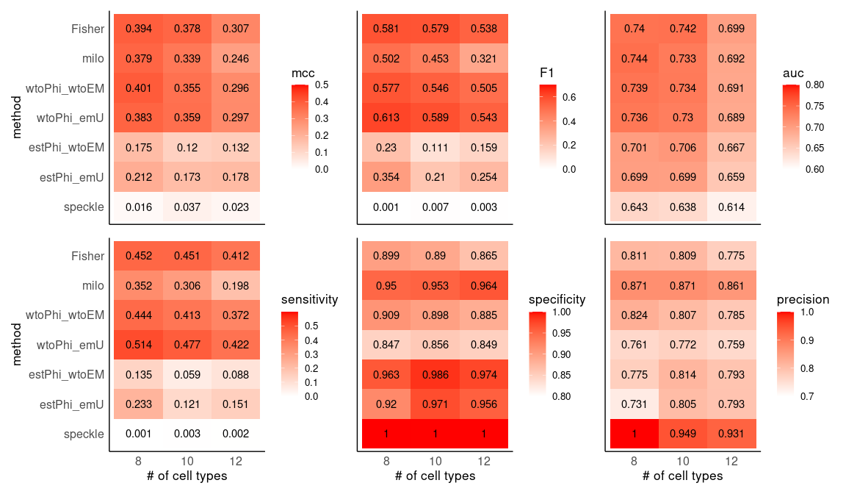

### Figure 2 - C

## method mcc auc prauc sensitivity specificity  
## 1 estPhi_emK 0.50398592 0.7975347 0.8360534 0.6000000 0.8833333  
## 2 estPhi_emSVM 0.48180779 0.7926736 0.8315759 0.5750000 0.8833333  
## 3 wtoPhi_emK 0.45000981 0.7883681 0.8191560 0.6250000 0.8166667  
## 4 wtoPhi_emU 0.44080462 0.7866319 0.8152553 0.6250000 0.8083333  
## 5 betabin_null 0.45775864 0.7852431 0.8163428 0.6333333 0.8166667  
## 6 wtoPhi_emSVM 0.45000981 0.7828125 0.8159578 0.6250000 0.8166667  
## 7 wtoPhi_emT 0.44858910 0.7800694 0.8142453 0.6333333 0.8083333  
## 8 estPhi_emU 0.46861576 0.7794792 0.8113149 0.6250000 0.8333333  
## 9 estPhi_null 0.45221368 0.7757639 0.8103624 0.5416667 0.8833333  
## 10 estPhi_emT 0.44387735 0.7723958 0.7864954 0.6083333 0.8250000  
## 11 fisher 0.21707238 0.7709722 0.5918117 0.8833333 0.2916667  
## 12 speckle 0.38765744 0.7571528 0.7894897 0.3333333 0.9666667  
## 13 diffcyt 0.39498278 0.7419792 0.7861028 0.3416667 0.9666667  
## 14 scDC 0.08838835 0.5531250 0.5428683 0.7083333 0.3750000  
## 15 estPhi_emU 0.26248980 0.6592014 0.6859386 0.3000000 0.9083333  
## 16 estPhi_emSVM 0.22827719 0.6573264 0.6792429 0.2416667 0.9250000  
## 17 estPhi_emK 0.22827719 0.6550347 0.6768958 0.2416667 0.9250000  
## 18 wtoPhi_emU 0.20321418 0.6461806 0.6486288 0.3333333 0.8416667  
## 19 estPhi_emT 0.19949224 0.6450694 0.6523249 0.2750000 0.8833333  
## 20 wtoPhi_emK 0.16853174 0.6430208 0.6490306 0.3000000 0.8416667  
## 21 estPhi_null 0.21004201 0.6422222 0.6646640 0.2250000 0.9250000  
## 22 wtoPhi_emSVM 0.17732484 0.6413889 0.6472692 0.3083333 0.8416667  
## 23 betabin_null 0.16853174 0.6364236 0.6430603 0.3000000 0.8416667  
## 24 wtoPhi_emT 0.15762208 0.6332639 0.6340066 0.3000000 0.8333333  
## 25 estPhi_emK 0.64051262 0.8798958 0.9098350 0.6250000 0.9750000  
## 26 estPhi_emSVM 0.64051262 0.8770833 0.9074158 0.6250000 0.9750000  
## 27 estPhi_emU 0.65410385 0.8761806 0.9080232 0.6916667 0.9416667  
## 28 estPhi_null 0.61353453 0.8717708 0.9015062 0.5916667 0.9750000  
## 29 estPhi_emT 0.58795729 0.8632986 0.8684158 0.6500000 0.9166667  
## 30 wtoPhi_emU 0.61237244 0.8609375 0.8912782 0.7000000 0.9000000  
## 31 wtoPhi_emK 0.61034485 0.8607986 0.8910688 0.7083333 0.8916667  
## 32 wtoPhi_emSVM 0.61237244 0.8605903 0.8909453 0.7000000 0.9000000  
## 33 betabin_null 0.60494034 0.8591667 0.8900139 0.6916667 0.9000000  
## 34 wtoPhi_emT 0.59013171 0.8485417 0.8748822 0.6750000 0.9000000  
## precision F1 factor  
## 1 0.8372093 0.6990291 condition  
## 2 0.8313253 0.6798030 condition  
## 3 0.7731959 0.6912442 condition  
## 4 0.7653061 0.6880734 condition  
## 5 0.7755102 0.6972477 condition  
## 6 0.7731959 0.6912442 condition  
## 7 0.7676768 0.6940639 condition  
## 8 0.7894737 0.6976744 condition  
## 9 0.8227848 0.6532663 condition  
## 10 0.7765957 0.6822430 condition  
## 11 0.5549738 0.6816720 condition  
## 12 0.9090909 0.4878049 condition  
## 13 0.9111111 0.4969697 condition  
## 14 0.5312500 0.6071429 condition  
## 15 0.7659574 0.4311377 age  
## 16 0.7631579 0.3670886 age  
## 17 0.7631579 0.3670886 age  
## 18 0.6779661 0.4469274 age  
## 19 0.7021277 0.3952096 age  
## 20 0.6545455 0.4114286 age  
## 21 0.7500000 0.3461538 age  
## 22 0.6607143 0.4204545 age  
## 23 0.6545455 0.4114286 age  
## 24 0.6428571 0.4090909 age  
## 25 0.9615385 0.7575758 gender  
## 26 0.9615385 0.7575758 gender  
## 27 0.9222222 0.7904762 gender  
## 28 0.9594595 0.7319588 gender  
## 29 0.8863636 0.7500000 gender  
## 30 0.8750000 0.7777778 gender  
## 31 0.8673469 0.7798165 gender  
## 32 0.8750000 0.7777778 gender  
## 33 0.8736842 0.7720930 gender  
## 34 0.8709677 0.7605634 gender

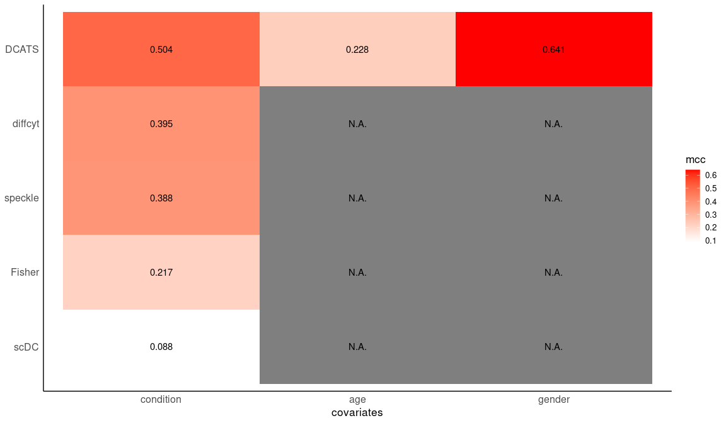

## Saving 12 x 7 in image

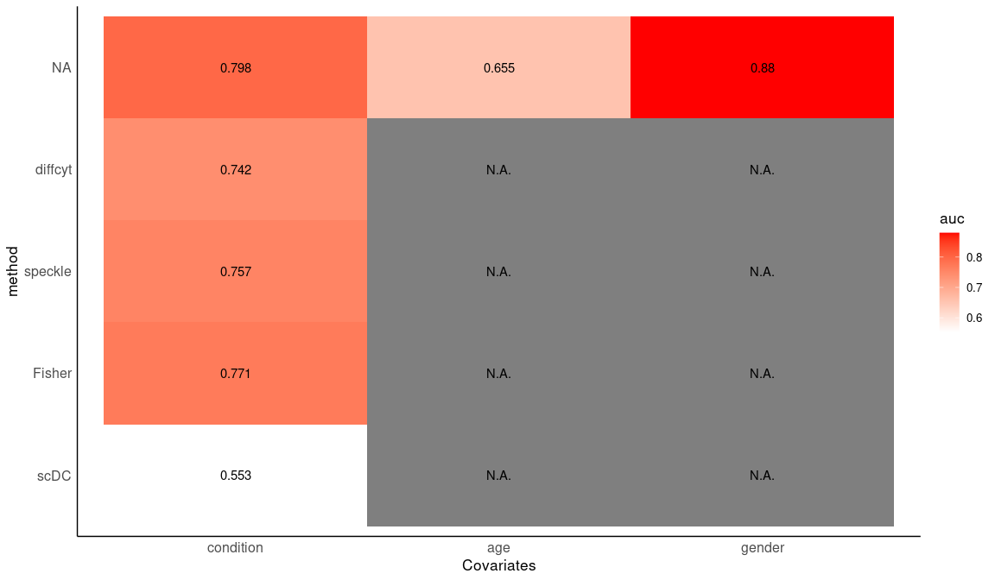

## Saving 12 x 7 in image

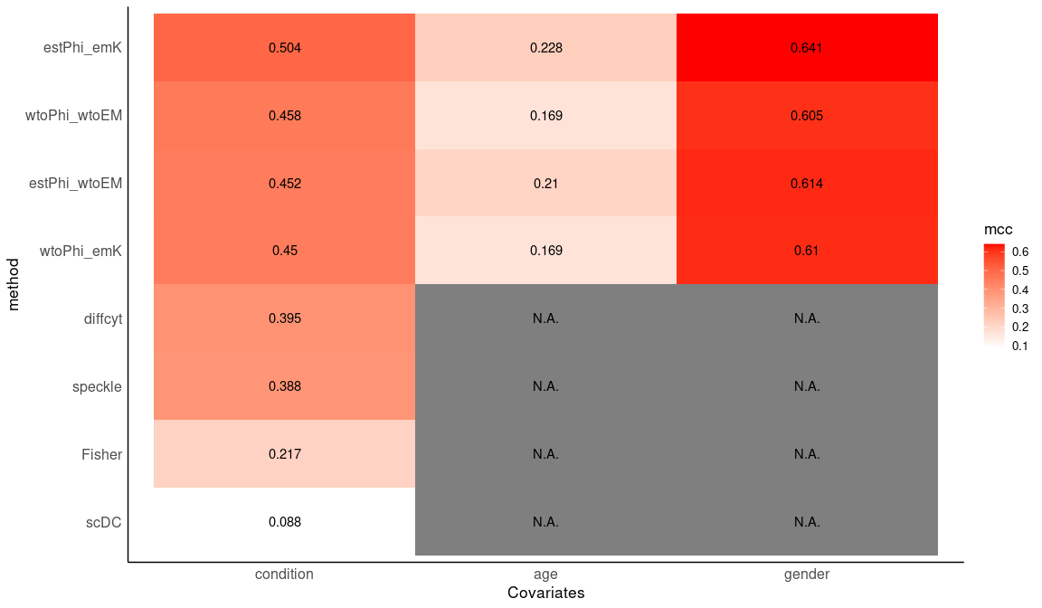

## Saving 12 x 7 in image

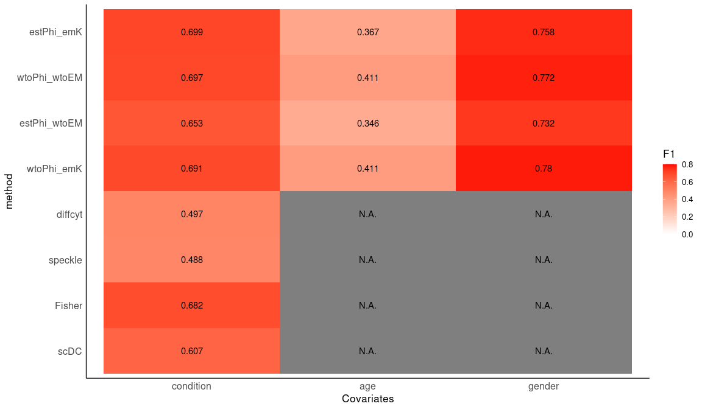

## Saving 12 x 7 in image

### extreme case1

## methods mcc auc prauc sensitivity specificity  
## 1 estPhi_null 0.71204129 0.9995753 0.9666667 1.0000000 0.89162562  
## 2 estPhi_emSVM 0.70321085 0.9983013 0.9666667 1.0000000 0.88669951  
## 3 estPhi_emK 0.70321085 0.9995753 0.9666667 1.0000000 0.88669951  
## 4 estPhi_emT 0.61017580 0.9723968 0.9072943 0.9655172 0.84236453  
## 5 estPhi_emU 0.60583246 0.9793613 0.8787879 1.0000000 0.82266010  
## 6 emSVM_org2 0.48795004 0.9861559 0.7837838 1.0000000 0.71428571  
## 7 emSVM_refSVM3 0.48349378 0.9882793 0.8285714 1.0000000 0.70935961  
## 8 emSVM_refSVM2 0.48349378 0.9863258 0.7837838 1.0000000 0.70935961  
## 9 emK_refK2 0.47909760 0.9859011 0.7837838 1.0000000 0.70443350  
## 10 emK_org2 0.47909760 0.9859011 0.7837838 1.0000000 0.70443350  
## 11 emSVM_truth2 0.47909760 0.9745201 0.6904762 1.0000000 0.70443350  
## 12 emK_refK3 0.47475976 0.9882793 0.8529412 1.0000000 0.69950739  
## 13 emSVM_org3 0.47475976 0.9890437 0.8055556 1.0000000 0.69950739  
## 14 emK_org3 0.47475976 0.9887039 0.8285714 1.0000000 0.69950739  
## 15 emK_truth2 0.47475976 0.9698488 0.6444444 1.0000000 0.69950739  
## 16 emSVM_truth3 0.46625240 0.9819942 0.7837838 1.0000000 0.68965517  
## 17 emK_truth3 0.45795900 0.9812298 0.7250000 1.0000000 0.67980296  
## 18 speckle 0.29277002 0.9819942 0.7440851 1.0000000 0.42857143  
## 19 diffcyt 0.27420425 0.9805504 0.5000000 1.0000000 0.39408867  
## 20 wtoPhi_emSVM 0.20063042 0.9763887 0.4677419 1.0000000 0.25123153  
## 21 wtoPhi_emK 0.20063042 0.9777476 0.4677419 1.0000000 0.25123153  
## 22 betabin_null 0.19557956 0.9754544 0.4531250 1.0000000 0.24137931  
## 23 wtoPhi_emU 0.19557956 0.9633090 0.4833333 1.0000000 0.24137931  
## 24 milo 0.19050836 0.9847121 NA 1.0000000 0.23152709  
## 25 wtoPhi_emT 0.14674182 0.9346866 0.4397111 0.9655172 0.20689655  
## 26 scDC 0.06158464 0.8801597 0.1288889 1.0000000 0.02955665  
## 27 fisher 0.05609486 1.0000000 1.0000000 1.0000000 0.02463054  
## precision F1  
## 1 0.5686275 0.7250000  
## 2 0.5576923 0.7160494  
## 3 0.5576923 0.7160494  
## 4 0.4666667 0.6292135  
## 5 0.4461538 0.6170213  
## 6 0.3333333 0.5000000  
## 7 0.3295455 0.4957265  
## 8 0.3295455 0.4957265  
## 9 0.3258427 0.4915254  
## 10 0.3258427 0.4915254  
## 11 0.3258427 0.4915254  
## 12 0.3222222 0.4873950  
## 13 0.3222222 0.4873950  
## 14 0.3222222 0.4873950  
## 15 0.3222222 0.4873950  
## 16 0.3152174 0.4793388  
## 17 0.3085106 0.4715447  
## 18 0.2000000 0.3333333  
## 19 0.1907895 0.3204420  
## 20 0.1602210 0.2761905  
## 21 0.1602210 0.2761905  
## 22 0.1584699 0.2735849  
## 23 0.1584699 0.2735849  
## 24 0.1567568 0.2710280  
## 25 0.1481481 0.2568807  
## 26 0.1283186 0.2274510  
## 27 0.1277533 0.2265625

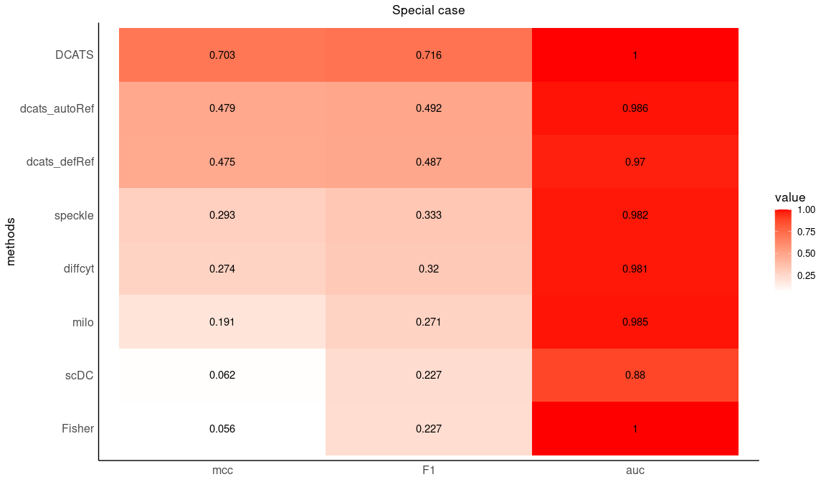

|  |  |  |  |  |  |  |  |
| --- | --- | --- | --- | --- | --- | --- | --- |
| methods | mcc | auc | prauc | sensitivity | specificity | precision | F1 |
| DCATS | 0.703 | 1.000 | 0.967 | 1 | 0.887 | 0.558 | 0.716 |
| Fisher | 0.056 | 1.000 | 1.000 | 1 | 0.025 | 0.128 | 0.227 |
| NA | 0.479 | 0.986 | 0.784 | 1 | 0.704 | 0.326 | 0.492 |
| milo | 0.191 | 0.985 | NA | 1 | 0.232 | 0.157 | 0.271 |
| speckle | 0.293 | 0.982 | 0.744 | 1 | 0.429 | 0.200 | 0.333 |
| diffcyt | 0.274 | 0.981 | 0.500 | 1 | 0.394 | 0.191 | 0.320 |
| NA | 0.475 | 0.970 | 0.644 | 1 | 0.700 | 0.322 | 0.487 |
| scDC | 0.062 | 0.880 | 0.129 | 1 | 0.030 | 0.128 | 0.227 |

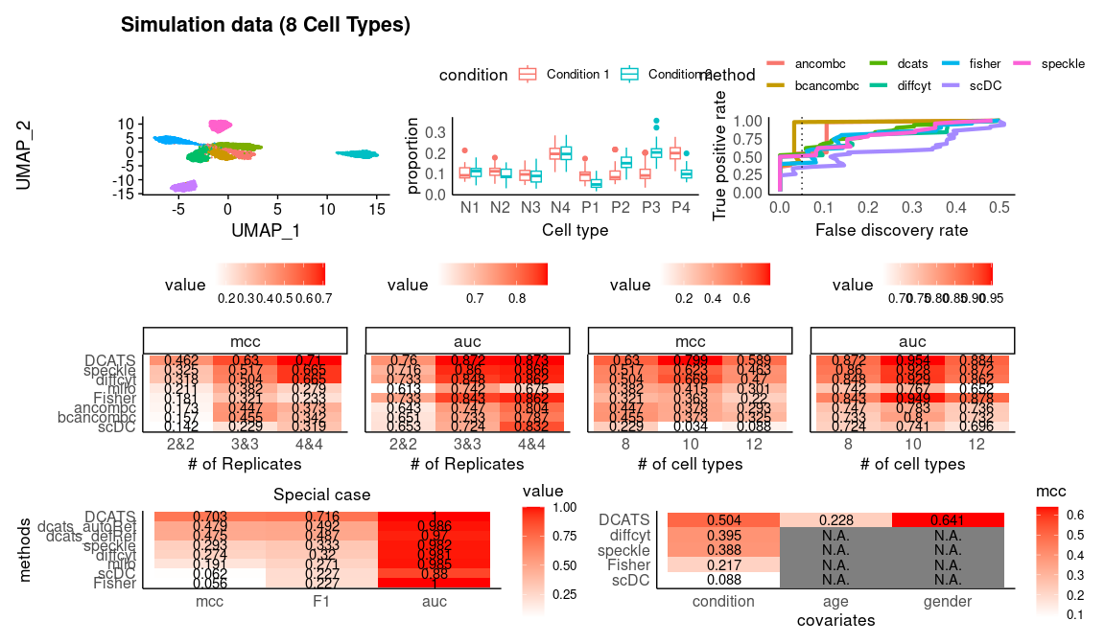

### extreme case1

## methods mcc auc prauc sensitivity specificity  
## 1 estPhi_emT 0.30457737 0.6256667 0.5136108 0.45555556 0.8266667  
## 2 emK_truth2 0.21408721 0.6166296 0.5201228 0.38888889 0.8066667  
## 3 estPhi_emU 0.21155426 0.5822593 0.4064931 0.41111111 0.7866667  
## 4 emSVM_truth2 0.17516226 0.6199259 0.5188618 0.36666667 0.7933333  
## 5 estPhi_null 0.15994799 0.5900370 0.5852532 0.27777778 0.8533333  
## 6 estPhi_emSVM 0.13912167 0.5891111 0.4215864 0.30000000 0.8200000  
## 7 estPhi_emK 0.13398842 0.5942593 0.4593704 0.31111111 0.8066667  
## 8 betabin_null 0.13146844 0.5771111 0.4689543 0.37777778 0.7466667  
## 9 wtoPhi_emK 0.13146844 0.5757037 0.4624846 0.37777778 0.7466667  
## 10 fisher 0.12886485 0.6064074 0.4110260 0.85555556 0.2533333  
## 11 wtoPhi_emSVM 0.12393974 0.5768519 0.4664495 0.37777778 0.7400000  
## 12 wtoPhi_emU 0.12393974 0.5748148 0.4629811 0.37777778 0.7400000  
## 13 emSVM_refSVM3 0.12010253 0.5904444 0.4872699 0.26666667 0.8333333  
## 14 emK_refK3 0.12010253 0.5873333 0.4737342 0.26666667 0.8333333  
## 15 emSVM_org3 0.12010253 0.5904444 0.4872699 0.26666667 0.8333333  
## 16 emK_org3 0.12010253 0.5873333 0.4737342 0.26666667 0.8333333  
## 17 scDC 0.11751411 0.5598519 0.4136969 0.78888889 0.3200000  
## 18 emSVM_org2 0.10846523 0.6324815 0.4869236 0.20000000 0.8800000  
## 19 emK_org2 0.10846523 0.6330000 0.4877277 0.20000000 0.8800000  
## 20 emSVM_refSVM2 0.10576394 0.6069259 0.4464946 0.22222222 0.8600000  
## 21 emK_refK2 0.10576394 0.6073704 0.4042161 0.22222222 0.8600000  
## 22 emK_truth3 0.10504814 0.6125185 0.4558142 0.34444444 0.7533333  
## 23 emSVM_truth3 0.09745758 0.6125185 0.4647697 0.34444444 0.7466667  
## 24 wtoPhi_emT 0.09390603 0.5760741 0.4578857 0.35555556 0.7333333  
## 25 speckle 0.02096754 0.5449259 0.3933947 0.07777778 0.9333333  
## 26 diffcyt -0.00398457 0.5501852 0.3661692 0.07777778 0.9200000  
## 27 milo -0.04794633 0.4801481 NA 0.02222222 0.9600000  
## precision F1  
## 1 0.6119403 0.52229299  
## 2 0.5468750 0.45454545  
## 3 0.5362319 0.46540881  
## 4 0.5156250 0.42857143  
## 5 0.5319149 0.36496350  
## 6 0.5000000 0.37500000  
## 7 0.4912281 0.38095238  
## 8 0.4722222 0.41975309  
## 9 0.4722222 0.41975309  
## 10 0.4074074 0.55197133  
## 11 0.4657534 0.41717791  
## 12 0.4657534 0.41717791  
## 13 0.4897959 0.34532374  
## 14 0.4897959 0.34532374  
## 15 0.4897959 0.34532374  
## 16 0.4897959 0.34532374  
## 17 0.4104046 0.53992395  
## 18 0.5000000 0.28571429  
## 19 0.5000000 0.28571429  
## 20 0.4878049 0.30534351  
## 21 0.4878049 0.30534351  
## 22 0.4558824 0.39240506  
## 23 0.4492754 0.38993711  
## 24 0.4444444 0.39506173  
## 25 0.4117647 0.13084112  
## 26 0.3684211 0.12844037  
## 27 0.2500000 0.04081633

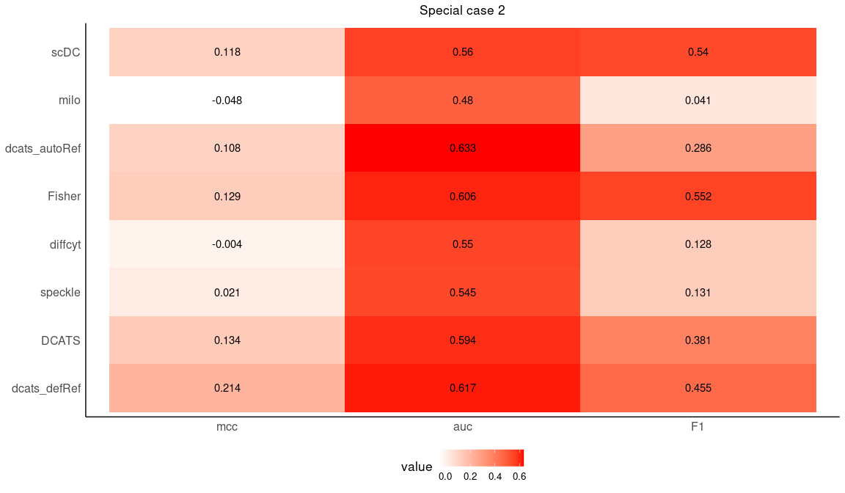

|  |  |  |  |  |  |  |  |
| --- | --- | --- | --- | --- | --- | --- | --- |
| methods | mcc | auc | prauc | sensitivity | specificity | precision | F1 |
| emK_autoRef | 0.108 | 0.633 | 0.488 | 0.200 | 0.880 | 0.500 | 0.286 |
| emK_defRef | 0.214 | 0.617 | 0.520 | 0.389 | 0.807 | 0.547 | 0.455 |
| Fisher | 0.129 | 0.606 | 0.411 | 0.856 | 0.253 | 0.407 | 0.552 |
| estPhi_emK | 0.134 | 0.594 | 0.459 | 0.311 | 0.807 | 0.491 | 0.381 |
| scDC | 0.118 | 0.560 | 0.414 | 0.789 | 0.320 | 0.410 | 0.540 |
| diffcyt | -0.004 | 0.550 | 0.366 | 0.078 | 0.920 | 0.368 | 0.128 |
| speckle | 0.021 | 0.545 | 0.393 | 0.078 | 0.933 | 0.412 | 0.131 |
| milo | -0.048 | 0.480 | NA | 0.022 | 0.960 | 0.250 | 0.041 |

## Figure 4

### real-world data 1 - Experiment 7

The ‘group’ column started with ‘B’ is the indicators of replicates

## `summarise()` has grouped output by 'batch', 'condition'. You can override  
## using the `.groups` argument.

## `summarise()` has grouped output by 'condition'. You can override using the  
## `.groups` argument.

|  |  |  |  |  |  |  |  |  |  |  |
| --- | --- | --- | --- | --- | --- | --- | --- | --- | --- | --- |
| cluster | truth | betabin_null | wtoPhi_emSVM | estPhi_null | estPhi_emSVM | fisher | scDC | speckle | milo_pct | treatment |
| Endocrine | N | 0.130 | 0.130 | 0.288 | 0.273 | 0.000 | 0.360 | 0.714 | 0.000 | Hpoly.Day3 |
| Enterocyte | N | 0.641 | 0.641 | 0.448 | 0.410 | 0.000 | 0.002 | 0.748 | 0.071 | Hpoly.Day3 |
| Enterocyte.Progenitor | N | 0.103 | 0.103 | 0.315 | 0.278 | 0.000 | 0.341 | 0.714 | 0.067 | Hpoly.Day3 |
| Goblet | N | 0.437 | 0.437 | 0.589 | 0.571 | 0.002 | 0.003 | 0.748 | 0.000 | Hpoly.Day3 |
| Stem | N | 0.254 | 0.254 | 0.222 | 0.164 | 0.032 | 0.010 | 0.714 | 0.000 | Hpoly.Day3 |
| TA | N | 0.883 | 0.883 | 0.883 | 0.975 | 0.205 | 0.099 | 0.993 | 0.000 | Hpoly.Day3 |
| TA.Early | N | 0.288 | 0.288 | 0.640 | 0.612 | 0.002 | 0.006 | 0.781 | 0.088 | Hpoly.Day3 |
| Tuft | P | 0.040 | 0.040 | 0.070 | 0.061 | 0.000 | 0.069 | 0.714 | 0.000 | Hpoly.Day3 |

|  |  |  |  |  |  |  |  |  |  |  |
| --- | --- | --- | --- | --- | --- | --- | --- | --- | --- | --- |
| cluster | truth | betabin_null | wtoPhi_emSVM | estPhi_null | estPhi_emSVM | fisher | scDC | speckle | milo_pct | treatment |
| Endocrine | N | 0.390 | 0.390 | 0.925 | 0.867 | 0.379 | 0.035 | 0.923 | 0.000 | Hpoly.Day10 |
| Enterocyte | P | 0.091 | 0.091 | 0.009 | 0.006 | 0.000 | 0.002 | 0.149 | 0.472 | Hpoly.Day10 |
| Enterocyte.Progenitor | N | 0.132 | 0.132 | 0.285 | 0.233 | 0.000 | 0.103 | 0.349 | 0.162 | Hpoly.Day10 |
| Goblet | P | 0.051 | 0.051 | 0.116 | 0.105 | 0.000 | 0.009 | 0.235 | 0.217 | Hpoly.Day10 |
| Stem | N | 0.824 | 0.824 | 0.865 | 0.830 | 0.279 | 0.406 | 0.923 | 0.096 | Hpoly.Day10 |
| TA | N | 0.852 | 0.852 | 0.836 | 0.592 | 1.000 | 0.572 | 0.923 | 0.647 | Hpoly.Day10 |
| TA.Early | P | 0.015 | 0.015 | 0.132 | 0.083 | 0.000 | 0.224 | 0.235 | 0.266 | Hpoly.Day10 |
| Tuft | P | 0.020 | 0.020 | 0.013 | 0.010 | 0.000 | 0.000 | 0.112 | 0.500 | Hpoly.Day10 |

|  |  |  |  |  |  |  |  |  |  |  |
| --- | --- | --- | --- | --- | --- | --- | --- | --- | --- | --- |
| cluster | truth | betabin_null | wtoPhi_emSVM | estPhi_null | estPhi_emSVM | fisher | scDC | speckle | milo_pct | treatment |
| Endocrine | N | 0.426 | 0.426 | 0.798 | 0.784 | 0.429 | 0.840 | 0.761 | 0.308 | Salmonella |
| Enterocyte | P | 0.008 | 0.008 | 0.000 | 0.000 | 0.000 | 0.022 | 0.008 | 0.457 | Salmonella |
| Enterocyte.Progenitor | N | 0.146 | 0.146 | 0.561 | 0.495 | 0.000 | 0.357 | 0.647 | 0.019 | Salmonella |
| Goblet | N | 0.681 | 0.681 | 0.821 | 0.802 | 0.558 | 0.253 | 0.864 | 0.100 | Salmonella |
| Stem | P | 0.031 | 0.031 | 0.059 | 0.046 | 0.000 | 0.080 | 0.094 | 0.320 | Salmonella |
| TA | P | 0.026 | 0.026 | 0.192 | 0.318 | 0.000 | 0.801 | 0.216 | 0.538 | Salmonella |
| TA.Early | P | 0.030 | 0.030 | 0.261 | 0.268 | 0.000 | 0.390 | 0.216 | 0.015 | Salmonella |
| Tuft | N | 0.587 | 0.587 | 0.833 | 0.844 | 0.129 | 0.059 | 0.761 | 0.000 | Salmonella |

|  |  |  |  |  |  |  |  |  |
| --- | --- | --- | --- | --- | --- | --- | --- | --- |
|  | Tuft | Endocrine | Enterocyte.Progenitor | Stem | Goblet | TA.Early | Enterocyte | TA |
| origin | P | N | N | N | N | N | N | N |
| DCATS | * | n.s. | n.s. | n.s. | n.s. | n.s. | n.s. | n.s. |
| fisher | *** | *** | *** | ** | *** | *** | *** | n.s. |
| scDC | * | n.s. | n.s. | *** | *** | *** | *** | * |
| speckle | n.s. | n.s. | n.s. | n.s. | n.s. | n.s. | n.s. | n.s. |
| milo | N | N | N | N | N | N | N | N |

|  |  |  |  |  |  |  |  |  |
| --- | --- | --- | --- | --- | --- | --- | --- | --- |
|  | Tuft | TA.Early | Goblet | Enterocyte | Enterocyte.Progenitor | Endocrine | Stem | TA |
| origin | P | P | P | P | N | N | N | N |
| DCATS | ** | * | n.s. | *** | n.s. | n.s. | n.s. | n.s. |
| fisher | *** | *** | *** | *** | *** | n.s. | n.s. | n.s. |
| scDC | *** | n.s. | *** | *** | n.s. | ** | n.s. | n.s. |
| speckle | n.s. | n.s. | n.s. | n.s. | n.s. | n.s. | n.s. | n.s. |
| milo | P | P | P | P | N | N | N | P |

|  |  |  |  |  |  |  |  |  |
| --- | --- | --- | --- | --- | --- | --- | --- | --- |
|  | Enterocyte | Stem | TA | TA.Early | Enterocyte.Progenitor | Tuft | Goblet | Endocrine |
| origin | P | P | P | P | N | N | N | N |
| DCATS | *** | ** | n.s. | n.s. | n.s. | n.s. | n.s. | n.s. |
| fisher | *** | *** | *** | *** | *** | n.s. | n.s. | n.s. |
| scDC | ** | * | n.s. | n.s. | n.s. | * | n.s. | n.s. |
| speckle | *** | * | n.s. | n.s. | n.s. | n.s. | n.s. | n.s. |
| milo | P | P | P | N | N | N | N | P |

|  |  |  |  |  |  |  |  |  |
| --- | --- | --- | --- | --- | --- | --- | --- | --- |
|  | Endocrine | Enterocyte | Enterocyte.Progenitor | Goblet | Stem | TA | TA.Early | Tuft |
| Endocrine | 0.9785933 | 0.0006868 | 0.0005495 | 0.0093209 | 0.0102934 | 0.0114537 | 0.0087549 | 0 |
| Enterocyte | 0.0000000 | 0.9800824 | 0.0170330 | 0.0000000 | 0.0000000 | 0.0000000 | 0.0000000 | 0 |
| Enterocyte.Progenitor | 0.0000000 | 0.0185440 | 0.9401099 | 0.0000000 | 0.0005147 | 0.0572687 | 0.0087549 | 0 |
| Goblet | 0.0091743 | 0.0000000 | 0.0000000 | 0.9826897 | 0.0056613 | 0.0017621 | 0.0019455 | 0 |
| Stem | 0.0030581 | 0.0006868 | 0.0000000 | 0.0026631 | 0.8625836 | 0.0933921 | 0.0345331 | 0 |
| TA | 0.0000000 | 0.0000000 | 0.0335165 | 0.0000000 | 0.0761709 | 0.7506608 | 0.0617704 | 0 |
| TA.Early | 0.0000000 | 0.0000000 | 0.0082418 | 0.0039947 | 0.0303654 | 0.0748899 | 0.8793774 | 0 |
| Tuft | 0.0091743 | 0.0000000 | 0.0005495 | 0.0013316 | 0.0144107 | 0.0105727 | 0.0048638 | 1 |

Supplementary Figures: Distribution of each cell type after bias correction

## Bin width defaults to 1/30 of the range of the data. Pick better value with  
## `binwidth`.  
## Bin width defaults to 1/30 of the range of the data. Pick better value with  
## `binwidth`.  
## Bin width defaults to 1/30 of the range of the data. Pick better value with  
## `binwidth`.

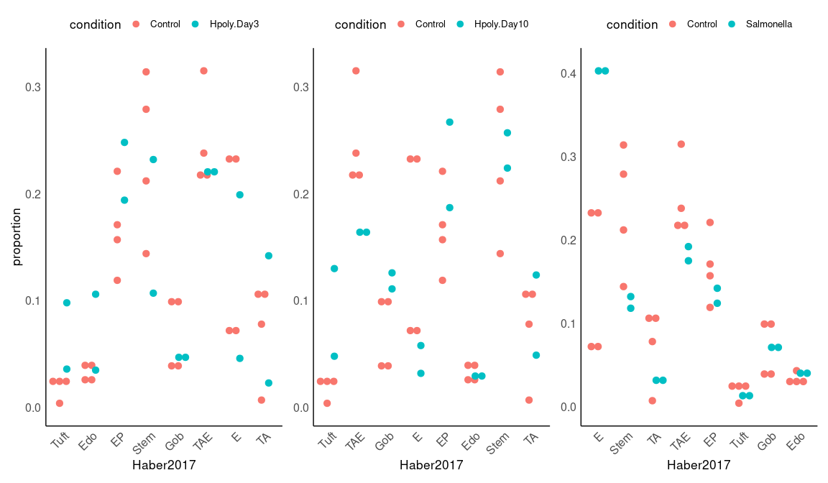

## Bin width defaults to 1/30 of the range of the data. Pick better value with  
## `binwidth`.  
## Bin width defaults to 1/30 of the range of the data. Pick better value with  
## `binwidth`.  
## Bin width defaults to 1/30 of the range of the data. Pick better value with  
## `binwidth`.

## real-world data2

## cell tsne1 tsne2 ind condition cluster clusterRes  
## 1 AAACATACAATGCC-1 -4.277833 -19.294709 107 ctrl 5 CD4 T cells  
## 2 AAACATACATTTCC-1 -27.640373 14.966629 1016 ctrl 9 CD14+ Monocytes  
## 3 AAACATACCAGAAA-1 -27.493646 28.924885 1256 ctrl 9 CD14+ Monocytes  
## 4 AAACATACCAGCTA-1 -28.132584 24.925484 1256 ctrl 9 CD14+ Monocytes  
## 5 AAACATACCATGCA-1 -10.468194 -5.984389 1488 ctrl 3 CD4 T cells  
## 6 AAACATACCTCGCT-1 -24.367997 20.429285 1256 ctrl 9 CD14+ Monocytes  
## multiplets  
## 1 doublet  
## 2 singlet  
## 3 singlet  
## 4 doublet  
## 5 singlet  
## 6 singlet

## `summarise()` has grouped output by 'condition'. You can override using the  
## `.groups` argument.

## # A tibble: 16 × 3  
## # Groups: condition [2]  
## condition clusterRes n  
## <chr> <chr> <int>  
## 1 ctrl B cells 1488  
## 2 ctrl CD14+ Monocytes 3365  
## 3 ctrl CD4 T cells 6005  
## 4 ctrl CD8 T cells 1409  
## 5 ctrl Dendritic cells 227  
## 6 ctrl FCGR3A+ Monocytes 906  
## 7 ctrl Megakaryocytes 166  
## 8 ctrl NK cells 1051  
## 9 stim B cells 1392  
## 10 stim CD14+ Monocytes 3082  
## 11 stim CD4 T cells 6028  
## 12 stim CD8 T cells 1225  
## 13 stim Dendritic cells 245  
## 14 stim FCGR3A+ Monocytes 1008  
## 15 stim Megakaryocytes 180  
## 16 stim NK cells 1279

## # A tibble: 0 × 2  
## # … with 2 variables: cell <chr>, n <int>

## BARCODE RD.TOTL RD.PASS RD.UNIQ N.SNP BEST SNG.1ST  
## 1 AAACATACAATGCC-1 5799 280 269 185 DBL-107-1244-0.500 107  
## 2 AAACATACATTTCC-1 5466 592 501 236 SNG-1016 1016  
## 3 AAACATACCAGAAA-1 4337 330 300 154 SNG-1256 1256  
## 4 AAACATACCAGCTA-1 7120 418 338 179 DBL-1256-1244-0.500 1256  
## 5 AAACATACCATGCA-1 2422 86 76 54 SNG-1488 1488  
## 6 AAACATACCTCGCT-1 5312 561 497 207 SNG-1256 1256  
## SNG.LLK1 SNG.2ND SNG.LLK2 SNG.LLK0 DBL.1ST DBL.2ND ALPHA LLK12  
## 1 -78.5388 1244 -92.3864 -75.9878 107 1244 0.5 -62.8745  
## 2 -61.8525 1256 -193.3940 -135.9317 1016 1256 0.5 -93.0213  
## 3 -50.6213 1015 -100.6965 -67.2587 101 1256 0.5 -64.5022  
## 4 -70.2734 1244 -110.3962 -82.1916 1256 1244 0.5 -67.3787  
## 5 -16.1294 1015 -31.7146 -27.0167 1015 1488 0.5 -18.5646  
## 6 -66.3586 1015 -180.3066 -115.0556 1256 101 0.5 -101.4645  
## LLK1 LLK2 LLK10 LLK20 LLK00 PRB.DBL PRB.SNG1  
## 1 -78.5388 -92.3864 -88.6649 -94.1498 -77.4107 1.00e+00 1  
## 2 -61.8525 -193.3940 -103.2284 -168.3927 -132.6010 4.15e-15 1  
## 3 -107.8190 -50.6213 -111.3319 -64.5022 -72.4244 1.95e-07 1  
## 4 -70.2734 -110.3962 -80.3745 -103.1706 -85.1143 7.21e-01 1  
## 5 -31.7146 -16.1294 -30.2045 -22.5295 -28.2980 1.28e-02 1  
## 6 -66.3586 -190.9367 -101.4645 -194.9529 -124.2197 8.42e-17 1

## BARCODE RD.TOTL RD.PASS RD.UNIQ N.SNP BEST SNG.1ST SNG.LLK1  
## 1 AAACATACCAAGCT-1 2491 239 228 141 SNG-101 101 -31.2822  
## 2 AAACATACCCCTAC-1 3747 282 274 173 SNG-1488 1488 -37.4261  
## 3 AAACATACCCGTAA-1 2844 144 133 108 SNG-1244 1244 -35.0043  
## 4 AAACATACCCTCGT-1 3575 199 189 115 SNG-1488 1488 -31.5489  
## 5 AAACATACGAGGTG-1 2649 170 158 99 SNG-1488 1488 -33.2782  
## 6 AAACATACGCGAAG-1 9874 880 822 345 SNG-101 101 -139.7810  
## SNG.2ND SNG.LLK2 SNG.LLK0 DBL.1ST DBL.2ND ALPHA LLK12 LLK1  
## 1 1015 -81.3393 -59.5871 101 1015 0.5 -47.8026 -31.2822  
## 2 1256 -104.7874 -74.9247 1256 1488 0.5 -53.8991 -104.7874  
## 3 1488 -61.5604 -51.6974 1488 1244 0.5 -36.9775 -61.5604  
## 4 1244 -79.8040 -57.9696 1256 1488 0.5 -42.8116 -83.5802  
## 5 1244 -66.4966 -48.9522 101 1488 0.5 -36.4330 -75.8228  
## 6 1256 -266.4763 -170.1924 101 1488 0.5 -154.9333 -139.7810  
## LLK2 LLK10 LLK20 LLK00 PRB.DBL PRB.SNG1  
## 1 -81.3393 -32.1591 -47.8026 -64.9647 1.07e-08 1  
## 2 -37.4261 -101.7666 -64.5707 -79.2115 1.00e-08 1  
## 3 -35.0043 -72.6479 -50.8297 -52.6835 2.03e-02 1  
## 4 -31.5489 -80.4661 -49.8506 -58.0733 2.38e-06 1  
## 5 -33.2782 -72.2344 -36.4330 -48.3017 8.06e-03 1  
## 6 -273.8806 -136.9040 -154.9333 -175.5614 3.82e-08 1

## cell batch  
## 1 AAACATACATTTCC-1 SNG-1016  
## 2 AAACATACCAGAAA-1 SNG-1256  
## 3 AAACATACCATGCA-1 SNG-1488  
## 4 AAACATACCTCGCT-1 SNG-1256  
## 5 AAACATACCTGGTA-1 SNG-1039  
## 6 AAACATACGATGAA-1 SNG-1488

## `summarise()` has grouped output by 'condition', 'clusterRes'. You can override  
## using the `.groups` argument.

|  |  |  |  |  |  |  |  |  |  |
| --- | --- | --- | --- | --- | --- | --- | --- | --- | --- |
| cluster | truth | betabin_null | wtoPhi_emSVM | estPhi_null | estPhi_emSVM | fisher | scDC | speckle | milo_pct |
| B cells | N | 0.997 | 0.997 | 0.995 | 0.995 | 0.338 | 0.000 | 0.989 | 0.032 |
| CD14+ Monocytes | N | 0.510 | 0.510 | 0.537 | 0.527 | 0.001 | 0.480 | 0.989 | 0.186 |
| CD4 T cells | N | 0.953 | 0.953 | 0.926 | 0.921 | 0.252 | 0.408 | 0.989 | 0.058 |
| CD8 T cells | N | 0.734 | 0.734 | 0.581 | 0.566 | 0.008 | 0.348 | 0.989 | 0.187 |
| Dendritic cells | N | 0.496 | 0.496 | 0.815 | 0.960 | 0.252 | 0.333 | 0.989 | 0.000 |
| FCGR3A+ Monocytes | N | 0.603 | 0.603 | 0.729 | 0.335 | 0.008 | 0.077 | 0.989 | 0.101 |
| Megakaryocytes | N | 0.738 | 0.738 | 0.820 | 0.364 | 0.862 | 0.761 | 0.989 | 0.167 |
| NK cells | N | 0.244 | 0.244 | 0.514 | 0.508 | 0.000 | 0.018 | 0.989 | 0.071 |

|  |  |  |  |  |  |  |  |  |
| --- | --- | --- | --- | --- | --- | --- | --- | --- |
|  | NK | Tc | cM | ncM | B | Th | DC | Mkc |
| origin | N | N | N | N | N | N | N | N |
| DCATS | n.s. | n.s. | n.s. | n.s. | n.s. | n.s. | n.s. | n.s. |
| fisher | *** | *** | *** | *** | n.s. | n.s. | n.s. | n.s. |
| scDC | ** | n.s. | n.s. | * | *** | n.s. | n.s. | n.s. |
| speckle | n.s. | n.s. | n.s. | n.s. | n.s. | n.s. | n.s. | n.s. |
| milo | N | N | N | N | N | N | N | N |

## Bin width defaults to 1/30 of the range of the data. Pick better value with  
## `binwidth`.  
## Bin width defaults to 1/30 of the range of the data. Pick better value with  
## `binwidth`.  
## Bin width defaults to 1/30 of the range of the data. Pick better value with  
## `binwidth`.

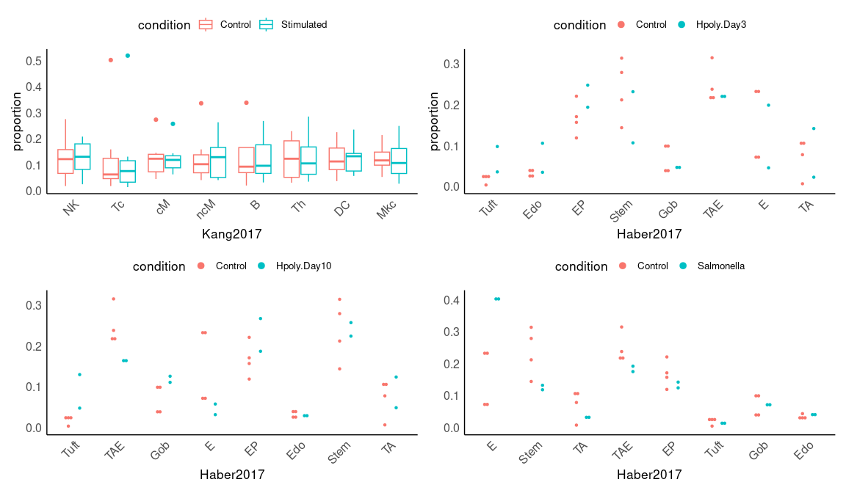

## Bin width defaults to 1/30 of the range of the data. Pick better value with  
## `binwidth`.  
## Bin width defaults to 1/30 of the range of the data. Pick better value with  
## `binwidth`.  
## Bin width defaults to 1/30 of the range of the data. Pick better value with  
## `binwidth`.

## Figure 4

### real-world data 3

Test between different groups

control vs mild/moderate_progression

control vs severe/critical_progression

mild/moderate_convalescence vs mild/moderate_progression

severe/critical_convalescence vs severe/critical_progression

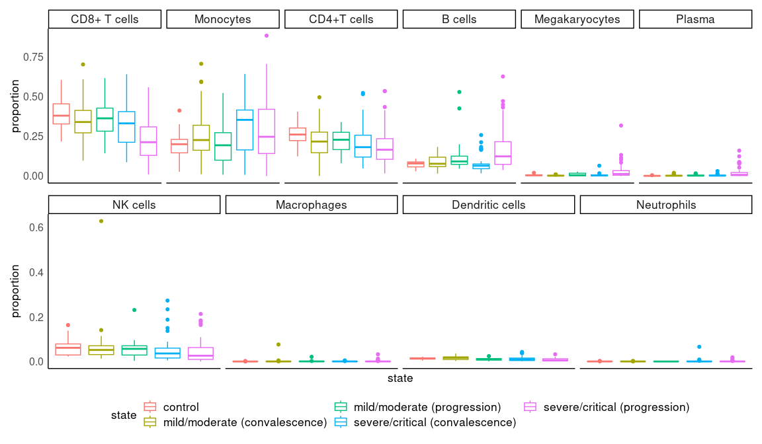

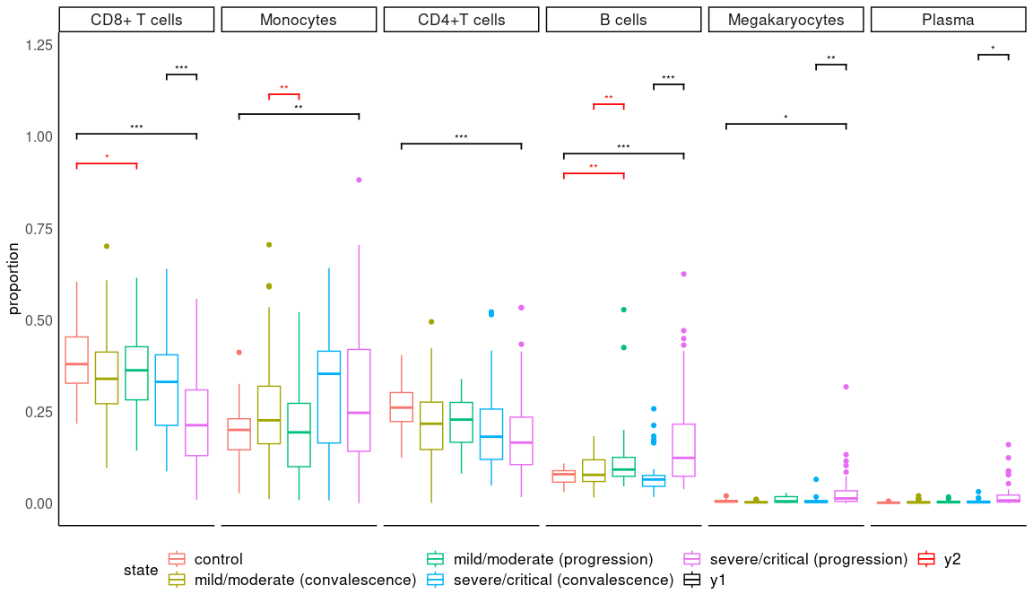

### Real world data 4

## [1] "Empty cell type exists in at least one conidtion; adding replicate & condition specific pseudo count:"

## [1] "Empty cell type exists in at least one conidtion; adding replicate & condition specific pseudo count:"

|  |  |  |  |  |
| --- | --- | --- | --- | --- |
|  | condition | condition | condition | condition |
| Alveolar_macrophage | 0.0021 | 0.0226 | 0.0849 | 0.1475 |
| B_cells | 0.0038 | 0.0315 | 0.0068 | 0.0280 |
| Capillary_endothelial_cells | 0.0330 | 0.1210 | 0.0141 | 0.0357 |
| Ccl17+/Cd103-/Cd11b-_dendritic_cells | 0.6332 | 0.7383 | 0.1099 | 0.1814 |
| Cd103+/Cd11b-_dendritic_cells | 0.5535 | 0.7025 | 0.1916 | 0.2634 |
| CD209+/Cd11b+_dendritic_cells | 0.4379 | 0.6021 | 0.1819 | 0.2610 |
| Cd4+_T_cells | 0.0109 | 0.0514 | 0.0050 | 0.0280 |
| CD8+_T_cells | 0.0671 | 0.1533 | 0.0079 | 0.0291 |
| Ciliated_cells | 0.8631 | 0.8901 | 0.0053 | 0.0280 |
| classical_monocyte_(Ly6c2+) | 0.0001 | 0.0020 | 0.0001 | 0.0038 |
| Club_cells | 0.0660 | 0.1533 | 1.0000 | 1.0000 |
| Eosinophils | 0.0207 | 0.0853 | 0.0121 | 0.0357 |
| Fn1+_macrophage | 0.3597 | 0.5162 | 0.0341 | 0.0663 |
| Gamma-Delta_T_cells | 1.0000 | 1.0000 | 0.1324 | 0.2080 |
| Goblet_cells | 0.5168 | 0.6821 | 0.0091 | 0.0301 |
| Interstitial_Fibroblast | 0.0697 | 0.1533 | 0.9195 | 0.9482 |
| Interstitial_macrophages | 0.0820 | 0.1691 | 0.0035 | 0.0280 |
| Lipofibroblast | 0.3004 | 0.4507 | 0.6183 | 0.6582 |
| low_quality_cells | 0.2152 | 0.3738 | 0.0186 | 0.0438 |
| lymphatic_endothelial_cells | 0.2415 | 0.3984 | 0.3332 | 0.4229 |
| Megakaryocytes | 0.0019 | 0.0226 | 0.0020 | 0.0280 |
| Mesothelial_cells | 0.6881 | 0.7383 | 0.0036 | 0.0280 |
| Mki67+_proliferating_cells | 0.0556 | 0.1533 | 0.4807 | 0.5665 |
| Natural_Killer_cells | 0.6935 | 0.7383 | 0.0209 | 0.0457 |
| Neutrophils | 0.6669 | 0.7383 | 0.0614 | 0.1126 |
| non-classical_monocyte_(Ly6c2-) | 0.0051 | 0.0339 | 0.0061 | 0.0280 |
| Plasma_cells | 0.0090 | 0.0492 | 0.0136 | 0.0357 |
| red_blood_cells | 0.2999 | 0.4507 | 0.1496 | 0.2244 |
| Smooth_muscle_cells | 0.1801 | 0.3301 | 0.4979 | 0.5666 |
| Type_2_pneumocytes | 0.0496 | 0.1533 | 0.2228 | 0.2942 |
| Type1_pneumocytes | 0.6713 | 0.7383 | 0.4557 | 0.5570 |
| vascular_endothelial_cells | 0.0578 | 0.1533 | 0.0222 | 0.0457 |
| Vcam1+_endothelial_cells | 0.1540 | 0.2990 | 0.5367 | 0.5904 |

## condition condition condition condition  
## Alveolar_macrophage TRUE TRUE FALSE FALSE  
## B_cells TRUE TRUE TRUE TRUE  
## Capillary_endothelial_cells TRUE FALSE TRUE TRUE  
## Ccl17+/Cd103-/Cd11b-_dendritic_cells FALSE FALSE FALSE FALSE  
## Cd103+/Cd11b-_dendritic_cells FALSE FALSE FALSE FALSE  
## CD209+/Cd11b+_dendritic_cells FALSE FALSE FALSE FALSE  
## Cd4+_T_cells TRUE FALSE TRUE TRUE  
## CD8+_T_cells FALSE FALSE TRUE TRUE  
## Ciliated_cells FALSE FALSE TRUE TRUE  
## classical_monocyte_(Ly6c2+) TRUE TRUE TRUE TRUE  
## Club_cells FALSE FALSE FALSE FALSE  
## Eosinophils TRUE FALSE TRUE TRUE  
## Fn1+_macrophage FALSE FALSE TRUE FALSE  
## Gamma-Delta_T_cells FALSE FALSE FALSE FALSE  
## Goblet_cells FALSE FALSE TRUE TRUE  
## Interstitial_Fibroblast FALSE FALSE FALSE FALSE  
## Interstitial_macrophages FALSE FALSE TRUE TRUE  
## Lipofibroblast FALSE FALSE FALSE FALSE  
## low_quality_cells FALSE FALSE TRUE TRUE  
## lymphatic_endothelial_cells FALSE FALSE FALSE FALSE  
## Megakaryocytes TRUE TRUE TRUE TRUE  
## Mesothelial_cells FALSE FALSE TRUE TRUE  
## Mki67+_proliferating_cells FALSE FALSE FALSE FALSE  
## Natural_Killer_cells FALSE FALSE TRUE TRUE  
## Neutrophils FALSE FALSE FALSE FALSE  
## non-classical_monocyte_(Ly6c2-) TRUE TRUE TRUE TRUE  
## Plasma_cells TRUE TRUE TRUE TRUE  
## red_blood_cells FALSE FALSE FALSE FALSE  
## Smooth_muscle_cells FALSE FALSE FALSE FALSE  
## Type_2_pneumocytes TRUE FALSE FALSE FALSE  
## Type1_pneumocytes FALSE FALSE FALSE FALSE  
## vascular_endothelial_cells FALSE FALSE TRUE TRUE  
## Vcam1+_endothelial_cells FALSE FALSE FALSE FALSE