Homework 3

Xinyi Lin

9/26/2019

## Question 1

## Min. 1st Qu. Median Mean 3rd Qu. Max.   
## 7.083 14.269 17.445 30.205 29.664 178.296

The minimum, quartiles and maximum of design weights are shown above, the histogram is shown below.

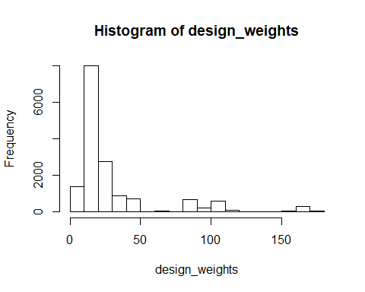

## Question 2

## Min. 1st Qu. Median Mean 3rd Qu. Max.   
## 7.169 14.428 17.657 30.587 29.800 181.725

The minimum, quartiles and maximum of adjusted design weights by unknown eligibility are shown above, the histogram is shown below.

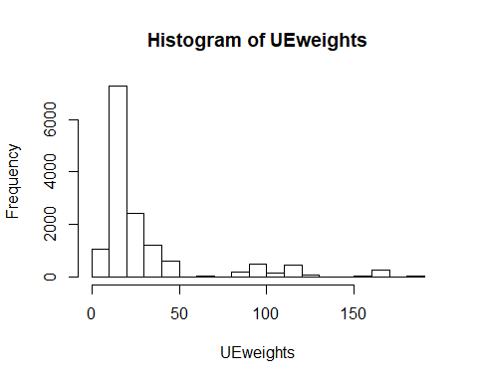

## Question 3

In order to apply adjustments for nonresponse to the weights using the CHAID method, I first use the CHAID package to seperate data into different cells, then calculate $w_{nr,c,nw}=\frac{1}{rrate_{c,nw}},rrate_{c,nw}=\frac{n_{r,c}}{n_{c}}$ for each cell, final weights is $w_{des}w_{eli}w_{nr,c,nw}$.

##   
## Model formula:  
## RESPSTAT2 ~ XSEXR + XSRRCR + XCPAY1R + XRETH4R  
##   
## Fitted party:  
## [1] root  
## | [2] XCPAY1R in 1, 2  
## | | [3] XRETH4R in 1: 2 (n = 1841, err = 26.6%)  
## | | [4] XRETH4R in 2: 2 (n = 4121, err = 18.4%)  
## | [5] XCPAY1R in 3  
## | | [6] XRETH4R in 1: 2 (n = 927, err = 44.7%)  
## | | [7] XRETH4R in 2  
## | | | [8] XSEXR in 1: 2 (n = 1483, err = 29.1%)  
## | | | [9] XSEXR in 2: 2 (n = 355, err = 34.6%)  
## | [10] XCPAY1R in 4, 6  
## | | [11] XRETH4R in 1  
## | | | [12] XCPAY1R in 1, 2, 3, 4, 5, 7  
## | | | | [13] XSRRCR in 1, 3, 5, 6: 1 (n = 362, err = 41.4%)  
## | | | | [14] XSRRCR in 2: 1 (n = 204, err = 27.0%)  
## | | | [15] XCPAY1R in 6: 1 (n = 1345, err = 42.2%)  
## | | [16] XRETH4R in 2: 1 (n = 1033, err = 49.8%)  
## | [17] XCPAY1R in 5: 1 (n = 898, err = 36.9%)  
## | [18] XCPAY1R in 7  
## | | [19] XSRRCR in 1, 3, 5, 6: 1 (n = 978, err = 32.1%)  
## | | [20] XSRRCR in 2  
## | | | [21] XRETH4R in 1: 1 (n = 569, err = 23.4%)  
## | | | [22] XRETH4R in 2: 1 (n = 216, err = 33.3%)  
##   
## Number of inner nodes: 9  
## Number of terminal nodes: 13

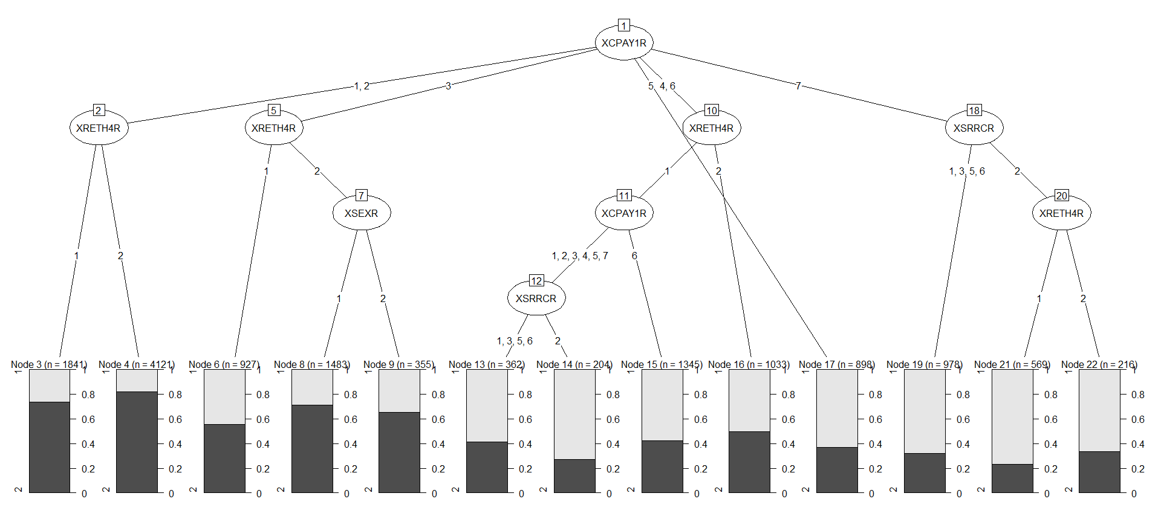

## Min. 1st Qu. Median Mean 3rd Qu. Max.   
## 10.56 18.87 33.34 77.70 87.74 663.24

The minimum, quartiles and maximum of adjusted design weights by unknown eligibility and nonresponse are shown above, the histogram is shown below.

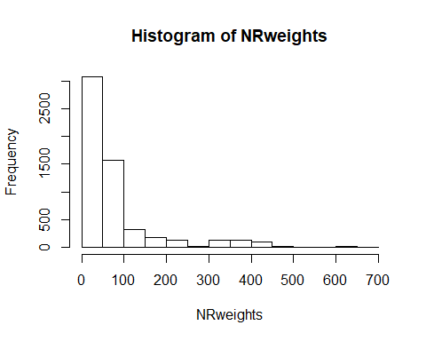

**Appendix**

knitr::opts_chunk$set(echo = FALSE)  
library(tidyverse)  
library(CHAID)  
## Question 1  
data = read.csv("./HW3.csv")   
p1_data = data %>%   
 mutate(design_weights = NSTRAT/NSAMP)  
summary(p1_data$design_weights)  
design_weights = p1_data$design_weights  
hist(design_weights)  
## Question 2  
UEwei_data = data %>%   
 group_by(STRATUM, RESPSTAT2) %>%   
 summarize(total = sum(NSAMP)) %>%   
 mutate(RESPSTAT2 = str_c("respSTAT_", RESPSTAT2)) %>%   
 spread(key = RESPSTAT2, value = total) %>%   
 mutate(respSTAT_3 = ifelse(is.na(respSTAT_3), 0, respSTAT_3),  
 respSTAT_4 = ifelse(is.na(respSTAT_4), 0, respSTAT_4)) %>%   
 mutate(total_num = respSTAT_1 + respSTAT_2 + respSTAT_3 + respSTAT_4,  
 UEweights = total_num/(respSTAT_1 + respSTAT_2 + respSTAT_3)) %>%   
 select(STRATUM, UEweights)  
  
p2_data = merge(p1_data, UEwei_data) %>%   
 mutate(UEweights = UEweights*design_weights) %>%   
 filter(RESPSTAT2 %in% c(1,2))  
  
summary(p2_data$UEweights)  
UEweights = p2_data$UEweights  
hist(UEweights)  
## Question 3  
set.seed(123)  
p3_data = data %>%   
 filter(RESPSTAT2 %in% c(1,2)) %>%   
 mutate(RESPSTAT2 = as.factor(RESPSTAT2),  
 XSEXR = as.factor(XSEXR),  
 XSRRCR = as.factor(XSRRCR),  
 XCPAY1R = as.factor(XCPAY1R),  
 XRETH4R = as.factor(XRETH4R))  
  
chaid_data = chaid(RESPSTAT2 ~ XSEXR + XSRRCR + XCPAY1R + XRETH4R, data = p3_data)  
print(chaid_data)  
plot(chaid_data)  
NR_data = p2_data %>%   
 mutate(id = 1:nrow(p2_data))  
# cell1  
cell1 = NR_data %>%   
 filter(XCPAY1R %in% c(1,2) & XRETH4R==1) %>%   
 select(id, RESPSTAT2)  
num2 = sum(cell1$RESPSTAT2)-nrow(cell1)  
cell1_w = nrow(cell1)/(nrow(cell1)-num2)  
cell1 = cell1 %>%   
 mutate(NRweights = cell1_w)  
# cell2  
cell2 = NR_data %>%   
 filter(XCPAY1R %in% c(1,2) & XRETH4R==2) %>%   
 select(id, RESPSTAT2)  
num2 = sum(cell2$RESPSTAT2)-nrow(cell2)  
cell2_w = nrow(cell2)/(nrow(cell2)-num2)  
cell2 = cell2 %>%   
 mutate(NRweights = cell2_w)  
# cell3  
cell3 = NR_data %>%   
 filter(XCPAY1R==3 & XRETH4R==1) %>%   
 select(id, RESPSTAT2)  
num2 = sum(cell3$RESPSTAT2)-nrow(cell3)  
cell3_w = nrow(cell3)/(nrow(cell3)-num2)  
cell3 = cell3 %>%   
 mutate(NRweights = cell3_w)  
# cell4  
cell4 = NR_data %>%   
 filter(XCPAY1R==3 & XRETH4R==2 & XSEXR==1) %>%   
 select(id, RESPSTAT2)  
num2 = sum(cell4$RESPSTAT2)-nrow(cell4)  
cell4_w = nrow(cell4)/(nrow(cell4)-num2)  
cell4 = cell4 %>%   
 mutate(NRweights = cell4_w)  
# cell5  
cell5 = NR_data %>%   
 filter(XCPAY1R==3 & XRETH4R==2 & XSEXR==2) %>%   
 select(id, RESPSTAT2)  
num2 = sum(cell5$RESPSTAT2)-nrow(cell5)  
cell5_w = nrow(cell5)/(nrow(cell5)-num2)  
cell5 = cell5 %>%   
 mutate(NRweights = cell5_w)  
# cell6  
cell6 = NR_data %>%   
 filter(XCPAY1R %in% c(4,6) & XRETH4R==1 & XCPAY1R %in% c(1,2,3,4,5,7) & XSRRCR %in% c(1,3,5,6)) %>%   
 select(id, RESPSTAT2)  
num2 = sum(cell6$RESPSTAT2)-nrow(cell6)  
cell6_w = nrow(cell6)/(nrow(cell6)-num2)  
cell6 = cell6 %>%   
 mutate(NRweights = cell6_w)  
# cell7  
cell7 = NR_data %>%   
 filter(XCPAY1R %in% c(4,6) & XRETH4R==1 & XCPAY1R %in% c(1,2,3,4,5,7) & XSRRCR==2) %>%   
 select(id, RESPSTAT2)  
num2 = sum(cell7$RESPSTAT2)-nrow(cell7)  
cell7_w = nrow(cell7)/(nrow(cell7)-num2)  
cell7 = cell7 %>%   
 mutate(NRweights = cell7_w)  
# cell8  
cell8 = NR_data %>%   
 filter(XCPAY1R %in% c(4,6) & XRETH4R==1 & XCPAY1R==6) %>%   
 select(id, RESPSTAT2)  
num2 = sum(cell8$RESPSTAT2)-nrow(cell8)  
cell8_w = nrow(cell8)/(nrow(cell8)-num2)  
cell8 = cell8 %>%   
 mutate(NRweights = cell8_w)  
# cell9  
cell9 = NR_data %>%   
 filter(XCPAY1R %in% c(4,6) & XRETH4R==2) %>%   
 select(id, RESPSTAT2)  
num2 = sum(cell9$RESPSTAT2)-nrow(cell9)  
cell9_w = nrow(cell9)/(nrow(cell9)-num2)  
cell9 = cell9 %>%   
 mutate(NRweights = cell9_w)  
# cell10  
cell10 = NR_data %>%   
 filter(XCPAY1R==5) %>%   
 select(id, RESPSTAT2)  
num2 = sum(cell10$RESPSTAT2)-nrow(cell10)  
cell10_w = nrow(cell10)/(nrow(cell10)-num2)  
cell10 = cell10 %>%   
 mutate(NRweights = cell10_w)  
# cell11  
cell11 = NR_data %>%   
 filter(XCPAY1R==7 & XSRRCR %in% c(1,3,5,6)) %>%   
 select(id, RESPSTAT2)  
num2 = sum(cell11$RESPSTAT2)-nrow(cell11)  
cell11_w = nrow(cell11)/(nrow(cell11)-num2)  
cell11 = cell11 %>%   
 mutate(NRweights = cell11_w)  
# cell12  
cell12 = NR_data %>%   
 filter(XCPAY1R==7 & XSRRCR==2 & XRETH4R==1) %>%   
 select(id, RESPSTAT2)  
num2 = sum(cell12$RESPSTAT2)-nrow(cell12)  
cell12_w = nrow(cell12)/(nrow(cell12)-num2)  
cell12 = cell12 %>%   
 mutate(NRweights = cell12_w)  
# cell13  
cell13 = NR_data %>%   
 filter(XCPAY1R==7 & XSRRCR==2 & XRETH4R==2) %>%   
 select(id, RESPSTAT2)  
num2 = sum(cell13$RESPSTAT2)-nrow(cell13)  
cell13_w = nrow(cell13)/(nrow(cell13)-num2)  
cell13 = cell13 %>%   
 mutate(NRweights = cell13_w)  
cell_data = rbind(cell1, cell2, cell3, cell4, cell5, cell6, cell7, cell8, cell9, cell10, cell11, cell12, cell13)  
p3_data = merge(NR_data, cell_data) %>%   
 mutate(NRweights = NRweights*UEweights) %>%   
 filter(RESPSTAT2==1)  
summary(p3_data$NRweights)  
NRweights = p3_data$NRweights  
hist(NRweights)