Homework 8

Xinyi Lin

10/12/2019

## Question 1

Weighted histogram of the Satisfaction with Government is shown above.

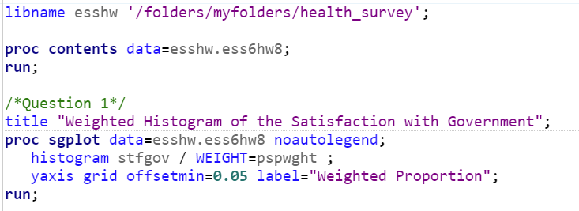

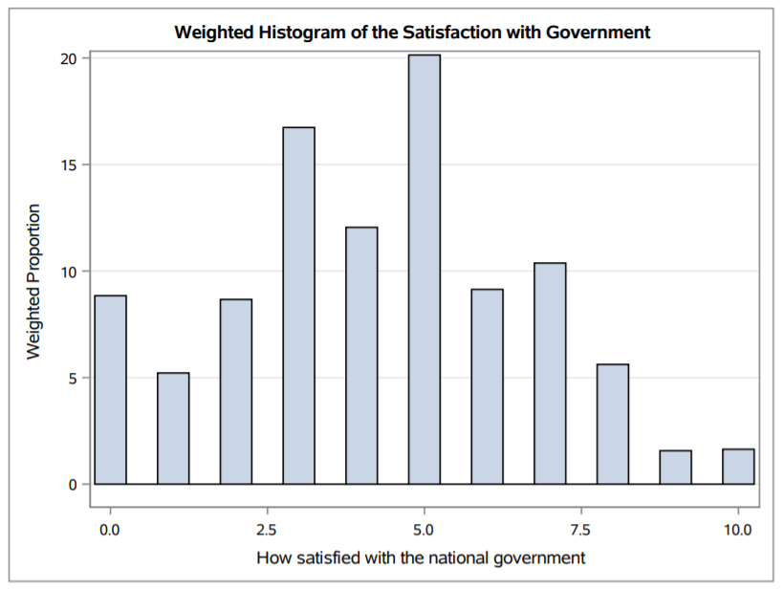

The distribution of variable STFGOV is similar to a normal distribution but not match around 5.

This variable can function as a continuous outcome because: 1. The variable is ordinal which means larger numbers indicates higher levels of satisfaction. 2. The increase of satisfaction can be continuous.

## Question 2

1. Political scale

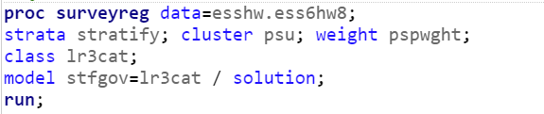

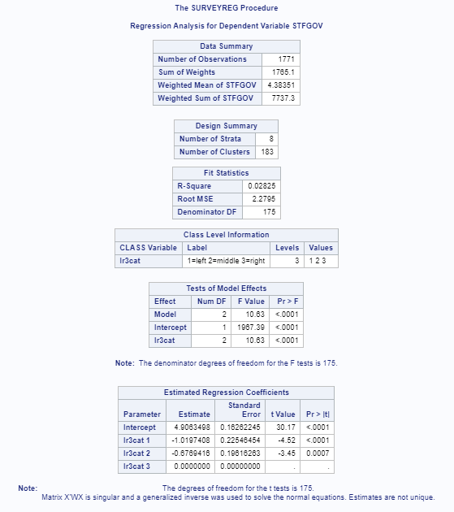

1. Gender

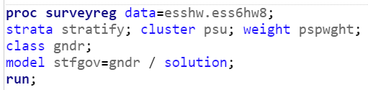

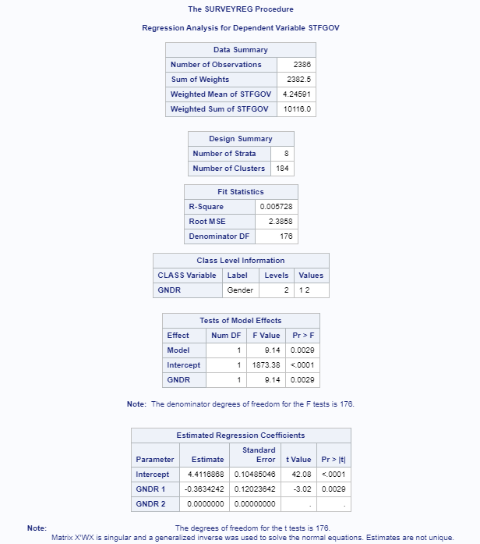

1. Self-rated health status

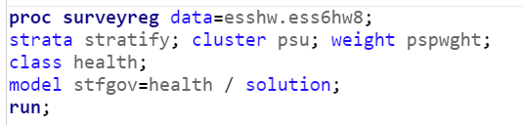

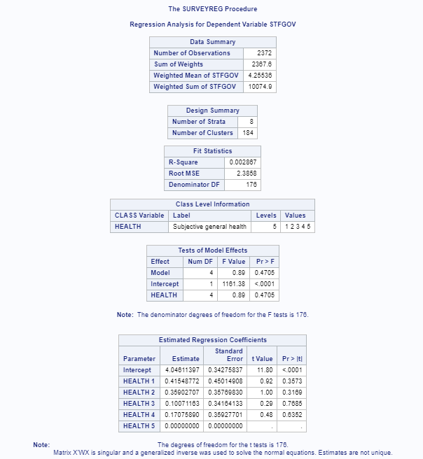

1. Satisfaction of life

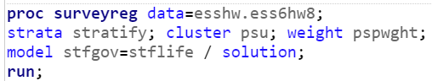

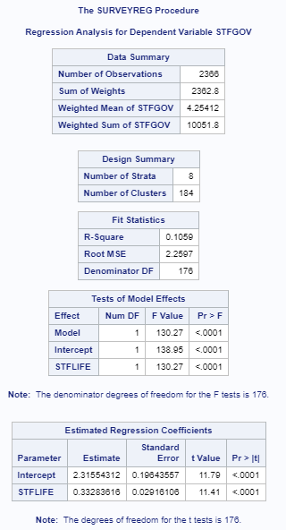

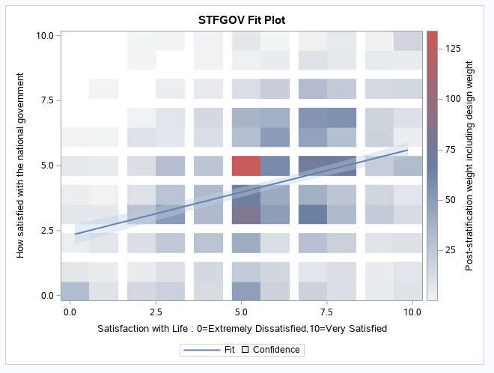

Conclusion: R-squared of above models are small and but predictor of model 1, 2, 4 are significant. This means those predictors are effective but not enough to predict dependent variable.

For R-squared: model 4 > model 2 > model 1 > model 3. This means if we fit bivariate models, satisfaction of life is the best predictor among these four predictors.

## Question 3

The multivariate model:

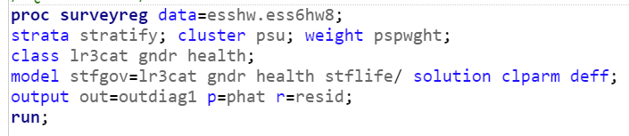

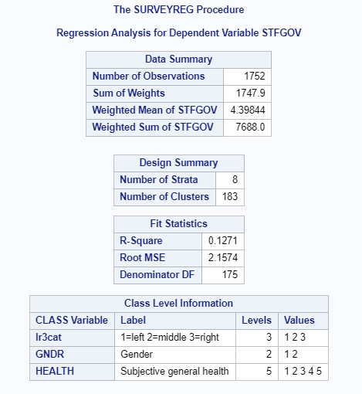

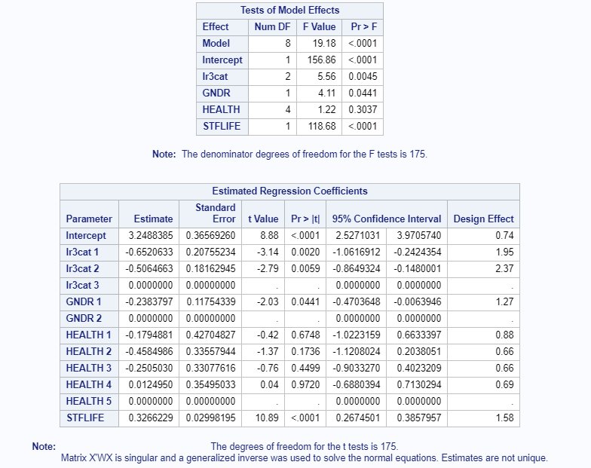

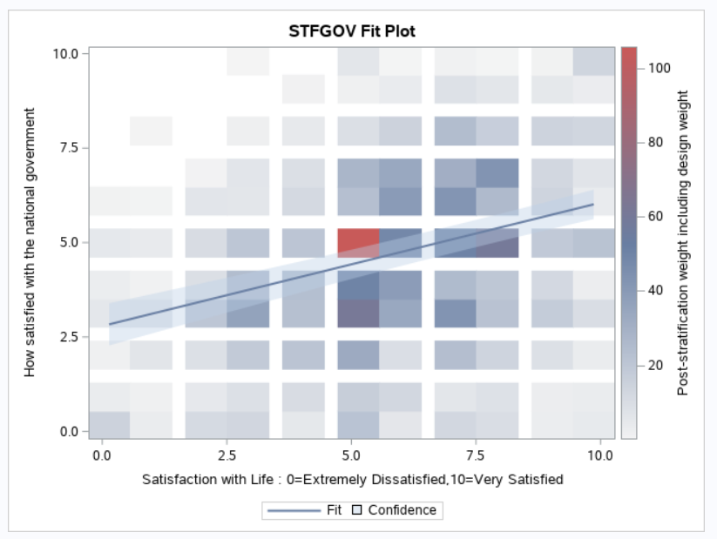

1)

According to results above, R-squared of this multivariate model is 0.1271.

R-squared is a statistical measure of how close the data are to the fitted regression line. R-square equals to 0.1271 indicates that the model explains 12.71% of the variability of the response data around its mean.

2)

The design effect for the slope associated with gender is 1.27. This means the ratio of true variance of this design in gender and the variance if data gathered using simple random sampling is 1.27.

3)

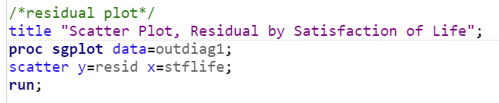

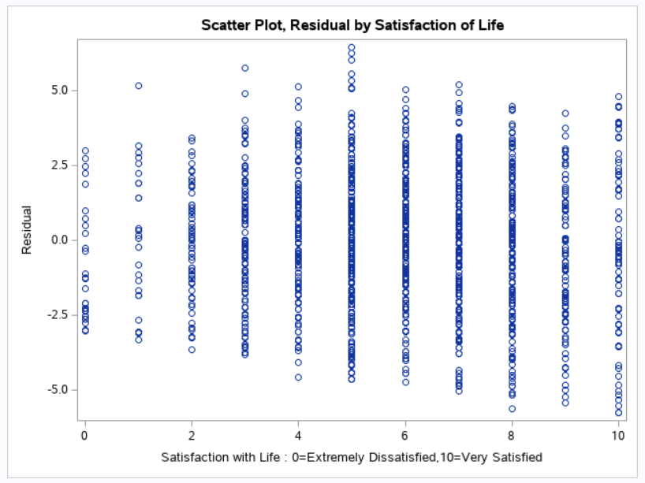

According to above plot, we can find that residuals do not random and constant across satisfaction with life. This means the model does not fit data well.

4)

Comparing to those with LR3CAT equaling to 3, those with LR3CAT equaling to 1 and 2 have less satisfaction with government. Comparing to female, male have less satisfaction with government. Among people with different self-rated health status, people with bad self-rated health status have more satisfaction with government. With satisfaction of life increases, satisfaction of government increases.