Homework 9

Xinyi Lin

11/26/2019



## Question 1



## Question 2

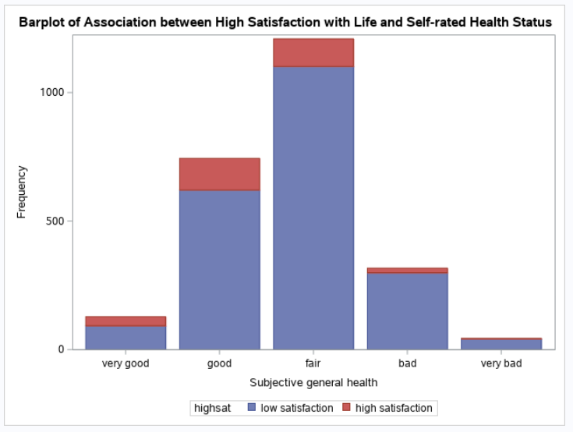

According to the bar plot, we can find that for those have self-rated health status equal to very good, good or fair, they have higher high satisfaction rate. For those with bad and very bad self-rated status, they have lower high satisfaction rate.

As the proportion of HIGHSAT in people with bad and very bad self-rated health status are similar and frequency of people with very bad self-rated health status is very low, I would recommend combining bad group and very bad group.

## Question 3

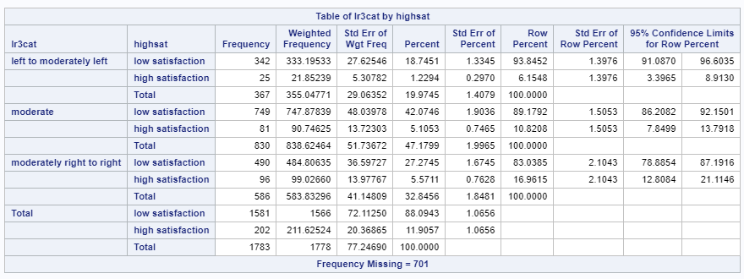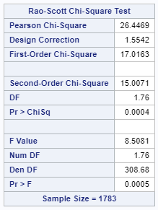

Percentages and 95% confidence intervals of high satisfaction with life for individuals in each political scale category are shown above. We can find that when political scale change from left to right, the percentage of high satisfaction increase.

Results of Rao-Scott F-statistic are shown above. We can get the test statistic equals to 8.5081 and p-value equals to 0.0005 which is smaller than 0.05. So we reject the null hypothesis and conclude that there is association between high satisfaction with life and political scale.

## Question 4

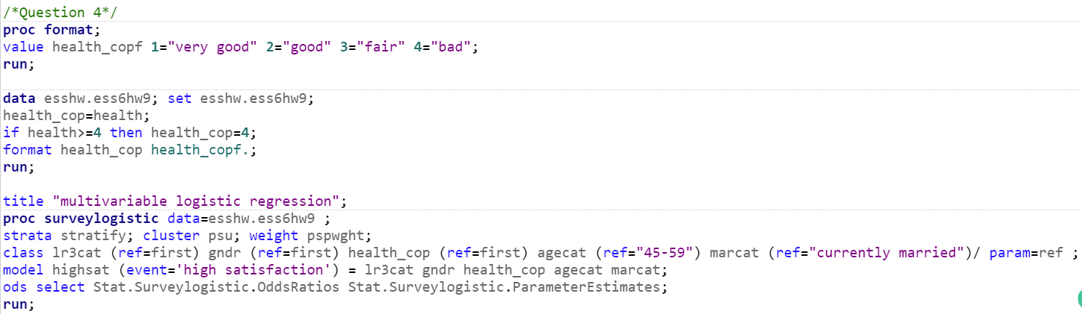

ORs, 95% Cis and p-value are shown below.

| **Effect** | **Point Estimate** | **95% Confidence Limits** | | **Pr > |t|** |
| --- | --- | --- | --- | --- |
| **lr3cat moderate vs left to moderately left** | 1.862 | 1.053 | 3.292 | 0.0326 |
| **lr3cat moderately right to right vs left to moderately left** | 3.029 | 1.775 | 5.167 | <.0001 |
| **GNDR male vs female** | 1.418 | 1.007 | 1.997 | 0.0458 |
| **health_cop fair vs bad** | 1.514 | 0.721 | 3.179 | 0.2713 |
| **health_cop good vs bad** | 3.567 | 1.504 | 8.462 | 0.0041 |
| **health_cop very good vs bad** | 3.520 | 1.150 | 10.772 | 0.0277 |
| **agecat 15-29 vs 45-59** | 1.267 | 0.716 | 2.240 | 0.4139 |
| **agecat 30-44 vs 45-59** | 1.036 | 0.608 | 1.767 | 0.8947 |
| **agecat 60+ vs 45-59** | 2.018 | 1.136 | 3.584 | 0.0169 |
| **marcat never married vs currently married** | 1.477 | 0.913 | 2.389 | 0.1110 |
| **marcat previously married vs currently married** | 1.229 | 0.807 | 1.872 | 0.3354 |

1. According to table above, we can find that people whose political scale is moderately right to right, gender is male, self-rated health status is good, age is larger than 60 and marriage status is never marriage are more likely to have high satisfaction with life.