Computing Assignment 1

Xinyi Lin

10/6/2019

## Problem 1

get_pr = function(n, s, a=0.5, b=1.5, d = delta, N=1000){  
 pe = rbeta(N, a+s, b+n-s)  
 ps = rbeta(N, 25, 75)  
 pr = sum(pe > (ps+delta))/N  
 return(pr)  
}

set.seed(123)  
delta = 0.15  
alpha = 0.05  
# stage 1  
n1 = 20  
s1 = 5  
# stage 2  
n2 = 71  
s2 = 23  
while (get_pr(n1, s1)>alpha | get_pr(n2,s2)>alpha) {  
 alpha = alpha + 0.05  
}  
alpha

## [1] 0.15

Assuming $δ=0.15$ and using $S_{20}=5,S_{71}=23$ as stopping boundary, I can get the smallest $α$ by updating $α$ until $δ,α$ mimics the two-stage adaptive design’s no-go criterion. $δ=0.15,α=0.15$ is the final restult.

## Problem 2

### Question a

a = 0.5  
b = 1.5  
delta = 0.15  
alpha = 0.15  
N=1000  
# stage 1  
n1 = 20  
s1 = 2  
set.seed(1)  
while (get_pr(n=n1, s=s1)<=alpha) {  
 s1 = s1+1  
}  
s1

## [1] 6

# s20<=5 -> no go  
# stage 2  
n2 = 40  
s2 = 6  
while (get_pr(n=n2, s=s2)<=alpha) {  
 s2 = s2+1  
}  
s2

## [1] 13

# s40<=12 -> no go  
# stage 3  
n3 = 60  
s3 = 13  
while (get_pr(n=n3, s=s3)<=alpha) {  
 s3 = s3+1  
}  
s3

## [1] 20

# s60<=19 -> no go  
# final  
n4 = 71  
s4 = 20  
while (get_pr(n=n4, s=s4)<=alpha) {  
 s4 = s4+1  
}  
s4

## [1] 24

# s71<=23 -> futility

So the stopping boundary at each interim are $s_{20}≤5,s_{40}≤12,s_{60}≤19$.

### Question b

N=1000  
stop1 = 5  
stop2 = 12  
stop3 = 19  
stop4 = 23  
stop_time = rep(NA, N)  
futile = rep(NA, N)  
pE = 0.25  
set.seed(1)  
for (i in 1:N){  
 s1 = rbinom(1,20,pE)  
 if (s1<=stop1) {  
 stop_time[i]=1  
 futile[i] = T  
 } else {  
 s2 = rbinom(1,20,pE)  
 if (s1+s2<=stop2) {  
 stop_time[i]=2  
 futile[i] = T  
 }else{  
 s3 = rbinom(1,20,pE)  
 if(s1+s2+s3<=stop3){  
 stop_time[i]=3  
 futile[i]=T  
 }else{  
 stop_time[i]=4  
 s4 = rbinom(1,11,pE)  
 if(s1+s2+s3+s4<=stop4){futile[i]=T}  
 else{futile[i]=F}}  
 }  
 }  
}  
pro_b = length(futile[futile==T])/N  
pro_b

## [1] 0.963

hist(stop_time)

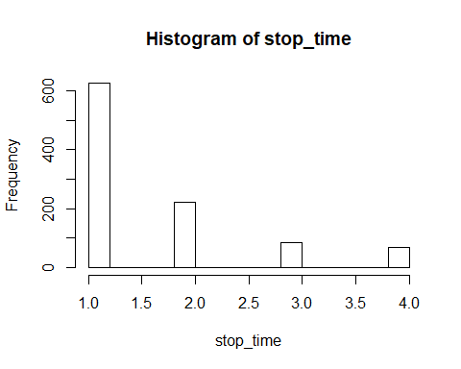

The probability of declaring futile is 0.963. The distribution is shown above.

### Question c

N=1000  
stop1 = 5  
stop2 = 12  
stop3 = 19  
stop4 = 23  
stop_time = rep(NA, N)  
futile = rep(NA, N)  
pE = 0.4  
set.seed(1)  
for (i in 1:N){  
 s1 = rbinom(1,20,pE)  
 if (s1<=stop1) {  
 stop_time[i]=1  
 futile[i] = T  
 } else {  
 s2 = rbinom(1,20,pE)  
 if (s1+s2<=stop2) {  
 stop_time[i]=2  
 futile[i] = T  
 }else{  
 s3 = rbinom(1,20,pE)  
 if(s1+s2+s3<=stop3){  
 stop_time[i]=3  
 futile[i]=T  
 }else{  
 stop_time[i]=4  
 s4 = rbinom(1,11,pE)  
 if(s1+s2+s3+s4<=stop4){futile[i]=T}  
 else{futile[i]=F}}  
 }  
 }  
}  
pro_c = length(futile[futile==T])/N  
pro_c

## [1] 0.264

hist(stop_time)

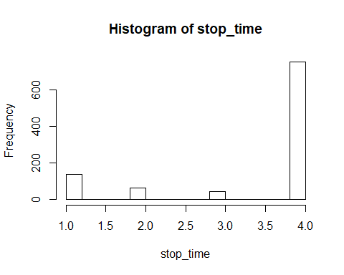

The probability of declaring futile is 0.264. The distribution is shown above.

## Problem 3

### Question a

new_pr = function(n, s, a=0.5, b=1.5){  
 pe = rbeta(1, a+s, b+n-s)  
 pr = pbinom(25, 71, pe, lower.tail = F)  
 return(pr)  
}

# stage 1  
n1 = 20  
s1 = 2  
alpha = 0.9  
set.seed(1)  
n1 = 20  
n2 = 3  
while (new_pr(n=n1, s=s1)<=alpha) {  
 s1 = s1+1  
}  
s1

## [1] 8

# s20<=7 -> no go  
# stage 2  
n2 = 40  
s2 = 6  
while (new_pr(n=n2, s=s2)<=alpha) {  
 s2 = s2+1  
}  
s2

## [1] 15

# s40<=14 -> no go  
# stage 3  
n3 = 60  
s3 = 13  
while (new_pr(n=n3, s=s3)<=alpha) {  
 s3 = s3+1  
}  
s3

## [1] 24

# s60<=23 -> no go  
# final  
n4 = 71  
s4 = 20  
while (new_pr(n=n4, s=s4)<=alpha) {  
 s4 = s4+1  
}  
s4

## [1] 26

# s71<=25 -> futility

So the stopping boundary at each interim are $s_{20}≤7,s_{40}≤14,s_{60}≤23$.

### Question b

N=1000  
stop1 = 7  
stop2 = 14  
stop3 = 23  
stop4 = 25  
stop_time = rep(NA, N)  
futile = rep(NA, N)  
pE = 0.25  
set.seed(1)  
for (i in 1:N){  
 s1 = rbinom(1,20,pE)  
 if (s1<=stop1) {  
 stop_time[i]=1  
 futile[i] = T  
 } else {  
 s2 = rbinom(1,20,pE)  
 if (s1+s2<=stop2) {  
 stop_time[i]=2  
 futile[i] = T  
 }else{  
 s3 = rbinom(1,20,pE)  
 if(s1+s2+s3<=stop3){  
 stop_time[i]=3  
 futile[i]=T  
 }else{  
 stop_time[i]=4  
 s4 = rbinom(1,11,pE)  
 if(s1+s2+s3+s4<=stop4){futile[i]=T}  
 else{futile[i]=F}}  
 }  
 }  
}  
pro_b = length(futile[futile==T])/N  
pro_b

## [1] 0.996

hist(stop_time)

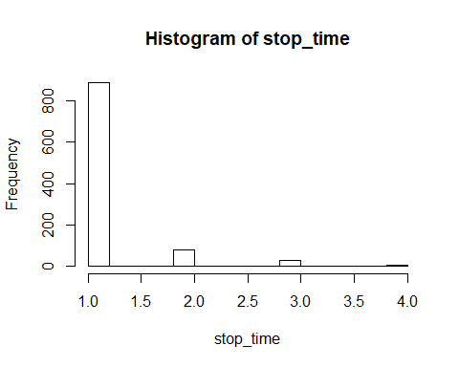

The probability of declaring futile is 0.996. The distribution is shown above.

### Question c

N=1000  
stop1 = 7  
stop2 = 14  
stop3 = 23  
stop4 = 25  
stop_time = rep(NA, N)  
futile = rep(NA, N)  
pE = 0.4  
set.seed(1)  
for (i in 1:N){  
 s1 = rbinom(1,20,pE)  
 if (s1<=stop1) {  
 stop_time[i]=1  
 futile[i] = T  
 } else {  
 s2 = rbinom(1,20,pE)  
 if (s1+s2<=stop2) {  
 stop_time[i]=2  
 futile[i] = T  
 }else{  
 s3 = rbinom(1,20,pE)  
 if(s1+s2+s3<=stop3){  
 stop_time[i]=3  
 futile[i]=T  
 }else{  
 stop_time[i]=4  
 s4 = rbinom(1,11,pE)  
 if(s1+s2+s3+s4<=stop4){futile[i]=T}  
 else{futile[i]=F}}  
 }  
 }  
}  
pro_c = length(futile[futile==T])/N  
pro_c

## [1] 0.608

hist(stop_time)

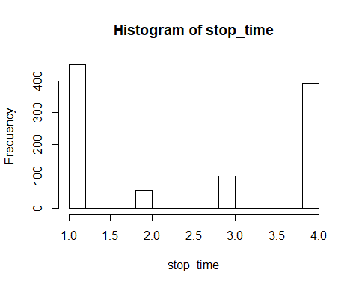

The probability of declaring futile is 0.608. The distribution is shown above.