Problem set

Xinyi Lin

9/25/2019

## Problem 1

### Question a

To calculate a sample size, we need additional information including:

1. The dependent variable is approximately normally distributed within each group.
2. The data is collected from a representative, randomly selected portion of the total population.
3. Sample sizes of two groups.

### Question b

If we assume sample size of two groups are the same and assumption 1) and 2) are valid. As In order to have 5% significance,

d = 10  
var = 20  
n = 2  
t = d/(var*sqrt(2/n))  
while (t<=qt(0.975, 2*n-2)) {  
 n = n+1  
 t = d/(var*sqrt(2/n))  
}  
n

## [1] 32

The sample size is 32.

## Problem 2

### Question a

14*pbinom(0, 14, 0.05) + 34*(1-pbinom(0, 14, 0.05))

## [1] 24.2465

The expected value of the sample size is around 24.25.

### Question b

Let be the number of responses in the first or second stages, where .

The probability of a “go” decision is

.

pbinom(2, 20, 0.05, lower.tail = FALSE)*dbinom(1, 14, 0.05) + pbinom(1, 20, 0.05, lower.tail = FALSE)*dbinom(2, 14, 0.05) + pbinom(0, 20, 0.05, lower.tail = FALSE)*dbinom(3, 14, 0.05) + pbinom(3, 14, 0.05, lower.tail = FALSE)

## [1] 0.0803739

So the probability of a “go” decision is around 0.080.

### Question c

pbinom(2, 20, 0.2, lower.tail = FALSE)*dbinom(1, 14, 0.2) + pbinom(1, 20, 0.2, lower.tail = FALSE)*dbinom(2, 14, 0.2) + pbinom(0, 20, 0.2, lower.tail = FALSE)*dbinom(3, 14, 0.2) + pbinom(3, 14, 0.2, lower.tail = FALSE)

## [1] 0.9041092

When the true response rate is 20%, the probability of a “go” decision is around 0.904.

### Question d

Let be the sample size of the fixed design, be the number of response in the trial, if there is at least response, then the treatment is deemed promising (“go”)

n = 3  
x = 1  
while(pbinom(x-1,n,0.05,lower.tail = FALSE)>0.080 | pbinom(x-1,n,0.2,lower.tail = FALSE)<0.904){  
 if(x<n-1){  
 x = x+1  
 } else {  
 x = 1  
 n = n+1}  
}  
n

## [1] 32

The sample size required for a fixed design with null response 5% and alternative response 20% is 32.

## Problem 3

### Question a

Assume, , for .

Posterior Distribution:

### Question b

### Question c

## Problem 4

Dose level 1 is safe:

1.number of DLT equals to 0 or

2.number of DLT equals to 1 and numbers of DLT equals to 0 for another 3 patients at same level.

dbinom(0,3,0.25)+dbinom(1,3,0.25)*dbinom(0,3,0.25)

## [1] 0.5998535

The probaility that the 3+3 algorithm declare dose level 1 is safe is 0.600.

## Problem 5

### Question a

Dose 1: 0.007 0.135 0.772 < 0.02 1/3 | 0.444 0.287 0.347 < 0.02 0/3

Dose 2: 0.777 0.604 0.025 < 0.04 1/3 | 0.584 0.715 0.110 < 0.04 0/3

Dose 3: 0.770 0.405 0.742 < 0.1 0/3

Dose 4: 0.923 0.591 0.567 < 0.25 0/3

Dose 5: 0.952 0.039 0.342 < 0.5 2/3

MTD = 4

### Question b

* Trial 1

Dose 1: 0.534 0.342 0.661 < 0.02 0/3

Dose 2: 0.829 0.489 0.710 < 0.04 0/3

Dose 3: 0.921 0.055 0.497 < 0.1 1/3 | 0.611 0.118 0.122 < 0.1 0/3

Dose 4: 0.472 0.853 0.931 < 0.25 0/3

Dose 5: 0.978 0.232 0.519 < 0.5 1/3 | 0.333 0.096 0.709 < 0.5 2/3

MTD = 4

* Trial 2

Dose 1: 0.985 0.844 0.948 < 0.02 0/3

Dose 2: 0.361 0.061 0.541 < 0.04 0/3

Dose 3: 0.815 0.153 0.177 < 0.1 0/3

Dose 4: 0.495 0.735 0.872 < 0.25 0/3

Dose 5: 0.799 0.028 0.555 < 0.5 1/3 | 0.763 0.752 0.682 < 0.5 0/3

MTD = 5

* Trial 3

Dose 1: 0.228 0.586 0.732 < 0.01 0/3

Dose 2: 0.014 0.753 0.412 < 0.04 1/3 | 0.765 0.176 0.919 < 0.04 0/3

Dose 3: 0.207 0.874 0.178 < 0.1 0/3

Dose 4: 0.820 0.783 0.231 < 0.25 1/3 | 0.541 0.925 0.207 < 0.25 1/3

MTD = 3

* Trial 4

Dose 1: 0.408 0.808 0.434 < 0.02 0/3

Does 2: 0.008 0.382 0.166 < 0.04 1/3 | 0.328 0.294 0.635 < 0.04 0/3

Dose 3: 0.672 0.669 0.460 < 0.1 0/3

Dose 4: 0.174 0.374 0.381 < 0.25 1/3 | 0.600 0.397 0.091 < 0.25 1/3

MTD = 3

* Trial 5

Dose 1: 0.922 0.872 0.754 < 0.02 0/3

Dose 2: 0.520 0.977 0.748 <0.04 0/3

Dose 3: 0.955 0.978 0.531 < 0.1 0/3

Dose 4: 0.196 0.963 0.356 <0.25 1/3 | 0.061 0.795 0.823 < 0.25 1/3

MTD = 3

* Trial 6

Dose 1: 0.731 0.284 0.929 <0.02 0/3

Dose 2: 0.687 0.858 0.439 <0.04 0/3

Dose 3: 0.944 0.676 0.189 < 0.1 0/3

Dose 4: 0.755 0.421 0.357 <0.25 0/3

Dose 5: 0.391 0.370 0.028 <0.5 3/3

MTD = 4

* Trial 7

Dose 1: 0.866 0.069 0.818 < 0.02 0/3

Dose 2: 0.888 0.381 0.989 < 0.04 0/3

Dose 3: 0.663 0.491 0.285 < 0.1 0/3

Dose 4: 0.000 0.652 0.341 < 0.25 1/3 | 0.316 0.599 0.977 < 0.25 0/3

Dose 5: 0.332 0.985 0.976 < 0.5 1/3 | 0.695 0.730 0.580 < 0.5 0/3

MTD = 5

* Trial 8

Dose 1: 0.562 0.674 0.435 < 0.02 0/3

Dose 2: 0.747 0.521 0.024 < 0.04 1/3 | 0.412 0.719 0.819 <0.04 0/3

Dose 3: 0.139 0.278 0.270 < 0.1 0/3

Dose 4: 0.877 0.431 0.867 < 0.25 0/3

Dose 5: 0.723 0.919 0.244 <0.5 1/3 | 0.362 0.442 0.196 <0.5 3/3

MTD = 4

* Trial 9

Dose 1: 0.409 0.752 0.351 <0.02 0/3

Dose 2: 0.979 0.189 0.523 <0.04 0/3

Dose 3: 0.332 0.690 0.061 <0.1 1/3 | 0.552 0.253 0.450 <0.1 0/3

Dose 4: 0.403 0.592 0.381 <0.25 0/3

Dose 5:

0.673 0.182 0.862 <0.5 1/3 | 0.223 0.090 0.729 <0.5 2/3

MTD = 4

* Trial 10

Dose 1 0.091 0.315 0.763 <0.02 0/3

Dose 2 0.373 0.174 0.927 < 0.04 0/3

Dose 3 0.264 0.799 0.653 <0.1 0/3

Dose 4 0.569 0.109 0.706 <0.25 1/3 | 0.858 0.357 0.950 <0.25 0/3

Dose 5 0.801 0.123 0.019 <0.5 2/3

MTD = 4

data.frame(Dose = 0:5, probability = c(0,0,0,3,5,2)/10)

## Dose probability  
## 1 0 0.0  
## 2 1 0.0  
## 3 2 0.0  
## 4 3 0.3  
## 5 4 0.5  
## 6 5 0.2

## Problem 6

library(dfcrm)  
target = 0.1  
prior = c(0.05, 0.12, 0.25, 0.40, 0.55)  
trueP = c(0.02, 0.04, 0.10, 0.25, 0.50)  
N = 20  
crmoutput = crmsim(trueP, prior, target, N, 3, model = "logistic")  
crmoutput$MTD

## [1] 2

## Problem 7

crmoutput = crmsim(trueP, prior, target, N, 3, nsim = 10, model = "logistic")

## simulation number: 1   
## simulation number: 2   
## simulation number: 3   
## simulation number: 4   
## simulation number: 5   
## simulation number: 6   
## simulation number: 7   
## simulation number: 8   
## simulation number: 9   
## simulation number: 10

data.frame(dose = 1：5, probability = crmoutput$MTD)

## dose probability  
## 1 1 0.0  
## 2 2 0.1  
## 3 3 0.6  
## 4 4 0.3  
## 5 5 0.0

## Problem 8

Assume ,

where

Given , we can simulate 1000 and and calculate .

## Problem 9

### Question a



Problem 9 Question a.

### Question b

According to Question a, where

As and are independent

## Problem 10

### Question a

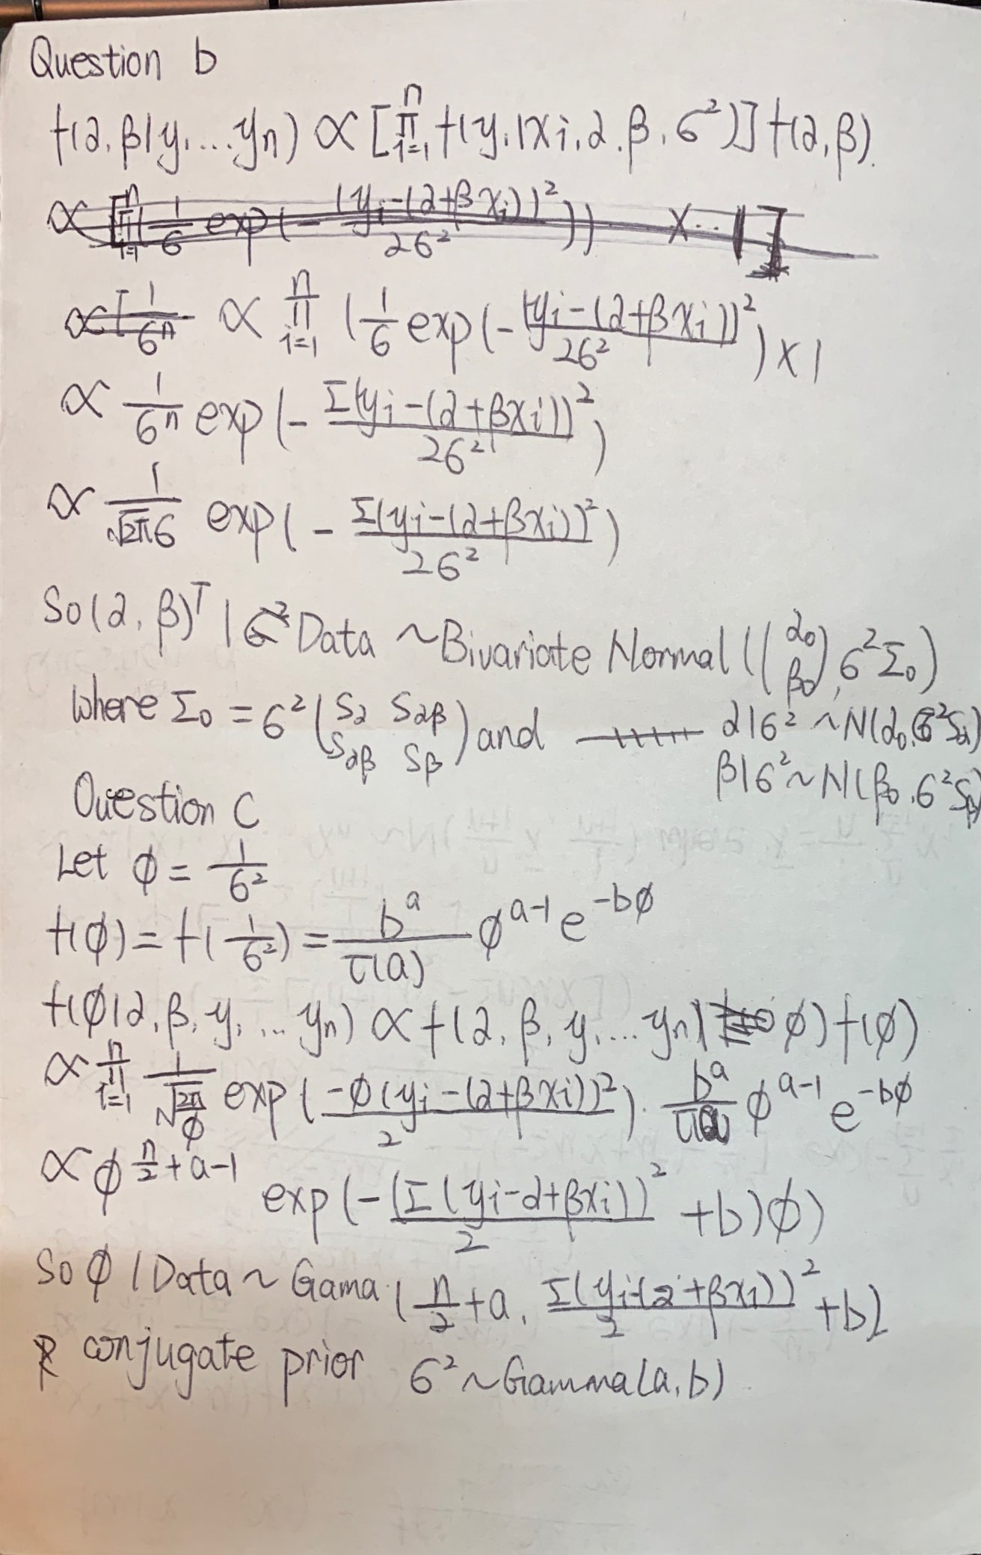

Problem 10 Question b&c.

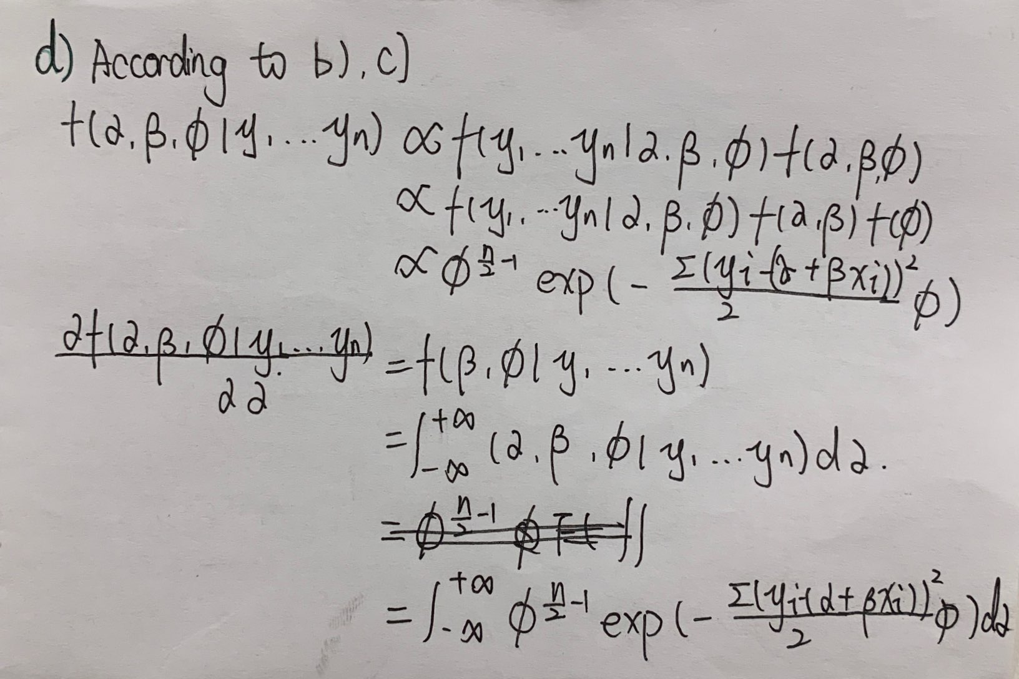

Problem 10 Question d.

## Problem 11

### Question a

assign_Trt = function(pA = 0.2, pB = 0.8) {  
 Treatment = rep(NA,4)  
 Treatment[1] = rbinom(1,1,0.5) # 0 for A, 1 for B  
 for (i in 2:4) {  
 if(Treatment[i-1]==0)  
 rep = rbinom(1,1,pA)  
 else  
 rep = rbinom(1,1,pB)  
 if(rep==1)  
 Treatment[i] = Treatment[i-1]  
 else  
 Treatment[i] = 1-Treatment[i-1]  
 }  
 return(Treatment)  
}

N = 10000  
B_distr = rep(NA,N)  
for (i in 1:N) {  
 B_distr[i] = sum(assign_Trt())  
}  
hist(B_distr)

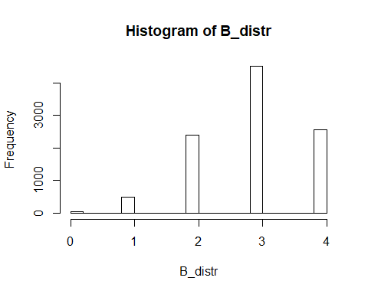

data.frame(Times = c(0,1,2,3,4), Freq = c(length(B_distr[B_distr==0])/N, length(B_distr[B_distr==1])/N, length(B_distr[B_distr==2])/N, length(B_distr[B_distr==3])/N, length(B_distr[B_distr==4])/N))

## Times Freq  
## 1 0 0.0037  
## 2 1 0.0486  
## 3 2 0.2404  
## 4 3 0.4513  
## 5 4 0.2560

Compared to a balanced design, the probability of more patients being assigned to treatment B is higher.

### Question b

N = 10000  
B_distr = rep(NA,N)  
for (i in 1:N) {  
 B_distr[i] = sum(assign_Trt(pA=0.3, pB=0.3))  
}  
hist(B_distr)

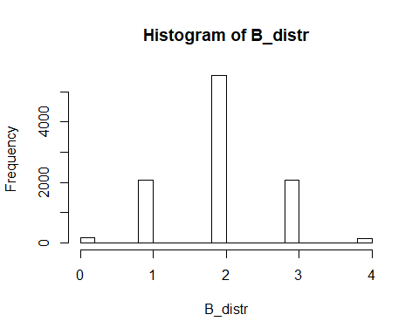

data.frame(Times = c(0,1,2,3,4), Freq = c(length(B_distr[B_distr==0])/N, length(B_distr[B_distr==1])/N, length(B_distr[B_distr==2])/N, length(B_distr[B_distr==3])/N, length(B_distr[B_distr==4])/N))

## Times Freq  
## 1 0 0.0161  
## 2 1 0.2064  
## 3 2 0.5543  
## 4 3 0.2089  
## 5 4 0.0143

Compared to a balanced design, the probabilities of 0, 1, 3 or 4 patients being assigned to treatment B are higher.

## Problem 12

### Question a

assign_Trt2 = function(pA = 0.2, pB = 0.8) {  
 Treatment = rep(NA,4)  
 nA = 1 # numbers of A ball  
 nB = 1   
 for (i in 1:4) {  
 Treatment[i] = rbinom(1,1,nB/(nA+nB)) # 0 for A, 1 for B  
 if(Treatment[i]==0){  
 rep = rbinom(1,1,pA)  
 if(rep==1)  
 nA = nA+1  
 else  
 nB = nB+1  
 }  
 else{  
 rep = rbinom(1,1,pB)  
 if(rep==1)  
 nB = nB+1  
 else  
 nA = nA+1  
 }  
 }  
 return(Treatment)  
}

N = 10000  
B_distr = rep(NA,N)  
for (i in 1:N) {  
 B_distr[i] = sum(assign_Trt2())  
}  
hist(B_distr)

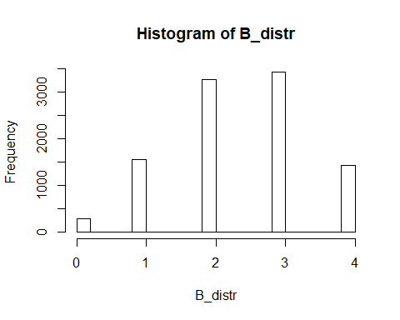

data.frame(Times = c(0,1,2,3,4), Freq = c(length(B_distr[B_distr==0])/N, length(B_distr[B_distr==1])/N, length(B_distr[B_distr==2])/N, length(B_distr[B_distr==3])/N, length(B_distr[B_distr==4])/N))

## Times Freq  
## 1 0 0.0290  
## 2 1 0.1557  
## 3 2 0.3283  
## 4 3 0.3438  
## 5 4 0.1432

Compared to a balanced design, the probability of more patients being assigned to treatment B is higher.

### Question b

N = 10000  
B_distr = rep(NA,N)  
for (i in 1:N) {  
 B_distr[i] = sum(assign_Trt2(pA=0.3, pB=0.3))  
}  
hist(B_distr)

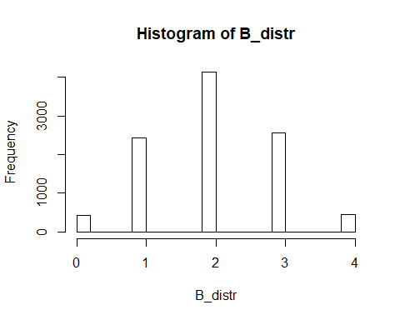

data.frame(Times = c(0,1,2,3,4), Freq = c(length(B_distr[B_distr==0])/N, length(B_distr[B_distr==1])/N, length(B_distr[B_distr==2])/N, length(B_distr[B_distr==3])/N, length(B_distr[B_distr==4])/N))

## Times Freq  
## 1 0 0.0439  
## 2 1 0.2428  
## 3 2 0.4134  
## 4 3 0.2553  
## 5 4 0.0446

Compared to a balanced design, the probabilities of 0, 1, 3 or 4 patients being assigned to treatment B are higher.

## Problem 13

### Question a

The type I error rate of the test is 0.05

### Question b

### Question c

According to the equation of power, we can know that the smaller , the bigger the power. So