## Automated ELK Stack Deployment

The files in this repository were used to configure the network depicted below.

![TODO: Update the path with the name of your diagram](Images/diagram_filename.png)

These files have been tested and used to generate a live ELK deployment on Azure. They can be used to either recreate the entire deployment pictured above. Alternatively, select portions of the _CONFIGURATION____ file may be used to install only certain pieces of it, such as Filebeat.

- _TODO: Enter the playbook file._

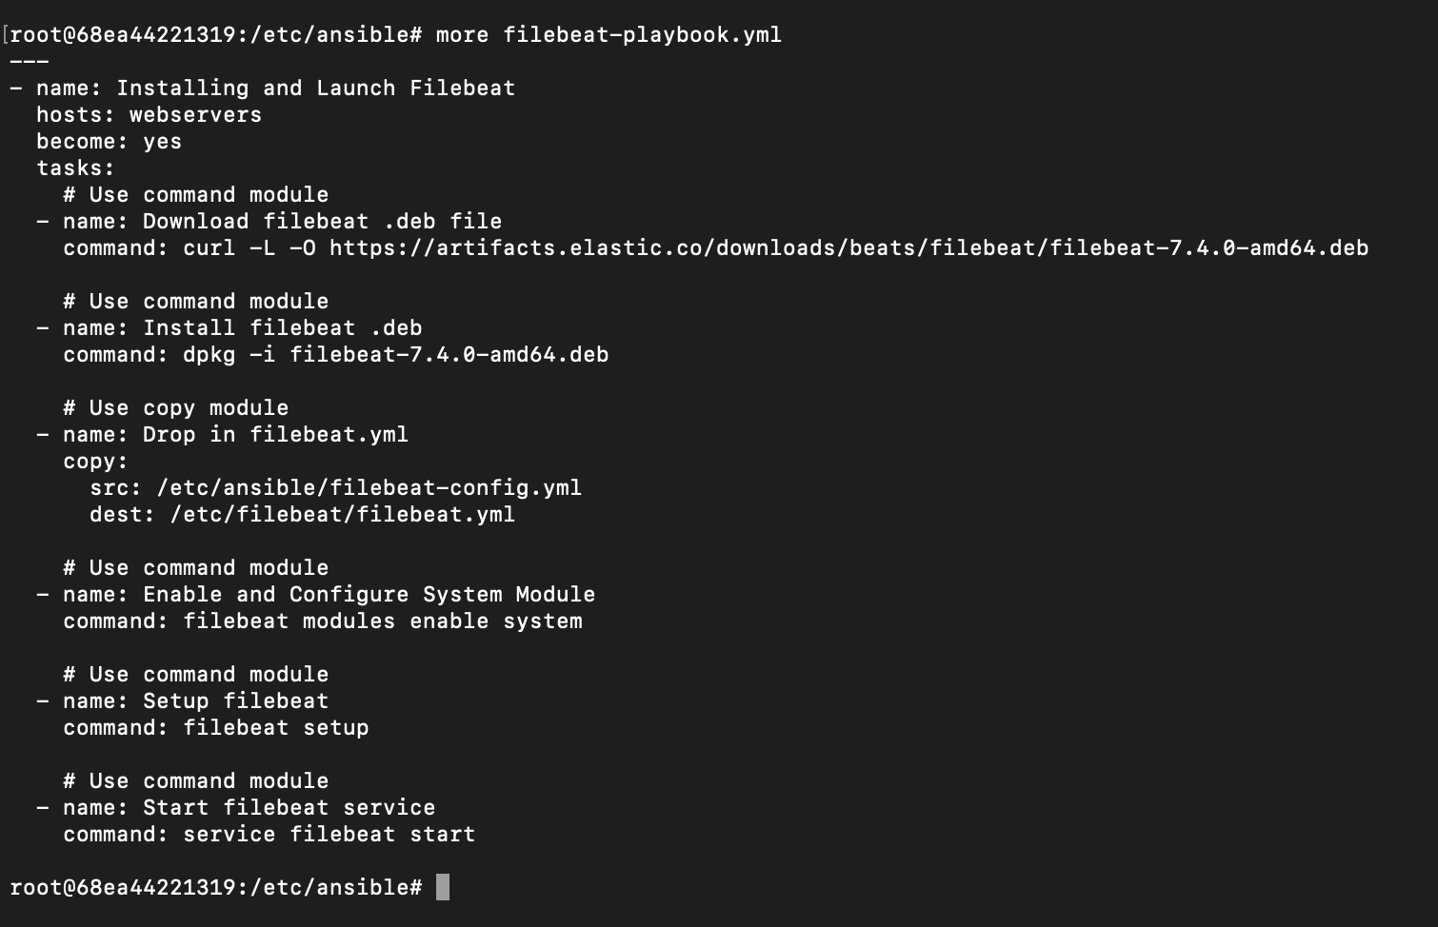

This document contains the following details:

- Description of the Topologu

- Access Policies

- ELK Configuration

- Beats in Use

- Machines Being Monitored

- How to Use the Ansible Build

### Description of the Topology

The main purpose of this network is to expose a load-balanced and monitored instance of DVWA, the D*mn Vulnerable Web Application.

Load balancing ensures that the application will be highly __AVAILABLE___, in addition to restricting __ACCESS___ to the network.

- _TODO: What aspect of security do load balancers protect? What is the advantage of a jump box?_

Integrating an ELK server allows users to easily monitor the vulnerable VMs for changes to the __LOG DATA + FILES___ and system _METRIC____.

- _TODO: What does Filebeat watch for?_(13.1 Student Guide) “collects data about the file system”

- _TODO: What does Metricbeat record?_(13.1 Student Guide) “collects machine metrics, such as uptime

The configuration details of each machine may be found below.

_Note: Use the [Markdown Table Generator](http://www.tablesgenerator.com/markdown_tables) to add/remove values from the table_.

| Name | Function | IP Address | Operating System |

|----------|----------|------------|------------------|

| Jump Box | Gateway | 10.0.0.6 | Linux |

| TODO | WEB | 10.0.0.7 | LINUX |

| TODO | WEB | 10.0.0.8 | LINUX |

| TODO | MONITOR | 10.1.0.4 | LINUX |

### Access Policies

The machines on the internal network are not exposed to the public Internet.

Only the __JUMP BOX___ machine can accept connections from the Internet. Access to this machine is only allowed from the following IP addresses:

- _TODO: Add whitelisted IP addresses_ 110.175.42.235

Machines within the network can only be accessed by __OTHER VMS___.

- _TODO: Which machine did you allow to access your ELK VM? What was its IP address?_

A summary of the access policies in place can be found in the table below.

| Name | Publicly Accessible | Allowed IP Addresses |

|----------|---------------------|----------------------|

| Jump Box | Yes/No | |

| VM-3 | NO | |

| VM-4 | NO | |

| VM-5. | NO | |

| LOAD BAL.| YES | |

ALLOWED IP ADDRESSES:

JUMP BOX: 10.0.0.7, 10.0.0.8, 10.1.0.4, 13.75.168.142

VM-3: 10.0.0.6, 10.0.0.8, 10.1.0.4, 13.75.168.142

VM-4: 10.0.0.6, 10.0.0.7, 10.1.0.4, 13.75.168.142

VM-5: 10.0.0.6, 10.0.0.7, 13.75.168.142

LOAD BALANCER: 10.0.0.6, 10.0.0.7, 10.0.0.8, 10.1.0.4

### Elk Configuration

Ansible was used to automate configuration of the ELK machine. No configuration was performed manually, which is advantageous because...

- _TODO: What is the main advantage of automating configuration with Ansible?_Every machine will be configured within minutes, avoiding human error and any issues can be reverted via IaC

The playbook implements the following tasks:

- _TODO: In 3-5 bullets, explain the steps of the ELK installation play. E.g., install Docker; download image; etc._

- Create new vNet (same resource group + new region)

- Create new VM (SSH key from Ansible, place new VM in Hosts file)

- Download contatiner (sebp/elk:761)

- NSG: Incoming rule for new VM port

The following screenshot displays the result of running `docker ps` after successfully configuring the ELK instance.

![TODO: Update the path with the name of your screenshot of docker ps output](Images/docker_ps_output.png)

### Target Machines & Beats

This ELK server is configured to monitor the following machines:

- _TODO: List the IP addresses of the machines you are monitoring_

10.0.0.7, 10.0.0.8

We have installed the following Beats on these machines:

- _TODO: Specify which Beats you successfully installed_

FILEBEAT AND METRICBEAT

These Beats allow us to collect the following information from each machine:

- _TODO: In 1-2 sentences, explain what kind of data each beat collects, and provide 1 example of what you expect to see. E.g., `Winlogbeat` collects Windows logs, which we use to track user logon events, etc._

FILEBEAT: DETECTS CHANGES IN FILES, FOR EXAMPLE LOGS

METRICBEAT: DETECS CHANGES IN SYSTEM METRICS, FOR EXAMPLE CPU PERFORMANCE

### Using the Playbook

In order to use the playbook, you will need to have an Ansible control node already configured. Assuming you have such a control node provisioned:

SSH into the control node and follow the steps below:

- Copy the _CONFIGURATION____ file to _ANSIBLE CONTAINER____.

- Update the __YAML___ file to include...

- Run the playbook, and navigate to __server GUI__ to check that the installation worked as expected.

_TODO: Answer the following questions to fill in the blanks:_

- _Which file is the playbook? Where do you copy it?_YAML, /etc/ansible

- _Which file do you update to make Ansible run the playbook on a specific machine? How do I specify which machine to install the ELK server on versus which to install Filebeat on?_Hosts file on Ansible  
[ELK]

10.0.0.7 (example)

- _Which URL do you navigate to in order to check that the ELK server is running? http://[your.VM.IP.Address]:5601/app/kibana

_As a **Bonus**, provide the specific commands the user will need to run to download the playbook, update the files, etc._