Item-based Collaborative Filtering Recommendation System

**Implementation Tutorial**

**(Part 2)**

**5. Item-based CF Prediction (lab_item_based_cf.ipynb)**

a. Loading the datasets

**Change your data path here**

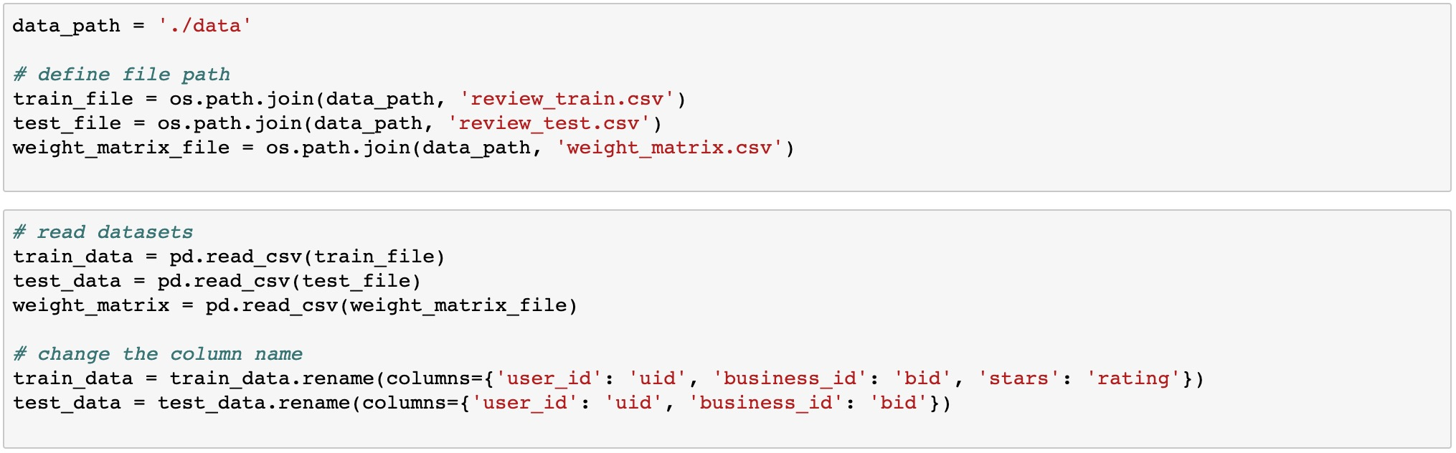

**Load the pre-generated weight matrix**

b. Generating some dictionaries to facilitate the computation

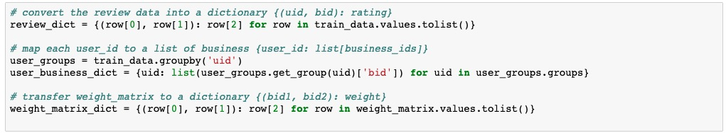

c. [Write your code] Implementing the function to find N most correlated business

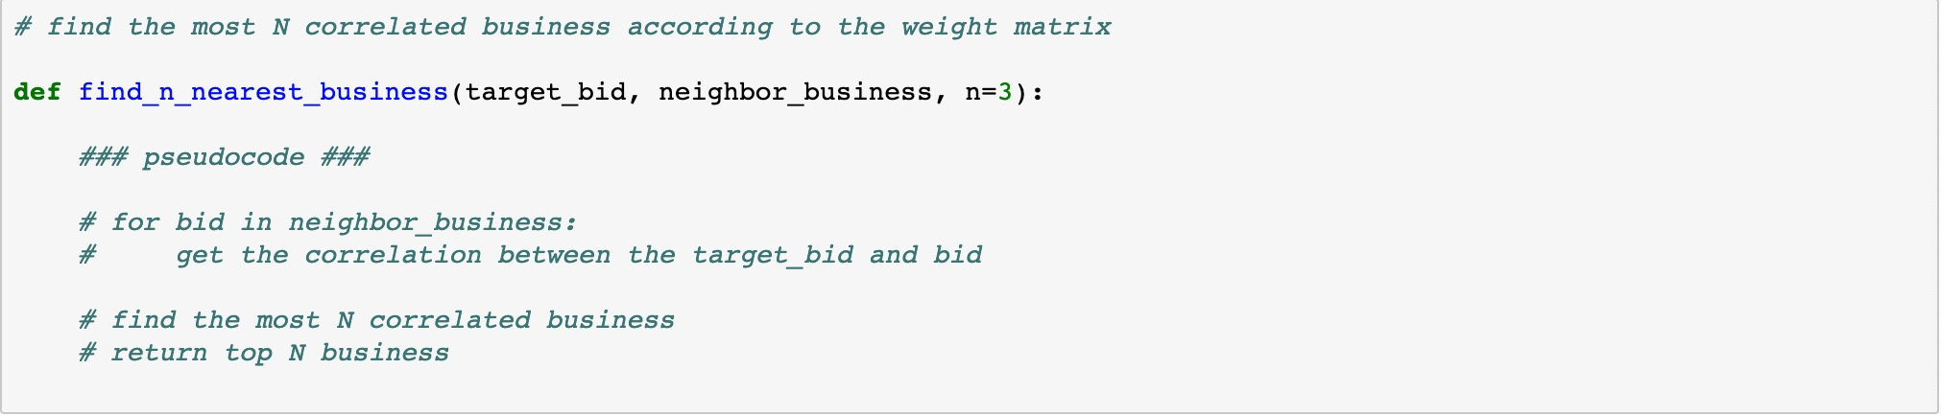

d. [Write your code] Implementing the function to compute weighted average

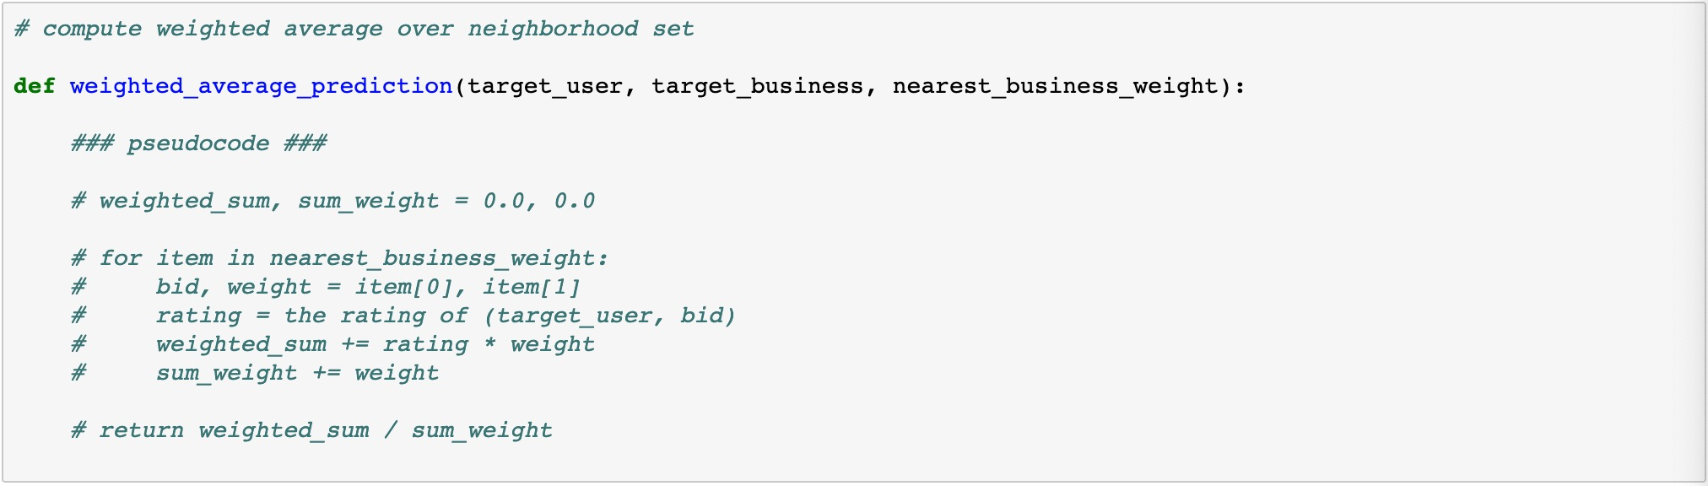

e. [Write your code] Making prediction for each given (user, business) pair in the testing data

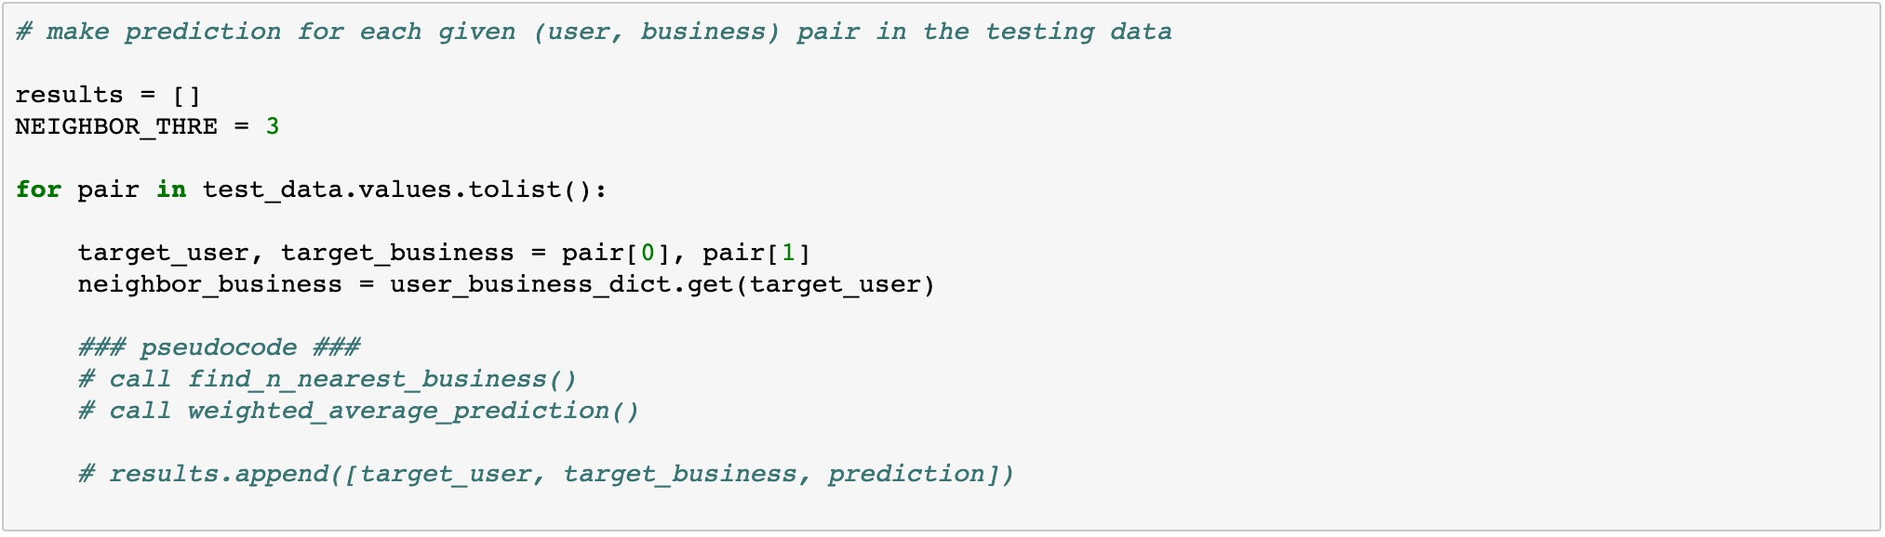

f. Finalize the results and write to a CSV file

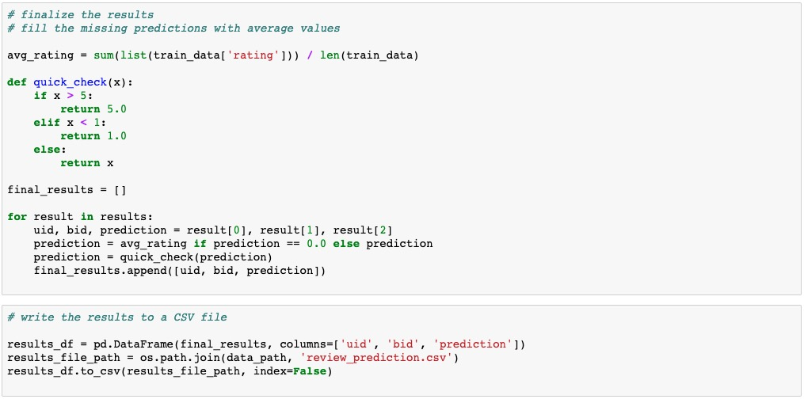

**You can refine this part yourself!**

g. [Write your code] Evaluate your recommendation system

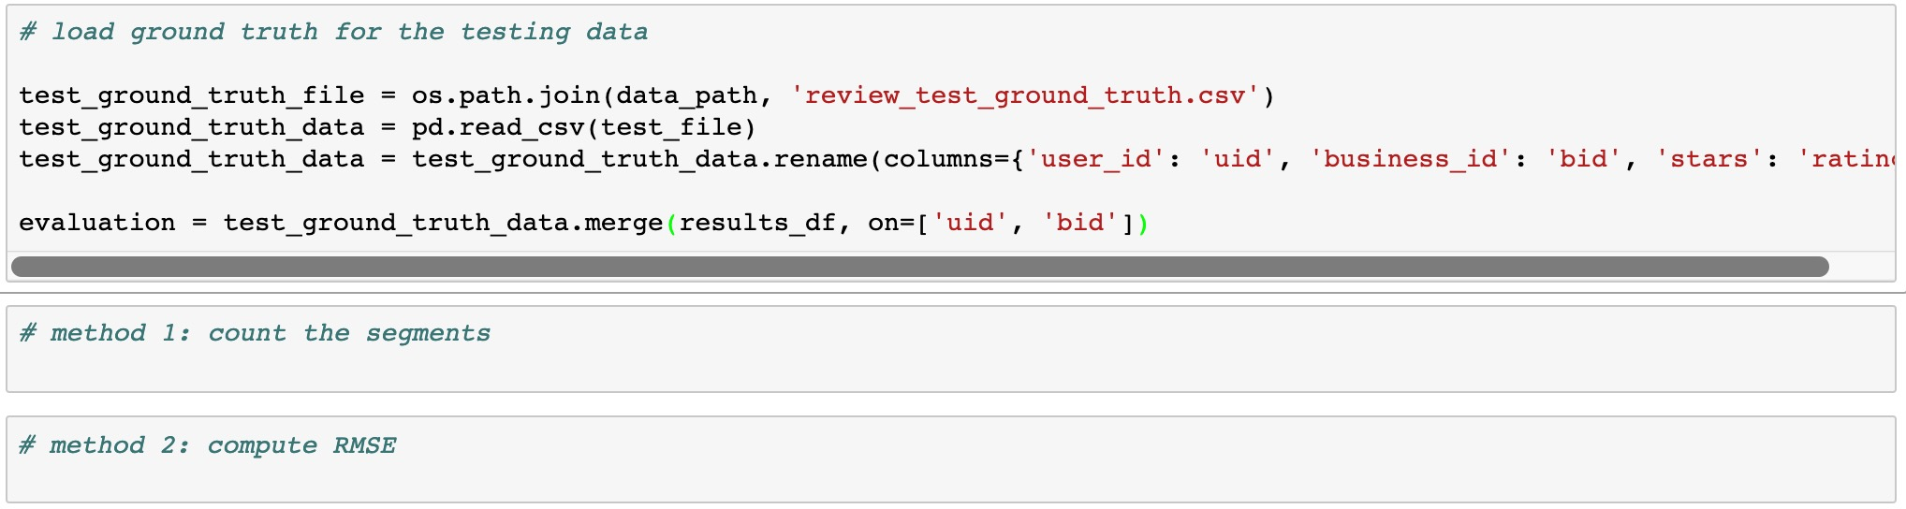

Evaluation method 1: count the segments

You can compare your prediction results to the corresponding ground truth and compute the absolute differences. You can divide the absolute differences into 5 levels and count the number for each level as following:

>=0 and <1: 12345

>=1 and <2: 123

>=2 and <3: 1234

>=3 and <4: 1234

>=4: 12

This means that there are 12345 predictions with < 1 difference from the ground truth. This way you will be able to know the error distribution of your predictions and to improve the performance of your recommendation systems.

Evaluation method 2: compute RMSE

You can compute the RMSE (Root Mean Squared Error) by using following formula:

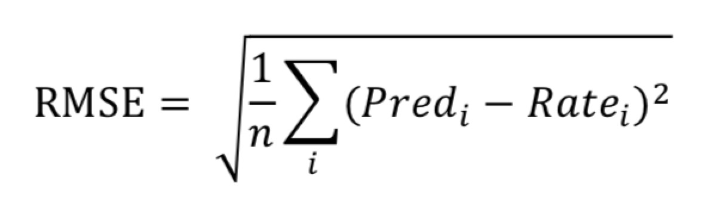

Where ${Pred}_{i}$ is the prediction for business $i$ and ${Rate}_{i}$ is the true rating for business $i$. n is the total number of the business you predict.