姓名：林佑恩 班級：四子三丙  
學號：1103105336老師：陳昭和老師

結果：

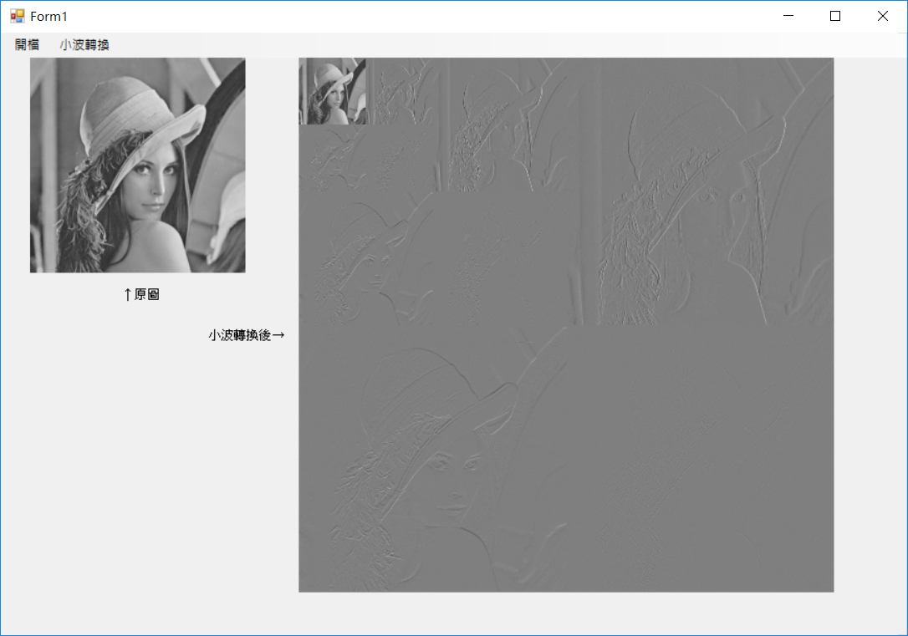

主要程式碼：

using System;

using System.Collections.Generic;

using System.ComponentModel;

using System.Data;

using System.Drawing;

using System.Drawing.Imaging;

using System.Linq;

using System.Text;

using System.Threading.Tasks;

using System.Windows.Forms;

namespace _20170517_work04_WaveletTransform

{

public partial class Form1 : Form

{

public Form1()

{

InitializeComponent();

}

Bitmap ori_image;

BitmapData ori_data;

Rectangle imageRect;

byte[] ori_Values;

int ori_bytes;

Bitmap wt_image;

BitmapData wt_data;

int wt_bytes;

bool check_input = false;

private void 開檔ToolStripMenuItem_Click(object sender, EventArgs e)

{

OpenFileDialog ofd = new OpenFileDialog();

ofd.Filter = "Image Files(*.BMP;*.JPG;*.GIF;*.PNG)|*.BMP;*.JPG;*.GIF;*.PNG";

if (ofd.ShowDialog() == DialogResult.OK)

{

pictureBox1.Image = Image.FromFile(ofd.FileName);

}

ori_image = pictureBox1.Image as Bitmap;

if (ori_image != null)

{

imageRect = new Rectangle(0, 0, ori_image.Width, ori_image.Height);

ori_data = ori_image.LockBits(imageRect, ImageLockMode.ReadWrite, ori_image.PixelFormat);

ori_bytes = ori_data.Stride * ori_image.Height;

ori_Values = new byte[ori_bytes];

System.IntPtr ori_Ptr = ori_data.Scan0;

System.Runtime.InteropServices.Marshal.Copy(ori_Ptr, ori_Values, 0, ori_bytes);//複製RGB信息到byte數組

GrayLevel(ori_image.Height, ori_image.Width, ori_data.Stride, ori_Values);

System.Runtime.InteropServices.Marshal.Copy(ori_Values, 0, ori_Ptr, ori_bytes); //複製byte陣列到RGB

ori_image.UnlockBits(ori_data);

check_input = true;

label1.Visible = true;

}

}

private void 小波轉換ToolStripMenuItem_Click(object sender, EventArgs e)

{

if (!check_input) return;

wt_image = new Bitmap(imageRect.Width, imageRect.Height);

wt_data = wt_image.LockBits(imageRect, ImageLockMode.ReadWrite, ori_image.PixelFormat);

wt_bytes = wt_data.Stride * wt_image.Height;

var tmp1_Values = new byte[wt_bytes];

var tmp2_Values = new byte[wt_bytes];

System.IntPtr wt_Ptr = wt_data.Scan0;

System.Array.Copy(ori_Values, 0, tmp1_Values, 0, ori_bytes); //把ori_Values陣列的數值複製到tmp1_Values陣列

int h = ori_image.Height;

int w = ori_image.Width;

WaveletTransform(h, w, 0, ori_data.Stride, tmp1_Values, tmp2_Values); //1-pass

WaveletTransform(h, w, 1, ori_data.Stride, tmp2_Values, tmp1_Values); //2-pass

WaveletTransform(h, w, 2, ori_data.Stride, tmp1_Values, tmp2_Values); //3-pass

System.Runtime.InteropServices.Marshal.Copy(tmp2_Values, 0, wt_Ptr, wt_bytes); //複製byte陣列到RGB

wt_image.UnlockBits(wt_data);

pictureBox2.Image = wt_image;

pictureBox2.Height = wt_image.Height;

pictureBox2.Width = wt_image.Width;

label2.Visible = true;

}

public void GrayLevel(int h, int w, int stride, byte[] ori_bmp)

{

for (int i = 0; i < h; i++) //轉成gray level

{

for (int j = 0; j < w; j++)

{

int p_Index = i * stride + j * 3;

byte pixel = Convert.ToByte((ori_bmp[p_Index + 0] + ori_bmp[p_Index + 1] + ori_bmp[p_Index + 2]) / 3);

ori_bmp[p_Index + 0] = pixel; //R

ori_bmp[p_Index + 1] = pixel; //G

ori_bmp[p_Index + 2] = pixel; //B

}

}

}

public void WaveletTransform(int h, int w,int c, int stride, byte[] bmp1,byte[] bmp2)

{

float value;

int a;

bool check = false;

byte[] tmp = new byte[ori_bytes];

var count = Math.Pow(2,c);

for (int i = 0; i < h; i++)

{

a = 0;

check = false;

for (int j = 0; j < w; j++)

{

if (j == (w / 2) / count)

{

a = 0;

check = true;

}

if (i < (h / count) && j < (w / count))

{

if (check == false)

value = (float)((bmp1[i * stride + a * 3] + bmp1[i * stride + (a + 1) * 3]) / 2);

else

value = (float)((bmp1[i * stride + a * 3] - bmp1[i * stride + (a + 1) * 3]) / 2) + 127;

if (value < 0) value = value - 0.5f;

else value = value + 0.5f;

tmp[i * stride + j * 3] = (byte)value;

tmp[i * stride + j * 3 + 1] = (byte)value;

tmp[i * stride + j * 3 + 2] = (byte)value;

a += 2;

}

else

{

tmp[i * stride + j * 3] = bmp1[i * stride + j * 3];

tmp[i * stride + j * 3 + 1] = bmp1[i * stride + j * 3 + 1];

tmp[i * stride + j * 3 + 2] = bmp1[i * stride + j * 3 + 2];

}

}

}

for (int i = 0; i < w; i++)

{

a = 0;

check = false;

for (int j = 0; j < h; j++)

{

if (j == (h / 2) / count)

{

a = 0;

check = true;

}

if (i < (h / count) && j < (w / count))

{

if (check == false)

value = (float)((tmp[a * stride + i * 3] + tmp[(a + 1) * stride + i * 3]) / 2);

else

value = (float)((tmp[a * stride + i * 3] - tmp[(a + 1) * stride + i * 3]) / 2) + 127;

if (value < 0) value = value - 0.5f;

else value = value + 0.5f;

bmp2[j * stride + i * 3] = (byte)value;

bmp2[j * stride + i * 3 + 1] = (byte)value;

bmp2[j * stride + i * 3 + 2] = (byte)value;

a += 2;

}

else

{

bmp2[j * stride + i * 3] = tmp[j * stride + i * 3];

bmp2[j * stride + i * 3 + 1] = tmp[j * stride + i * 3 + 1];

bmp2[j * stride + i * 3 + 2] = tmp[j * stride + i * 3 + 2];

}

}

}

}

}

}