**8102 Lab 2** Yue Lin

**Assignment Ⅰ**

The box map and box plot for variable *AL99PC* are shown in Figure 1, where negative outliers in the box map are highlighted. According to Figure 1, there is a higher percent of Alianza Votes over Valid Votes in the center Argentina; compared to that in the eastern and southern Argentina, the percent of Alianza Votes over Valid Votes is observed to be higher in the north-west. The negative outliers are more clustered in the east.

Figure 1. Box map and box plot for variable AL99PC.

The box map and box plot for variable *TURN99PC* are shown in Figure 2, where negative outliers in the box map are highlighted. According to Figure 2, there is a higher Percent of Effective Votes over Valid Votes in the western Argentina, which gradually decreases as it goes to the east. Negative outliers are mostly located in the east.

Figure 2. Box map and box plot for variable TURN99PC.

**Assignment Ⅱ**

The box plot for variable *INC* is shown in Figure 3, where the highest *INC* value is highlighted. The selected value seems to still fall into the 1. 5 times interquartile range (IQR), so it is not an outlier.

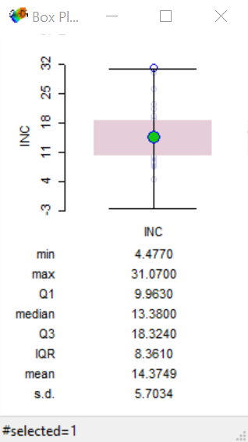

Figure 3. Box plot for variable INC.

As is shown in the scatterplot, the observation with the highest *INC* value is not a potential outlier, because it falls approximately on the best-fitting line in the plot.

The quantile plot for variable *INC* is shown in Figure 4, where the highest *INC* value is highlighted. The observation with the highest *INC* value seems not to be an outlier here because its value is not distinctively different compared to its neighbors. I don’t think there are any spatial outliers here because the spatial variations are gradual among the research units.

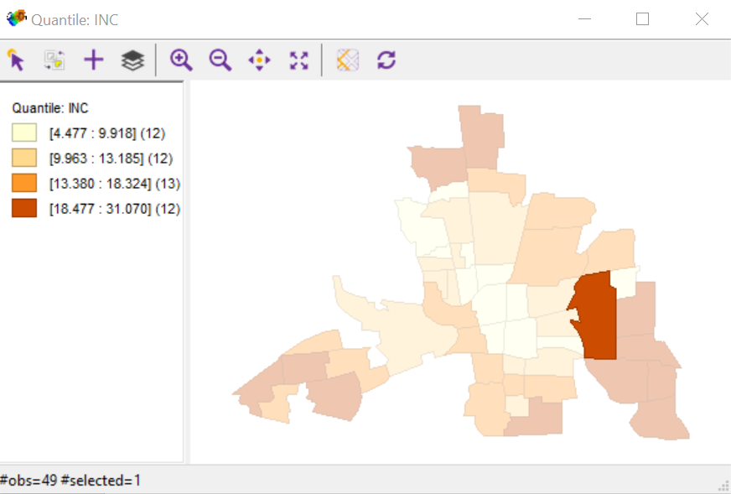

Figure 4. Quantile plot for variable INC.