**8102 Lab 4** Yue Lin

**Assignment Ⅰ**

The covariogram map that shows the spatial structure in the covariance matrix based on a true exponential covariance model is presented in Figure 1. Parameters “*theta1*” and “*theta2*” are set to 5 and 0.5, respectively.

Figure 1. The covariogram map generated based on a true exponential covariance model.

The plot of simulated spatial process with map overlay from the Gaussian model is presented in Figure 2, with one using all original realization and the other using only 30% of the original realization.

Figure 2. Plots of simulated spatial process from the Gaussian model with all and 30% of the original realization, respectively.

The plot of empirical, fitted and true semi-variograms as well as the plot of the empirical semi-variogram in each of 4 principle directions are presented in Figure 3. The empirical values fit well with the truth, where the true trend is equal to 5. The estimated spatial parameters fit well with the true values as well. The assumption of isotropy is invalid here, for the empirical semi-variogram in 90° is significantly different from the other three.

Figure 3. Plot of empirical, fitted and true semi-variograms and plot of the empirical semi-variogram in each of 4 principle directions.

The simulated map, sampled map, prediction map, predicted standard error for ordinary Kriging are provided in Figure 4.

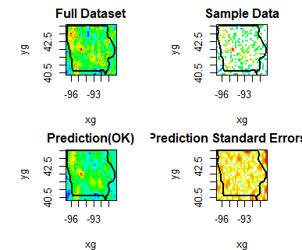

Figure 4. The simulated map, sampled map, prediction map, predicted standard error for ordinary Kriging.

**Assignment Ⅱ**

The bubble map of lead is presented in Figure 5.

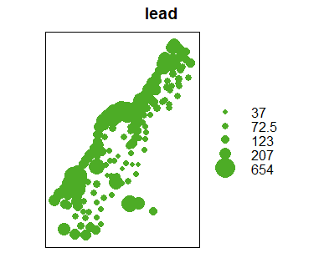

Figure 5. A bubble map of lead.

The plot of empirical and fitted semi-variograms are provided in Figure 6.

Figure 6. Plot of empirical and fitted semi-variograms.

The prediction map (with ordinary Kriging) and Kriging error map are provided in Figure 7.

Figure . The prediction map (with ordinary Kriging) and Kriging error map.