**8102 Lab 5** Yue Lin

**Assignment Ⅰ**

The bar plot linking the number of neighbors and the number of cases is presented in Figure 1. The census tracts in Columbus are well-connected, because there are no census tracts without any neighbors, and most of the census tracts have three to six neighbors.

Figure 1. The bar plot linking the number of neighbors and the number of cases.

**Assignment Ⅱ**

The plot for k nearest neighbors is presented in Figure 2. To interpret the plots, we can examine how many links are reaching out from one census tract to another.

Figure 2. The plot for k nearest neighbors (k = 1, 2).

**Assignment Ⅲ**

The plot for distance-based neighbors is presented in Figure 3. To interpret the plots, we can examine the distance between two census tracts when there is a link between them.

Figure 3. The plot for distance-based neighbors (band width = 0.5, 0.8).

**Assignment Ⅳ**

The Moran’s I scatterplot is presented in Figure 4. Based on the Moran’s I value (0.637), the crime rate shows spatial autocorrelation.

Figure 4. The Moran’s I scatterplot.

**Assignment V**

The LISA cluster map is presented in Figure 5. The high-high clusters are located in the center of Columbus, while the low-low clusters are in the southeast and the southwest.

Figure 5. The LISA cluster map.

**Assignment VI**

The Gi and Gi* cluster maps are presented in Figure 6. Similar to the LISA map, the high-high clusters are located in the center of Columbus, while the low-low clusters are in the southeast and the southwest. Twos small differences are that the high-high clusters in both the Gi and Gi* cluster maps cover a larger area than those in the LISA map, and the low-low clusters in the Gi* cluster map cover a larger area than those in the LISA map.

Figure 6. The Gi and Gi* cluster maps.

**Assignment VII**

The residual plot is presented in Figure 7. The map of residuals indicates moderate spatial dependence and thus suggests dependent errors. The results of the Moran’s I test indicate a significant Moran’s I of 0.3131, which reject the hypothesis of independence in the residuals. The Moran’s I and p-value of the residuals are both lower than those of the variable CRIME itself.

Figure 7. The residual plot.

**Assignment VIII**

The fitted results for SAR and CAR models are presented in Figure 8 and Figure 9. In comparison with the CAR model, the SAR model reports a lower value of AIC, which suggests a higher quality of the model.

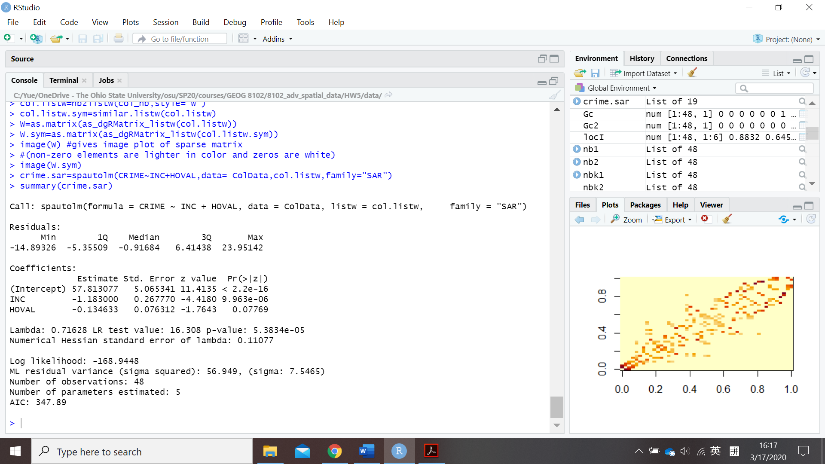

Figure 8. The fitted results for SAR model.

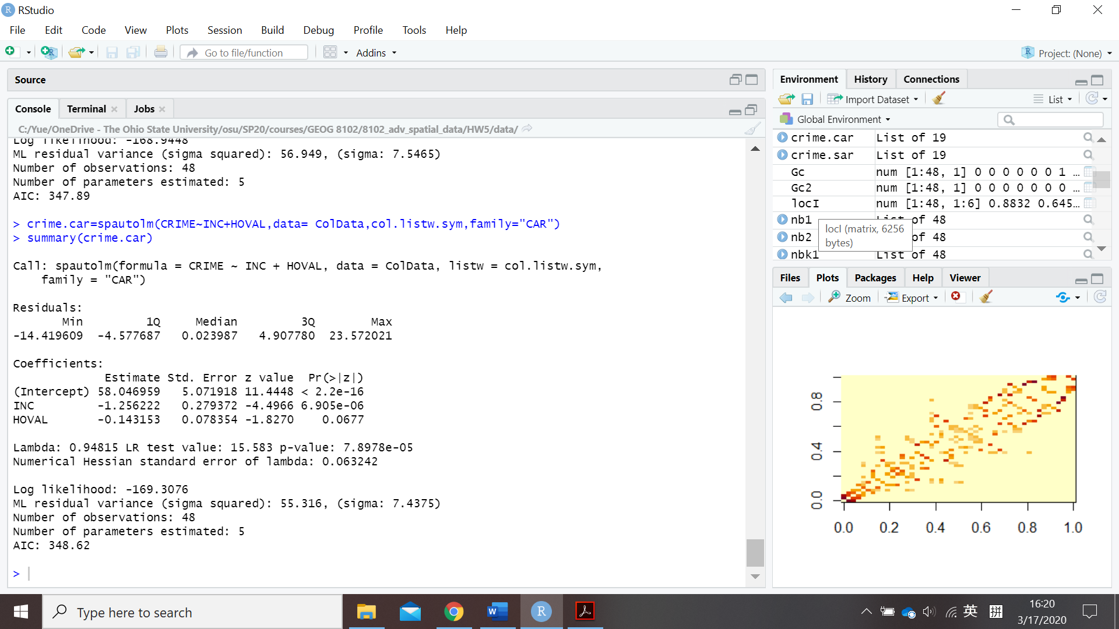

Figure 9. The fitted results for CAR model.