东方财富早鸟批

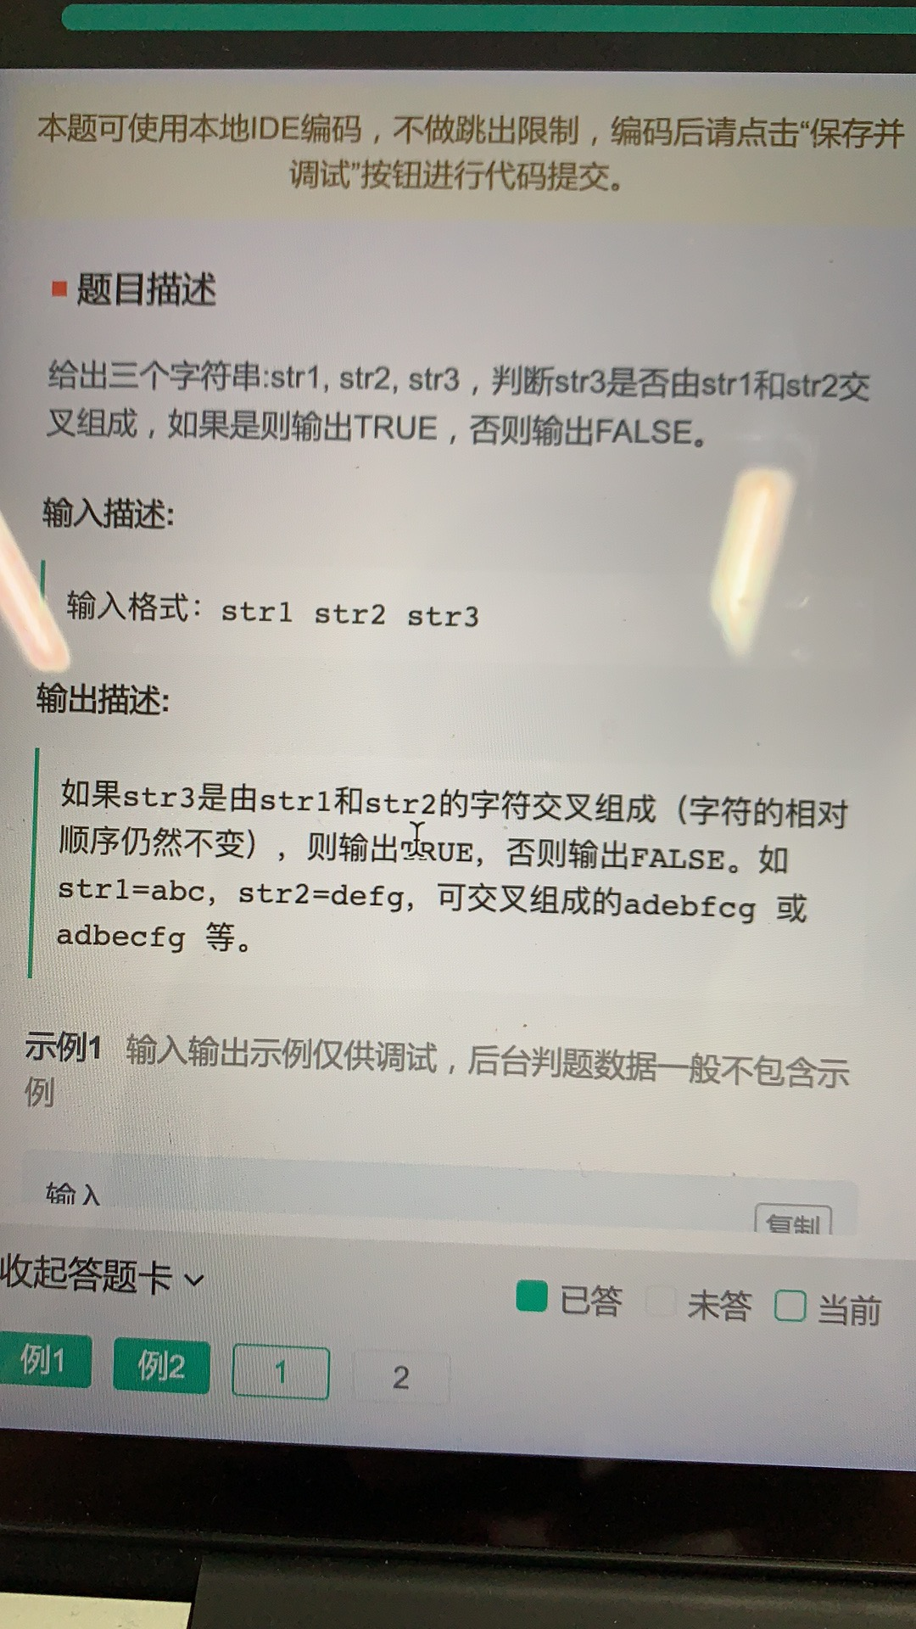

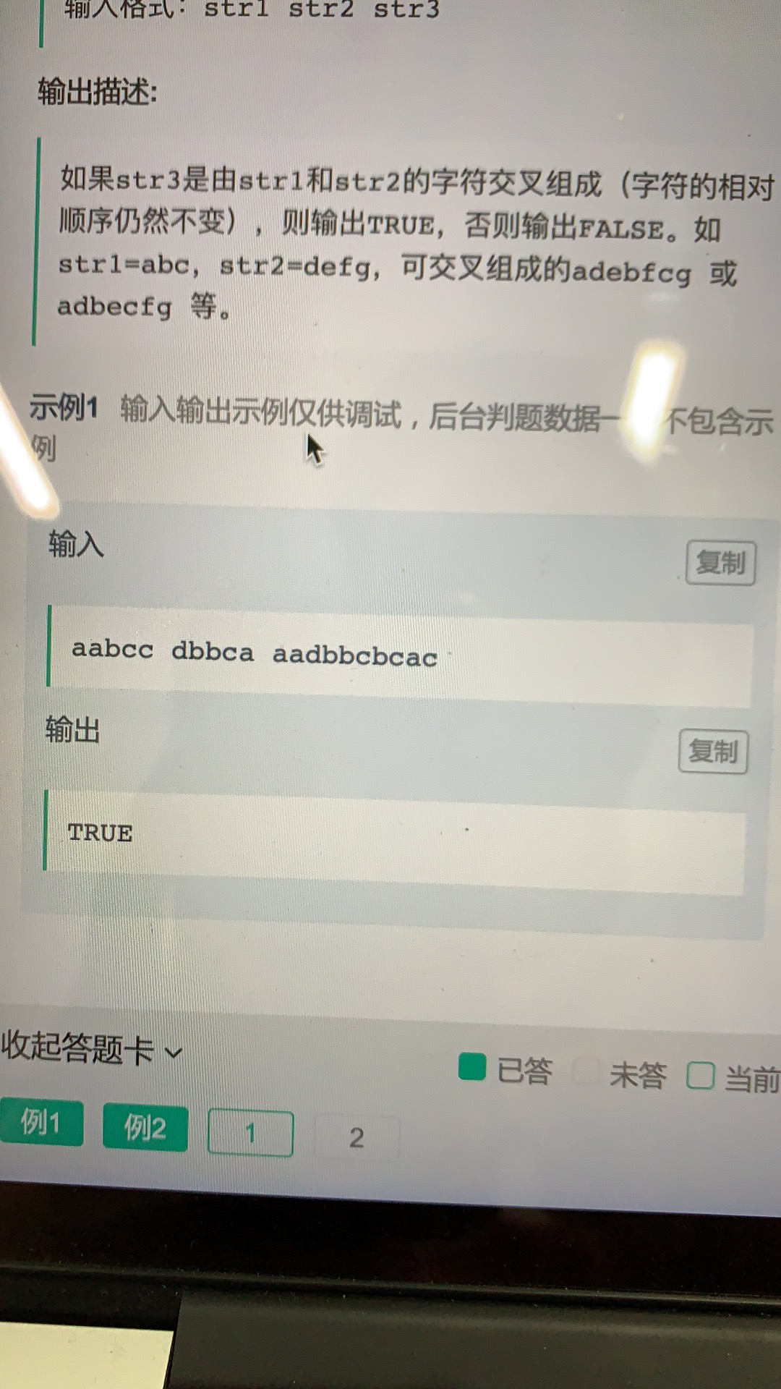

|  |
| --- |
| public class Solution {     public boolean isInterleave(String s1, String s2, String s3) {         if (s3.length() != s1.length() + s2.length()) {             return false;         }         boolean dp[] = new boolean[s2.length() + 1];         for (int i = 0; i <= s1.length(); i++) {             for (int j = 0; j <= s2.length(); j++) {                 if (i == 0 && j == 0) {                     dp[j] = true;                 } else if (i == 0) {                     dp[j] = dp[j - 1] && s2.charAt(j - 1) == s3.charAt(i + j - 1);                 } else if (j == 0) {                     dp[j] = dp[j] && s1.charAt(i - 1) == s3.charAt(i + j - 1);                 } else {                     dp[j] = (dp[j] && s1.charAt(i - 1) == s3.charAt(i + j - 1)) || (dp[j - 1] && s2.charAt(j - 1) == s3.charAt(i + j - 1));                 }             }         }         return dp[s2.length()];     }  }  作者：LeetCode  链接：<https://leetcode-cn.com/problems/two-sum/solution/jiao-cuo-zi-fu-chuan-by-leetcode/>  来源：力扣（LeetCode）  著作权归作者所有。商业转载请联系作者获得授权，非商业转载请注明出处。 |

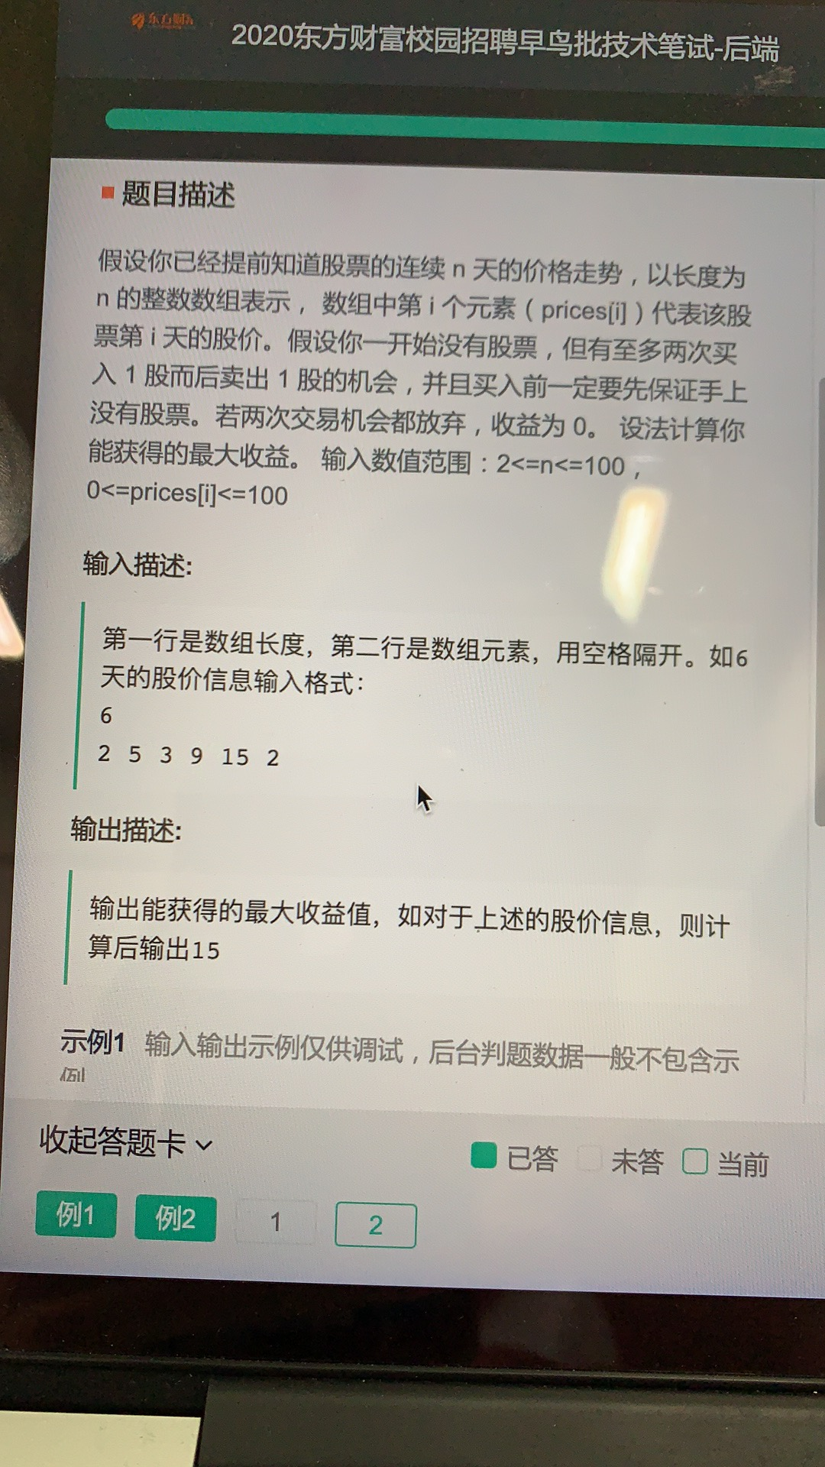

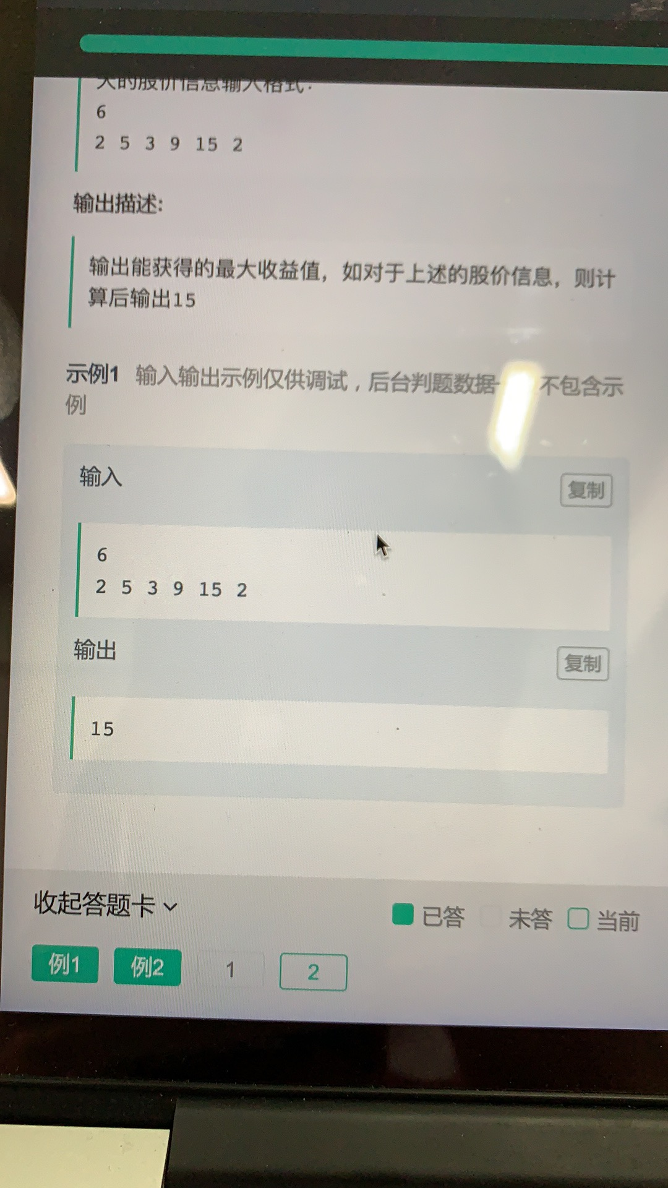

|  |
| --- |
| import java.math.BigInteger; import java.util.*;  public class Main{   public static void main(String[] args) {  *fun2*();  }  public static void fun2(){  Scanner scanner = new Scanner(System.*in*);  int x = scanner.nextInt();  int[] arr = new int[x];  for (int i = 0; i < x; i++) {  arr[i] = scanner.nextInt();  }  System.*out*.println(*maxProfit_k_2*(arr));  }  static int maxProfit_k_2(int[] prices) {  int dp_i10 = 0, dp_i11 = Integer.*MIN_VALUE*;  int dp_i20 = 0, dp_i21 = Integer.*MIN_VALUE*;  for (int price : prices) {  dp_i20 = Math.*max*(dp_i20, dp_i21 + price);  dp_i21 = Math.*max*(dp_i21, dp_i10 - price);  dp_i10 = Math.*max*(dp_i10, dp_i11 + price);  dp_i11 = Math.*max*(dp_i11, -price);  }  return dp_i20;  } } |