Air:

***Michael 3778***

Jason 3775

Richard 3774

Air is a mixture of gases. It is mainly nitrogen and oxygen. This shows what is in ‘clean’ air:

* Nitrogen 78%
* Oxygen 21%
* Other gases 1% (the noble gases, water vapor, carbon dioxide.)

The gases can be separated by fractional distillation:

1. The air is cooled down until it becomes a liquid.
2. Then it is warmed up slowly. This allows the gases to boil off separately, since they all have different boiling points.
3. The gases are put into tanks or cylinders under pressure, and sold for different uses.

Oxygen is used

* In oxygen tents in hospitals, for people with breathing difficulties
* Along with the hydrocarbon acetylene(ethane) in torched for cutting and welding metal; the burning mixture is so hot that it can melt steel.
* As an oxygen supply for astronauts and deep-sea divers
* In steel works, to remove carbon from pig iron

Nitrogen is used

* Inside food packaging, to protect food from oxidation by the oxygen in air
* To rinse out fuel storage tanks, where a mixture of air and fumes could be explosive
* To freeze liquid in pipelines, allowing the pipes to be repaired
* To freeze food and keep containers of food frozen during transport
* Make ammonia

Air pollution

1. Carbon monoxide, CO colorless no smell, from incomplete combustion of substances contains carbon. It’s deadly, binds to the hemoglobin in blood
2. Sulfur dioxide, SO2 main from the fossil fuels(contain some sulfur compounds. Causes lung damage and breathing problems, acid rain)
3. Oxides of nitrogen, NO/NO2/N2O N2 and O2 reacts in car engines. Causes lung damage and breathing problems, acid rain)
4. Lead compounds used in many industries, once added to petrol to help it burn smoothly. Harms the body’s nervous system; can cause brain damage and behavioral problems

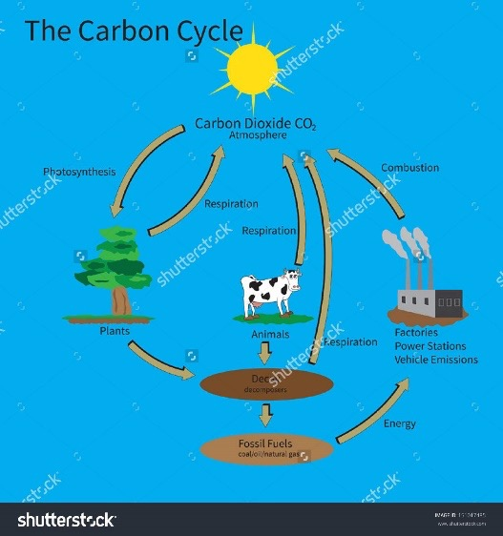 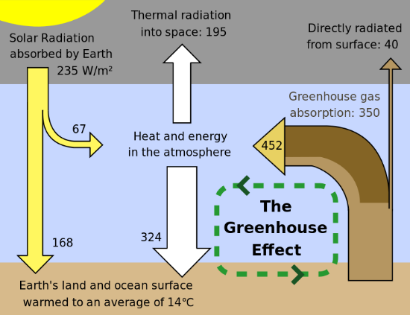

Rusting

* Rusting is the special name for the corrosion of iron.
* It is an oxidation. Oxygen from the air reacts with iron in the presence of moisture.
* The product is hydrated iron(III) oxide, Fe2O3-H2O, a brown flaky solid.

Ways to prevent rusting

1. Stop oxygen (air) from reaching the iron
2. Sacrifice another metal in place of iron
3. Galvanizing

In industry

* as a solvent
* to wash things
* to cool tanks where reactions are going on

Water:

* Why do we ned water?

In the home:

* for cooking

On the farm

* for animals to drink
* for watering crops(irrigation)

On the power station

* to make steam to drive turbines
* then to cool the steam
* for drinking
* for toilet flushing
* for washing
* Physical property: BP:100℃, MP: 0 ℃r
* Chemical test for water:
* **Copper(II) sulfate test for water**





solide turn from white to blue

* **Cobalt(II) chloride test for water**

**solid turns from white to pink**

**the water molecules are called water of crystallization**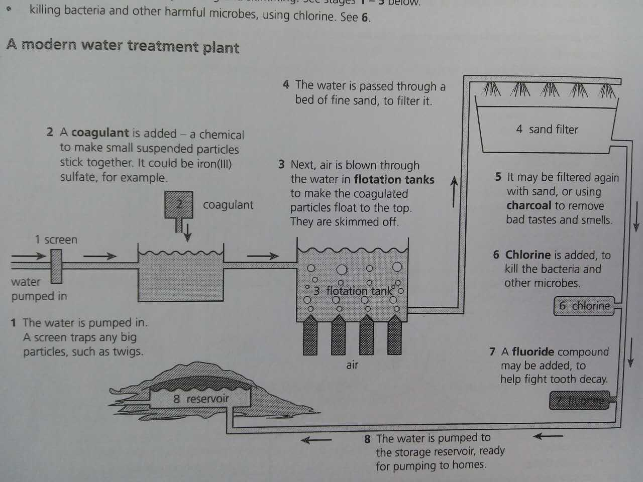

* **Modern water treatment**