This pie chart shows the number of script submitted to the “China teenager” website from different provinces of China. This chart was taken from a webpage in this website. The chart is just for display the information in order to encourage more people to post their script. There are two provinces with an especially large amount, which are SiChuan and ZheJiang.

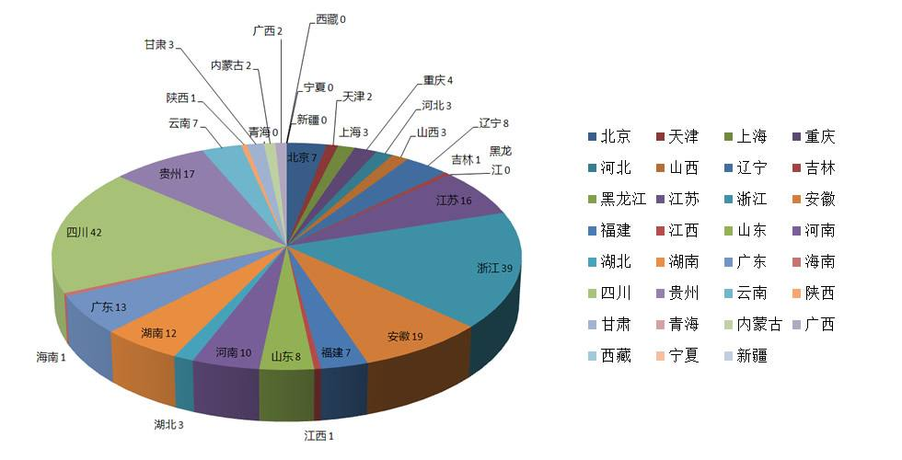

I think the use of a pie chart to display this data is not a good choice as there are too many provinces in China and some of them are even not big enough to be seen on the graph.

Moreover, the graph puts all the small areas next to each other, making them more difficult for readers to see. To display this information better, I suggest to use a bar graph, which will not only allow small numbers easier to see, but also make the entire graph neater.