1. 安装hadoop01

修改主机名、配置网络（IP地址必须在虚拟机可选网络范围内）

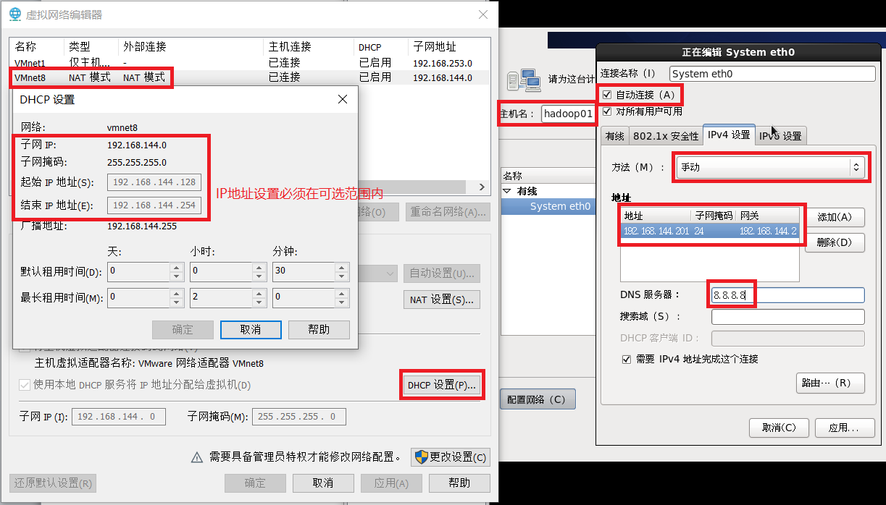

1. 配置主机名和IP映射

**vi /etc/hosts**

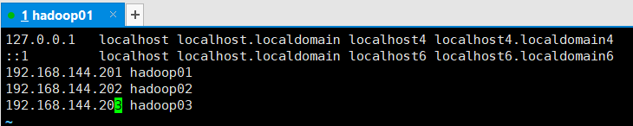

1. 安装jdk和hadoop

**mkdir -p /export/servers**

**tar -zxvf hadoop-2.7.4.tar.gz -C /export/servers**

**tar -zxvf jdk-8u251-linux-x64.tar.gz -C /export/servers**

**mv /export/servers/jdk1.8.0_251 /export/servers/jdk**

**vi /etc/profile**

#配置JDK环境变量

export JAVA_HOME=/export/servers/jdk

export PATH=$PATH:$JAVA_HOME/bin

export CLASSPATH=.:$JAVA_HOME/lib/dt.jar:$JAVA_HOME/lib/tools.jar

#配置Hadoop系统环境变量

export HADOOP_HOME=/export/servers/hadoop-2.7.4

export PATH=$PATH:$HADOOP_HOME/bin:$HADOOP_HOME/sbin

**source /etc/profile**

1. Hadoop集群配置

**cd /export/servers/hadoop-2.7.4/etc/hadoop/**

**vi hadoop-env.sh**

找到JAVA_HOME参数位置，进行如下修改（注意jdk路径）

export JAVA_HOME=/export/servers/jdk

**vi core-site.xml**

<configuration>

<property>

<name>fs.defaultFS</name>

<value>hdfs://hadoop01:9000</value>

</property>

<property>

<name>hadoop.tmp.dir</name>

<value>/export/servers/hadoop-2.7.4/tmp</value>

</property>

</configuration>

**vi hdfs-site.xml**

<configuration>

<property>

<name>dfs.replication</name>

<value>3</value>

</property>

<property>

<name>dfs.namenode.secondary.http-address</name>

<value> hadoop02:50090</value>

</property>

</configuration>

**cp mapred-site.xml.template mapred-site.xml**

**vi mapred-site.xml**

<configuration>

<property>

<name>mapreduce.framework.name</name>

<value>yarn</value>

</property>

</configuration>

**vi yarn-site.xml**

<configuration>

<property>

<name>yarn.resourcemanager.hostname</name>

<value>hadoop01</value>

</property>

<property>

<name>yarn.nodemanager.aux-services</name>

<value>mapreduce_shuffle</value>

</property>

</configuration>

**vi slaves**

localhost（删除）

hadoop01

hadoop02

hadoop03

1. 服务器环境准备

时间同步：

**yum install ntp -y**

**ntpdate cn.pool.ntp.org**

关闭防火墙

**service iptables stop**

**chkconfig iptables off**

1. 克隆hadoop02、hadoop03（完整克隆）

然后对hadoop02、hadoop03都做以下修改

修改hadoop02、hadoop03主机名为hadoop02、hadoop03

**vi /etc/sysconfig/network**

配置hadoop02、hadoop03网络

**vi /etc/sysconfig/network-scripts/ifcfg-eth0**

修改IPADDR

删除HWADDR

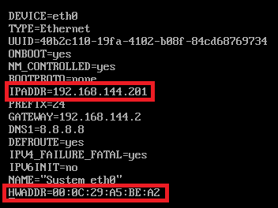

**rm -rf /etc/udev/rules.d/70-persistent-net.rules**

重启虚拟机

**reboot**

1. 在hadoop01上执行以下命令

ssh免密单向登录

**ssh-keygen -t rsa**

（一路回车）

**ssh-copy-id hadoop01**

（yes-输入密码）

**ssh-copy-id hadoop02**

**ssh-copy-id hadoop03**

**hdfs namenode -format**

**start-dfs.sh**

**start-yarn.sh**

**OJBK**