**FanCtl_Spd**

## 1.基本信息

### 1.1.目的

根据发动机状态、环境温度、环境压力产生的冷却性能信号输出到设备封装（DE）模块。

### 1.2.参考

FanCtl_Spd；Fans_ClgDem ；Fans_trq；Fan_DD；Fan_VD；FanSpd_DD；FanSpd_VD。

## 2.功能描述

### 2.1.Top level overview

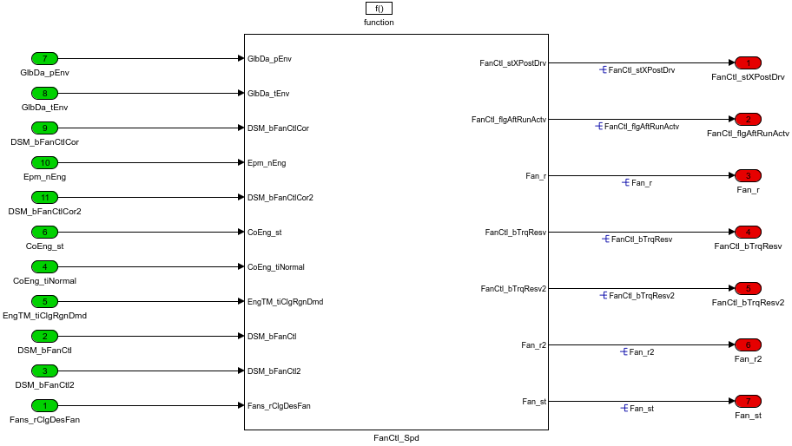

根据发动机状态、环境等信号输出风扇开度和风扇运行状态信号。

#### 2.1.1.FanCtl_Spd

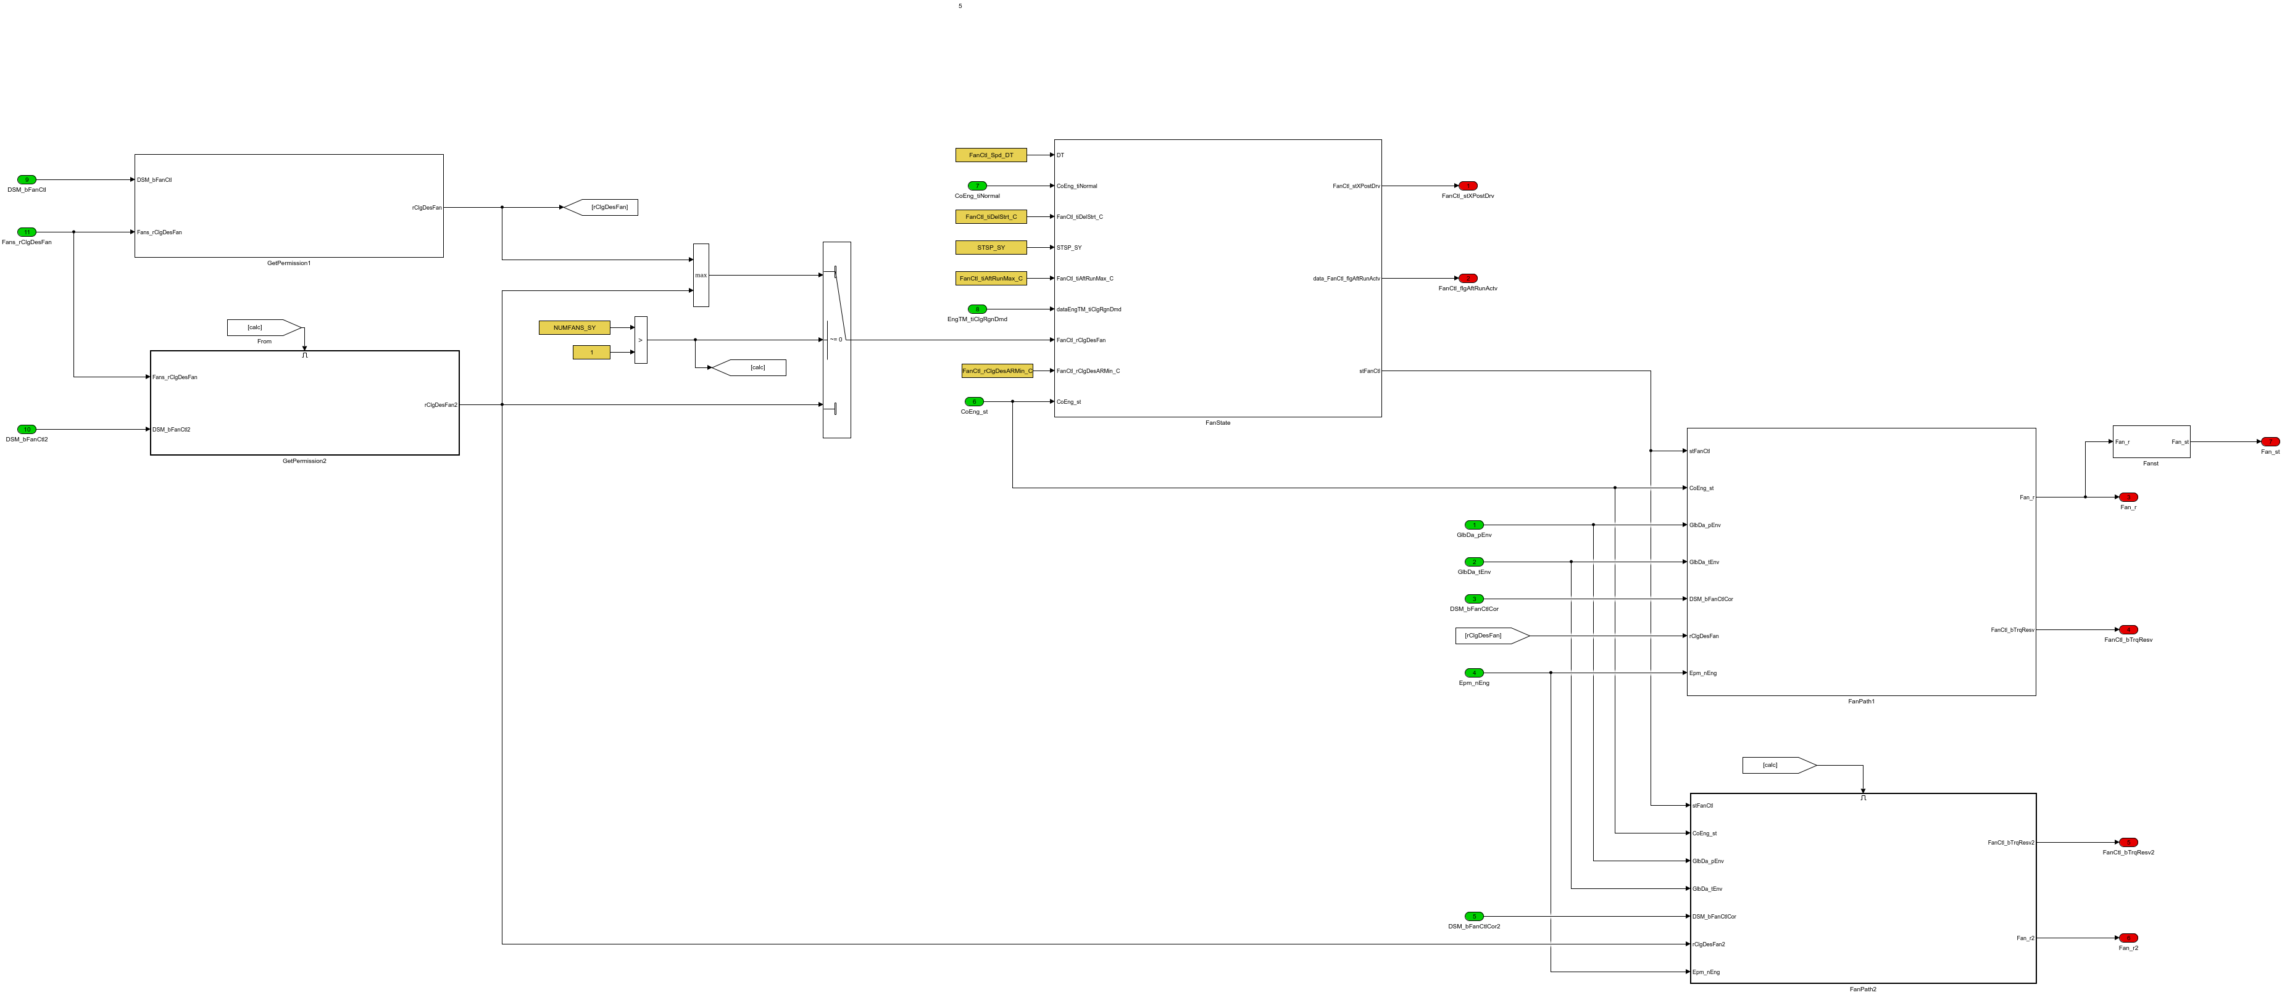

NUMFANS_SY>1，两路风扇作用，NUMFANS_SY=1，一路风扇作用。

##### 2.1.1.1.FanPath1

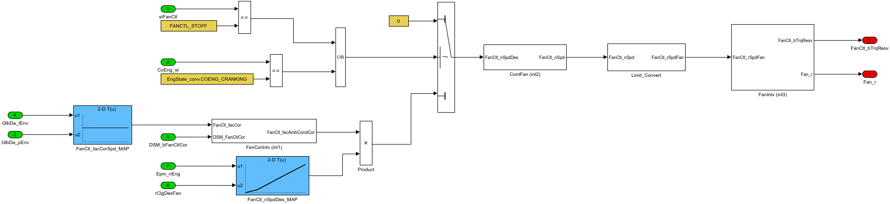

冷却风扇通道1逻辑，得到冷却风扇开度百分比需求和风扇起动过程信号。

###### 2.1.1.1.1.ContFan (inl2)

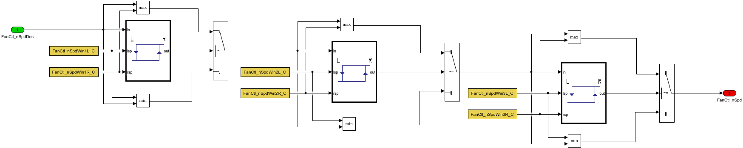

转速迟滞滤波处理。

###### 2.1.1.1.2.FanCorIntv (inl1)

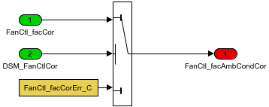

没有故障时风扇转速系数传递。

###### 2.1.1.1.3.FanIntv (inl3)

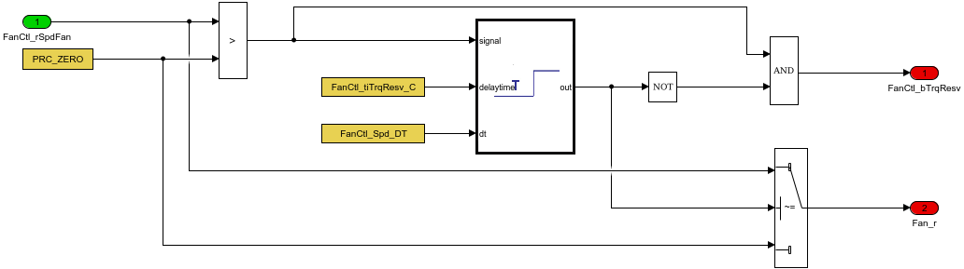

利用延迟滤波模块得到风扇起动时的信号和风扇开度信号。

###### 2.1.1.1.4.Limit_Convert

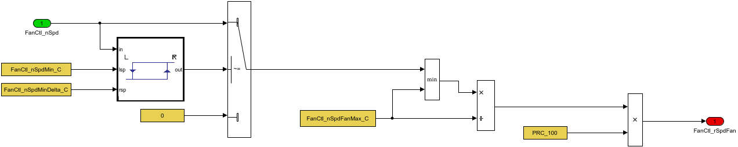

利用风扇转速和最大转速比值，得到风扇转速百分比信号。

##### 2.1.1.2.FanPath2

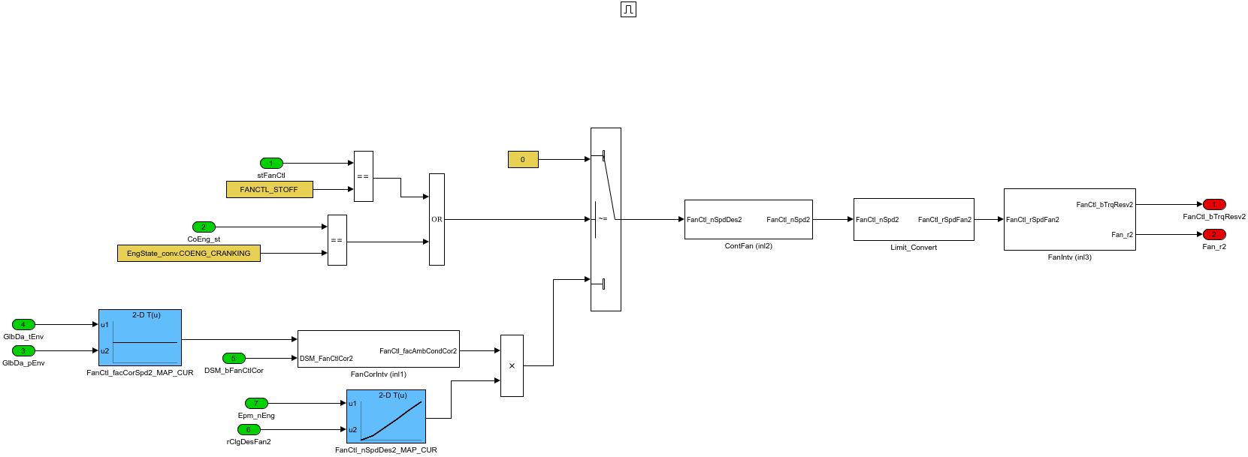

冷却风扇通道2逻辑，得到冷却风扇开度百分比需求和风扇起动过程信号。

###### 2.1.1.2.1.ContFan (inl2)

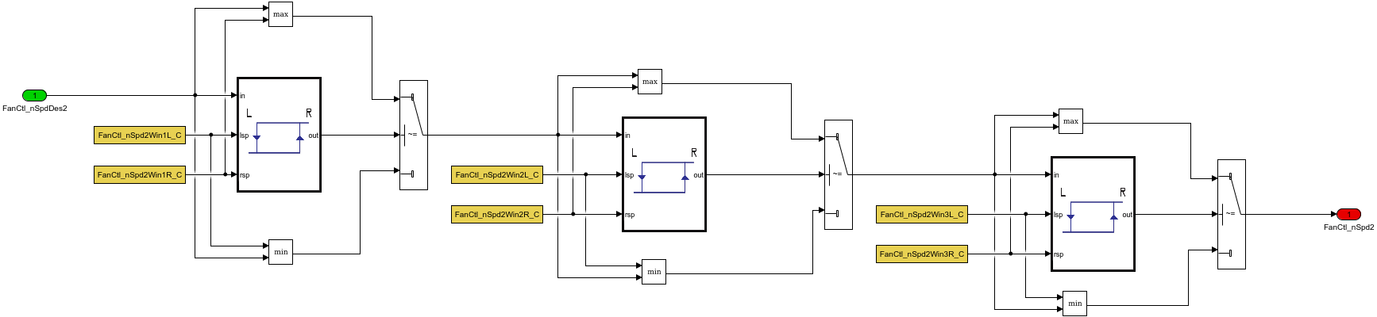

转速迟滞滤波处理。

###### 2.1.1.2.2.FanCorIntv (inl1)

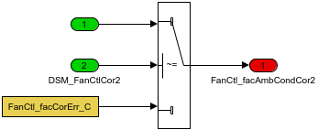

没有故障时系数传递。

###### 2.1.1.2.3.FanIntv (inl3)

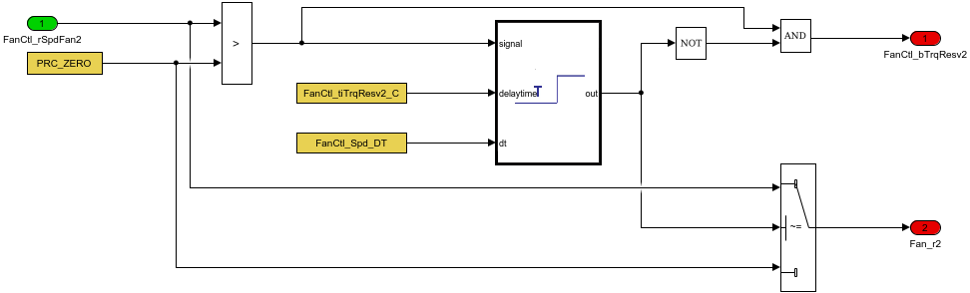

利用延迟滤波模块得到风扇起动时的信号和风扇开度信号。

###### 2.1.1.2.4.Limit_Convert

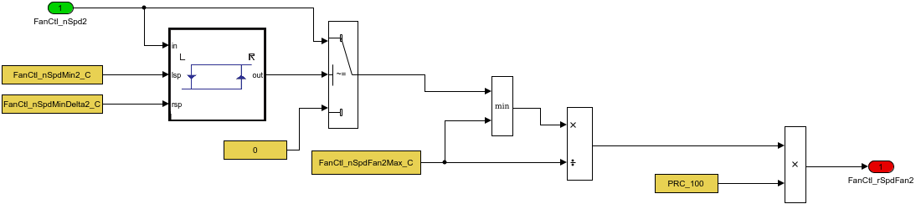

利用风扇转速和最大转速比值，得到风扇转速百分比信号。

##### 2.1.1.3.FanState

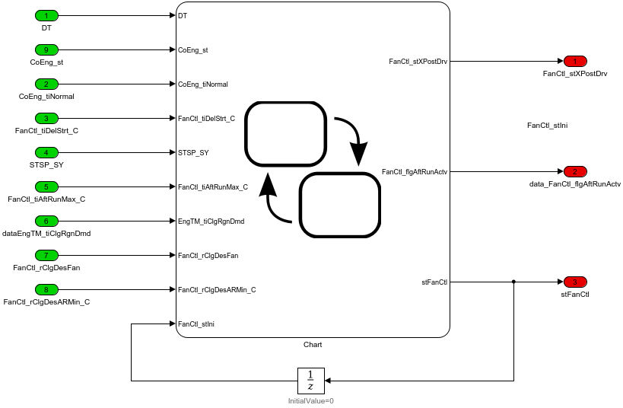

风扇状态转换。

###### 2.1.1.3.1.Chart

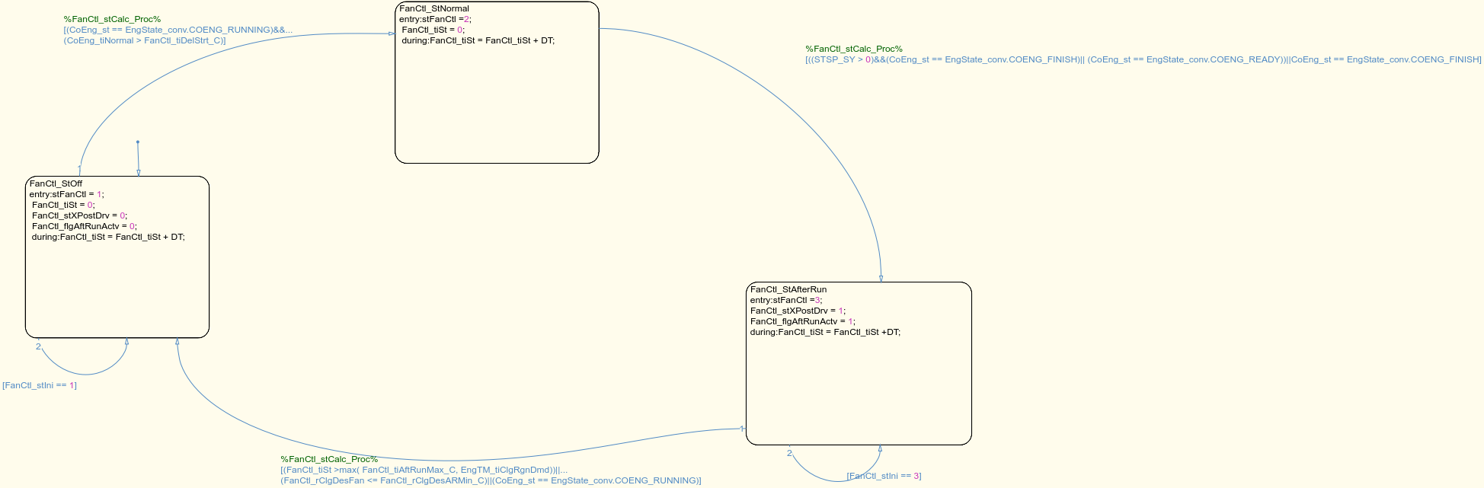

冷却风扇关闭-正常运行-后运行三种状态，循环具有单向性。

(1)风扇关闭-正常运行

发动机运行时间CoEng_tiNormal大于阈值，发动机处于运行模式。

(2) 正常运行-后运行

启停功能STSP_SY>0,发动机运行状态决定风扇状态切换，状态机优先级()>&&>||。

(3) 后运行-风扇关闭

切换条件包括运行时间大于FanCtl_tiAftRunMax_C和EngTM_tiClgRgnDmd的最大值；中间变量风扇开度小于FanCtl_rClgDesARMin_C；发动机运行状态。

##### 2.1.1.4.Fanst

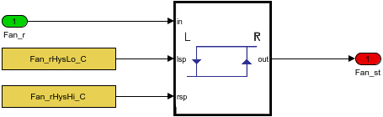

风扇开度大于或小于定值得到风扇开度状态。

##### 2.1.1.5.GetPermission1

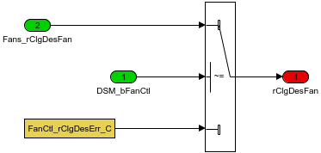

##### 2.1.1.6.GetPermission2

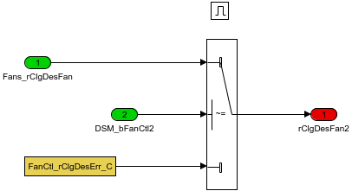

Table. 输入信号

|  |  |  |  |  |  |  |  |
| --- | --- | --- | --- | --- | --- | --- | --- |
| Name | Min | Max | Width | Description | Object Class | Typedef | Unit |
| Fans_rClgDesFan | -300.0 | 300.0 | -1.0 | Relative cooling performance demand to fan |  | Prc_100_rate | % |
| DSM_bFanCtl | 0.0 | 1.0 | -1.0 |  |  | Dsm |  |
| DSM_bFanCtl2 | 0.0 | 1.0 | -1.0 |  |  | Dsm |  |
| CoEng_tiNormal | 0.0 | 42949672950.0 | -1.0 | Time since state"CONENG_RUNNING"was reached |  | EngTime_ms | ms |
| EngTM_tiClgRgnDmd | 0.0 | 42949672950.0 | -1.0 | Duration to keep fan On to cool the DPF and surrounding |  | EngTime_ms | ms |
| CoEng_st |  |  | -1.0 | Engine coordinator state |  | Enum:EngState_conv |  |
| GlbDa_pEnv | -3000.0 | 3000.0 | -1.0 | environmental pressure |  | AirPressure_kPa | kPa |
| GlbDa_tEnv | -50.0 | 150.0 | -1.0 | environment temperature |  | Temp_deg | deg |
| DSM_bFanCtlCor | 0.0 | 1.0 | -1.0 |  |  | Dsm |  |
| Epm_nEng | 0.0 | 6000.0 | -1.0 | Engine speed |  | EngSpeed_rpm | rpm |
| DSM_bFanCtlCor2 | 0.0 | 1.0 | -1.0 |  |  | Dsm |  |

Table. 输出信号

|  |  |  |  |  |  |  |  |  |
| --- | --- | --- | --- | --- | --- | --- | --- | --- |
| Name | Min | Max | Width | Description | Object Class | Typedef | DefaultValue | Unit |
| FanCtl_stXPostDrv | 0.0 | 1.0 | -1.0 | Prolonging post drive due to fan |  | boolean | 0.0 |  |
| FanCtl_flgAftRunActv | 0.0 | 1.0 | -1.0 | fan afterrun active |  | boolean | 0.0 |  |
| Fan_r | 0.0 | 100.0 | -1.0 | Actuator setpoint value for the first fan output |  | DutyCycle_rate | 0.0 | % |
| FanCtl_bTrqResv | 0.0 | 1.0 | -1.0 | the additional torque required for Fan1 from the engine |  | boolean | 0.0 |  |
| FanCtl_bTrqResv2 | 0.0 | 1.0 | -1.0 | the additional torque required for Fan2 from the engine |  | boolean | 0.0 |  |
| Fan_r2 | 0.0 | 100.0 | -1.0 | set point duty cycle for PWM fan power stage 2 |  | DutyCycle_rate | 0.0 | % |
| Fan_st | 0.0 | 1.0 | -1.0 | Fan status based on fan opening |  | boolean | 0.0 |  |

Table. 监控量

|  |  |  |  |  |  |  |  |  |
| --- | --- | --- | --- | --- | --- | --- | --- | --- |
| Name | Min | Max | Width | Description | Object Class | Typedef | DefaultValue | Unit |

Table. 标定量

|  |  |  |  |  |  |  |  |  |
| --- | --- | --- | --- | --- | --- | --- | --- | --- |
| Name | Min | Max | Width | Description | Object Class | Typedef | DefaultValue | Unit |
| FanCtl_rClgDesErr_C | -300.0 | 300.0 | -1.0 | cooling request in case of a error |  | Prc_100_rate | 0.0 | % |
| FanCtl_tiDelStrt_C | 0.0 | 42949672950.0 | -1.0 | delay time to activte the fan after engine start |  | EngTime_ms | 0.0 | ms |
| FanCtl_tiAftRunMax_C | 0.0 | 42949672950.0 | -1.0 | max fan afterrun time |  | EngTime_ms | 0.0 | ms |
| FanCtl_rClgDesARMin_C | -300.0 | 300.0 | -1.0 | low limit of abourt condition of fan afterrun dependent on colling request |  | Prc_100_rate | 0.0 | % |
| FanCtl_facCorSpd_MAP | 0.0 | 1.0 | [6 6] | System constants for the number of Xy co-ordinates for the map FANCTL_FACCORSPD_MAP |  | Factor | [1 1 1 1 1 1 ; 1 1 1 1 1 1 ; 1 1 1 1 1 1 ; 1 1 1 1 1 1 ; 1 1 1 1 1 1 ; 1 1 1 1 1 1 ] |  |
| FanCtl_facCorSpd_MAPX | -3000.0 | 3000.0 | 6.0 | System constants for the number of X co-ordinates for the map FANCTL_FACCORSPD_MAP |  | AirPressure_kPa | [0 20 40 60 80 100] | kPa |
| FanCtl_facCorSpd_MAPY | -50.0 | 150.0 | 6.0 | System constants for the number of Y co-ordinates for the map FANCTL_FACCORSPD_MAP |  | Temp_deg | [0 20 40 60 80 100] | deg |
| FanCtl_nSpdDes_MAP | -32768.0 | 32767.0 | [6 6] | System constants for the number of XY co-ordinates for the map FANCTL_NSPDDES_MAP |  | FanSpd_rpm | [10 10 10 10 10 10 ; 20 20 20 20 20 20 ; 40 40 40 40 40 40 ; 60 60 60 60 60 60 ; 80 80 80 80 80 80 ; 100 100 100 100 100 100 ] | rpm |
| FanCtl_nSpdDes_MAPY | 0.0 | 6000.0 | 6.0 | System constants for the number of Y co-ordinates for the map FANCTL_NSPDDES_MAP |  | EngSpeed_rpm | [0 20 40 60 80 100] | rpm |
| FanCtl_nSpdDes_MAPX | -300.0 | 300.0 | 6.0 | System constants for the number of X co-ordinates for the map FANCTL_NSPDDES_MAP |  | Prc_100_rate | [0 20 40 60 80 100] | % |
| FanCtl_facCorErr_C | 0.0 | 1.0 | -1.0 | correction factor of fan in case of an error |  | Factor | 0.0 |  |
| FanCtl_nSpdWin1L_C | -32768.0 | 32767.0 | -1.0 | low limit: window 1 |  | FanSpd_rpm | 0.0 | rpm |
| FanCtl_nSpdWin1R_C | -32768.0 | 32767.0 | -1.0 | high limit: window 1 |  | FanSpd_rpm | 0.0 | rpm |
| FanCtl_nSpdWin2L_C | -32768.0 | 32767.0 | -1.0 | low limit: window 2 |  | FanSpd_rpm | 0.0 | rpm |
| FanCtl_nSpdWin2R_C | -32768.0 | 32767.0 | -1.0 | high limit: window 2 |  | FanSpd_rpm | 0.0 | rpm |
| FanCtl_nSpdWin3L_C | -32768.0 | 32767.0 | -1.0 | low limit: window 3 |  | FanSpd_rpm | 0.0 | rpm |
| FanCtl_nSpdWin3R_C | -32768.0 | 32767.0 | -1.0 | high limit: window 3 |  | FanSpd_rpm | 0.0 | rpm |
| FanCtl_nSpdMin_C | -32768.0 | 32767.0 | -1.0 | Hysteresis minimum: fan speed as minimal fan speed fan 1 |  | FanSpd_rpm | 0.0 | rpm |
| FanCtl_nSpdMinDelta_C | -32768.0 | 32767.0 | -1.0 | Hysteresis delta: fan speed as minimal fan speed fan1 |  | FanSpd_rpm | 0.0 | rpm |
| FanCtl_nSpdFanMax_C | -32768.0 | 32767.0 | -1.0 | Maximal fan speed fan 1 |  | FanSpd_rpm | 100.0 | rpm |
| FanCtl_tiTrqResv_C | 0.0 | 4294967295.0 | -1.0 | Time for reserve torque for Fan1 |  | State_uint32 | 0.0 |  |
| Fan_rHysHi_C | -300.0 | 300.0 | -1.0 | High threshold of hysterisis to set digital fan power stage output to true |  | DutyCycle_rate | 10.0 | % |
| Fan_rHysLo_C | -300.0 | 300.0 | -1.0 | Low threshold of hysterisis to set digital fan power stage output to true |  | DutyCycle_rate | 10.0 | % |
| FanCtl_facCorSpd2_MAP | 0.0 | 1.0 | [6 6] | System constants for the number of XY co-ordinates for the map FANCTL_FACCORSPD2_MAP |  | Factor | [1 1 1 1 1 1 ; 1 1 1 1 1 1 ; 1 1 1 1 1 1 ; 1 1 1 1 1 1 ; 1 1 1 1 1 1 ; 1 1 1 1 1 1 ] |  |
| FanCtl_facCorSpd2_MAPX | -3000.0 | 3000.0 | 6.0 | System constants for the number of X co-ordinates for the map FANCTL_FACCORSPD2_MAP |  | AirPressure_kPa | [0 20 40 60 80 100] | kPa |
| FanCtl_facCorSpd2_MAPY | -50.0 | 150.0 | 6.0 | System constants for the number of Y co-ordinates for the map FANCTL_FACCORSPD2_MAP |  | Temp_deg | [0 20 40 60 80 100] | deg |
| FanCtl_nSpdDes2_MAP | -32768.0 | 32767.0 | [6 6] | System constants for the number of XY co-ordinates for the map FANCTL_NSPDDES2_MAP |  | FanSpd_rpm | [10 10 10 10 10 10 ; 20 20 20 20 20 20 ; 40 40 40 40 40 40 ; 60 60 60 60 60 60 ; 80 80 80 80 80 80 ; 100 100 100 100 100 100 ] | rpm |
| FanCtl_nSpdDes2_MAPX | -300.0 | 300.0 | 6.0 | System constants for the number of X co-ordinates for the map FANCTL_NSPDDES2_MAP |  | Prc_100_rate | [0 20 40 60 80 100] | % |
| FanCtl_nSpdDes2_MAPY | 0.0 | 6000.0 | 6.0 | System constants for the number of Y co-ordinates for the map FANCTL_NSPDDES2_MAP |  | FanSpd_rpm | [0 20 40 60 80 100] | rpm |
| FanCtl_nSpd2Win1L_C | -32768.0 | 32767.0 | -1.0 | lower limit: fan speed window 1 fan 1/fan 2 |  | FanSpd_rpm | 0.0 | rpm |
| FanCtl_nSpd2Win1R_C | -32768.0 | 32767.0 | -1.0 | upper limit: fan speed window 1 fan 1/fan 2 |  | FanSpd_rpm | 0.0 | rpm |
| FanCtl_nSpd2Win2L_C | -32768.0 | 32767.0 | -1.0 | lower limit: fan speed window 2 fan 1/fan 2 |  | FanSpd_rpm | 0.0 | rpm |
| FanCtl_nSpd2Win2R_C | -32768.0 | 32767.0 | -1.0 | upper limit: fan speed window 2 fan 1/fan 2 |  | FanSpd_rpm | 0.0 | rpm |
| FanCtl_nSpd2Win3L_C | -32768.0 | 32767.0 | -1.0 | lower limit: fan speed window 3 fan 1/fan 2 |  | FanSpd_rpm | 0.0 | rpm |
| FanCtl_nSpd2Win3R_C | -32768.0 | 32767.0 | -1.0 | upper limit: fan speed window 3 fan 1/fan 2 |  | FanSpd_rpm | 0.0 | rpm |
| FanCtl_nSpdMin2_C | -32768.0 | 32767.0 | -1.0 | Hysteresis minimum: fan speed as minimal fan speed fan 2 |  | FanSpd_rpm | 0.0 | rpm |
| FanCtl_nSpdMinDelta2_C | -32768.0 | 32767.0 | -1.0 | Hysteresis delta: fan speed as minimal fan speed fan 2 |  | FanSpd_rpm | 0.0 | rpm |
| FanCtl_nSpdFan2Max_C | -32768.0 | 32767.0 | -1.0 | Maximal fan speed fan 2 |  | FanSpd_rpm | 100.0 | rpm |
| FanCtl_tiTrqResv2_C | 0.0 | 4294967295.0 | -1.0 | Time for reserve torque for Fan2 |  | State_uint32 | 0.0 |  |

Table. 系统常量

|  |  |  |  |  |  |
| --- | --- | --- | --- | --- | --- |
| Name | Value | Description | Object Class | Typedef | Unit |
| FANCTL_STOFF | 1.0 | Cooling fan stop |  | State_uint8 |  |
| FANCTL_STNORMAL | 2.0 | Cooling fan operation |  | State_uint8 |  |
| FANCTL_STAFTRUN | 3.0 | cooling fan after Operation |  | State_uint8 |  |
| PRC_100 | 100.0 | 100 percent |  | Prc_100_rate | % |
| PRC_ZERO | 0.0 | 0 percent |  | Prc_100_rate | % |
| NUMFANS_SY | 2.0 | number of engine fan available |  | State_uint8 |  |
| STSP_SY | 0.0 | Start-Stop Functionality |  | State_uint8 |  |