**Fans_ClgDem**

## 1.基本信息

### 1.1.目的

根据空调压缩机（AC）、发动机（CoETM）、协调热系统（CoTS）和颗粒捕捉器（DFP）的冷却请求，输出冷却需求百分比。

### 1.2.参考

FanCtl_Spd；Fans_ClgDem ；Fans_trq；Fan_DD；Fan_VD；FanSpd_DD；FanSpd_VD。

## 2.功能描述

### 2.1.Top level overview

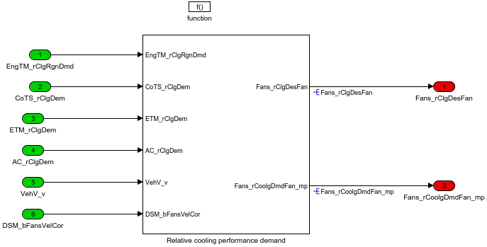

Fans_rCoolgDmdFan_mp是滤波前的冷却请求，Fans_rClgDesFan是对风扇的冷却请求百分比。

#### 2.1.1.Relative cooling performance demand

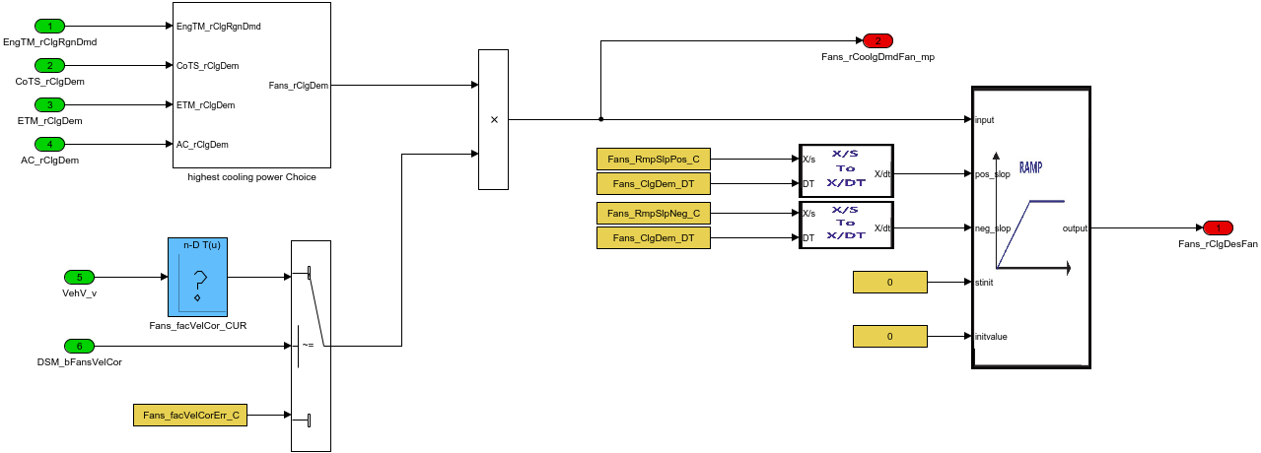

根据车速查表得到系数乘以空调、发动机等需求的百分比开度，经过滤波输出冷却风扇需求开度的百分比。

##### 2.1.1.1.highest cooling power Choice

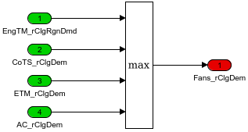

选择最大冷却需求。

Table. 输入信号

|  |  |  |  |  |  |  |  |
| --- | --- | --- | --- | --- | --- | --- | --- |
| Name | Min | Max | Width | Description | Object Class | Typedef | Unit |
| EngTM_rClgRgnDmd | -300.0 | 300.0 | -1.0 | Cooling demand required to cool the DPF |  | Prc_100_rate | % |
| CoTS_rClgDem | -300.0 | 300.0 | -1.0 | cool demand percent |  | Prc_100_rate | % |
| ETM_rClgDem | -300.0 | 300.0 | -1.0 | Relative fan cooling power required by engine cooling |  | Prc_100_rate | % |
| AC_rClgDem | -300.0 | 300.0 | -1.0 |  |  | Prc_100_rate | % |
| VehV_v | 0.0 | 250.0 | -1.0 | Vehicle speed |  | VehSpeed_km_h | km/h |
| DSM_bFansVelCor | 0.0 | 1.0 | -1.0 |  |  | Dsm |  |

Table. 输出信号

|  |  |  |  |  |  |  |  |  |
| --- | --- | --- | --- | --- | --- | --- | --- | --- |
| Name | Min | Max | Width | Description | Object Class | Typedef | DefaultValue | Unit |
| Fans_rClgDesFan | -300.0 | 300.0 | -1.0 | Relative cooling performance demand to fan |  | Prc_100_rate | 0.0 | % |
| Fans_rCoolgDmdFan_mp | -300.0 | 300.0 | -1.0 | corrected fan−demand after maximum choice |  | Prc_100_rate | 0.0 | % |

Table. 监控量

|  |  |  |  |  |  |  |  |  |
| --- | --- | --- | --- | --- | --- | --- | --- | --- |
| Name | Min | Max | Width | Description | Object Class | Typedef | DefaultValue | Unit |

Table. 标定量

|  |  |  |  |  |  |  |  |  |
| --- | --- | --- | --- | --- | --- | --- | --- | --- |
| Name | Min | Max | Width | Description | Object Class | Typedef | DefaultValue | Unit |
| Fans_facVelCorErr_C | 0.0 | 1.0 | -1.0 | Adaptation value in case of error |  | Factor | 0.0 |  |
| Fans_RmpSlpPos_C | -327.68 | 327.67 | -1.0 | Positive slope for fan cooling demand |  | DutyCycle_rate_s | 10.0 | %/s |
| Fans_RmpSlpNeg_C | -327.68 | 327.67 | -1.0 | Negative slope for fan cooling demand |  | DutyCycle_rate_s | 10.0 | %/s |
| Fans_facVelCor_CURY | 0.0 | 1.0 | [6 1] | cooling by vehicle velocity/ cooling demand fac |  | Factor | [0 0.2 0.4 0.6 0.8 1] |  |
| Fans_facVelCor_CURX | 0.0 | 250.0 | 6.0 | Vehicle speed |  | VehSpeed_km_h | [0 20 40 60 80 100] | km/h |

Table. 系统常量

|  |  |  |  |  |  |
| --- | --- | --- | --- | --- | --- |
| Name | Value | Description | Object Class | Typedef | Unit |