**Fans_trq**

## 1.基本信息

### 1.1.目的

根据风扇开度和风扇起动信号，得到风扇静态扭矩和风扇起动储备扭矩大小。

### 1.2.参考

FanCtl_Spd；Fans_ClgDem ；Fans_trq；Fan_DD；Fan_VD；FanSpd_DD；FanSpd_VD。

## 2.功能描述

### 2.1.Top level overview

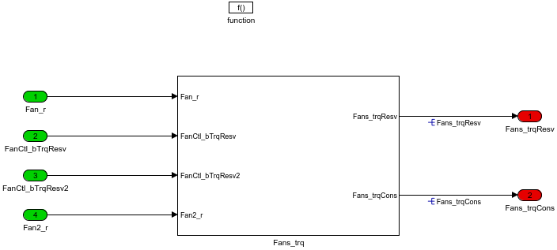

输出Fans_trqCons计算风扇的静态扭矩需求，Fans_trqResv风扇开始运行前的扭矩需求。

#### 2.1.1.Fans_trq

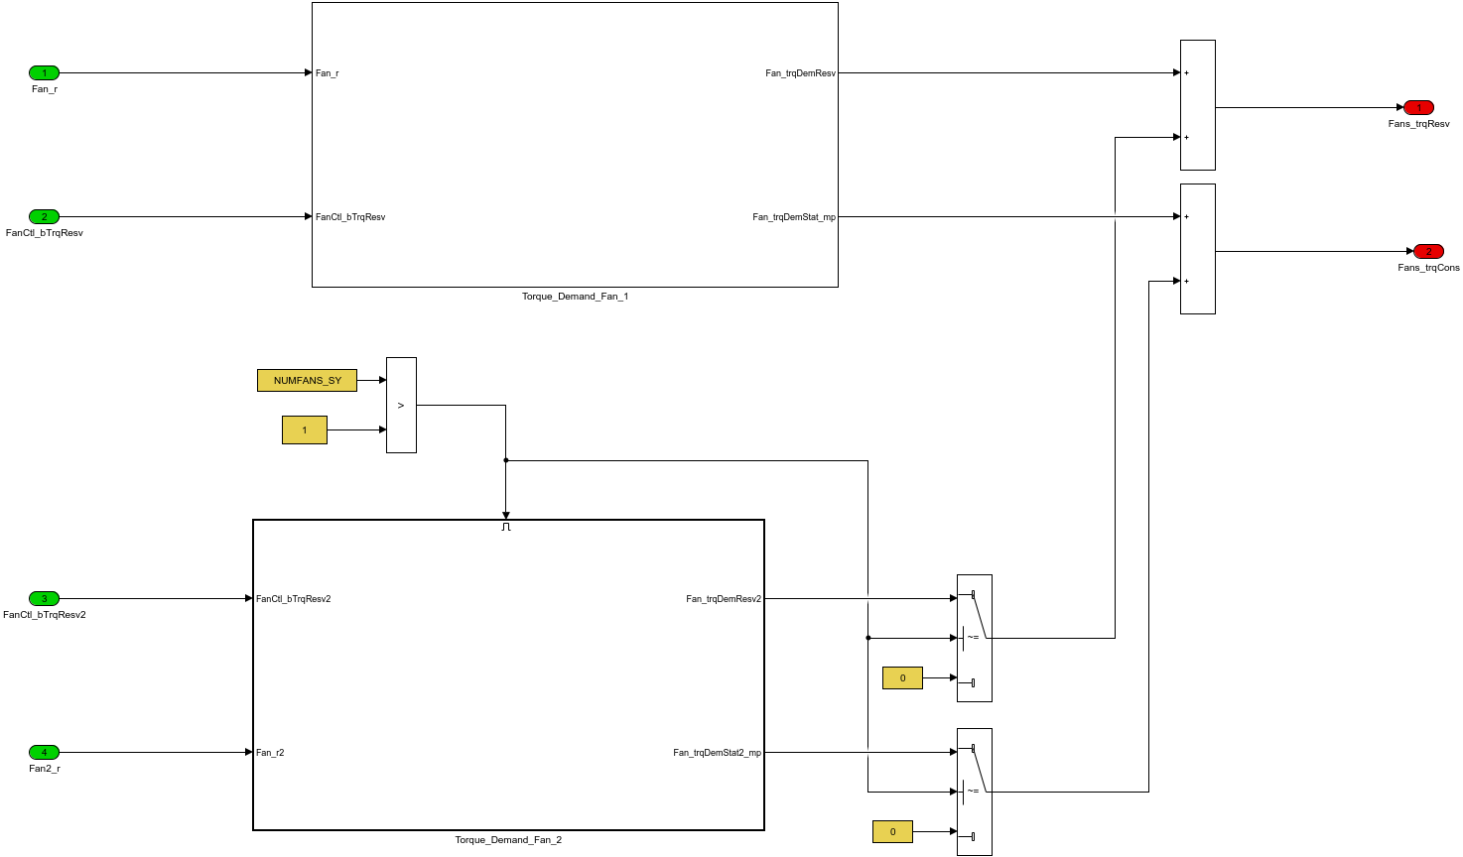

根据系统常数NUMFANS_SY，决定一个或两个风扇静态和储备扭矩需求，NUMFANS_SY>1,表示两个风扇，NUMFANS_SY=1是一个风扇。

##### 2.1.1.1.Torque_Demand_Fan_1

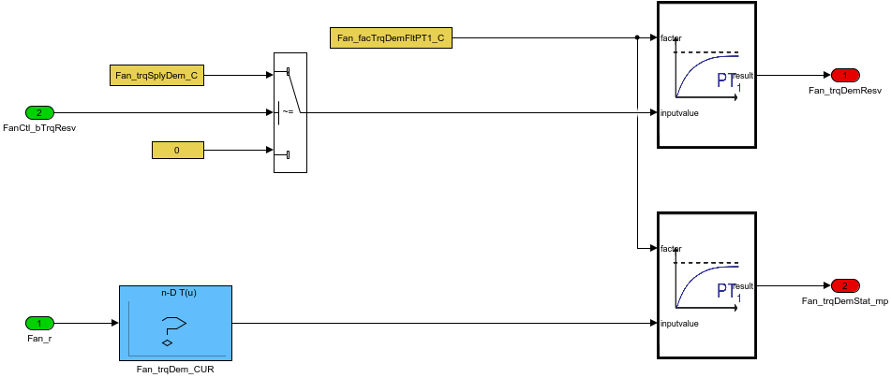

FanCtl_bTrqResv是风扇占空比开度逐渐增大时，风扇即将启动还未完全起动时的信号，完全起动时，FanCtl_bTrqResv=1，Fans_trqResv既是此阶段的扭矩大小。

##### 2.1.1.2.Torque_Demand_Fan_2

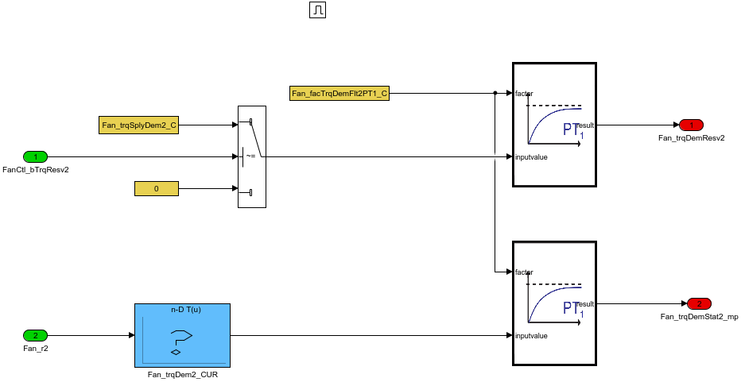

Table. 输入信号

|  |  |  |  |  |  |  |  |
| --- | --- | --- | --- | --- | --- | --- | --- |
| Name | Min | Max | Width | Description | Object Class | Typedef | Unit |
| Fan_r | 0.0 | 100.0 | -1.0 | Actuator setpoint value for the first fan output |  | DutyCycle_rate | % |
| FanCtl_bTrqResv | 0.0 | 1.0 | -1.0 | the additional torque required for Fan1 from the engine |  | boolean |  |
| FanCtl_bTrqResv2 | 0.0 | 1.0 | -1.0 | the additional torque required for Fan2 from the engine |  | boolean |  |
| Fan_r2 | 0.0 | 100.0 | -1.0 | set point duty cycle for PWM fan power stage 2 |  | DutyCycle_rate | % |

Table. 输出信号

|  |  |  |  |  |  |  |  |  |
| --- | --- | --- | --- | --- | --- | --- | --- | --- |
| Name | Min | Max | Width | Description | Object Class | Typedef | DefaultValue | Unit |
| Fans_trqResv | -3000.0 | 3000.0 | -1.0 | Torque reserve for cooling fan |  | Trq_Nm | 0.0 | Nm |
| Fans_trqCons | -3000.0 | 3000.0 | -1.0 | Torque consumed by Fan |  | Trq_Nm | 0.0 | Nm |

Table. 监控量

|  |  |  |  |  |  |  |  |  |
| --- | --- | --- | --- | --- | --- | --- | --- | --- |
| Name | Min | Max | Width | Description | Object Class | Typedef | DefaultValue | Unit |

Table. 标定量

|  |  |  |  |  |  |  |  |  |
| --- | --- | --- | --- | --- | --- | --- | --- | --- |
| Name | Min | Max | Width | Description | Object Class | Typedef | DefaultValue | Unit |
| Fan_trqSplyDem_C | -3000.0 | 3000.0 | -1.0 | Reserve Torque Demand for Fan 1 |  | Trq_Nm | 10.0 | Nm |
| Fan_facTrqDemFltPT1_C | 0.0 | 99.9985 |  | Time Delay for Filtering of static Torque Demand of |  | PT_fac | 50.0 |  |
| Fan_trqDem_CURX | 0.0 | 100.0 | 6.0 | Mapping between PWM signal of Fan_r1 and the resulting static torque demand X |  | DutyCycle_rate | [0 20 40 60 80 100] | % |
| Fan_trqDem_CURY | -3000.0 | 3000.0 | [6 1] | Mapping between PWM signal of Fan_r1 and the resulting static torque demand Y |  | Trq_Nm | [0 20 40 60 80 100] | Nm |
| Fan_trqSplyDem2_C | -3000.0 | 3000.0 | -1.0 | Reserve Torque Demand for Fan 2 |  | Trq_Nm | 10.0 | Nm |
| Fan_facTrqDemFlt2PT1_C | 0.0 | 99.9985 | -1.0 | Time Delay for Filtering of static Torque Demand of Fan2 |  | PT_fac | 50.0 |  |
| Fan_trqDem2_CURX | 0.0 | 100.0 | 6.0 | Mapping between PWM signal of Fan_r2 and the resulting static torque demand X |  | DutyCycle_rate | [0 20 40 60 80 100] | % |
| Fan_trqDem2_CURY | -3000.0 | 3000.0 | [6 1] | Mapping between PWM signal of Fan_r2 and the resulting static torque demand Y |  | Trq_Nm | [0 20 40 60 80 100] | Nm |

Table. 系统常量

|  |  |  |  |  |  |
| --- | --- | --- | --- | --- | --- |
| Name | Value | Description | Object Class | Typedef | Unit |
| NUMFANS_SY | 2.0 | number of engine fan available |  | State_uint8 |  |