**RailP_PRV**

## 1.基本信息

### 1.1.目的

判断泄压阀PRV开启关闭状态，通过轨压变化率进行计算后，进入轨压评估模块进行PRV轨压状态判断，结果再进入PRV状态判断，得到最终状态结果，PRV进入开启状态后，针对开启次数和开启时间进行累计计算，超过标定次数和累积时长后，发出wearout故障，表示需要更换。

### 1.2.参考

博世文档，P_1187_761_Customer_Document_V2.0，Page2007.

## 2.功能描述

### 2.1.Top level overview

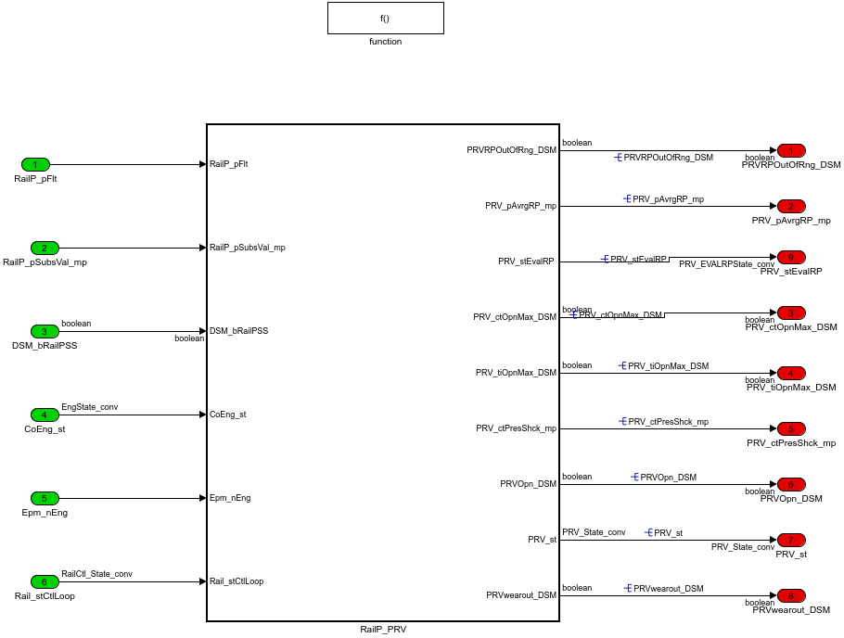

#### 2.1.1.RailP_PRV

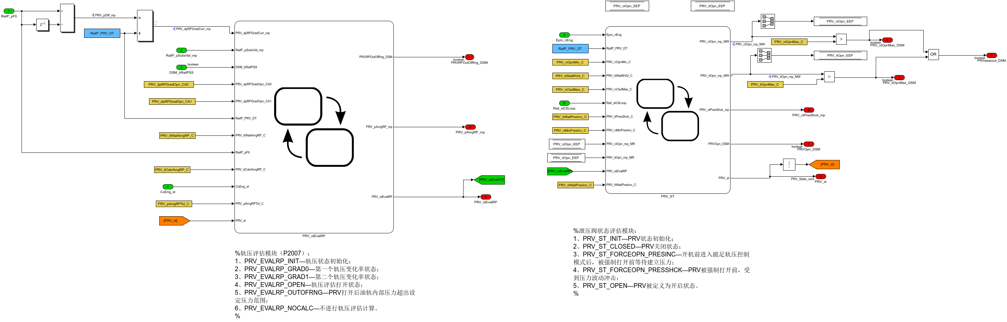

模块被激活后，首先计算轨压梯度，然后进入轨压评估模块进行轨压梯度判断，最后进入泄压阀评估模块进行泄压阀状态判断。

##### 2.1.1.1.PRV_stEvalRP

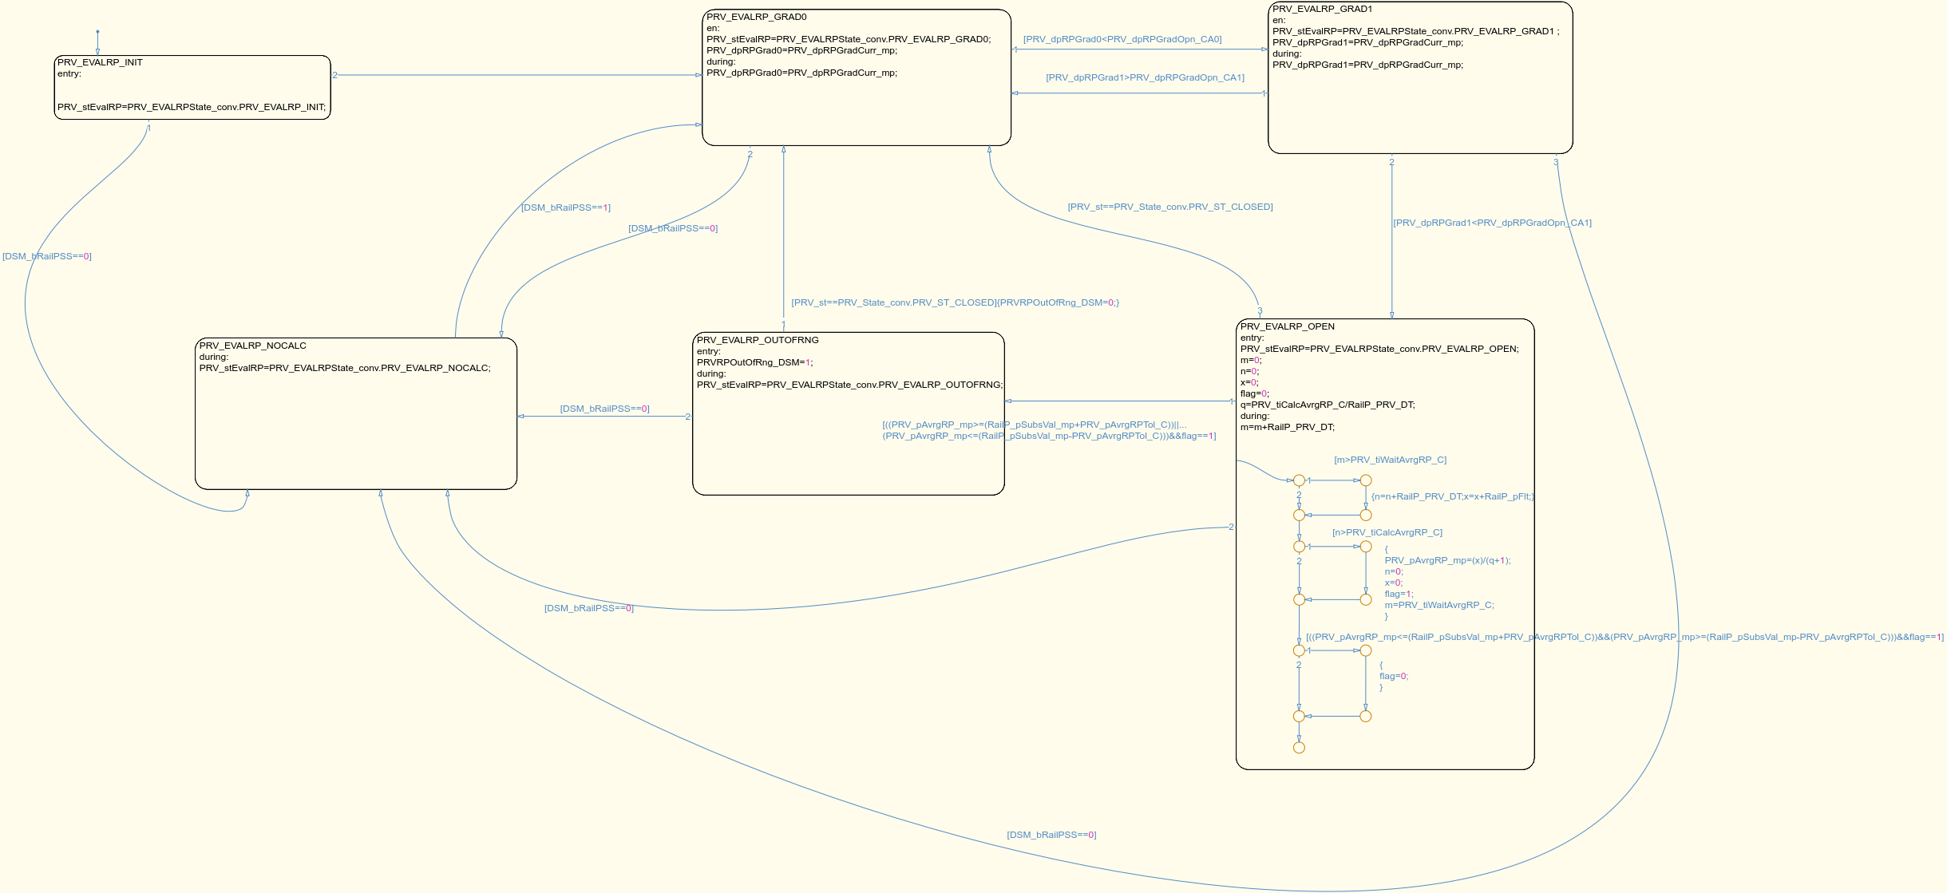

轨压评估模块：

1、PRV_EVALRP_INIT—轨压状态初始化；

2、PRV_EVALRP_GRAD0—第一个轨压梯度变化状态；

3、PRV_EVALRP_GRAD1—第二个轨压梯度变化状态；

4、PRV_EVALRP_OPEN—PRV轨压评估打开状态；

5、PRV_EVALRP_OUTOFRNG—油轨内部压力超出设定范围；

6、PRV_EVALRP_NOCALC—不进行轨压评估计算。

各状态之间迁移条件：

1、ECU上电初始化后；

2、无条件转移；

3、PRV_dpRPGrad0<PRV_dpRPGradOpn_CA0，第一个实际轨压变化梯度值小于设定值；4、PRV_dpRPGrad1<PRV_dpRPGradOpn_CA1，第二个实际轨压变化梯度值小于设定值；

5、PRV_dpRPGrad1>PRV_dpRPGradOpn_CA1，第二个实际轨压变化梯度值大于设定值； 6、((PRV_pAvrgRP_mp>=(RailP_pSubsVal_mp+PRV_pAvrgRPTol_C))||(PRV_pAvrgRP_mp<=(RailP_pSubsVal_mp-PRV_pAvrgRPTol_C))，轨压平均值大于轨压替代值加偏差范围设定值或者小于轨压替代值减去偏差范围设定值；

7、DSM_bRailPSS==0，若轨压传感器发生故障，轨压评估计算进入停止计算状态。

##### 2.1.1.2.PRV_ST

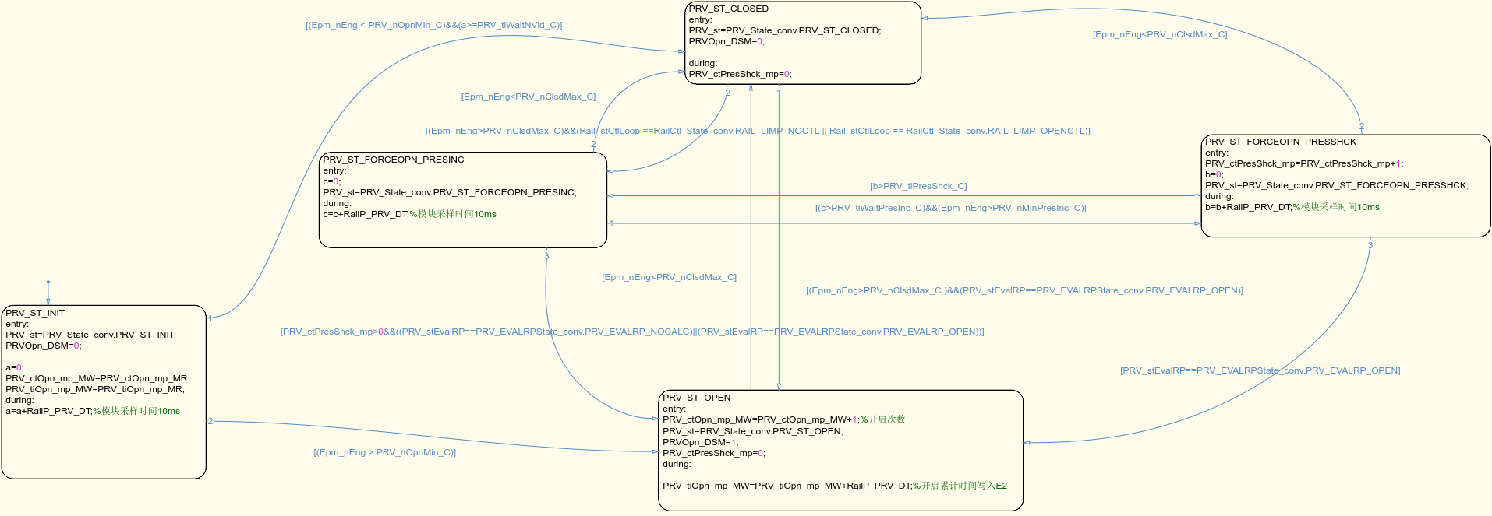

泄压阀状态评估模块：

1、PRV_ST_INIT—PRV状态初始化；

2、PRV_ST_CLOSED—PRV关闭状态；

3、PRV_ST_FORCEOPN_PRESINC—PRV被强制打开后等待重新建立压力；

4、PRV_ST_FORCEOPN_PRESSHCK—PRV被强制打开后，受到压力波动冲击；

5、PRV_ST_OPEN—PRV被定义为开启状态。

各状态之间迁移条件：

1、ECU上电初始化后；

2、(Epm_nEng < PRV_nOpnMin_C)&&(a>=PRV_tiWaitNVld_C)，发动机转速小于PRV最小开启转速并且经过一段设定时间后；

3、Epm_nEng>PRV_nClsdMax_C )&&(PRV_stEvalRP==PRV_EVALRPState_conv.PRV_EVALRP_OPEN，发动机转速大于最大PRV关闭转速并且PRV轨压开启状态；

4、[(Epm_nEng>PRV_nClsdMax_C)&&(Rail_stCtlLoop ==RailCtl_State_conv.RAIL_LIMP_NOCTL || Rail_stCtlLoop == RailCtl_State_conv.RAIL_LIMP_OPENCTL)]，转速大于最大PRV关闭转速且轨压控制状态处于跛行不控制状态或者跛行开环控制状态；

5、[(c>PRV_tiWaitPresInc_C)&&(Epm_nEng>PRV_nMinPresInc_C)]，经过一段建压等待时间后并且转速大于最小建压转速；

6、b>PRV_tiPresShck_C，经过一段压力波动冲击时间后；

7、[PRV_stEvalRP==PRV_EVALRPState_conv.PRV_EVALRP_OPEN]，当轨压评估状态处于开启状态时；

8、[PRV_ctPresShck_mp>0&&((PRV_stEvalRP==PRV_EVALRPState_conv.PRV_EVALRP_NOCALC)||(PRV_stEvalRP==PRV_EVALRPState_conv.PRV_EVALRP_OPEN))]，压力冲击次数大于等于1次并且轨压评估专题处于停止计算状态或者处于PRV轨压开启状态；

9、[(Epm_nEng > PRV_nOpnMin_C)]，转速大于最小PRV开启转速；

10、[Epm_nEng<PRV_nClsdMax_C]，转速小于最大PRV关闭转速。

Table 1 输入信号列表

|  |  |  |  |
| --- | --- | --- | --- |
| Name | Description | Typedef | Unit |
| RailP_pFlt | Maximum rail pressure of the last 10 sampling cycle | RailPressure_bar | bar |
| RailP_pSubsVal_mp | Rail pressure substitution value in case of an error in pressure sensor | RailPressure_bar | bar |
| DSM_bRailPSS | Status of FId_RailPSS | boolean |  |
| CoEng_st | Engine coordinator state | Enum:EngState_conv |  |
| Epm_nEng | Engine speed | EngSpeed_rpm | rpm |
| Rail_stCtlLoop | State of the rail pressure governor control | Enum:RailCtl_State_conv |  |

Table 2 输出信号列表

|  |  |  |  |
| --- | --- | --- | --- |
| Name | Description | Typedef | Unit |
| PRVRPOutOfRng_DSM | Averaged rail pressure is outside the expected tolerance range | boolean |  |
| PRV_pAvrgRP_mp | averaged rail pressure for detection of an opened pressure relief valve by the rail pressure evaluation | RailPressure_bar | bar |
| PRV_ctOpnMax_DSM | Maximum number of opening cycles till wear out of PRV | boolean |  |
| PRV_tiOpnMax_DSM | Maximum open time till wear out of PRV | boolean |  |
| PRV_ctPresShck_mp | number of performed rail pressure shock cycles to force the opening of the pressure relief valve | State_uint16 |  |
| PRVOpn_DSM | PRV valve open state diagnostic | boolean |  |
| PRV_st | state variable of the pressure relief valve | Enum:PRV_State_conv |  |
| PRVwearout_DSM | PRV valve open counters or duration beyond setpoint value | boolean |  |
| PRV_stEvalRP | state variable of the rail pressure evaluation for the recognition of the opening of the pressure relief valve | Enum:PRV_EVALRPState_conv |  |

Table 3 标定量列表

|  |  |  |  |
| --- | --- | --- | --- |
| Name | Description | Typedef | Unit |
| PRV_nOpnMin_C | engine speed threshold for detection of an opened pressure relief valve at startup of the ECU | EngSpeed_rpm | rpm |
| PRV_tiWaitNVld_C | Waiting time to enshure save detection of engine speed at ECU start | EngTime_ms | ms |
| PRV_ctOpnMax_C | Maximum number of opening cycles till wear out of PRV | State_uint8 |  |
| PRV_nClsdMax_C | below this engine speed the PRV will close again even if it was open | EngSpeed_rpm | rpm |
| PRV_tiOpnMax_C | Maximum open time till wear out of PRV | EngTime_ms | ms |
| PRV_tiPresShck_C | duration to perform a rail pressure shock cycle to force the opening of the pressure relief valve | EngTime_ms | ms |
| PRV_tiWaitPresInc_C | time period for the rail pressure build up before performing a rail pressure shock | EngTime_ms | ms |
| PRV_dpRPGradOpn_CA0 | pattern of rail pressure gradients for recognition of the opening of the pressure relief valve | RailPressure_bar_ms | bar/ms |
| PRV_dpRPGradOpn_CA1 | pattern of rail pressure gradients for recognition of the opening of the pressure relief valve | RailPressure_bar_ms | bar/ms |
| PRV_pAvrgRPTol_C | rail pressure tolerance for detection of the opening of the pressure relief valve by the rail pressure evaluation | RailPressure_bar | bar |
| PRV_tiWaitAvrgRP_C | stabilisation time before the verification of the averaged rail pressure | EngTime_ms | ms |
| PRV_tiCalcAvrgRP_C | calculation time of the averaged rail pressure | EngTime_ms | ms |
| PRV_nMinPresInc_C | The minimum engine speed to perform a pressure shock is determined | EngSpeed_rpm | rpm |

Table 4 中间测量量列表

|  |  |  |  |
| --- | --- | --- | --- |
| Name | Description | Typedef | Unit |
| PRV_dpRPGradCurr_mp | current calculated rail pressure gradient | RailPressure_bar_ms | bar/ms |
| PRV_pDiff_mp | rail pressure deviation between two sample cycle | RailPressure_bar | bar |
| PRV_ctOpn_mp_MW | count number of the opening of PRV | State_uint8 |  |
| PRV_tiOpn_mp_MW | open time till wear out of PRV | EngTime_ms | ms |