**FanSpd_DD**

## 1.基本信息

### 1.1.目的

利用风扇转速传感器脉冲和脉冲间隔时间计算冷却风扇转速。

### 1.2.参考

FanCtl_Spd；Fans_ClgDem ；Fans_trq；Fan_DD；Fan_VD；FanSpd_DD；FanSpd_VD。

## 2.功能描述

### 2.1.Top level overview

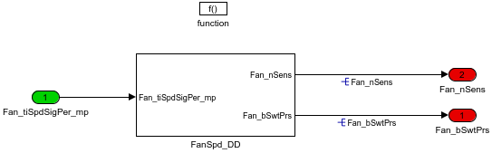

#### 2.1.1.FanSpd_DD

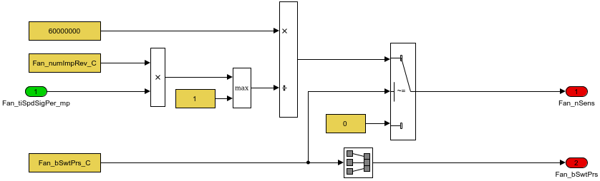

Fan_bSwtPrs表示有无转速传感器，0无，1有。

Table. 输入信号

|  |  |  |  |  |  |  |  |
| --- | --- | --- | --- | --- | --- | --- | --- |
| Name | Min | Max | Width | Description | Object Class | Typedef | Unit |
| Fan_tiSpdSigPer_mp | 0.0 | 6553.0 | -1.0 |  |  | Period_us | us |

Table. 输出信号

|  |  |  |  |  |  |  |  |  |
| --- | --- | --- | --- | --- | --- | --- | --- | --- |
| Name | Min | Max | Width | Description | Object Class | Typedef | DefaultValue | Unit |
| Fan_bSwtPrs | 0.0 | 1.0 | -1.0 | Fan_bSwtPrs ==0 fan sensor is not installed/==1 sensor stalled |  | boolean | 1.0 |  |
| Fan_nSens | 0.0 | 32767.0 | -1.0 |  |  | FanSpd_rpm | 1000.0 | rpm |

Table. 监控量

|  |  |  |  |  |  |  |  |  |
| --- | --- | --- | --- | --- | --- | --- | --- | --- |
| Name | Min | Max | Width | Description | Object Class | Typedef | DefaultValue | Unit |

Table. 标定量

|  |  |  |  |  |  |  |  |  |
| --- | --- | --- | --- | --- | --- | --- | --- | --- |
| Name | Min | Max | Width | Description | Object Class | Typedef | DefaultValue | Unit |
| Fan_numImpRev_C | 0.0 | 65535.0 | -1.0 | number of pulses per revolution |  | Counter_num | 100.0 |  |
| Fan_bSwtPrs_C | 0.0 | 1.0 | -1.0 |  |  | boolean | 1.0 |  |

Table. 系统常量

|  |  |  |  |  |  |
| --- | --- | --- | --- | --- | --- |
| Name | Value | Description | Object Class | Typedef | Unit |