**FanSpd_VD**

## 1.基本信息

### 1.1.目的

冷却风扇转速滤波处理和转速监测。

### 1.2.参考

FanCtl_Spd；Fans_ClgDem ；Fans_trq；Fan_DD；Fan_VD；FanSpd_DD；FanSpd_VD

## 2.功能描述

### 2.1.Top level overview

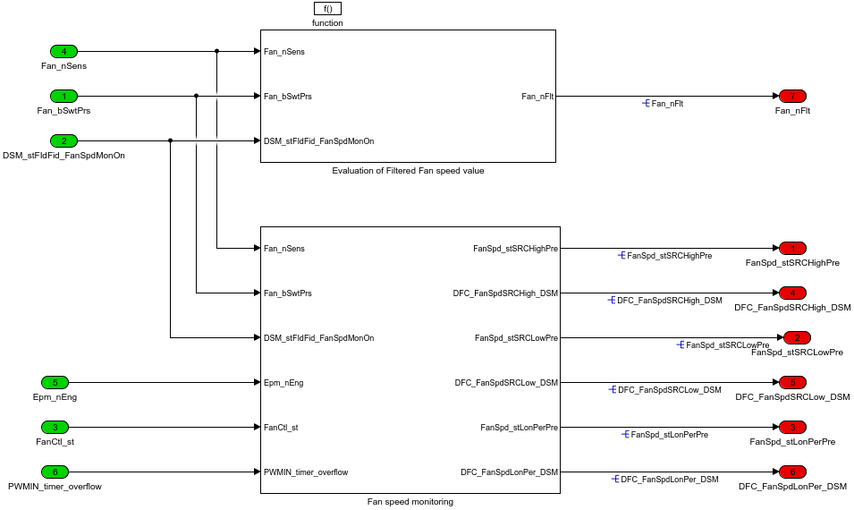

上边子模块是风扇转速滤波，下面子模块是风扇转速监测。

#### 2.1.1.Evaluation of Filtered Fan speed value

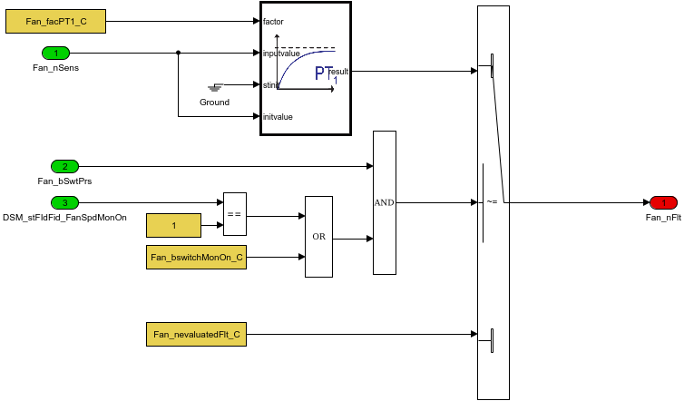

风扇转速滤波处理。

#### 2.1.2.Fan speed monitoring

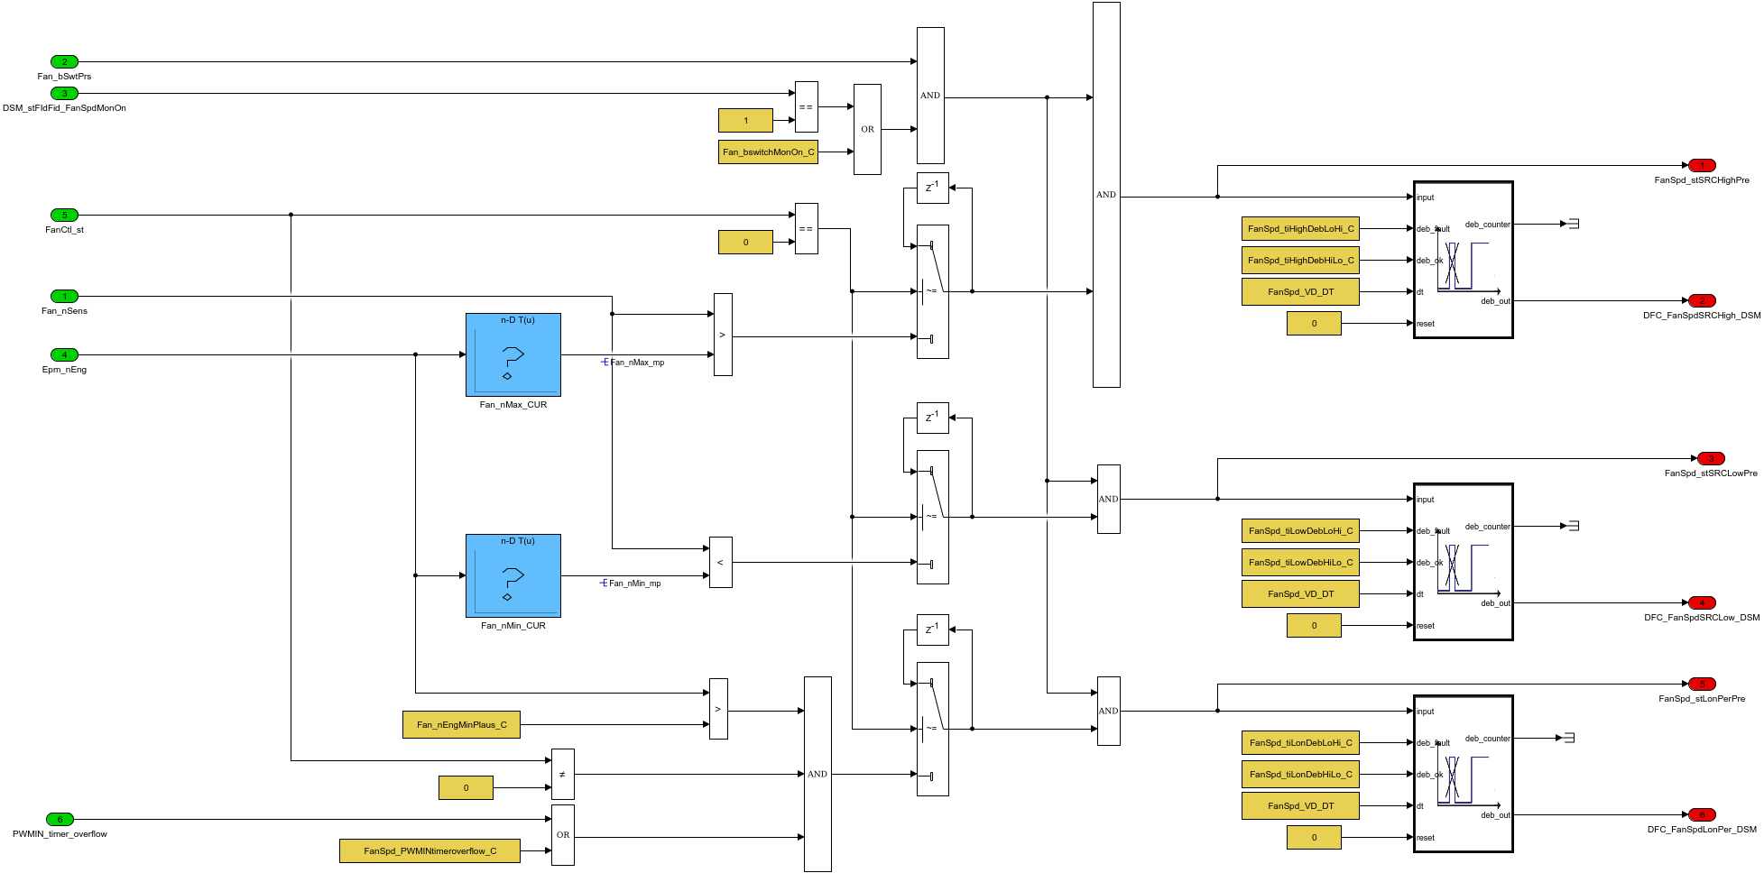

风扇转速监测和故障处理。FanSpd_stSRCLowPre表示初步错误。DFC_FanSpdSRCLow_DSM传到DFC故障处理。

Table. 输入信号

|  |  |  |  |  |  |  |  |
| --- | --- | --- | --- | --- | --- | --- | --- |
| Name | Min | Max | Width | Description | Object Class | Typedef | Unit |
| Fan_bSwtPrs | 0.0 | 1.0 | -1.0 | Fan_bSwtPrs ==0 fan sensor is not installed/==1 sensor stalled |  | boolean |  |
| DSM_stFIdFid_FanSpdMonOn | 0.0 | 255.0 | -1.0 | monitoring signal |  | State_uint8 |  |
| FanCtl_st | 0.0 | 255.0 | -1.0 |  |  | State_uint8 |  |
| Fan_nSens | 0.0 | 32767.0 | -1.0 |  |  | FanSpd_rpm | rpm |
| Epm_nEng | 0.0 | 6000.0 | -1.0 | Engine speed |  | EngSpeed_rpm | rpm |
| PWMIN_timer_overflow | 0.0 | 65535.0 | -1.0 |  |  | State_uint16 |  |

Table. 输出信号

|  |  |  |  |  |  |  |  |  |
| --- | --- | --- | --- | --- | --- | --- | --- | --- |
| Name | Min | Max | Width | Description | Object Class | Typedef | DefaultValue | Unit |
| FanSpd_stSRCHighPre | 0.0 | 1.0 | -1.0 |  |  | boolean | 0.0 |  |
| FanSpd_stSRCLowPre | 0.0 | 1.0 | -1.0 |  |  | boolean | 0.0 |  |
| FanSpd_stLonPerPre | 0.0 | 1.0 | -1.0 |  |  | boolean | 0.0 |  |
| DFC_FanSpdSRCHigh_DSM | 0.0 | 1.0 | -1.0 | after debouncing FanSpd_stSRCHighPre |  | boolean | 0.0 |  |
| DFC_FanSpdSRCLow_DSM | 0.0 | 1.0 | -1.0 | after debouncing FanSpd_stSRCLowPre |  | boolean | 0.0 |  |
| DFC_FanSpdLonPer_DSM | 0.0 | 1.0 | -1.0 | after debouncing FanSpd_stLonPerPre |  | boolean | 0.0 |  |
| Fan_nFlt | 0.0 | 32767.0 | -1.0 |  |  | FanSpd_rpm | 0.0 | rpm |

Table. 监控量

|  |  |  |  |  |  |  |  |  |
| --- | --- | --- | --- | --- | --- | --- | --- | --- |
| Name | Min | Max | Width | Description | Object Class | Typedef | DefaultValue | Unit |
| Fan_nMax_mp | 0.0 | 32767.0 | -1.0 |  |  | FanSpd_rpm | 3000.0 | rpm |
| Fan_nMin_mp | 0.0 | 32767.0 | -1.0 |  |  | FanSpd_rpm | 0.0 | rpm |

Table. 标定量

|  |  |  |  |  |  |  |  |  |
| --- | --- | --- | --- | --- | --- | --- | --- | --- |
| Name | Min | Max | Width | Description | Object Class | Typedef | DefaultValue | Unit |
| Fan_nEngMinPlaus_C | 0.0 | 3000.0 | -1.0 |  |  | EngSpeed_rpm | 800.0 | rpm |
| FanSpd_tiHighDebLoHi_C | 0.0 | 65535.0 | -1.0 | Parameter structure for debounce times high / Time for a Low to High transition |  | Debounce_ms | 300.0 | ms |
| FanSpd_tiHighDebHiLo_C | 0.0 | 65535.0 | -1.0 | Parameter structure for debounce times high / Time for a High to Low transition |  | Debounce_ms | 300.0 | ms |
| FanSpd_tiLowDebLoHi_C | 0.0 | 65535.0 | -1.0 | Parameter structure for debounce times low / Time for a Low to High transition |  | Debounce_ms | 300.0 | ms |
| FanSpd_tiLowDebHiLo_C | 0.0 | 65535.0 | -1.0 | Parameter structure for debounce times low / Time for a High to Low transition |  | Debounce_ms | 300.0 | ms |
| FanSpd_tiLonDebLoHi_C | 0.0 | 65535.0 | -1.0 | Parameter structure for debounce times LonPer/ Time for a Low to High transition |  | Debounce_ms | 300.0 | ms |
| FanSpd_tiLonDebHiLo_C | 0.0 | 65535.0 | -1.0 | Parameter structure for debounce times LonPer / Time for a High to Low transition |  | Debounce_ms | 300.0 | ms |
| Fan_facPT1_C | 0.0 | 99.9985 | -1.0 | Time constant of PT1 filter for fan speed |  | PT_fac | 50.0 |  |
| Fan_nevaluatedFlt_C | 0.0 | 32767.0 | -1.0 | function is evaluated |  | FanSpd_rpm | 0.0 | rpm |
| Fan_nMax_CUR | 0.0 | 32767.0 | 25.0 | engine speed look up table obtain fan speed max |  | FanSpd_rpm | [0 6 12 16 20 24 28 32 36 40 44 48 52 56 60 64 68 72 76 80 84 88 92 96 100] | rpm |
| Fan_nMax_CURX | 0.0 | 3000.0 | 25.0 | engine speed input mp to mmax fan speed |  | EngSpeed_rpm | [0 6 12 16 20 24 28 32 36 40 44 48 52 56 60 64 68 72 76 80 84 88 92 96 100] | rpm |
| Fan_nMin_CUR | 0.0 | 32767.0 | 25.0 | engine speed look up table obtain fan speed min |  | FanSpd_rpm | [0 6 12 16 20 24 28 32 36 40 44 48 52 56 60 64 68 72 76 80 84 88 92 96 100] | rpm |
| Fan_nMin_CURX | 0.0 | 3000.0 | 25.0 | engine speed input mp to min fan speed |  | EngSpeed_rpm | [0 6 12 16 20 24 28 32 36 40 44 48 52 56 60 64 68 72 76 80 84 88 92 96 100] | rpm |
| FanSpd_PWMINtimeroverflow_C | 0.0 | 1.0 | -1.0 | If the PWMIN_timer_overflow used calibrated to 1 |  | boolean | 0.0 |  |
| Fan_bswitchMonOn_C | 0.0 | 1.0 | -1.0 | DINH_stFId.FId_FanSpdMonOn Under influence Fan speed |  | boolean | 0.0 |  |

Table. 系统常量

|  |  |  |  |  |  |
| --- | --- | --- | --- | --- | --- |
| Name | Value | Description | Object Class | Typedef | Unit |