**Fan_DD**

## 1.基本信息

### 1.1.目的

根据电池修正系数和冷却风扇开度状态得到风扇开度占空比。

### 1.2.参考

FanCtl_Spd；Fans_ClgDem ；Fans_trq；Fan_DD；Fan_VD；FanSpd_DD；FanSpd_VD。

## 2.功能描述

### 2.1.Top level overview

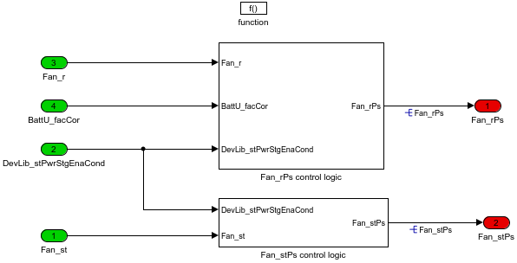

#### 2.1.1.Fan_rPs control logic

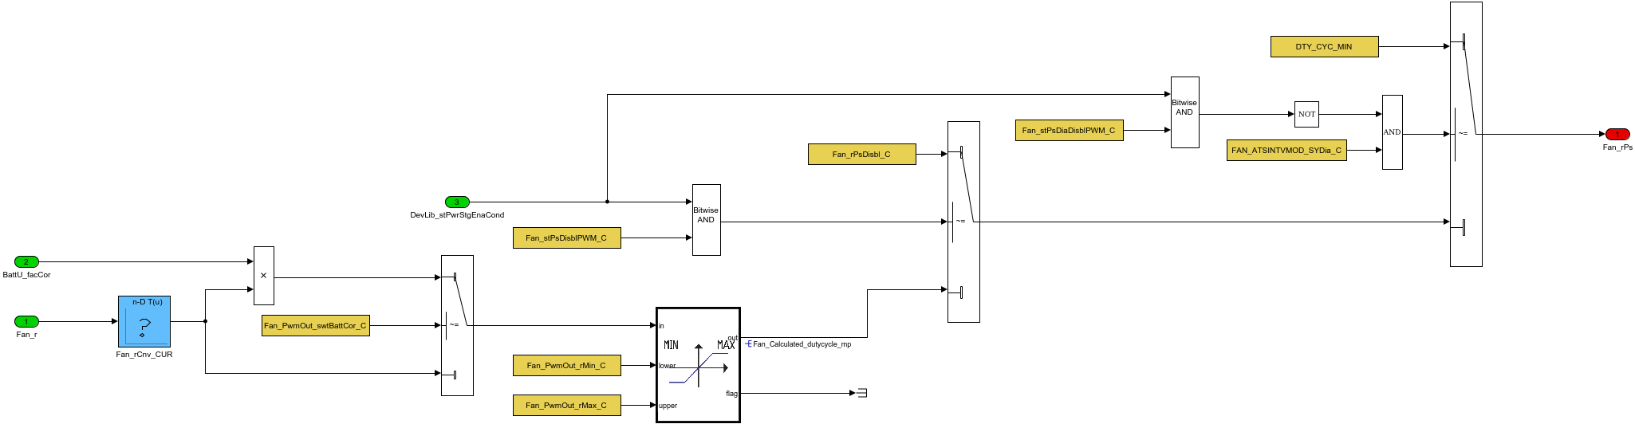

风扇开度乘以电池修正系数，经过限制处理得到最终风扇开度占空比。

DevLib_stPwrStgEnaCond：是与功率级停用相关的控制诊断信号。

#### 2.1.2.Fan_stPs control logic

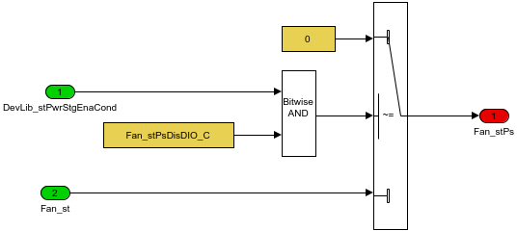

FanCtl_Spd传过来的风扇开度状态。

Table. 输入信号

|  |  |  |  |  |  |  |  |
| --- | --- | --- | --- | --- | --- | --- | --- |
| Name | Min | Max | Width | Description | Object Class | Typedef | Unit |
| Fan_st | 0.0 | 1.0 | -1.0 |  |  | boolean |  |
| DevLib_stPwrStgEnaCond | 0.0 | 65535.0 | -1.0 | Control unit status relevant to power stage deactivation/error diagnosis |  | State_uint16 |  |
| Fan_r | 0.0 | 100.0 | -1.0 | Actuator setpoint value for the first fan output |  | DutyCycle_rate | % |
| BattU_facCor | -32.0 | 31.9 | -1.0 | Battery correction factor |  | Factor |  |

Table. 输出信号

|  |  |  |  |  |  |  |  |  |
| --- | --- | --- | --- | --- | --- | --- | --- | --- |
| Name | Min | Max | Width | Description | Object Class | Typedef | DefaultValue | Unit |
| Fan_rPs | 0.0 | 100.0 | -1.0 | Fan duty cycle |  | DutyCycle_rate | 0.0 | % |
| Fan_stPs | 0.0 | 1.0 | -1.0 | fan output state |  | boolean | 0.0 |  |

Table. 监控量

|  |  |  |  |  |  |  |  |  |
| --- | --- | --- | --- | --- | --- | --- | --- | --- |
| Name | Min | Max | Width | Description | Object Class | Typedef | DefaultValue | Unit |
| Fan_Calculated_dutycycle_mp | 0.0 | 100.0 | -1.0 | out duty cycle value is limited between maximum and minimum |  | DutyCycle_rate | 0.0 | % |

Table. 标定量

|  |  |  |  |  |  |  |  |  |
| --- | --- | --- | --- | --- | --- | --- | --- | --- |
| Name | Min | Max | Width | Description | Object Class | Typedef | DefaultValue | Unit |
| Fan_rCnv_CURY | 0.0 | 100.0 | 11.0 | The set-point value Fan_r%output duty cycle value use Fan_rCnv%_CUR |  | DutyCycle_rate | [0 10 20 30 40 50 60 70 80 90 100] | % |
| Fan_rCnv_CURX | 0.0 | 100.0 | 11.0 | Fan speed set point |  | DutyCycle_rate | [0 10 20 30 40 50 60 70 80 90 100] | % |
| Fan_PwmOut_swtBattCor_C | 0.0 | 1.0 | -1.0 | Class Instance for PWM Output / Switch to enable battery correction |  | boolean | 0.0 |  |
| Fan_stPsDisblPWM_C | 0.0 | 65535.0 | -1.0 | Application parameter array to disable PWM powerstage |  | State_uint16 | 1.0 |  |
| Fan_stPsDiaDisblPWM_C | 0.0 | 65535.0 | -1.0 | Application parameter array to Disable diagnosis of PWM |  | State_uint16 | 2.0 |  |
| Fan_PwmOut_rMax_C | 0.0 | 100.0 | -1.0 | The corrected duty cycle value is limited a maximum value |  | DutyCycle_rate | 100.0 | % |
| Fan_PwmOut_rMin_C | 0.0 | 100.0 | -1.0 | The corrected duty cycle value is limited a minimum value |  | DutyCycle_rate | 0.0 | % |
| Fan_rPsDisbl_C | 0.0 | 100.0 | -1.0 | substitute output duty cycle while locking condition for PWM fan stage is active |  | DutyCycle_rate | 0.0 | % |
| Fan_stPsDisDIO_C | 0.0 | 65535.0 | -1.0 | Application parameter array to disable powerstage of DIO |  | State_uint16 | 1.0 |  |
| FAN_ATSINTVMOD_SYDia_C | 0.0 | 1.0 | -1.0 | Diagnostic interface switch |  | boolean | 0.0 |  |

Table. 系统常量

|  |  |  |  |  |  |
| --- | --- | --- | --- | --- | --- |
| Name | Value | Description | Object Class | Typedef | Unit |
| DTY_CYC_MIN | 0.0 | the minimum duty cycle |  | DutyCycle_rate | % |