1. **C3D8约束3个面的对应的法向位移 ☑**

matlab C3D8_ 3surf

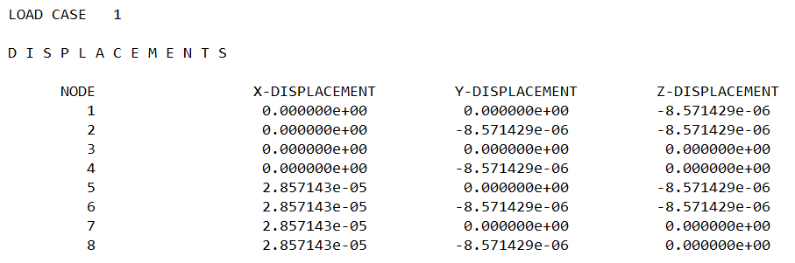

abaqus C3D8-P-wwt

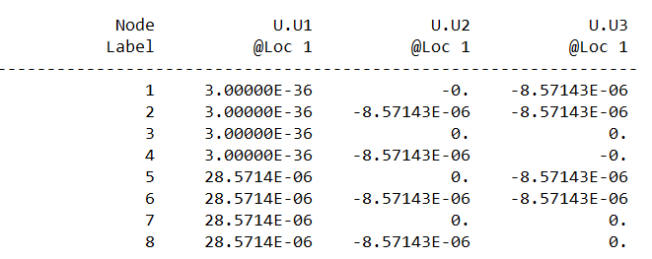

**二、C3D8约束一个面的4个顶点的3个自由度** 🗵

matlab C3D8_4np

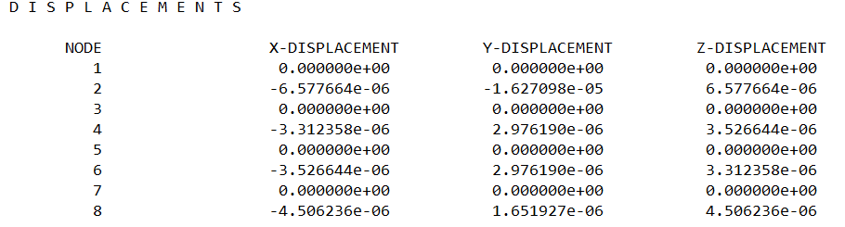

abaqus C3D8-wwt-fourpoint-Static-Copy

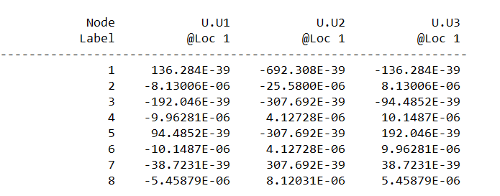

**三、C3D20 约束4个顶点3个自由度** 🗵

共12个自由度被约束 还剩48个自由度

静力学对比

abaqus Job-C3D20-Fix4p

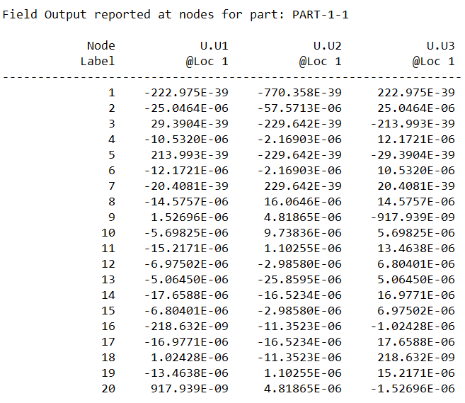

matlab C3D20_4np.in

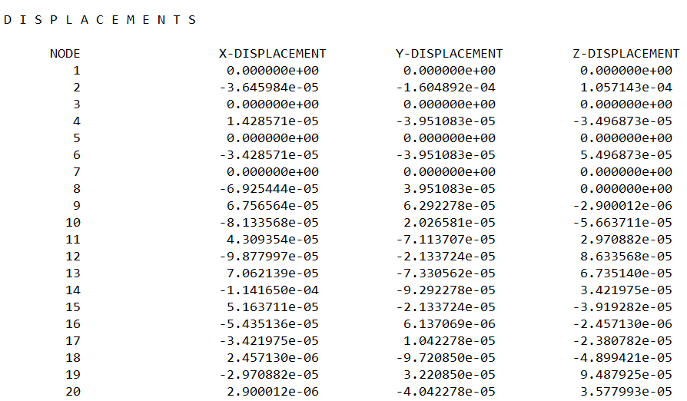

特征值对比：

matlab C3D20_4np.in

刚度rank_stiff = 46有刚体平移的特征值

质量阵 协调质量阵 rank_stiff = 24 特征值负的 一个0频

质量阵 集中质量阵 rank_stiff = 48 特征值负的 两个0频

ansys

刚度rank_stiff= 46 有刚体平移的特征值

质量 rank_mass = 39

abaqus Job-C3D20-Fix4p-wwt-Freq.inp

刚度 rank_stiff = 48

ansys frequency 结果

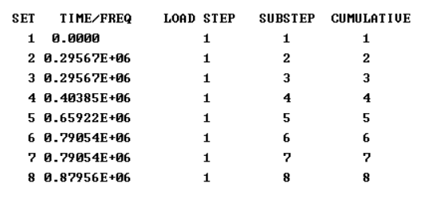

abaqus frequency结果

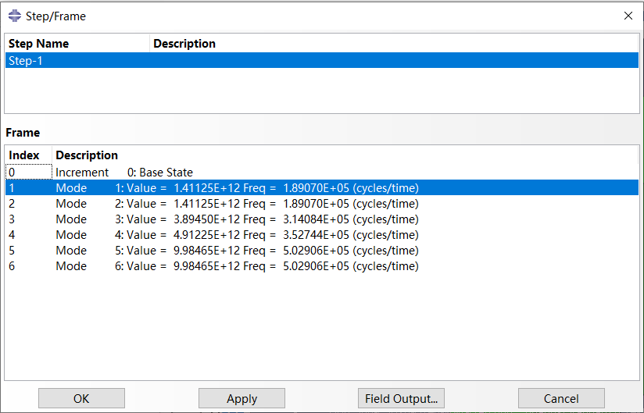

matlab frequency 结果

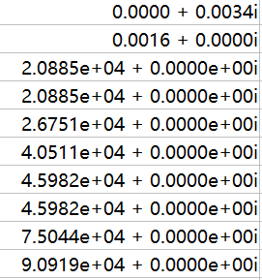

**四、C3D20 约束3个面的对应的法向位移 ☑**

matlab frequency计算结果与 abaqus 一致

matlab C3D20_3surf

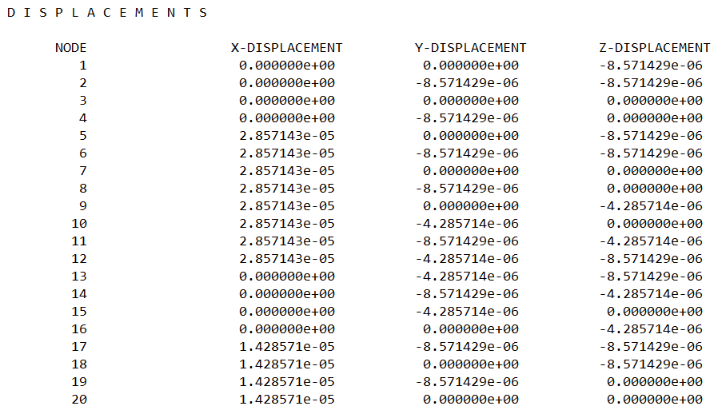

abaqus Job-C3D20-P-wwt

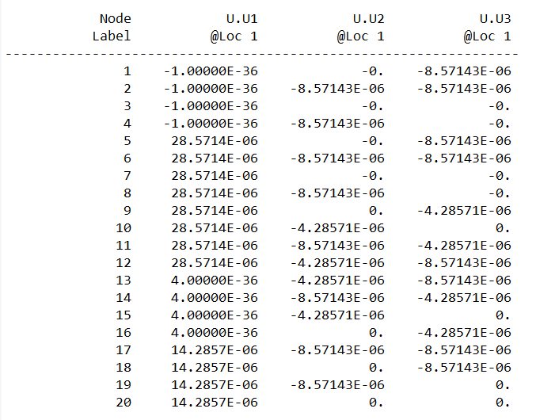

五、悬臂梁

abaqus Job-C3D20-cantilever-beam

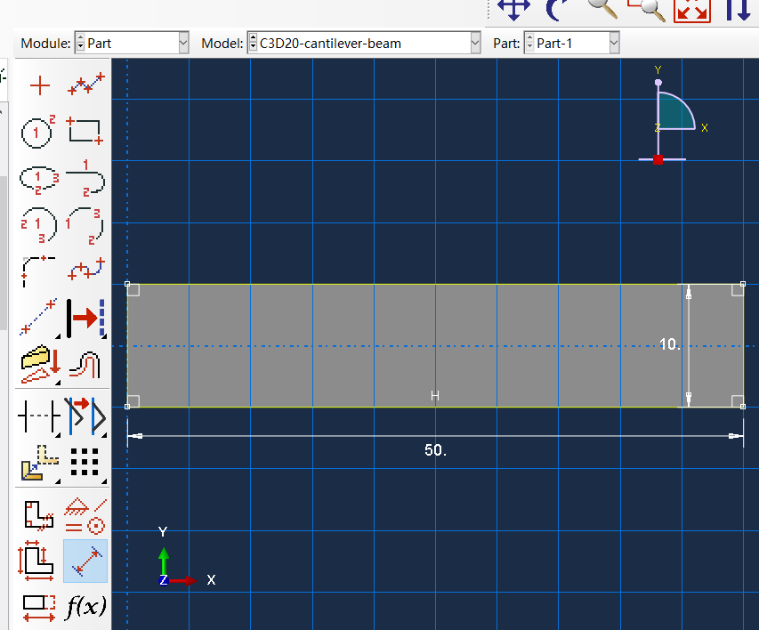

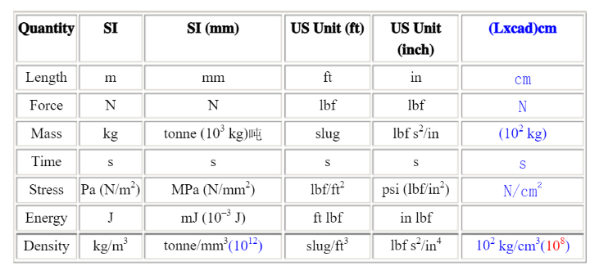

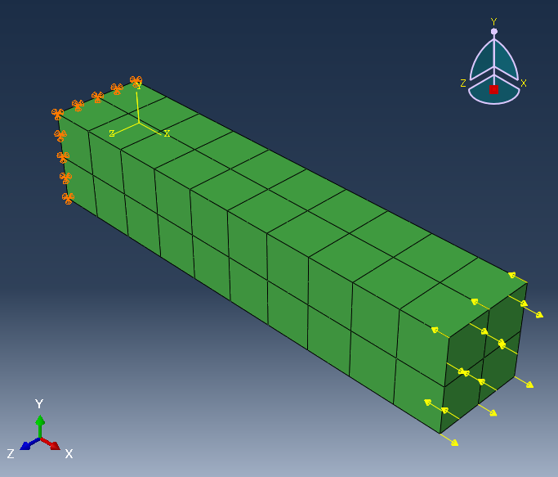

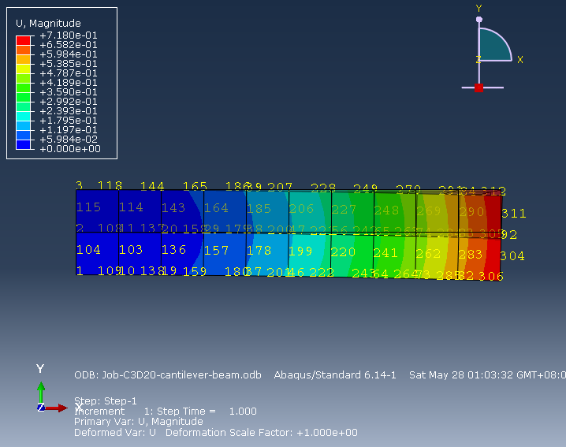

1 2 3 4 5

6 7 8

9 10 11 12 13

14 15 16

17 18 19 20 21

-833.33[1 5] [93 99] 1

3333.3[2 4 6 8] [310 320 311 319] 2

-1666.7[3] [96] 3

6666.7[7] [309] 4

-3333.3[14 16 18 20] [304 315 301 314] 5

-6666.7[15] [302] 6

833.33[17 21] [91 97] 7

1666.7[19] [94] 8

*Nset, nset=Set-31, instance=Part-1-1

93, 99

*Nset, nset=Set-32, instance=Part-1-1

310, 320, 311, 319

*Nset, nset=Set-33, instance=Part-1-1

96

*Nset, nset=Set-34, instance=Part-1-1

309

*Nset, nset=Set-35, instance=Part-1-1

304, 315, 301, 314

*Nset, nset=Set-36, instance=Part-1-1

302

*Nset, nset=Set-37, instance=Part-1-1

91, 97

*Nset, nset=Set-38, instance=Part-1-1

94

93 310 96 320 99

311 309 319

92 303 95 316 98

304 302 315

91 301 94 314 97