Nhân viên:

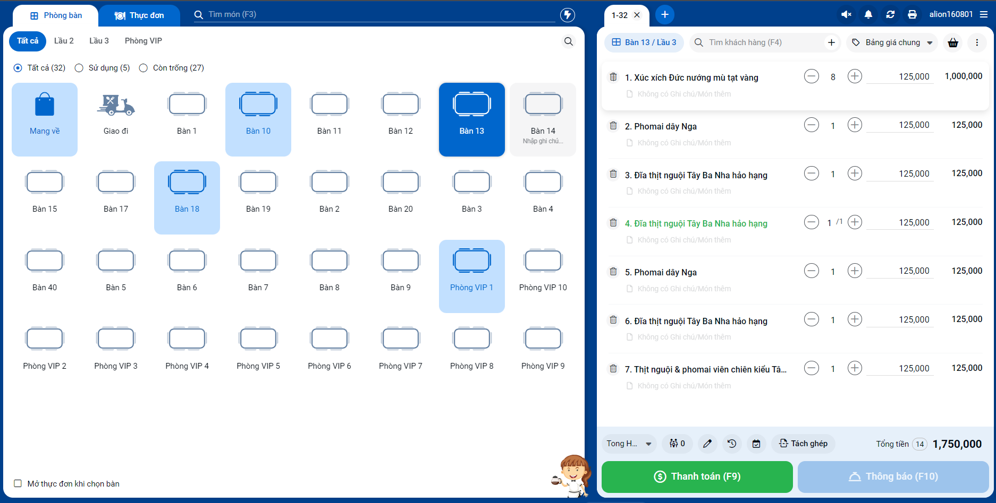

Đầu bếp:

Lễ tân:

