**Merge sort sorting technique**

Merge sort is an sorting technique were divide and conquer rule is been applied.As per the rule the whole problem is divided into sub problems and solved indivisually and then merged to get the solution for a problem**.**

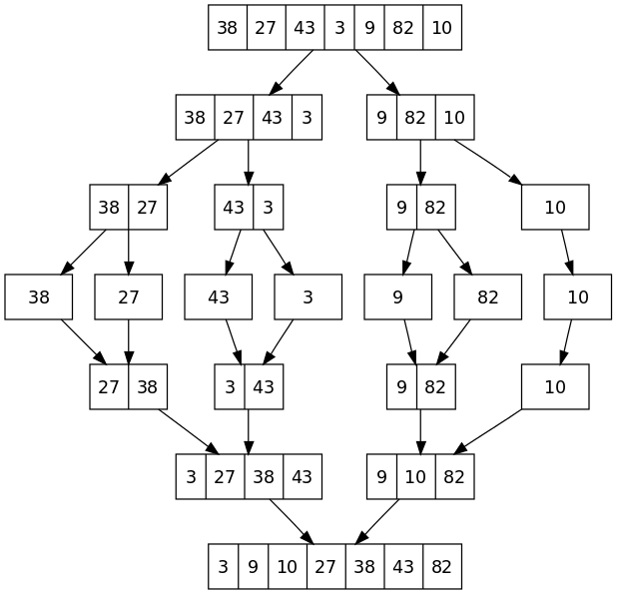

**Working of merge sort:**

1. **Whole array to be divided into sub arrays till the sub array consist of single element.**
2. **Once we reach to the end the left array is compared with right array and merged which are sorted.**
3. **So this steps are executed until all the sub arrays are merged and sorted list is been formed.**

**Function to merge (pseudo code):**

Merge(L,R,A) // **3 arrays left,right,unsorted array**

{

Variables nl,nr; //**num of elements in left and right array**

I,j,k ->0 //**initial values**

While (i<nl && i<nr)

{

If(l[i]<r[j])

A[k]==l[i];

I+1;

K+1;

}

Else

{

A[k]=r[j];

J+1;

K+1;

}

While(i<nl)

{

A[k]=l[i];

K+1;

I+1;

}

While(j<nr)

{

A[k]=r[j];

K+1;

J+1;

}

**Function for sorting (pseudo code)**

Merge sort(A)

{

Variable n //**number of elements in array A**

If(n/2)

Return;

Else

Mid=n/2;

Left array -> from index 0 to mid-1;

Right array ->from mid to n-1;

For(i=0;i<mid-1;i++)

Left[i]=A[i];

For(i=mid;i<n-1;i++)

Right[i-mid]=A[i];

Mergesort(left); //**calling function recursively**

Mergesort(right);

Merge(l,r,A); //**calling merge function**