Lionbridge AI | AI Training Data (AIT)
AIT Tracker
PM Step-by-Step Guide
Set up a SharePoint tracker for any project in about 10 minutes — no admin ticket, no Excel file to babysit.
June 2026 · v1.0

What this replaces
Until now every project tracked work in a shared Excel file on SharePoint. With ~25 people editing at once those files broke: sync conflicts, millions of blank rows, slow formulas, and five different spellings of the same status. The AIT Tracker moves each project into SharePoint Lists — a real database with an Excel-like grid — created by you, through a wizard, in three steps.
- You need — your normal Lionbridge Microsoft 365 account, the project's Excel tracker (or nothing, if you start from a standard template), and the URL of the project's SharePoint site.
- You do NOT need — Python, IT support, or anyone in another timezone.

Step 1 — Launch the wizard and choose your tracker
Double-click 'Start_Tracker_Wizard' (shortcut provided by the AIT program team, or the hosted URL once available). Your browser opens the wizard:
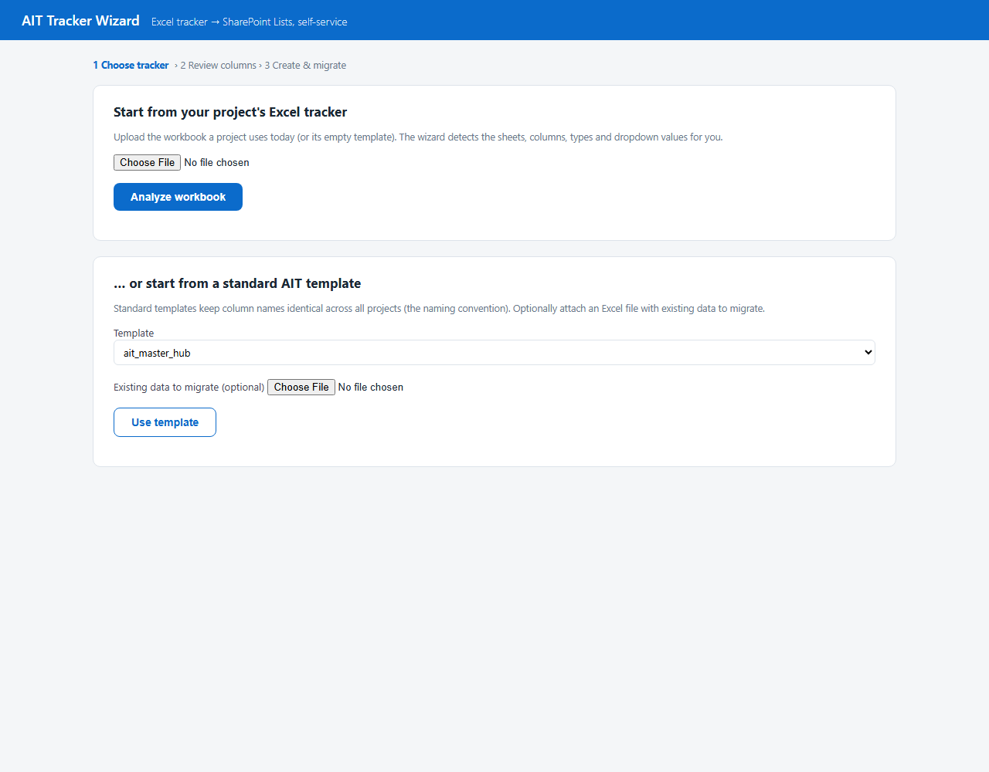
Step 1 — upload the project's Excel tracker, or pick a standard AIT template

Choose one of two paths
- Upload the project's Excel tracker — the wizard reads every sheet and detects columns, types and dropdown values automatically. Use this when the project already has a tracker (even an empty template).
- Start from a standard AIT template — instant, and keeps column names identical to every other project (our naming convention). Optionally attach an Excel file whose data should be migrated in.
Click Analyze workbook (or Use template). Analysis of a large tracker takes a few seconds.

Step 2 — Review what was detected
The wizard shows one card per sheet it found. Nothing has been created yet — this screen is where you tidy the proposal before it becomes a tracker.
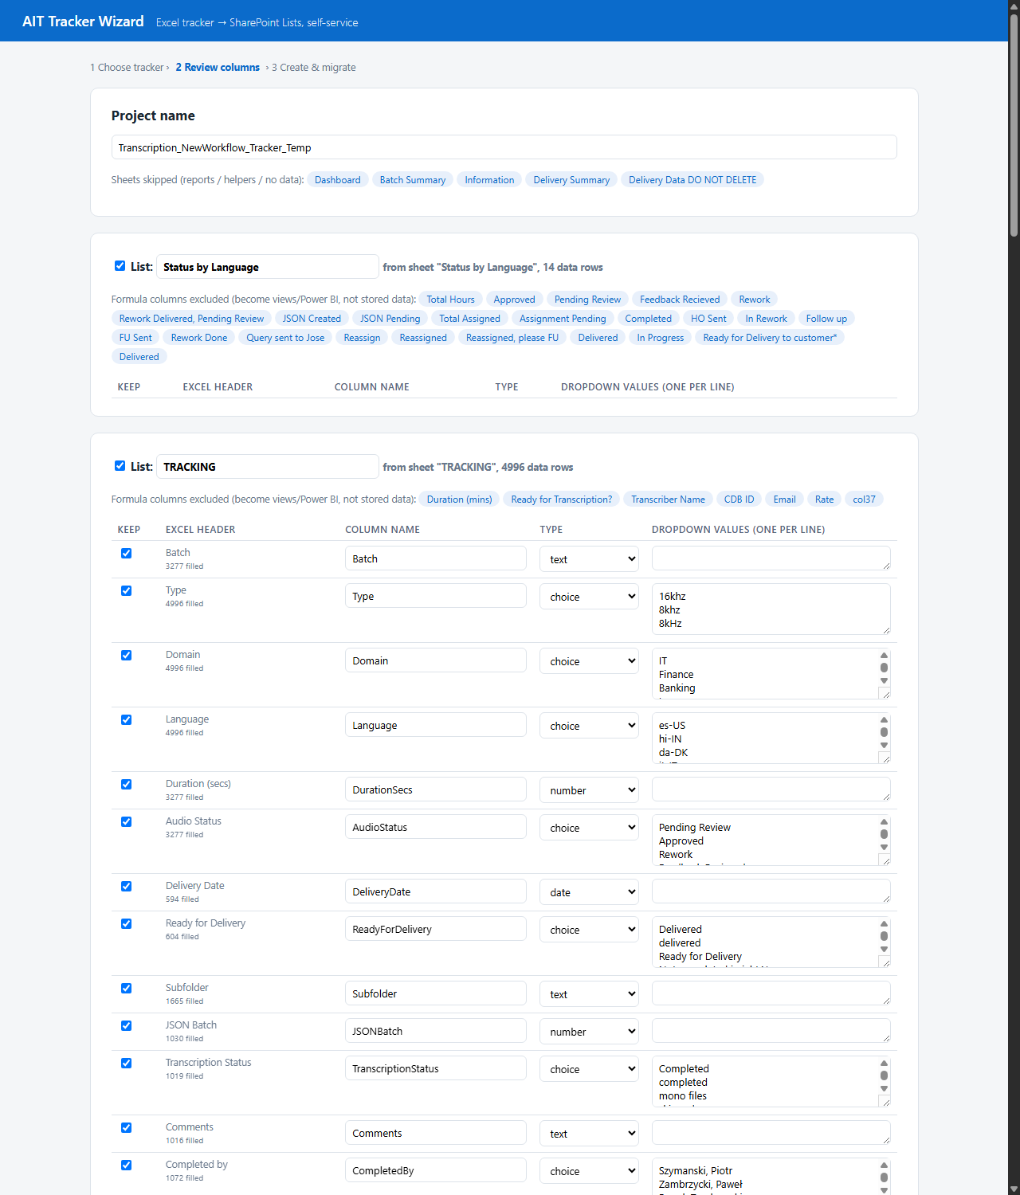
Step 2 — every detected column with its type, dropdown values, and fill count

What to check on this screen
- Keep checkboxes — untick sheets or columns you don't want. Report sheets (Dashboard, Batch Summary…) are already excluded automatically — they become views and Power BI later.
- Column names — rename to something clean; these become the column headers everyone sees.
- Type — text, multiline, choice (dropdown), date, or number. The wizard guesses from the data; fix any it got wrong.
- Dropdown values — for choice columns, the detected values are listed one per line. Delete duplicates and typos here (e.g. keep 'Completed', remove 'completed') — from then on the tracker only offers the clean values.
- Formula columns — shown as grey chips ('excluded — become views/Power BI'). Their results are calculated from other columns, so they are not stored as data.
Click Continue when it looks right.

Step 3 — Preview, then create the tracker
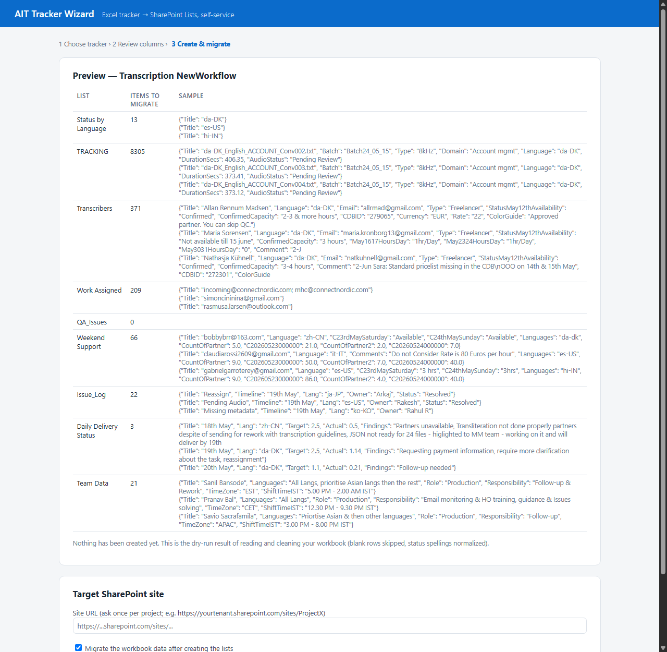
Step 3 — dry-run preview of exactly what will be migrated, then the target site
- Preview table — shows how many items will be migrated into each list, with sample rows. Blank rows are skipped and status spellings are normalized automatically.
- Target SharePoint site — paste the project site URL, e.g. https://yourtenant.sharepoint.com/sites/ProjectX.
- Create tracker — one click. A progress log streams on screen: lists created, then data migrated in batches.

First-time sign-in
The first run shows a message like: 'To sign in, use a web browser to open microsoft.com/devicelogin and enter the code ABC-DEF-GHI'. Open the link, enter the code, sign in with your normal work account. This happens once; afterwards your sign-in is remembered.

Step 4 — Your tracker is live: what the team sees
The illustration below shows a project tracker once created (mock-up of the SharePoint Lists interface, populated with rows from a real migrated tracker).
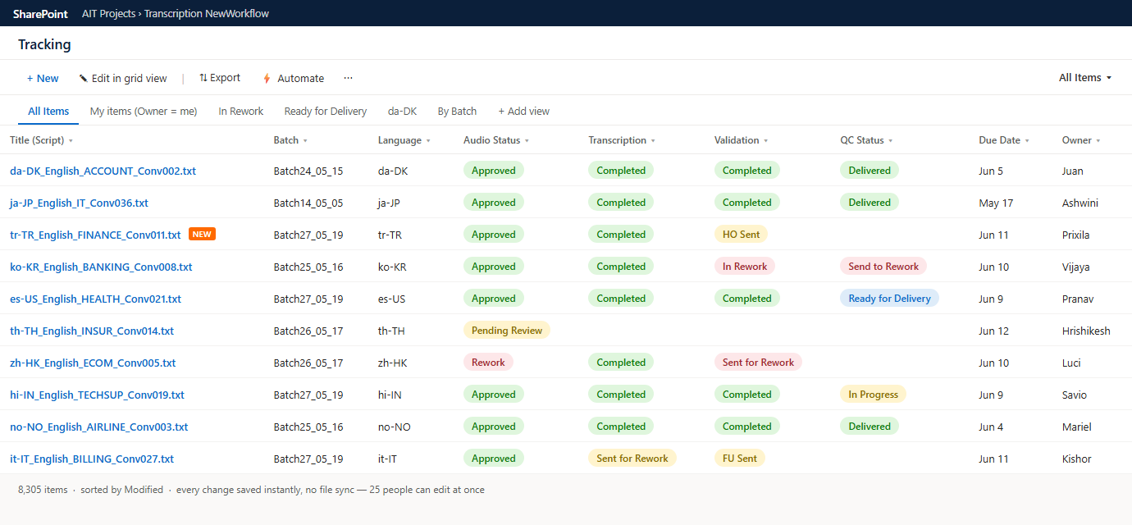
The live Tracking list — Excel-like grid, enforced status dropdowns, saved views (mock-up)

Everyday actions
- Edit — click any cell, or use 'Edit in grid view' for fast Excel-style editing of many rows. Every change saves instantly — there is no file, so nothing to sync or corrupt, and 25 people can edit at the same time.
- Views — the tabs across the top ('My items', 'In Rework', 'da-DK', 'By Batch') are saved queries. Anyone can add one with '+ Add view' — they never break the data.
- Statuses — are dropdowns. 'completed' vs 'Completed' can never happen again.
- Export — 'Export' gives a live read-only Excel connection for anyone who wants to slice data in a workbook — without endangering the tracker.
- Automate — notification rules ('email me when Severity = Critical') in two clicks; bigger flows (risk alerts, intake forms) are set up once per program in Power Automate.

Accountability built in
Selecting an item opens its details, including full version history — the 'Arun updated ABS' feed the team asked for:
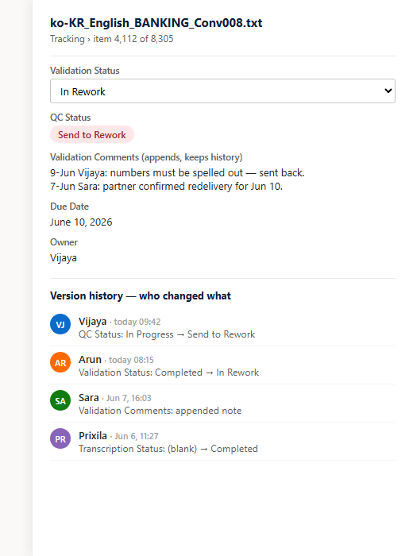
Item panel with version history — every change, who and when (mock-up)

Tips for the first week
- Run in parallel — keep the old Excel read-only for a week while the team works in the list; compare, then retire the file.
- Create role views early — one view per language lead and a 'Blocked/In Rework' view for the PM keeps everyone out of each other's way.
- Comments — comment columns append with date and author automatically (the old '20-Sep Sara:' convention, but enforced).
- Big lists are fine — 8,000+ items work smoothly because key columns are indexed at creation — just keep views filtered (the wizard's defaults are).

Troubleshooting
Symptom | Fix
Site lookup failed | Check the site URL — it must be the site root (…/sites/ProjectX), not a folder or file link. Verify you can open the site in the browser.
Sign-in code expired | Re-run the step; a fresh code is generated. Codes last ~15 minutes.
'List already exists' | The wizard is re-runnable: existing lists are kept and missing columns added. Items are not duplicated unless you migrate the same file twice.
A column came in as text but should be a dropdown | List settings → edit the column → Choice. Existing values are kept.
Permission denied creating lists | You need at least Member rights on the target site. Ask the site owner, or the AIT program team.

Questions or a tracker shape the wizard can't handle? Contact the AIT tracker program team — every schema you create is saved automatically and can be turned into a shared template for the next project.

