Assignment 2 - Solved Answers

Q1: =IFERROR(VLOOKUP(D2,Products!$A$2:$D$4,2,FALSE),"Not Found")

Q2: =IFERROR(VLOOKUP(D2,Products!$A$2:$D$4,3,FALSE),"Not Found")

Q3: =INDEX(Products!$B$2:$B$4,MATCH(D2,Products!$A$2:$A$4,0))

Q4 Answer: 2

Q5 Answer: 4

Q6 Answer: 61000

Q7 Answer: 6

Q8 Answer: 1
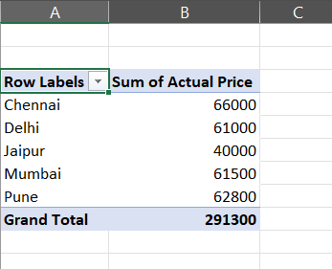
Q9

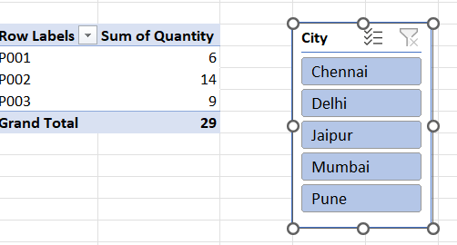
Q10

