**Lyceum of Subic Bay**

**Lot 73, Central Business District, SBFZ**

**College of Engineering**

LYCEUM OF SUBIC BAY

COLLEGE OF ENGINEERING

Documentation of Project Proposal

“TIC-TAC-TOE “

A Software Development Proposal

In Partial Fulfillment of Requirement

For Software Engineering

**Submitted by:**

Lioneil Balois

Phyll Aaron Sereño

BSCpE-III

**Submitted to:**

Ms. Paula B. Antonio

School Year 2020-2021

**TABLE OF CONTENTS**

# PART I

# Introduction

A. System Overall Description ------------------------------------------------

B. Scope and Purpose of Software Development ---------------------------

C. Project Objectives ------------------------------------------------------------

1. Objectives

2. Major functions

3.Acceptance Criteria

1. Project Resources ------------------------------------------------------------

1. People

2.Hardware

3.Software

4.Special Resources

1. Project Cost Estimations ----------------------------------------------------

# II. Application Design

1. Methodology ------------------------------------------------------------------
   1. Paradigm Employed
   2. Proposed Programming Language to be Used
   3. Conceptual Data Model (ERD)
2. System Model -----------------------------------------------------------------

1. Data Flow Diagram

2. Program Structure

1. Algorithms and Flowcharts --------------------------------------------------

1. **Results and Findings** -------------------------------------------------------------

* 1. Software Evaluation and Test Results
  2. Software Quality Metrics

1. **Summary, Conclusions and Recommendation** -------------------------------

1. **Bibliography** -------------------------------------------------------------------------

**PART II: USER MANUAL**

# I. Introduction

1. Software Uses ------------------------------------------------------------------
2. Hardware Requirements ------------------------------------------------------
3. Definition of Terms -----------------------------------------------------------

# II. Software Environment

A. Main Screen --------------------------------------------------------------------

B. Menus and Work Area --------------------------------------------------------

**C.** Command Buttons -------------------------------------------------------------

# III. Procedures in Working with the Software

1. Data Entry -----------------------------------------------------------------------
2. Data Access ---------------------------------------------------------------------
3. Report Generation --------------------------------------------------------------

**IV. Sample Output of the System**

**I. Introduction**

**A. System Overall Description**

X-O-X is a windows application that allows users to play Tic-Tac-Toe in offline mode. Aside from playing, it also allows users to read mechanics of the game and change the theme of the application.

The main highlight of the application is the game modes. It has two different game modes; one is the B*asic* and the other is the *Ultimate. Basic* gives experience to the original 3x3 table of the Tic-Tac-Toe while the *Ultimate* is just combination of the 3x3 which have 9x9 table and more complexity to win other than the *Basic.*

**B. Scope and Purpose of Software Development**

The application offers a way in order to play the Tic-Tac-Toe game in offline manner so that players do not have to have multiple units to play. It requires two players and it does not provide a way to play with only one player (AI mode).

It allows players to choose from two game modes which is the *Basic* and the *Ultimate*. And before, after and even in-game, they may learn or read the instructions to win the game.

**C. Project Objectives**

**1. Objectives**

* To produce a windows application prototype that is simple and easy to use.
* To provide an offline mode of playing Tic-Tac-Toe that engage two players facing each other.
* To set two different game modes of Tic-Tac-Toe – classic (3x3) and ultimate (9x9).

**2. Major Functions**

* Learn Mechanics – let users learn the rules or mechanics of the game
* Play 3x3 classic – let users play the classic game mode of Tic-Tac-Toe that is won by getting a three-tile X’s or O’s.
* Play 9x9 ultimate – let users play the ultimate game mode of Tic-Tac-Toe that is based on the classic 3x3 that is also won by getting three-tile X’s or O’s. However, each tile here is composed of a single 3x3 tiles.

**3. Acceptance Criteria**

* Convenient – The users should have no difficulty in accessing and using the application with controls and easily understand the mechanics of the game by giving more direct and graphical representation
* Entertaining – The users should feel the game. They should have a good time while playing the game even it offers complexity based from the traditional Tic-Tac-Toe game, which is playing the *Ultimate* game mode.

**D. People Resources**

**1. People**

* + Developers – The creators and the masterminds of the application. The idea, planning the whole application and designing the interface was done by them. They are also the programmers who developed the application’s logic and all things working under the hood. All the problems were all checked then fixed by the programmers.
  + Users – The players who uses the application and experiences all the offers of the application. These are the targets of the creating of the application. The application is created that may pass their preferences and standards.

**2. Hardware**

* + Hardware used in making the software includes the computer peripherals such as personal computer which is readily available for the proponent. The software is designed to run on windows desktops. The software will run on the display’s resolution (Depends on the device used) 1900x 1080 and 1360x 768 resolution.
  + Processor with 1.6gHz
  + 2Gb RAM
  + 5Gb Free space

**3. Software**

Visual Basic 2019

In creating the application X-O-X, the developers used the Microsoft Visual Basic 2019. An application that is great for creating programmable projects such as the application created.

**4. Special Resources**

* + A desktop or laptop is needed to create the software that requires the use of the Microsoft Visual Basic 2019. It also ideal for storing different files required for the application even the documentations.
  + Internet. Nowadays, we cannot live with internet anymore especially on creating technology-based projects such as programming. It provides good help on doing the coding such as how to use different commands, and how’s of certain programming language.

**E. Project Cost Estimations**

**1. Personnel Cost**

Software Developer ……………………….…………. ₱ 25,000/Month

**2. Hardware Cost**

Computer ………………………………………………………… FREE

Internet ……………………………………………………...……. FREE

Peripherals ……………………………………….…………….… FREE

**3. Software Cost**

Visual Studio ……………………………….……………………. FREE

**4. Documentation**

User Manual …………………………………………………… ₱ 200.00

Document………………………………………………...….…. ₱ 400.00

**Total** ₱ 25, 600.00

**II. Application Design**

**A. Methodology**

**1. Paradigm Employed**

Rapid Application Development or RAD model is the paradigm employed in creating the application. It is chosen for the software development mainly because it allows the process not to require long amount of time; so, it is ideal because the application time-frame for the development is not a lot. In this paradigm, there is a long-term process of planning and more focused on adaptability, as it matches the customer preference while the development continues. The stages on the said model are divided in order to make them achievable and understandable, these phases are:

* Business Modeling – in this phase, the taking of information from the target users, gathered ideas and sources takes place. These data are combined into a useful description of how it will be used when it is processed.
* Data Modeling – All the information gathered during the previous process – Business Modeling, will be analyzed in this phase. The data are grouped on how it will be useful. The quality per group is carefully examined and the relationship among them is defined as well on this phase.
* Process Modeling – In this phase, the data gathered and organized will be converted into required usable information. Also, during this phase, changes and optimization can be done while adding more description to the data objects.
* Application Generation – The information gathered is coded in this phase. The system is created here. The data models before are turned into actual prototype that can be tested.
* Testing and Turnover – In this phase, the prototype is tested and since the previous phases, most elements have already been examined, no major problems will be finding during this phase.

**2. Proposed Programming Language to be Used**

The programming language used in the system is the Visual Basic by Microsoft. It is one of the common programming languages for creating software applications and it is easy to use and understand.

**3. Conceptual Data Model (Entity Relationship Diagram)**

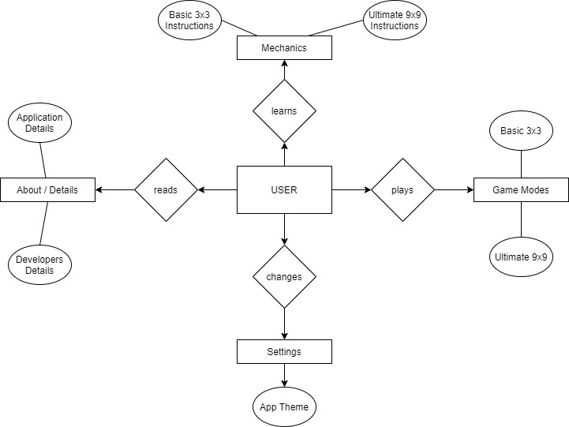

Business Rules

* User learns mechanics
* Mechanics contains basic and ultimate instructions
* User plays game modes
* Game modes divides into basic and ultimate
* User changes settings
* Settings contains app theme selection
* User reads about/details
* About contains application and developer details

**B. System Model**

**1. Data Flow Diagram**

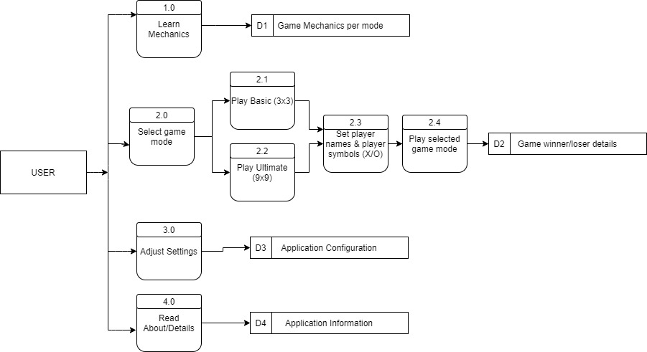

The user will choose among these four main options: (1) Learn Mechanics, (2) Select Game Mode, (3) Adjust Settings and (4) Read About/Details. First option contains the instructions per game mode (basic and ultimate). Second, it is the primary option where user will be picking among two game modes to play. While third option allows user to change application theme and the last will simply let user read details about the application.

**2. Program Structure**

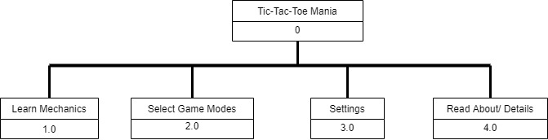

Learn Mechanics module contains the instructions on how to play the game on different modes. Select Game Modes module contains the two game modes of the game which will be played: basic and ultimate. Settings module contains the available controls for the game to adjust. The last module, Read About/Details, contains application and developer details such as email and website to address any bug, issue or something.

**3. Algorithms and Flowchart**

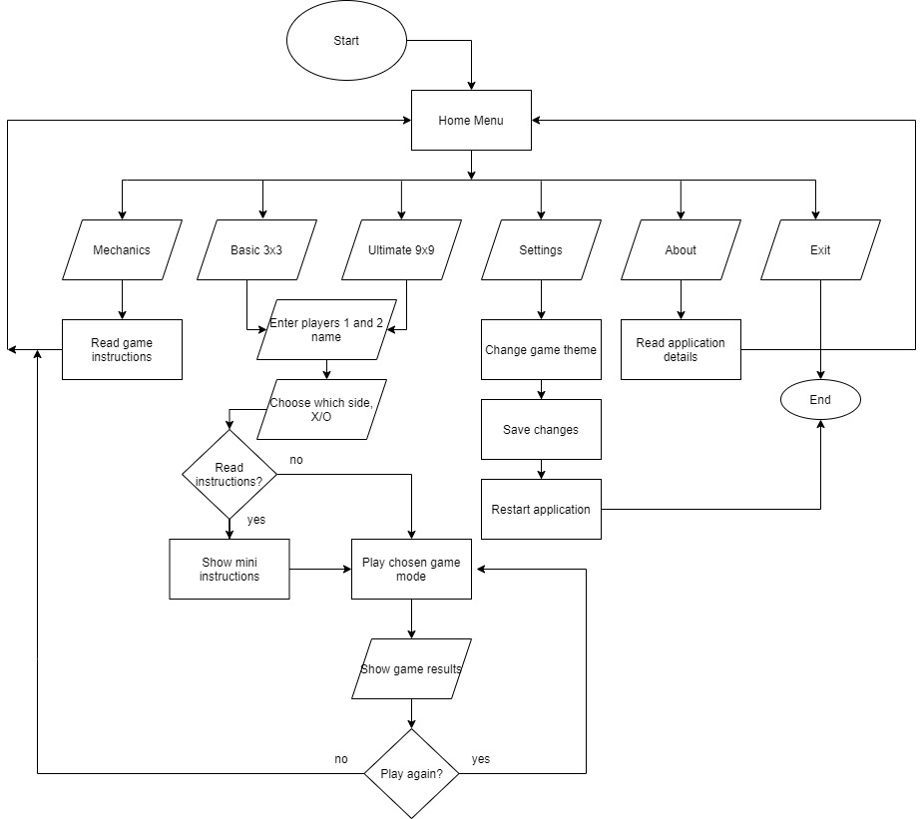

**II. Results and Findings**

**A. Software Evaluation and Test Results**

**B. Software Quality Metrics**

**III. Summary, Conclusions and Recommendation**

**IV. Bibliography**

**PART II. USER MANUAL**

**I. Introduction**

**A. Software Use**

**B. Hardware Requirements**

**C. Definition of Terms**

**II. Software Environment**

**A. Main Screen**

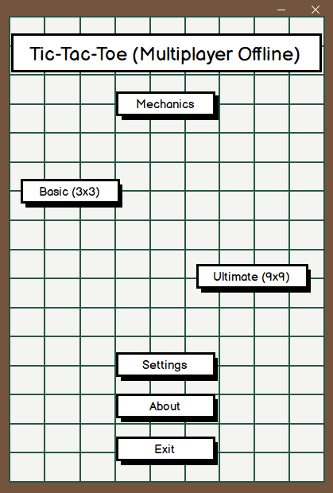This is the start menu. Its purpose is to welcome the users and boot into the application’s main menu

This is the main menu screen. It composed of the application name and the main functions of the application.

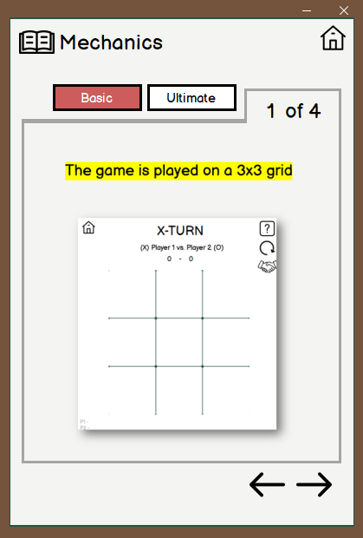 **B. Menus and Work Area**

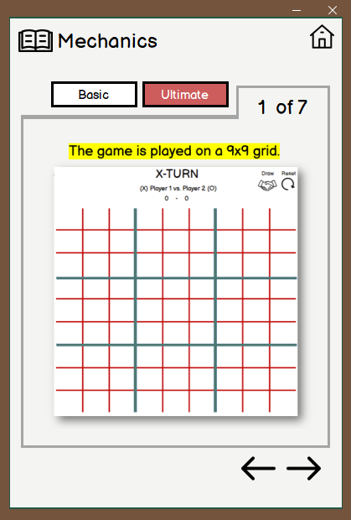This screen will appear when “Mechanics” button is clicked. It includes the game instructions for both game mode, the default and the first to show will be the “Basic” game mechanics.

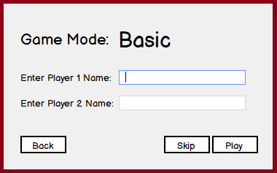In addition to the “Basic” game mechanics panel, this is the “Ultimate” game mechanics panel that will be shown if “Ultimate” button is clicked.

This screen will pop-up when either of the game modes is clicked. Players’ name are optionally ask in here before entering the actual game screen.

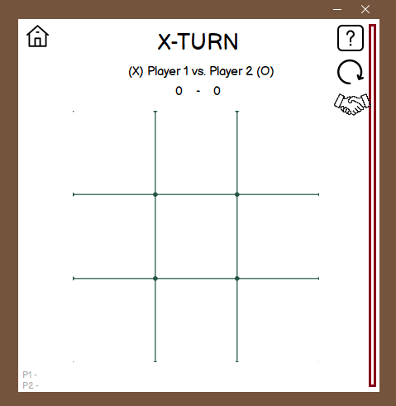

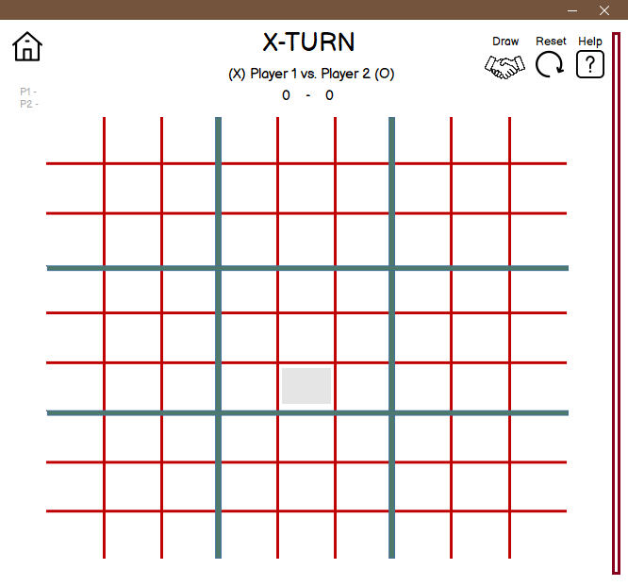This screen is one of the two game modes, which is the “Basic”. It is accessible through the main screen’s “Basic” button but it will go to ask the name of the players first before showing the game screen.

This is the other game mode, “Ultimate” game screen that is accessible through the main menu’s button: “Ultimate”. This is more complex than the “Basic” mode. But like in the “Basic” game mode, it will be redirected first to ask the name 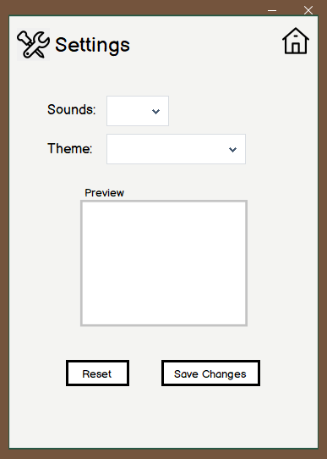of the players before playing.

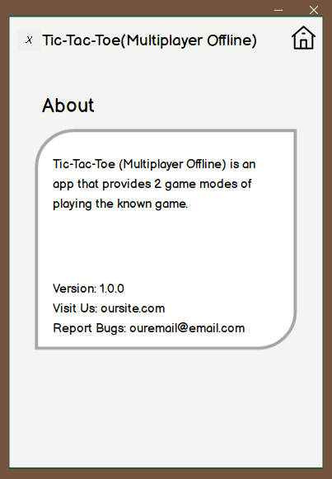This is the “Settings” screen which will be shown when its button from the main menu is clicked. Its function is to offer the users to control the style of the application.

When “About” button is clicked from the main menu, this screen will appear. It contains some application and developer details such as email and website for reporting and stuffs.

**C. Command Buttons**

**III. Procedures in Working with the Software**

**A. Data Entry**

**B. Data Access**

**C. Report Generation**

**D. Other what to do’s (prerequisites)**

**IV. Sample Output of the System**