**WEBAPI Project**  
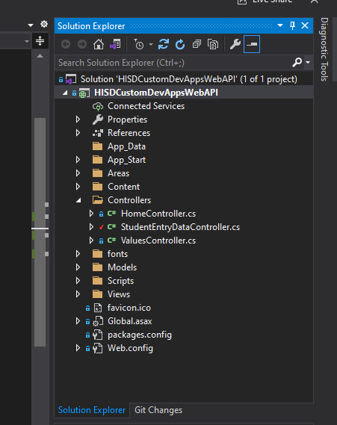 **Location:**C:\DevProjects\Programming\VisualStudio\HISDCustomDevAppsWebAPI\  
Local Web Install – IIS  
C:\DevProjects\Programming\WebServices\HISDCustAppsWebAPI  
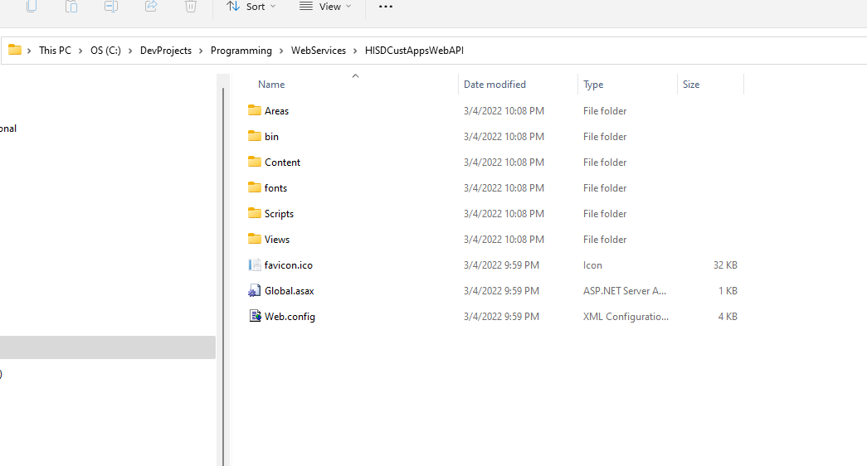  
  
**I CHANGED THE CONNECTION STRINGS  
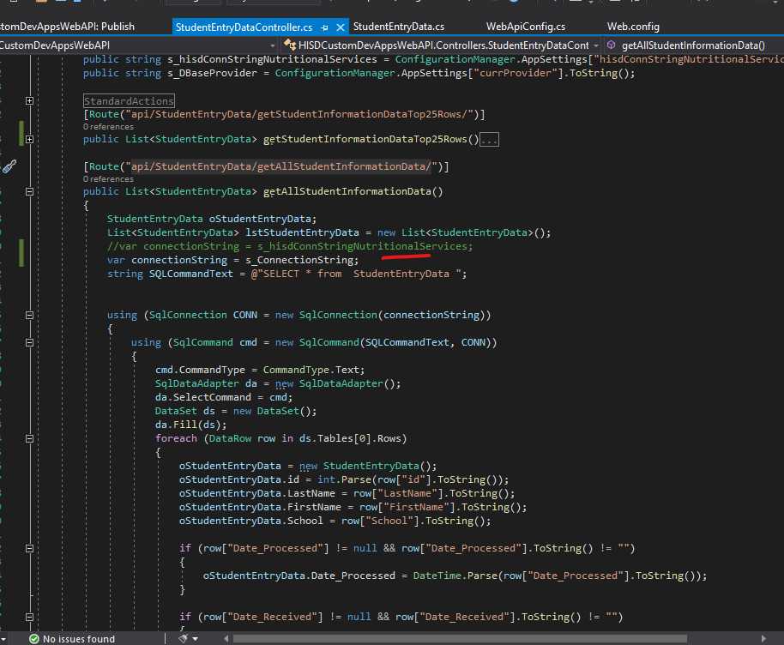**

**Current Project Locations  
Name:**

HISDCustomDevAppsWebAPI

FOR GITHUB: - I pushed the project to GitHUB  
git clone:  
https://github.com/lionel5116/SBHISDCustomDevAppsWebAPI.git

**For my personal SandBox React Project – WEBAPI**

**https://github.com/lionel5116/SBHISDCustomDevAppsWebAPI.git**

C:\DevProjects\Programming\SANDBOX_REACT_WEBAPI_PROJECT_FILES\HISDCustomDevAppsWebAPI

echo "# SBHISDCustomDevAppsWebAPI" >> README.md

git init

git add README.md

git commit -m "first commit"

git branch -M main

git remote add origin https://github.com/lionel5116/SBHISDCustomDevAppsWebAPI.git

git push -u origin main  
  
git remote add origin https://github.com/lionel5116/SBHISDCustomDevAppsWebAPI.git

git branch -M main

git push -u origin main

The Deployed Location  
  
Name is IIS

HISDCustAppsWebAPI

**FOR THE DATABASE**

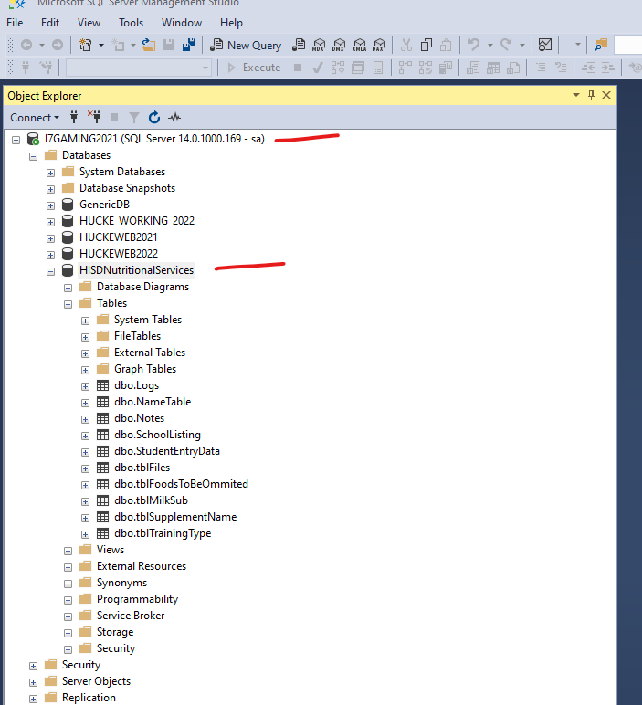

I am using a local copy of the HISDNutritionalServices DB

**POSTMAN ENDPOINTS**

http://localhost/HISDCustAppsWebAPI/api/StudentEntryData/getAllStudentInformationData/  
http://localhost:54751/api/StudentEntryData/getAllStudentInformationData/

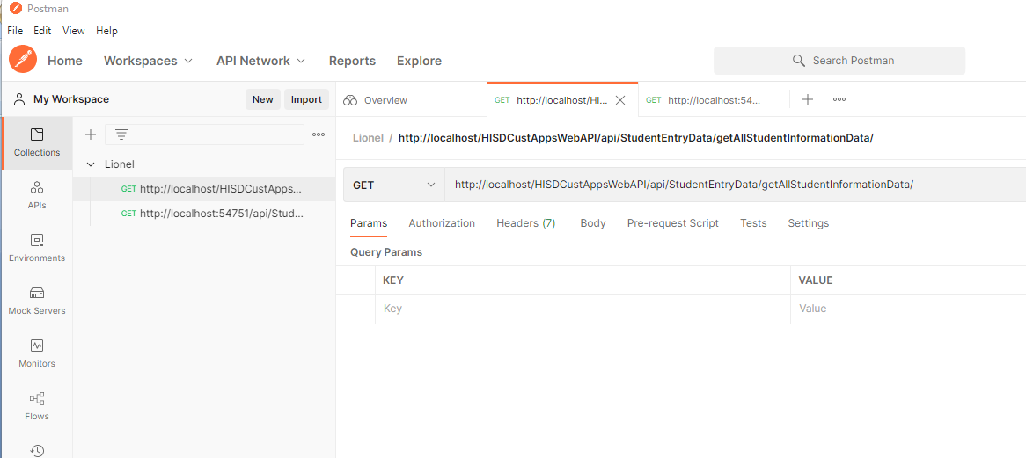

React Project  
C:\DevProjects\Programming\React\SandBoxReactWithWebPack  
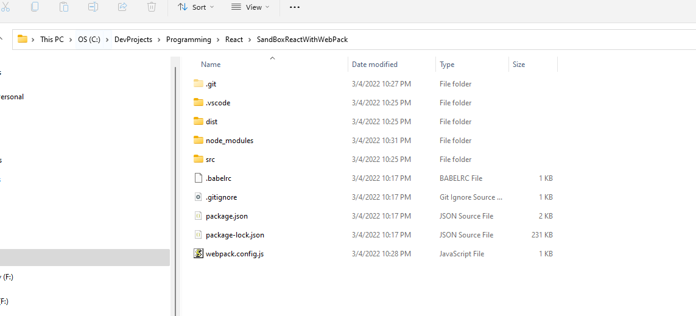  
Site Install  
C:\DevProjects\Programming\WebSites\SandBoxReactWithWebPackWeb  
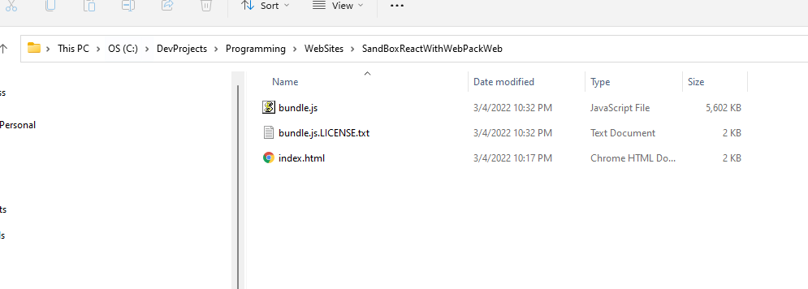  
Renamed project in package.json file

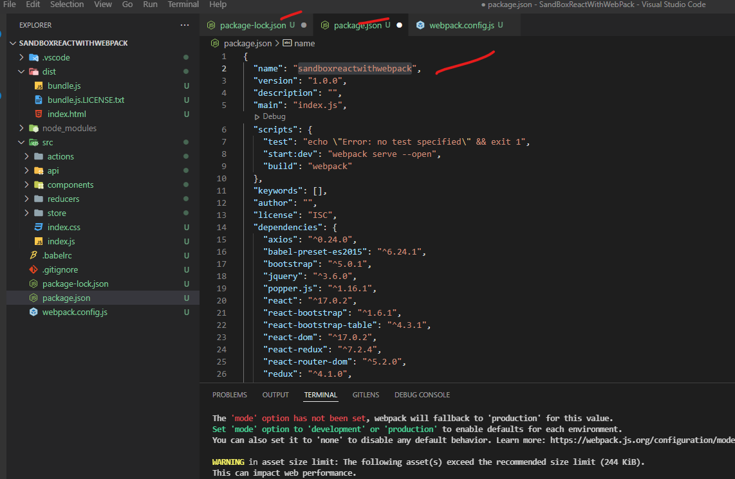  
Then deleted node_modules and did a   
**npm install**  
To build project  
**npm run build**  
To run project:  
**npm run start:dev**  
  
**I CREATED A GIT REPO**  
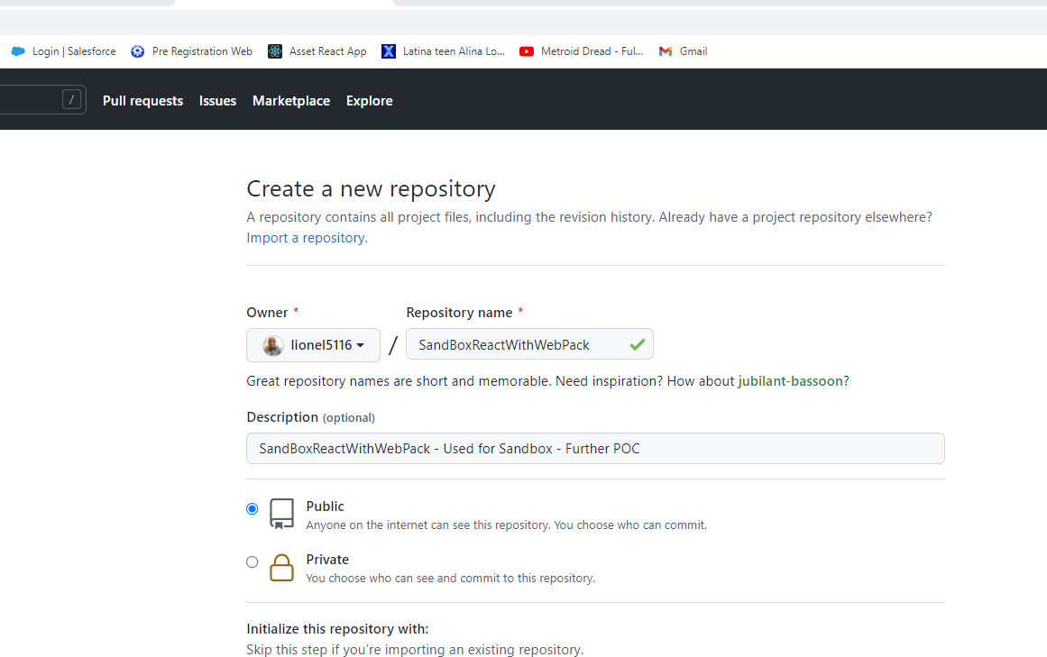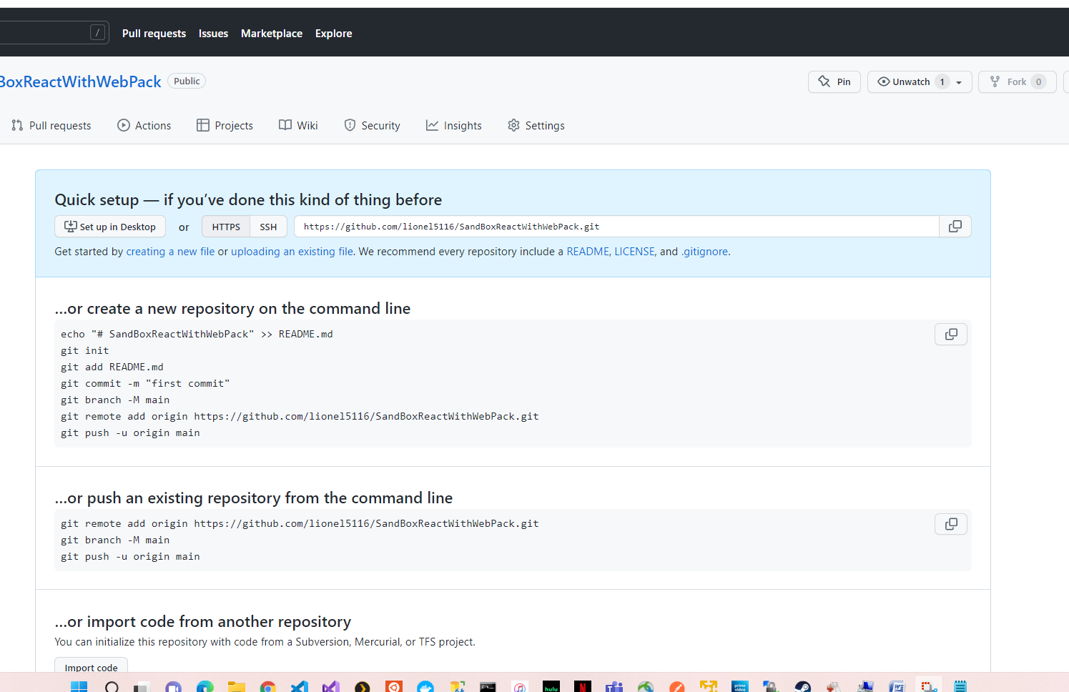**First Initialize**git init

git remote add origin https://github.com/lionel5116/SandBoxReactWithWebPack.git

**For subsequent pushes**

git add -A

git add .

git status

git commit -m "change notes"

git push origin master

If you get this error:

error: failed to push some refs

to 'https://github.com/lionel5116/HisdNutritionalServices.git'

Type this command:

git push origin main  
  
**Nutritional Services – Web Project and Local DB Files**The FILES with LOCAL_CONN are the web.config file and function for pulling shool data  
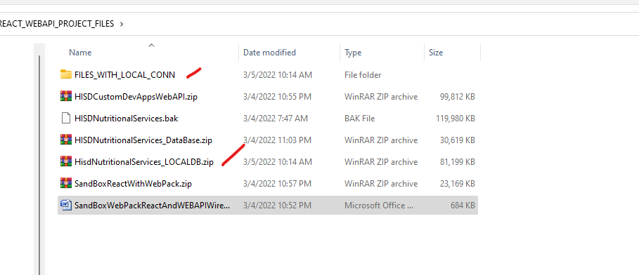  
**React NPM’s for file-upload**  
<https://www.npmjs.com/package/use-file-upload>  
**React-dropzone-npm**

**Below is a good video on how to use react hooks with nodejs API**

<https://www.youtube.com/watch?v=PEGUFi9Sx-U>  
**Another good video on file upload**  
<https://www.youtube.com/watch?v=sp9r6hSWH_o>

**Good Video Series on React**

**React Hooks:**

Allow you to use React features without having to write a class, Ex; State of a component

<https://www.youtube.com/watch?v=cF2lQ_gZeA8&list=PLC3y8-rFHvwgg3vaYJgHGnModB54rxOk3&index=44>  
  
**React Effects**  
Mimics lifecycle hooks for a functional component. i:e componentDidMount, it essentially adds "effects" to a functional component

<https://www.youtube.com/watch?v=BH4xvzHa7H8&list=PLC3y8-rFHvwgg3vaYJgHGnModB54rxOk3&index=52>

**Great Article on React Hooks with REDUX**

<https://thoughtbot.com/blog/using-redux-with-react-hooks>  
**How to use Redux with Hooks**

React Redux now includes its own useSelector and useDispatch Hooks that can be used instead of **connect**.

**useSelector** is analogous to connect’s **mapStateToProps**. You pass it a function that takes the Redux store state and returns the pieces of state you’re interested in.

**useDispatch** replaces connect’s **mapDispatchToProps** but is lighter weight. All it does is return your store’s dispatch method so you can manually dispatch actions. I like this change, as binding action creators can be a little confusing to newcomers to React Redux.

Alright, so now let’s convert a React component that formerly used connect into one that uses Hooks.

**Here a working example – This is in the sandbox project**

<https://www.freecodecamp.org/news/learn-redux-by-making-a-counter-application/>

**And it works:**

**­­A recap of REDUX  
Actions:  
**

**React Bootstrap5 Sample Page Demo**

<https://www.youtube.com/watch?v=l2131Rok8XU>  
We implemented a react bootstrap web page  
**NOTE**: WE ALSO DID LIVE MARKUP CODING, WE STARTED THE WEBSITE AND CODED AND SAVED THE FILE WHILE IT DID LIVE RELOADING!!!  
Docs:  
<https://react-bootstrap.github.io/getting-started/introduction>  
Page: “SampleReactBootStrapWebPage.js”  
Key Notes on the Page  
  
The **’px-4 my-5’** is padding an margins in bootstrap react  
  
**Responsive Grids:**  
<https://react-bootstrap.netlify.app/layout/grid/#grid-system>  
  
**Images**

**Notice how when you using regular markup (not components):**class (for regular elements)  
className (for components)  
  
https://react-bootstrap.github.io/components/cards/  
He also just copied and pasted the sample card code from the website (sweet), just like regular bootrap example coding  
  
After coding:

SWEET!!!!!  
He also has some information on free web page hosting of your react application, kinda like Heroku  
<https://www.youtube.com/watch?v=VLGLlIhn3Ng>  
  
For spacing in bootstrap react

https://getbootstrap.com/docs/5.1/utilities/spacing/  
**You first specify what spacing you want either:**  
m (margin)  
p( padding)  
Then you specify the sides  
t (top  
b(bottom)  
…..  
Then a # between 0 and 5 (also auto) (You cannot specify any other numbers)

So for this example below, he used “mt-4” (margin-top) with a 4 spacer (* 1.5)

And for Text  
https://getbootstrap.com/docs/5.1/utilities/text/  
Its in the docs

For example:

**Adding a Custom Style css attribute**

If you want to add your own custom style for a component, you have to use in the format below:  
{ { <style: ‘ ‘}}  
  
  
For Components used by bootstrap react

https://react-bootstrap.github.io/components/alerts/  
  
  
<https://reactjs.org/docs/hooks-state.html>  
What is a hook in functional programming  
A Hook is a special function that lets you “hook into” React features  
**When would I use a Hook?**

If you write a function component and realize you need to add some state to it,

previously you had to convert it to a class. Now you can use a Hook inside the existing function component  
  
**Example:**

const [count, setCount] = useState(0);

What do we pass to useState as an argument? The only argument to the useState() Hook is the initial state.

Above we pass in 0 as the initial value

What does useState return?

It returns a pair of values: the current state and a **function** that updates it.

This is why we write const [count, **setCount**] = useState()

This is similar to this.state.count and this.**setState** in a class

Real world example I used in my file upload component example:

How to kill server when seeing “EADDRINUSE: address already in use”

<https://levelup.gitconnected.com/how-to-kill-server-when-seeing-eaddrinuse-address-already-in-use-16c4c4d7fe5d>

C:\Users\admin>netstat -ano|findstr "PID :3000"

Proto Local Address Foreign Address State PID

TCP 0.0.0.0:3000 0.0.0.0:0 LISTENING 18264

To kill this process (the /f is force):

taskkill /pid 18264 /f  
  
How React let’s you do an import as an “an”

Notice above how you can reference a reducer as an alias without spelling out the actual function name