Mean input firing rate: 0.0 Hz
Excitatory population Inhibitory population
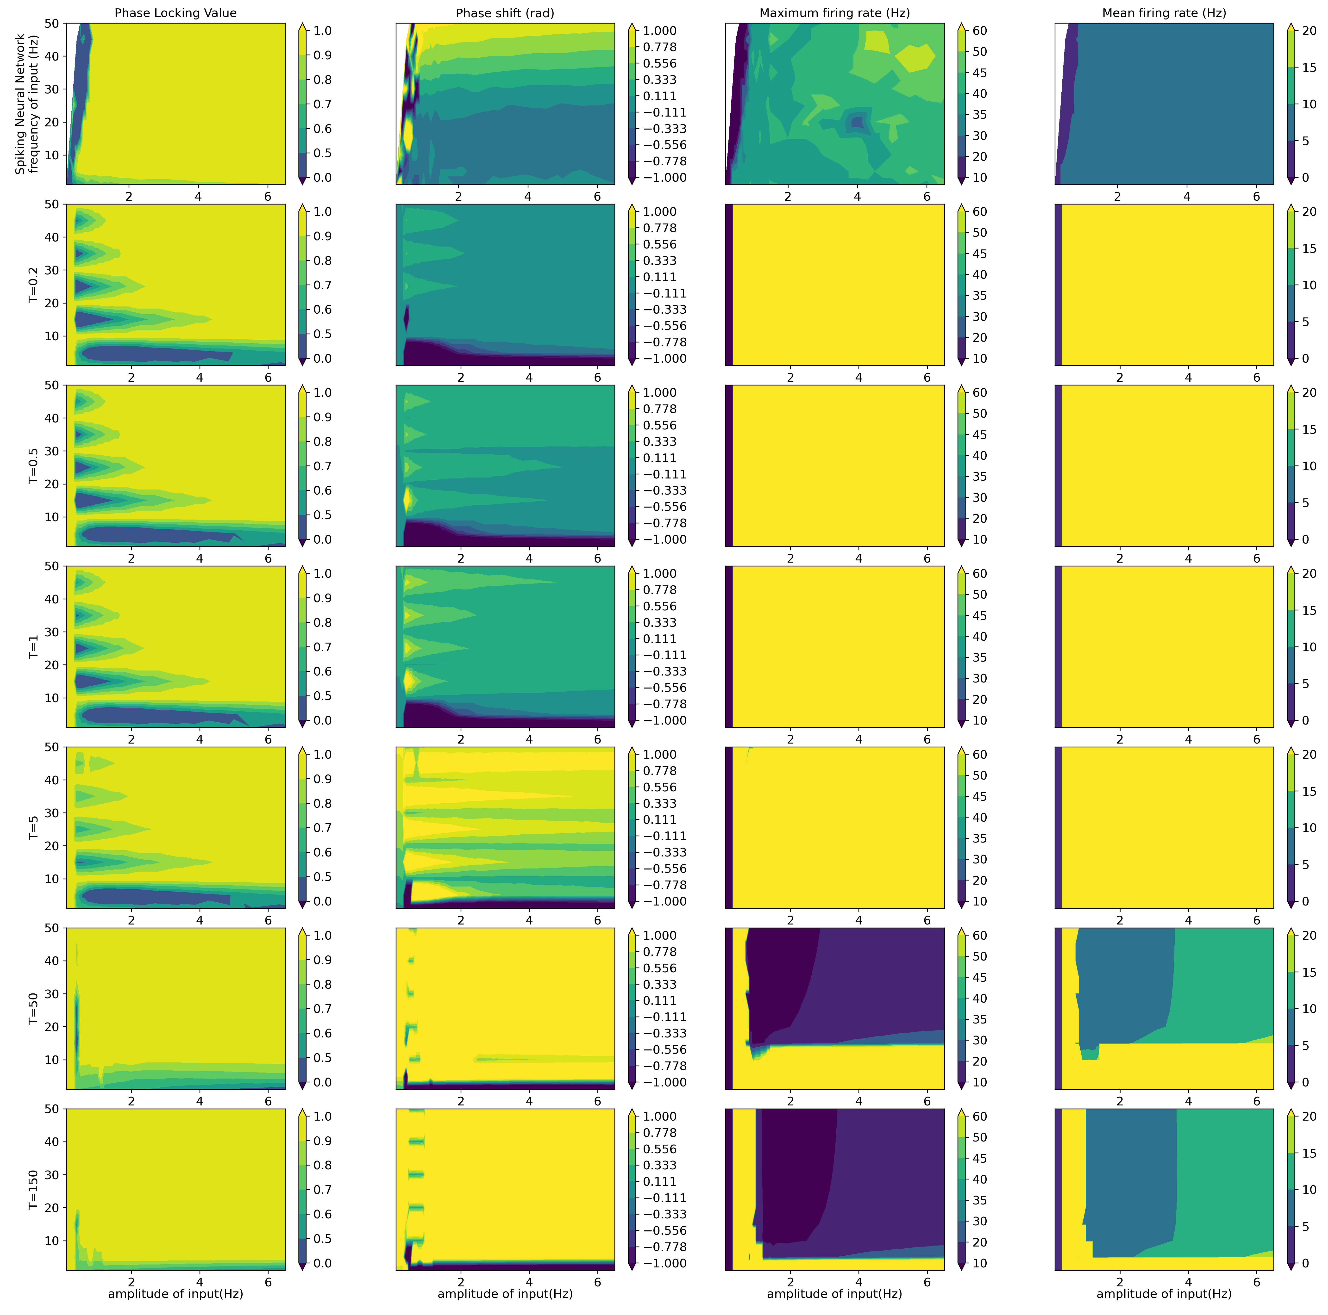
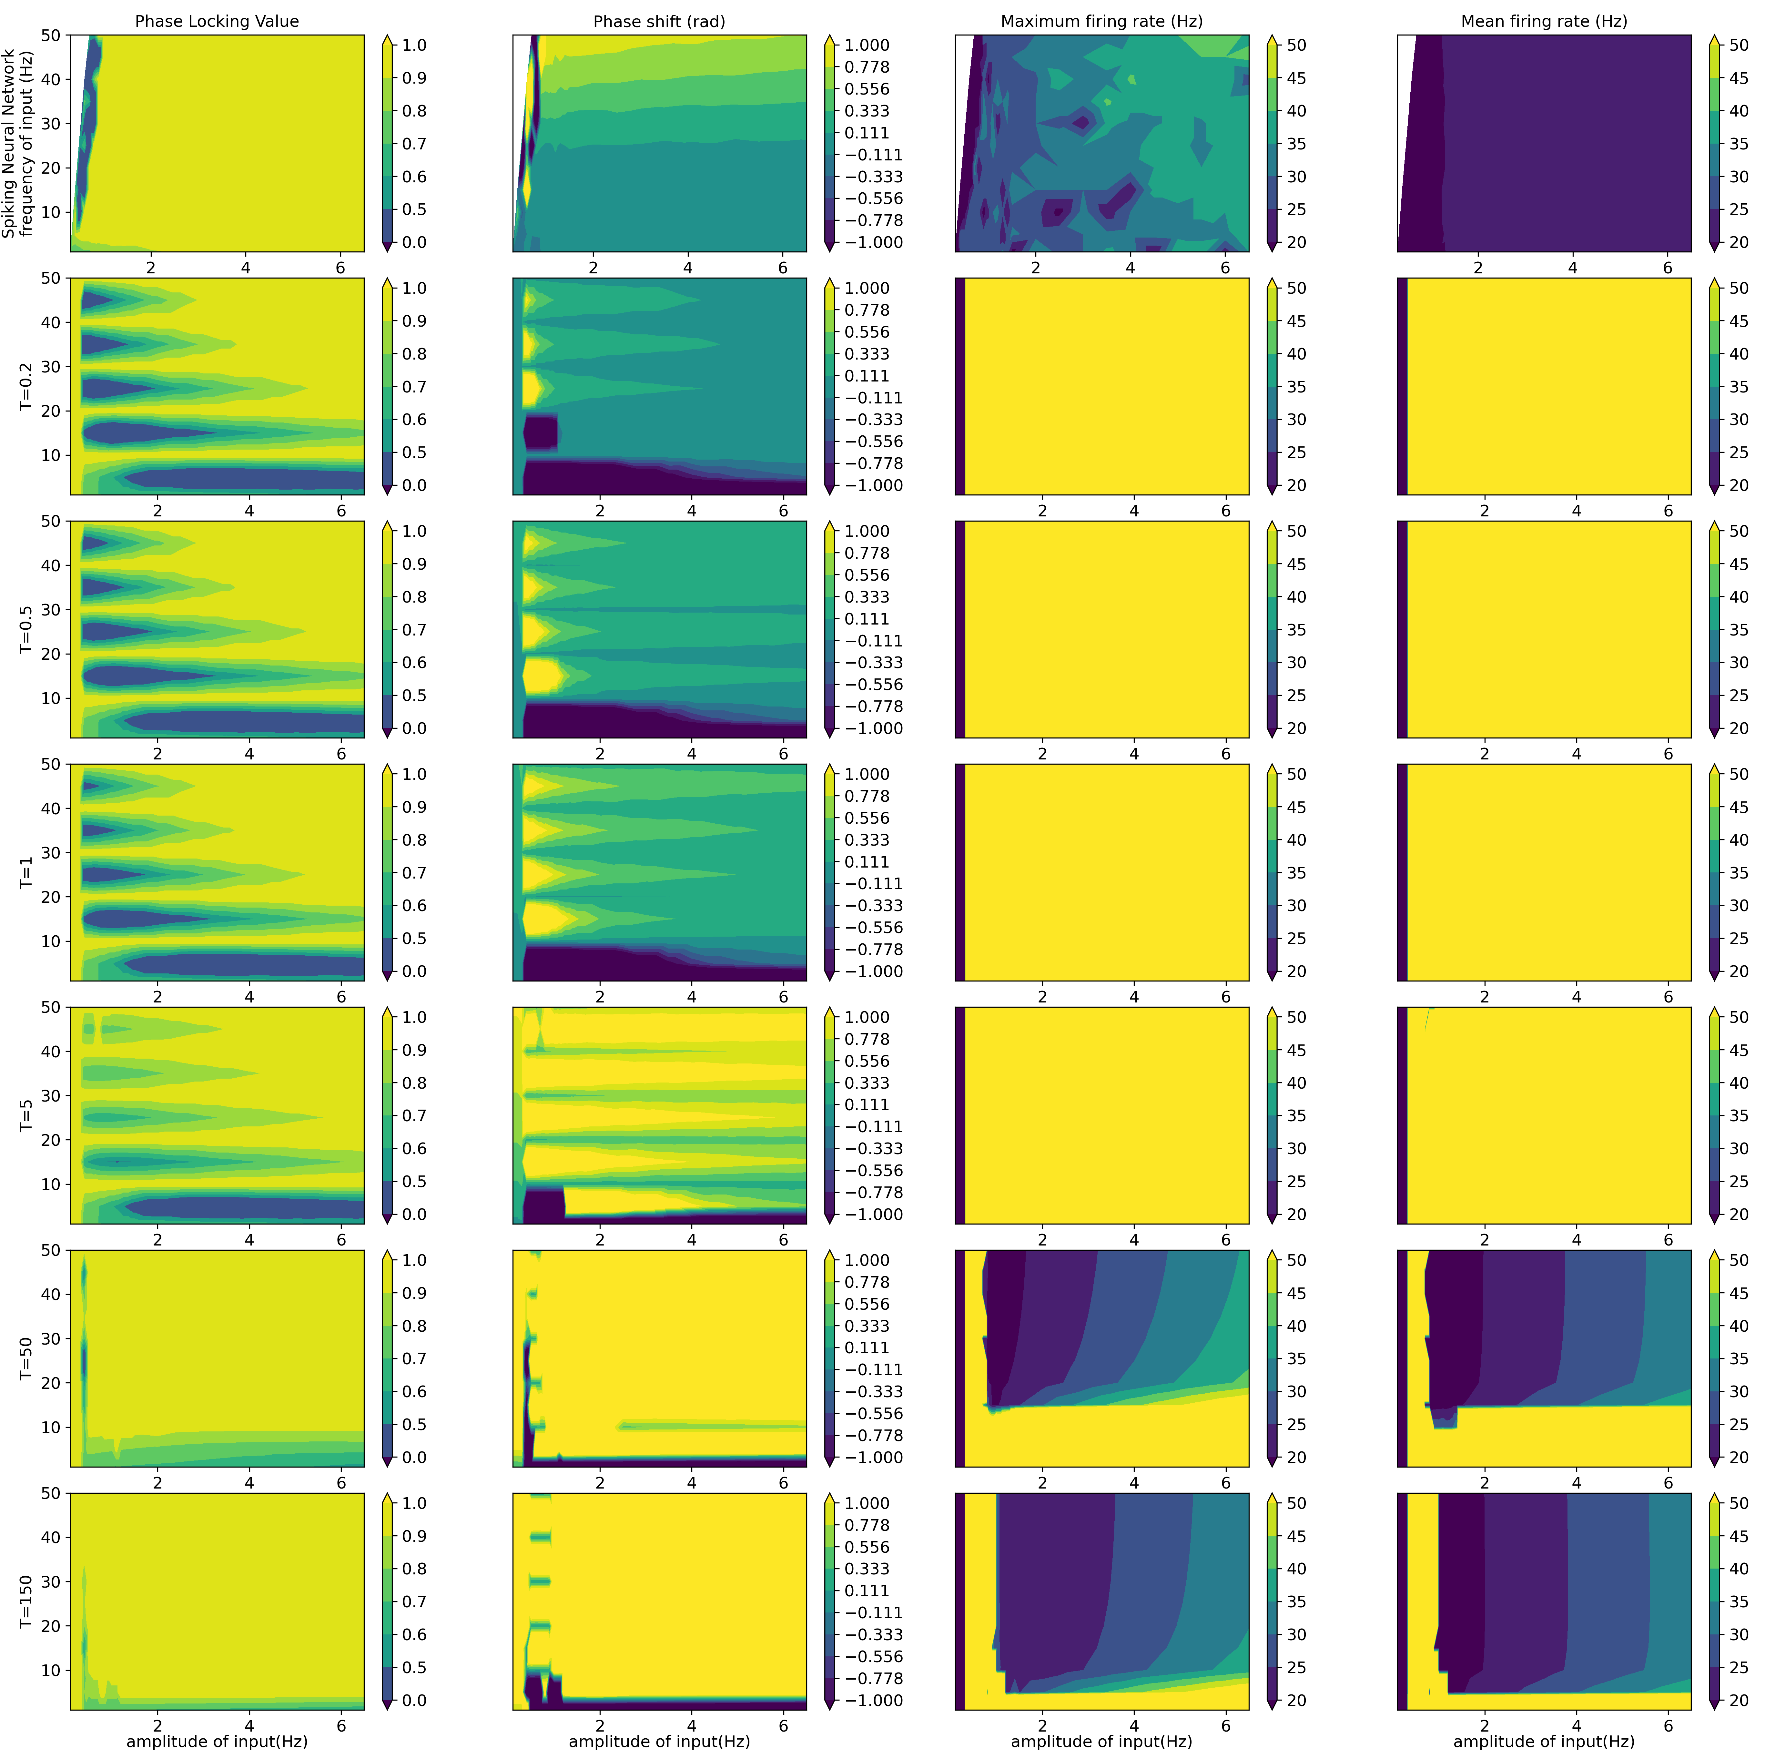
Mean input firing rate: 7.0 Hz
Excitatory population Inhibitory population
