Mean input firing rate:0.0Hz, frequency :5.0 and amplitude:3.0
Population Excitatory Population Inhibitory
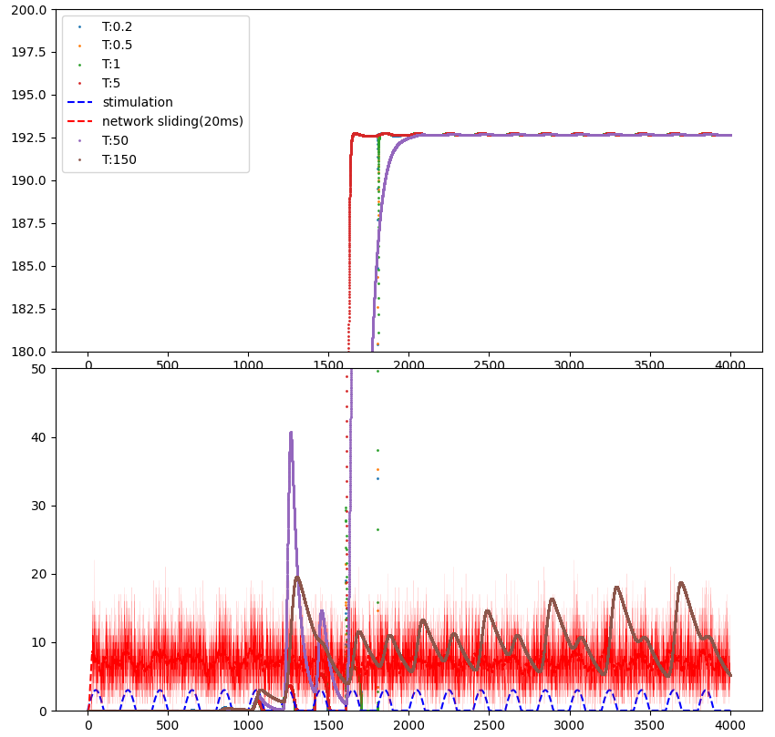
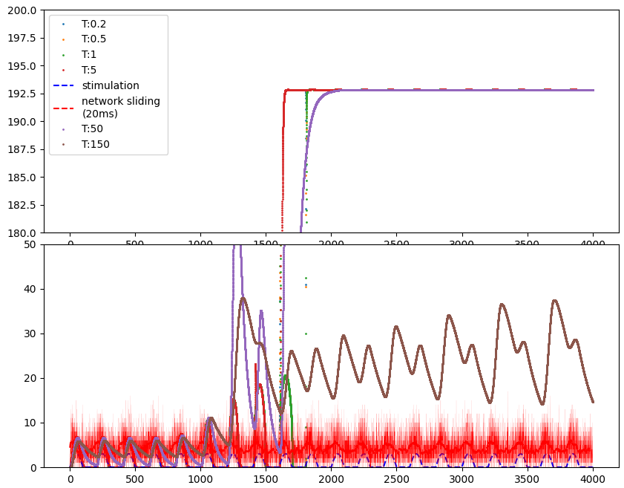
Mean input firing rate:0.0Hz, frequency :20.0 and amplitude:3.0
Population Excitatory Population Inhibitory
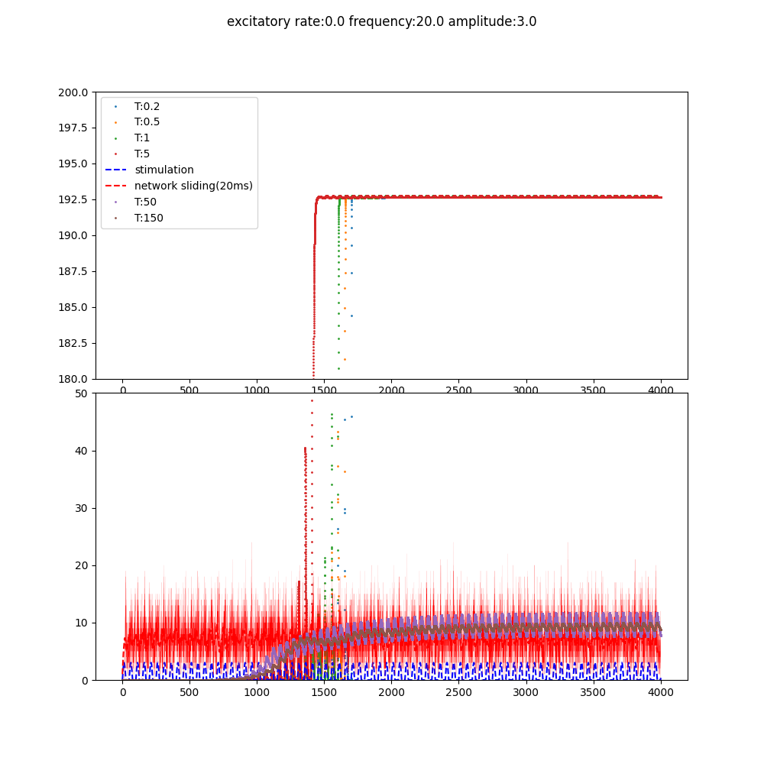
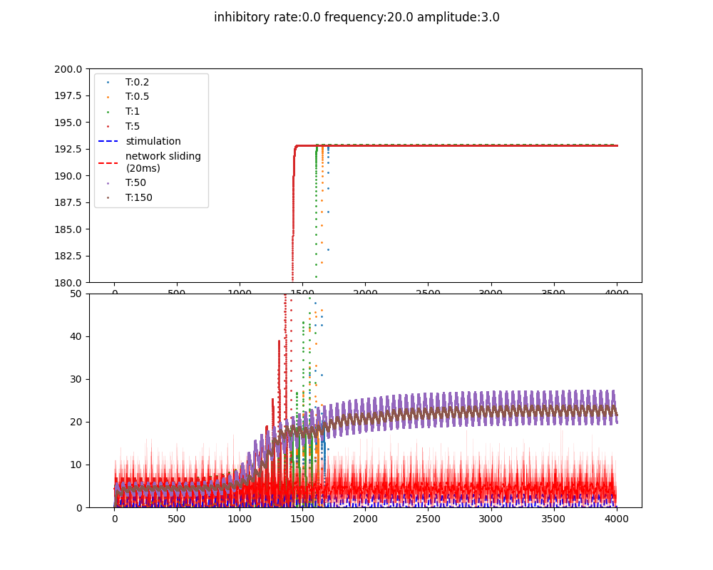

Mean input firing rate:7.0Hz, frequency :5.0 and amplitude:3.0
Population Excitatory Population Inhibitory
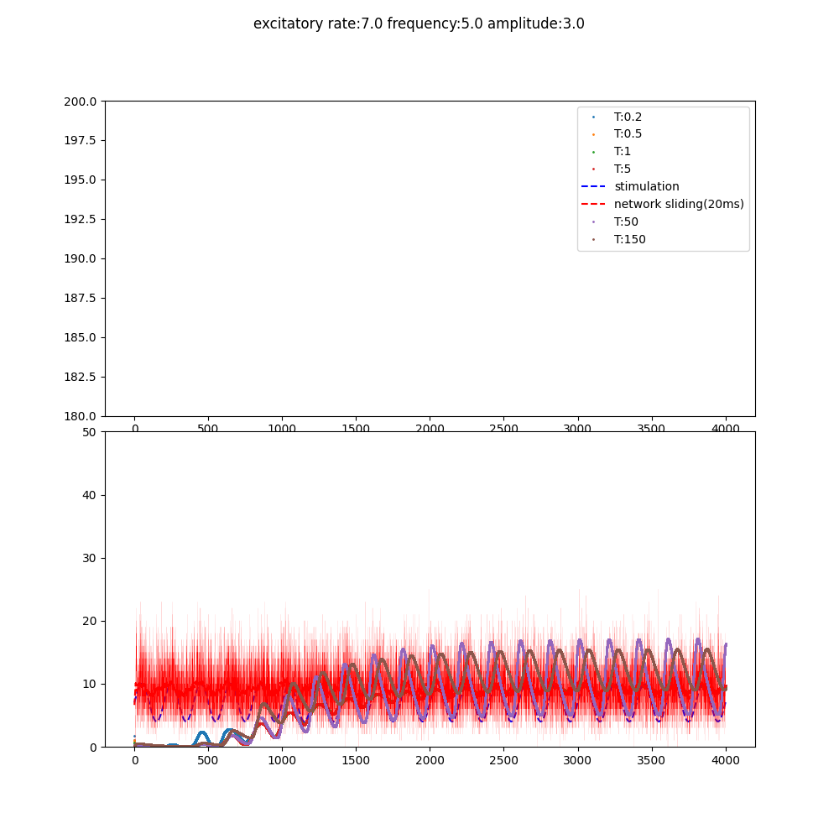
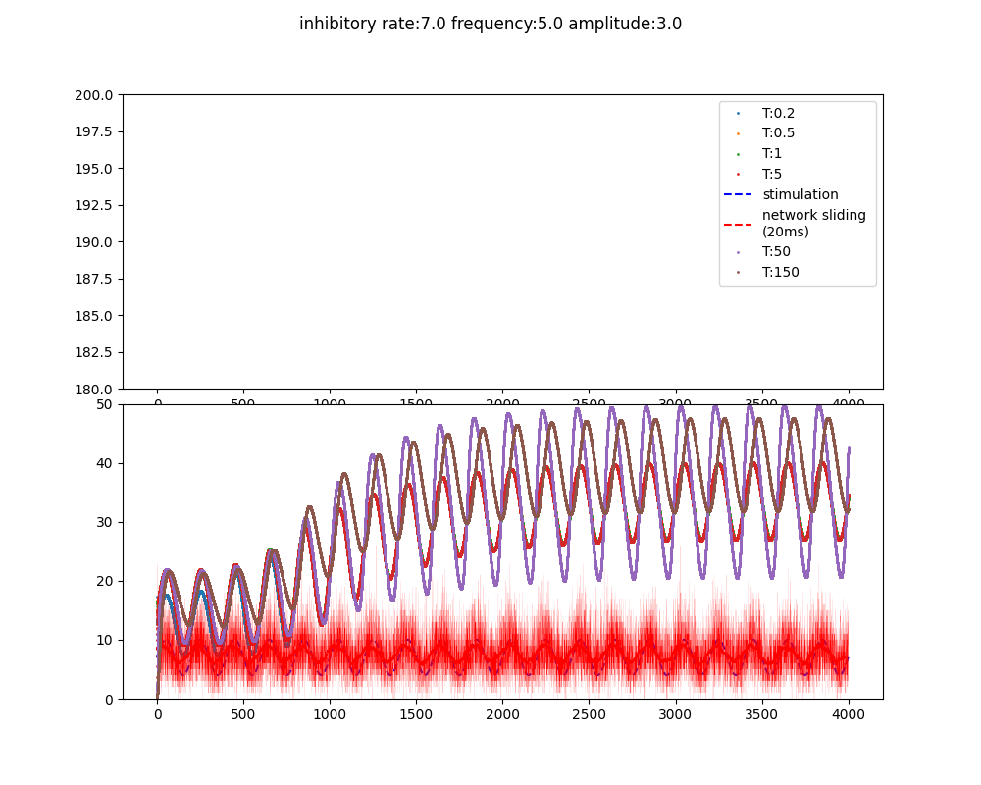
Mean input firing rate:7.0Hz, frequency :20.0 and amplitude:3.0
Population Excitatory Population Inhibitory
