CAS Applied Data Science, University of Bern, S. Haug

**Assignment Work Instructions for Module 1**

The assignment work for Module 1 is a Conceptual Design Report for a Data Science project you would like to perform. Ideally during the CAS with some dataset you find interesting. Please use or orient yourself according to the template below. Remove this page for the submission version. Key information is the following.

**Language:** English or German

**Deadline:** To be defined in class

**Deliverables M1:** Conceptual Design Report, (this document), GitHub Repository, including also Jupyter Notebook and poster from Module 2.

**Expected effort and length:** About 30 hours, minimum 5 pages

**Further formal quality requirements:**

* All references to be listed in corresponding section and cited with number in text
* All tables and figures to have numbered legends with short explanations (tables above, figures below) and be referenced in text (Figure 1: blablan, Table 1: blblbl).
* Figures to be as self explanatory as possible, e.g. plots with at least axis labeling including units.

**Your names etc**

Your addresses

Your emails

**Data Science Project**

**Project Name**

**Conceptual Design Report**

**X October 2020**

# Abstract

10-20 lines

Lor

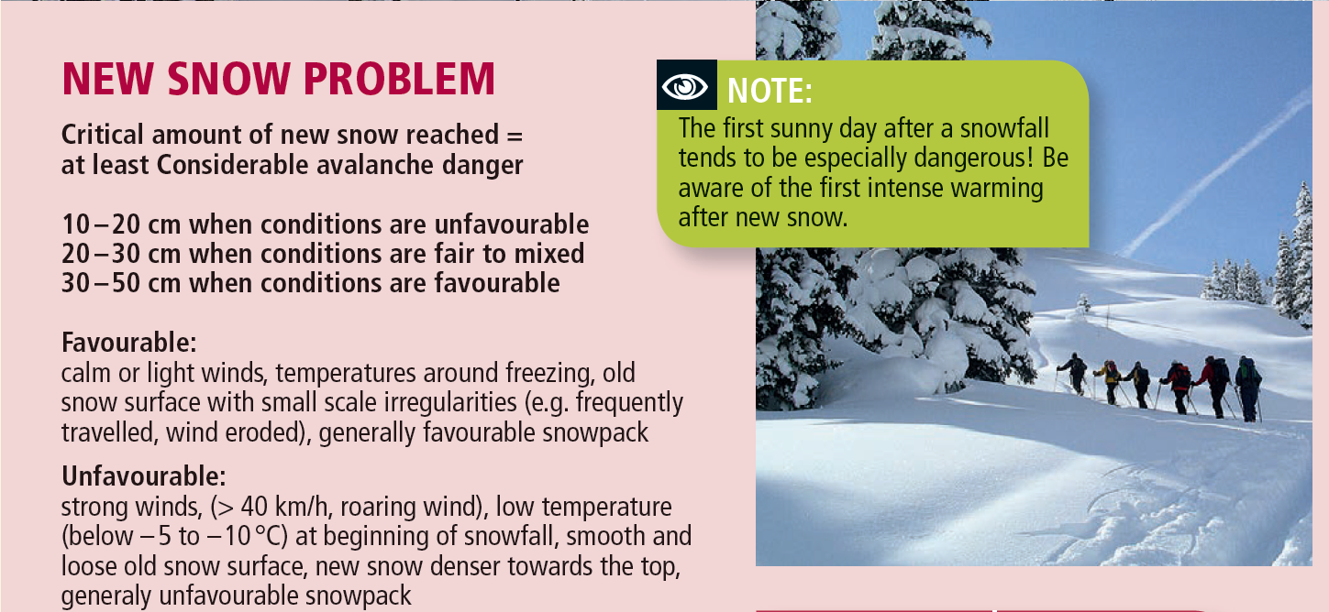

Figure 1 : (SLF, Favorable and unfavourable avalanche condition after new snow)

# 

# 

# Table of Contents

**Abstract** **1**

**Table of Contents** **2**

**1 Project Objectives** **3**

**2 Methods** **3**

**3 Data** **3**

**4 Metadata** **3**

**5 Data Quality** **3**

**6 Data Flow** **4**

**7 Data Model** **4**

**8 Risks** **4**

**9 Preliminary Studies** **4**

**10 Conclusions** **4**

**Acknowledgements** **4**

**Appendix X** **4**

**References and Bibliography** **5**

# 

# 1 Project Objectives

0.5-1.0 page

Formulate goal and purpose of your project here. It is very important to be very specific on your goals. What do you want to find out or predict? What are the numbers and plots you need to do that?

# 2 Methods

0.5-1.0 page

Which infrastructure, tools, software libraries, statistical methods etc do you intend to use. It is clear that you may not know this at this stage, but try to make yourself some plan, even if it is going to change during the CAS.

# 3 Data

Which data will be used (with references) 0.5-1.0 page

A couple of plots, maybe the histograms of the columns

A couple table row as an example maybe

Security issues etc (see data management plan, you may attach a SNSF data management plan for your data)

# 4 Metadata

What metadata is required for reproducing your analysis?

Where do you store the metadata, how can people access it?

# 5 Data Quality

What are the quality requirements you have to reach your analysis goal (precision ...)?

Are they met? If not, do you expect a significant impact on your results,

Any measures to improve the quality?

# 6 Data Flow

Explain with a figure and words how the data flow of your project will be, from the data source to the final plots and numbers and.

# 7 Data Model

Draw and explain your data model at the conceptual level, the logical level and the physical level. .

Conceptual

Logical (with dataframes and with databases)

Physical (infrastructure needs)

# 8 Risks

What can go wrong?

When this and that goes wrong, what counter measures do you have?

What will be the impact on the quality of the aimed output, project time schedule, project cost ?

# 9 Preliminary Studies

Plots and numbers from Module 2.

# 10 Conclusions

….

# Acknowledgements

Acknowledge persons or institutions that helped you with the CDR here.

# Appendix X

If you have something to attach to your report, do it here.

# References and Bibliography

Please number any information source you used in the report with corresponding links here [1]:

[1] S. Haug et al., How to make a CDR, own brain, 2020 (put a weblink or DOI here)

[2]