**Flutter Qualification Documentation**

**LL20-2**

**Description**

**Sport Horizon** is an online sport apparel store. **Sport Horizon** sell any kind of sport equipments such as shoes and swimming suit from exclusive brands such as New Balance, Adidas, Nike, and more.

**Pages**

1. **Login Page**

In this page, the application will show the logo of Sport Horizon and two text form field for user to input their username and password.

When login button is clicked, the form will validate it self. There are three unique validation in this page, which are:

* Username must not be empty.
* Password’s length must be at least 8 characters long
* Password much contain at least one uppercase letter

If the form validation passed, then user will be redirected to **Home Page.**

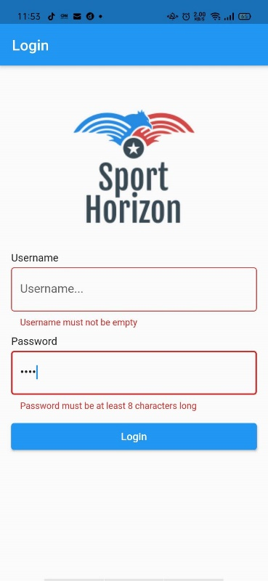

Figure 1. Login Page

1. **Home Page**

In this page, the application will show:

* Carousel for current promos
* Top Category
* Brand Carousel
* Information about Sport Horizon

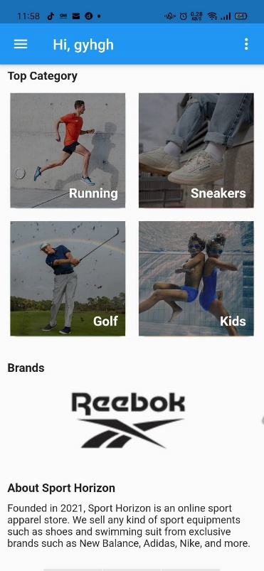

Figure 2. Home Page

1. **Products Page**

In this page, the application will show all products in Sport Horizon. The information that will be shown for each product is:

* Product Image
* Product Name
* Product Price
* 'View More’ Text Button

When ‘View More’ button is clicked, the app will redirect to **Product Detail Page**.

Figure 3. Product Detail Page

1. **Product Detail Page**

In this page, the application will show two tabs, which are:

* Information Tab
* This tab will contains information about the product, such as image, name, price, description.
* Other than that, a form to add a review for this product will be provided for user to fill.

Figure 4. Product Information Tab

* When submit button is clicked, the form will validate whether the field is empty or not.
* If the field is empty, then the application will show a snackbar to inform the user.
* Otherwise, the application will add the review to current product’s reviews.

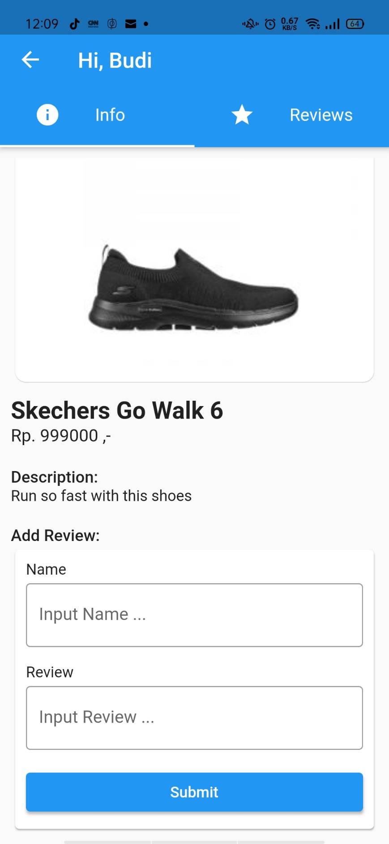 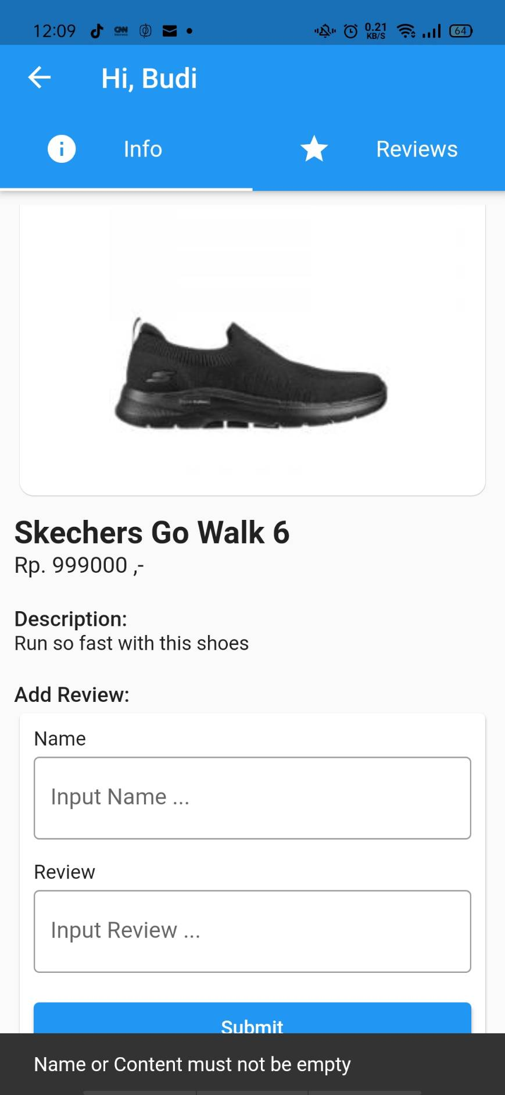

Figure 5. Add Review Form

* Reviews Tab

In this tab, the application will show all reviews of a current product. For each review, the information that will be shown are username and of course, the review content.

Figure 6. Product Reviews Tab

**Components**

1. **Navigation Bar**

* In home page, the application will show navigation bar that consists of a navigation drawer button, welcome text, and a popup menu button.

Figure 7. Home Page Nav Bar

* Otherwise, the application will show a navigation bar that contains the welcome message and back button.

Figure 8. Other Page Nav Bar

1. **Navigation Drawer**

* The navigation drawer will contains Sport Horizon Logo, a link to Product Page, and Logout button.
* When the logout button is clicked, user will be redirected to **Login Page** and all the navigation stack will be popped.

Figure 9. Navigation Drawer

1. **Popup Menu**

The popup menu will contains a button to toggle dark theme. Upon clicked, the corresponding theme will be applied to the application.

Figure 10. Pop Up Menu Button