My Cats
Folllowing are the story of my cats …

Nala
Nala is an orange cat

Ocean
Ocean is our first cat

Simba
Simba is also an orange cat

Photo
Here is the photo of them.
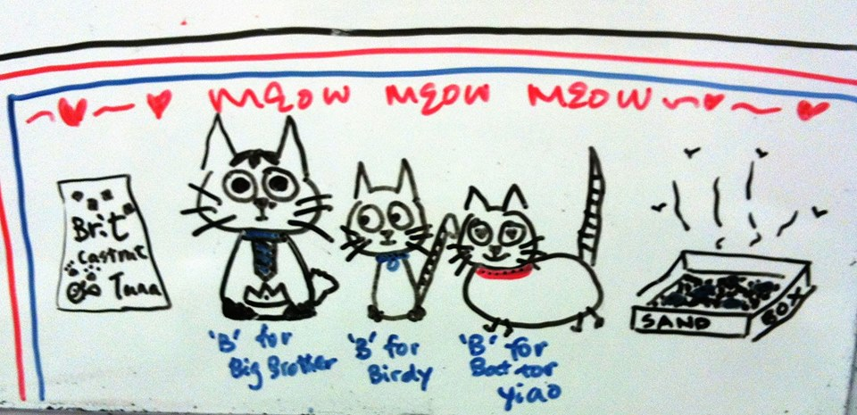
I hope u like them.

