Adversarial Examples Study
Hello!
Computers often get confused by things called ‘adversarial examples’ which are carefully crafted images that contain changes which cause the computer to misclassify the image. For example the right hand image below is a slightly altered version of the dog on the left. Humans still see a dog, while the computer sees an ostrich.
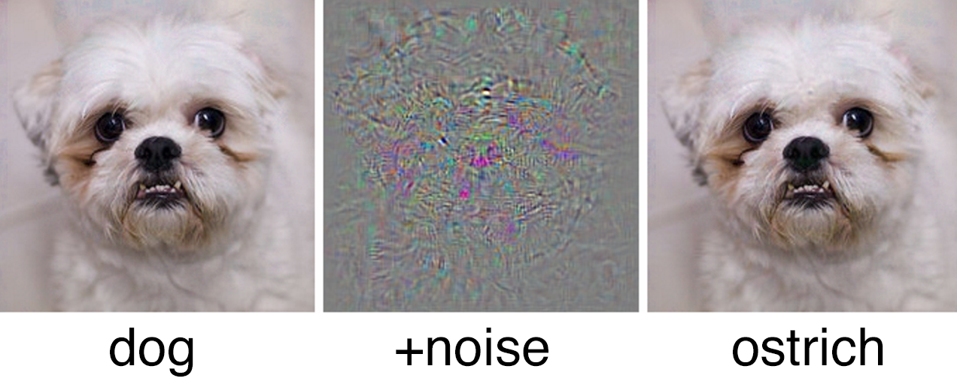
Image credit: Christian Szegedy (Google)

I’m interested in whether we can flip this experiment? We first take an image of one digit, and change it to make it look like another digit, to a human. We then ask a computer, trained on digit images to classify the new digit: Does it see the new number the humans see, or the original number? In effect can a human be more susceptible in this case to adversarial examples?

Tasks There are three tasks that need doing (the screen will be showing one of them).
1) Drawing digits: Simply drag the circles around to make the two lines into the shape of the digit it asked for. Please use both of the lines to make the digit!
2) Decide which of the symbols look more like a particular digit.
3) Decide which digit a symbol looks most like.

Use of the data The digit images from task 1 will be used to train a computer classifier to recognise digits. The decisions you make (from tasks 2 and 3) will be used to make the adversarial examples later tested on the computer classifier. The data is anonymously collected and may be released for other researchers to use. If we find interesting results we may publish a paper.

Taking part in this experiment is optional! If you want your responses to be removed from the data at a future date (prior to its release), please email me (details below) with the dates and times that you took part, and I’ll remove those times from the data.

By taking part you agree to the analysis of the data as above, and its release for use by other researchers.

This project isn’t funded, and is just something I’m interested in. The project has been approved by the Computer Science ethical review procedure. If you’ve any questions about the project, please email me: m.t.smith@sheffield.ac.uk or visit me in office COM136. Or if I’m not available please speak to Wil Ward, w.ward@sheffield.ac.uk. A copy of this information sheet can be downloaded from www.michaeltsmith.org.uk/other/informationsheet.pdf.

Thank you for taking part!
- Dr Mike Smith

Other notes (not part of the information sheet)

Computers often get confused by things called ‘adversarial examples’ which are carefully crafted images or data that contain small changes which cause the computer to misclassify the image. For example an image of a dog might be slightly altered such that humans still see a dog, while the computer sees an ostrich.

We're interested in whether we can flip this experiment. We first take an image of one digit (e.g. a 3), and change it to make it look like another digit (e.g. a 5), to a human. We then ask a computer, trained on other, similar digit images to classify the new digit: Does it see the new number (5) the humans see, or the original number (3)? In effect, can a human be more susceptible in this case to the adversarial example?

This is interesting as currently adversarial examples have only been generated against computer algorithms. It is known that such examples are less effective when tested against a different class of algorithm from the one that it was originally generated for. Hence would an example generated for a human be effective against a computer?

This could lead on to further research into other modalities of adversarial examples against humans, and potentially give insights into what makes a classifier more robust against such attacks - a key question in the field of machine learning.

Note: The data will be collected using a tablet mounted in the department. This hopefully will result in engagement and discussion amongst researchers in the department about the topic, and has potential positive spin-offs around inter-group work etc.

The data will be collected using a tablet mounted in the departmental kitchen. Besides the tablet will be an information sheet, explaining the project, the task and the use of the data. The very short time periods during which people will interact will reduce the risk of fatigue or poor attention, common in standard psychophysical experiments and thus may lead to more accurate results.
If insufficient responses are achieved, I'd also like permission for using a paid-crowd-source method (such as Amazon's mechanical turk) to collect the data. However, I expect over the course of 6-8 weeks for sufficient (~1000) samples to be collected in the three tasks.

There are three tasks that are requested of the participants (the screen will be showing only one of them).
1) The participant drags 6 circles (joined together with two lines) around the screen to make the two lines into the shape of the digit that was asked for. See http://www.michaeltsmith.org.uk/other/draw.html for an example.
2) The participant decides which of two symbols look more like a particular digit. These are the perturbed adversarial examples, based on initial images from task 1. See http://www.michaeltsmith.org.uk/other/compare.html for an example.
3) The participant decides which digit a symbol looks most like (0,1,2,3,..). No example currently available (awaiting data from tasks 1 and 2).

The last task (3) ensures the quality of task 1 and 2 - as it allows us to verify the digits are genuinely recognisable, by confirming several people each recognise the digit.

Analysis:
1. We will train and validate a variety of classifiers on the images from task 1 (and after verification in task 3).
2. We will test the classifiers on the images produced in task 2 (after their verification in task 3).
The two hypotheses to be tested are:
- The classifier will classify the perturbed images (from task 2) as the same class that the human does (i.e. the perturbation leading to an adversarial example for a human will equally affect the computer classifier).
- The classifier will classify the image as being the same class as before the perturbation (i.e. the computer classifier is [at least partly] immune to the perturbation that led to the adversarial example against the human).

We will perform standard statistical analysis (two t-tests - one for each hypothesis) on the numbers of images that fall into the three categories (class change aligned with human, class not changed, class changed to another digit) to test the above two hypotheses.

The recruitment will be through self-selecting individuals who decide to interact with the wall-mounted tablet screen after reading the information sheet.

An information-sheet besides the tablet will explain the project, the tasks and the use of the data.

(for the paid-for online data collection solution (such as Amazon mechanical turk), the standard platform's recruitment system will be used to recruit participants). The text from the information-sheet below will be made available to potential participants through this medium too.

Possible physical harm that may befall the participants include:
- The tablet may fall off the wall, and hurt someone.
- Someone might tamper with the plug socket and sustain an electric shock.

There is no foreseeable potential for psychological harm or distress to the participants.

Regarding the above risks:
- We will mount the tablet carefully to reduce the risk of it falling.
- We will have the USB charger PAT tested to ensure its electrical safety.

No information will be collected from participants except in the symbols they create and the decisions they make in the tasks. There is no information collected about which (anonymised) individual was responsible for which set of inputs. Time and date information will be held to allow future removal of data from the database. However this data will also not be included in any future data release. The data release will also shuffle the order of the data to reduce the likelihood identifying those choices and symbols made by the same participant. The camera and microphone on the tablet will be taped over to reduce any risk of unplanned data collection.

- The data will be stored initially on an AWS instance, later it will be moved to the local, encrypted drive on the applicant's work laptop (backed up to an encrypted hard disk), the 'custodian'.
- The analysis will take place on the same computer, by the applicant.
- The data will be encrypted in its transfer from AWS and its later storage.
- 'Anonymisation' will remove the dates and times (prior to moving the data from AWS).
- Ideally all the data (once dates and times have been removed, and the data has been shuffled) will be released for other researchers.
- The data will not be destroyed deliberately.
- This research is not funded.

- Audio and video will not be recorded.

