EES 3310/5310 Lab #3

Exercises with the MODTRAN Model

put your name here

Lab: Wed. Jan. 24. Due: Wed. Jan. 31

Table of Contents

Fill in R code for the exercises (I have put the comment # TODO in all of the code chunks where you need to do this) and then fill in the answers where I have marked **Answer:**. Be sure to write explanations of your answer and don’t just put numbers with no text.

## Exercise 4.1: Methane

Methane has a current concentration of 1.7 ppm in the atmosphere and is doubling at a faster rate than CO2.

1. **Would an additional 10 ppm of methane in the atmosphere have a larger or smaller impact on the outgoing IR flux than an additional 10 ppm of CO2 at current concentrations?**

* **Hint:** See the suggestion in the lab-03-instructions document.

# TODO  
# Put your R code here  
  
modtran_default = run_modtran()  
plot_modtran(modtran_data = modtran_default)

## Warning: Using `size` aesthetic for lines was deprecated in ggplot2 3.4.0.  
## ℹ Please use `linewidth` instead.  
## This warning is displayed once every 8 hours.  
## Call `lifecycle::last_lifecycle_warnings()` to see where this warning was  
## generated.

## Warning: The `size` argument of `element_line()` is deprecated as of ggplot2 3.4.0.  
## ℹ Please use the `linewidth` argument instead.  
## This warning is displayed once every 8 hours.  
## Call `lifecycle::last_lifecycle_warnings()` to see where this warning was  
## generated.

## Warning: A numeric `legend.position` argument in `theme()` was deprecated in ggplot2  
## 3.5.0.  
## ℹ Please use the `legend.position.inside` argument of `theme()` instead.  
## This warning is displayed once every 8 hours.  
## Call `lifecycle::last_lifecycle_warnings()` to see where this warning was  
## generated.

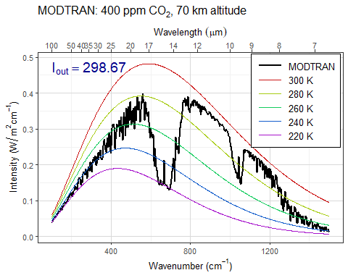

modtran_moreCarbon = run_modtran(co2_ppm = 410)  
plot_modtran(modtran_data = modtran_moreCarbon)

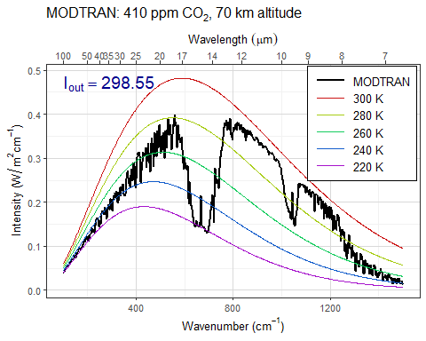

modtran_moreMethane = run_modtran(ch4_ppm = 11.7)  
plot_modtran(modtran_data = modtran_moreMethane)

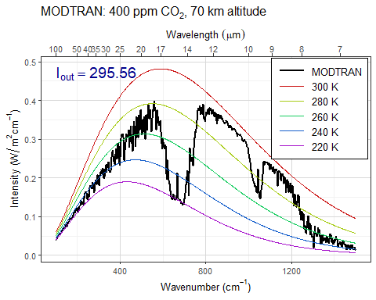

**Answer:** *Put your answer here.* The additional 10 ppm of methane has a greater impact. You can see this both because the curve looks more noticeably different than the default with the extra methane than with the co2, and there is also a greater difference in the final IR Flux values.

1. **Where in the spectrum does methane absorb? What concentration does it take to begin to saturate the absorption in this band? Explain what you are looking at to judge when the gas is saturated.**

* **Hints:**  
  See the hints in the lab-03-instructions document.

# TODO  
# Put your R code here  
  
methaneValues = c(0,1,2,4,8,16,32,64,128)  
  
  
for (i in methaneValues) {  
 modtran_spectrum = run_modtran(co2_ppm = 0, ch4_ppm = i, trop_o3_ppb = 0, strat_o3_scale = 0, h2o_scale = 0, freon_scale = 0)  
 p <- plot_modtran(modtran_data = modtran_spectrum)  
 print(p)  
}

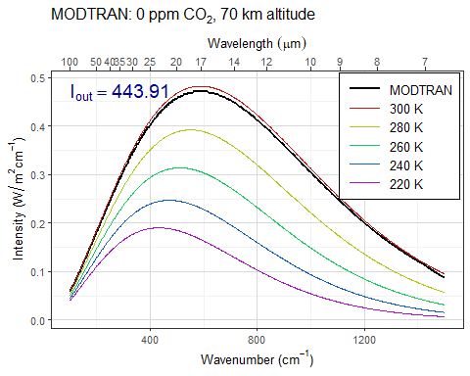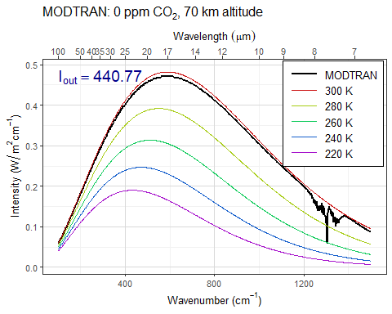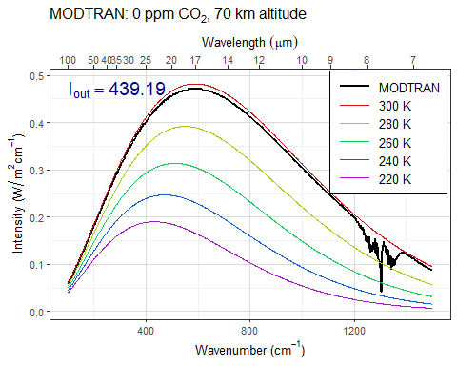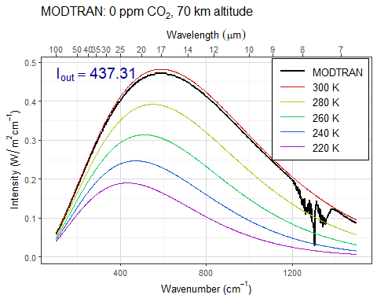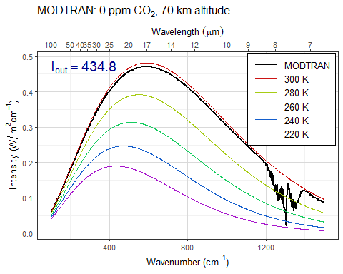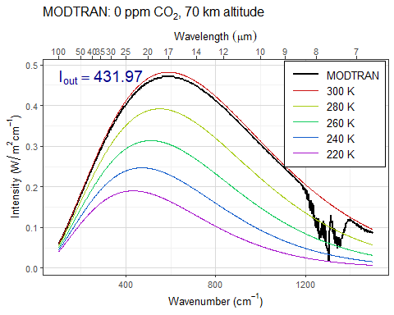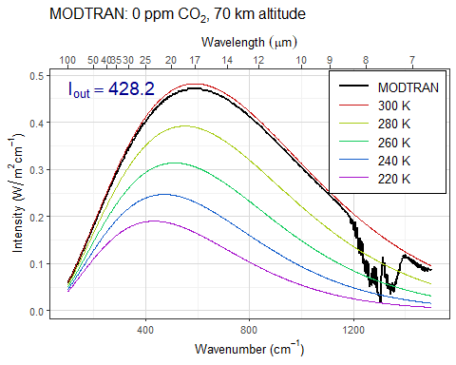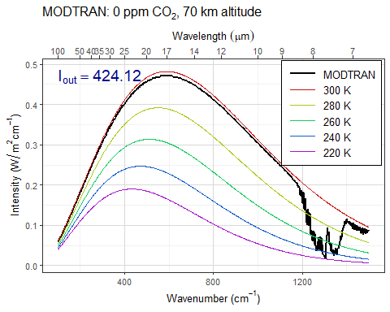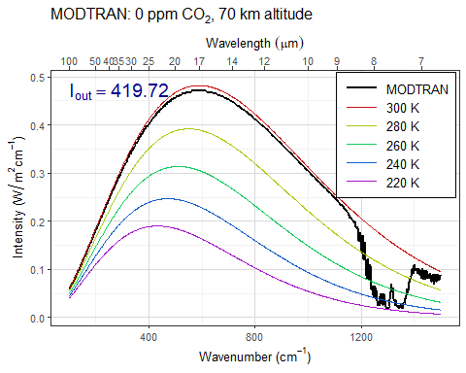

**Answer:** *Put your answer here.* Be sure to show your work and include any data, plots, etc. that you need in order to explain how you came up with your answer.

The plot shows that the wavenumbers between about 1100 and onwards get altered more noticeably the more methane is added, with most of the discrepancy from the base curve occurring between about 1225 and 1450 cm^-1, so that is likely where the absorption spectrum is.

1. **Would a doubling of methane have as great an impact on the heat balance as a doubling of CO2?**

* **Hint:** See the suggestion in the lab-03-instructions document.

plot_modtran(modtran_data = modtran_default)



modtran_DoubleC = run_modtran(co2_ppm = 800)  
plot_modtran(modtran_DoubleC)

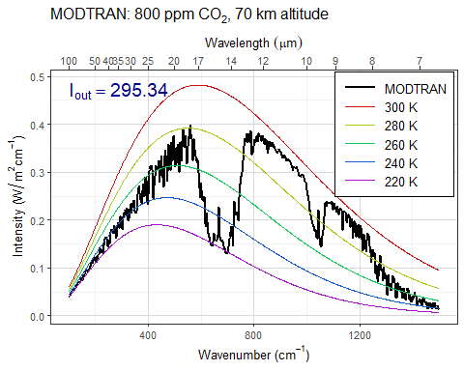

modtran_DoubleM = run_modtran(ch4_ppm = 3.4)  
plot_modtran(modtran_DoubleM)

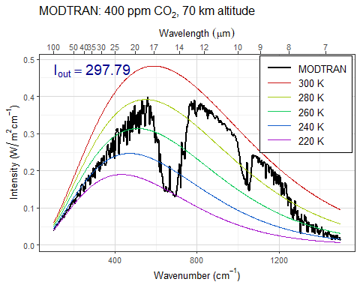

**Answer:** *Put your answer here.* Be sure to show your work and include any data, plots, etc. that you need in order to explain how you came up with your answer.

The change to the graph and to the final IR Flux value differs from the default more with the double CO2 than with the double methane, so doubling the CO2 has a greater impact.

1. **What is the “equivalent CO2” of doubling atmospheric methane? That is to say, how many ppm of CO2 would lead to the same change in outgoing IR radiation energy flux as doubling methane? What is the ratio of ppm CO2 change to ppm methane change?**

plot_modtran(modtran_data = modtran_default)



eqCo2Values = c(425,450,475,500,525,550,575,600)  
  
for (i in eqCo2Values) {  
 modtran_Eq = run_modtran(co2_ppm = i)  
 p <- plot_modtran(modtran_data = modtran_Eq)  
 print(p)  
}

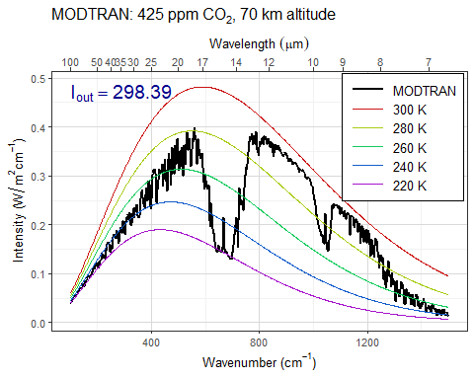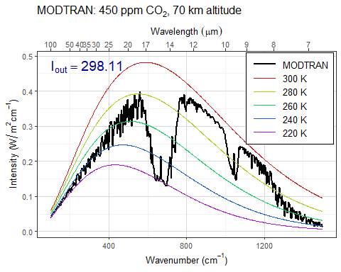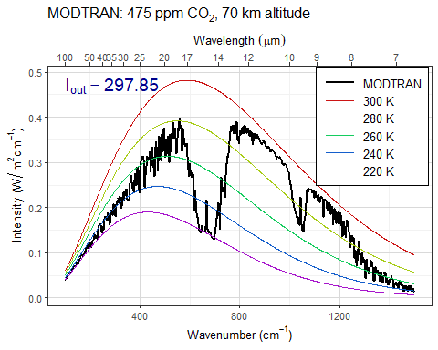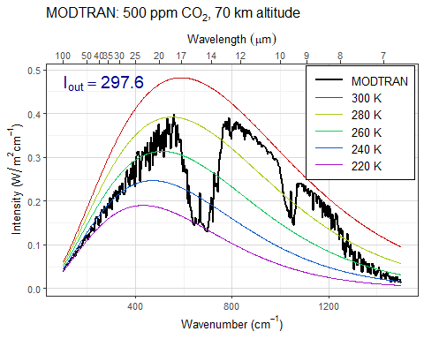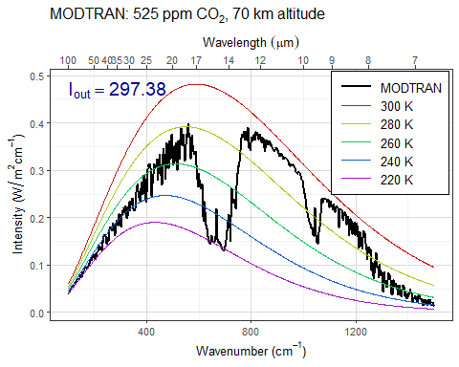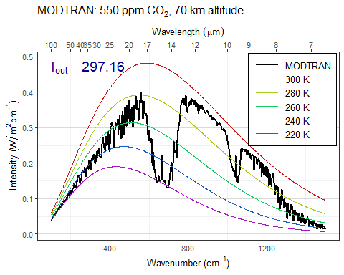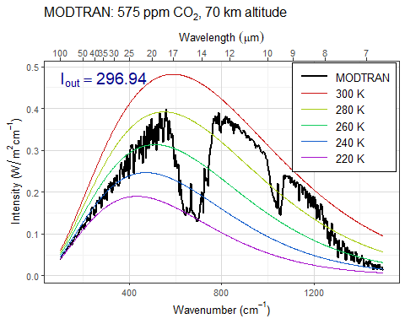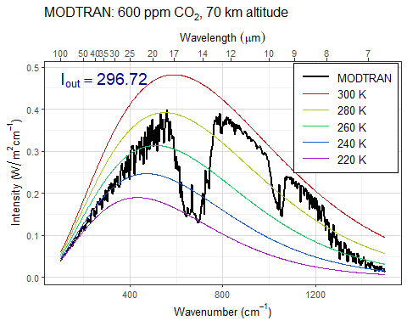

## Exercise 4.3: Water vapor

Our theory of climate presumes that an increase in the temperature at ground level will lead to an increase in the outgoing IR energy flux at the top of the atmosphere.

1. **How much extra outgoing IR would you get by raising the temperature of the ground by 5°C? What effect does the ground temperature have on the shape of the outgoing IR spectrum and why?**

* **Hint:** See the hint in the lab-03-instructions document.

plot_modtran(modtran_data = modtran_default)



modtran_raisedTemp = run_modtran(delta_t = 5)  
plot_modtran(modtran_data = modtran_raisedTemp)

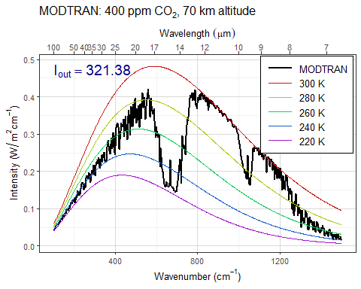

**Answer:** *Put your answer here.* Be sure to show your work and include any data, plots, etc. that you need in order to explain how you came up with your answer.

Increasing the temperature lifts the MODTRAN curve upwards noticeably. This checks out, as intensity tends to increase with higher temperature and since the colored baseline temperature curves stay constant, the MODTRAN curve will elevate relative to those curves on the intensity axis.

1. **More water can evaporate into warm air than into cool air. Change the model settings to hold the water vapor at constant relative humidity rather than constant vapor pressure (the default), calculate the change in outgoing IR energy flux for a 5°C temperature increase. Is it higher or lower? Does water vapor make the Earth more sensitive to CO2 increases or less sensitive?**

* **Note:** By default, the MODTRAM model holds water vapor pressure constant, but you can set it to hold relative humidity constant instead with the option h2o_fixed = "relative humidity", like this: run_modtran(file_name, delta_t = 5, h2o_fixed = "relative humidity").

# TODO  
# Put your R code here  
  
#first to get the baseline from the last part so that everything is easy to see and parse  
  
plot_modtran(modtran_data = modtran_raisedTemp)



modtran_RelHumid = run_modtran(delta_t = 5, h2o_fixed = 'relative humidity')  
plot_modtran(modtran_data = modtran_RelHumid)

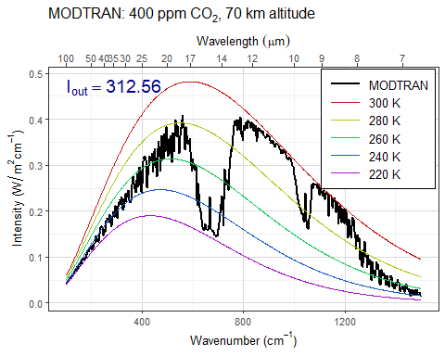

**Answer:** *Put your answer here.* Be sure to show your work and include any data, plots, etc. that you need in order to explain how you came up with your answer.

The IR Flux goes down by a little under 9 units when the model holds humidity constant compared to when it holds vapor pressure. These graphs would imply that more water vapor would mean the earth is MORE sensitive to CO2

1. **Now see this effect in another way.**
   * **Starting from the default base case, record the total outgoing IR flux.** Flux = 298.67
   * **Now double CO2. The temperature in the model stays the same (that’s how the model is written), but the outgoing IR flux goes down.** Flux = 295.34
   * **Using constant water vapor pressure, adjust the temperature offset until you get the original IR flux back again. Record the change in temperature.** Necessary Delta T ~= 0.75
   * **Now repeat the exercise, but holding the relative humidity fixed instead of the water vapor pressure.** Delta T ~= 1.2
   * **The ratio of the warming when you hold relative humidity fixed to the warming when you hold water vapor pressure fixed is the feedback factor for water vapor. What is it?** 1.2 / 0.75 = 1.6. Ratio of 1.6

# TODO  
# Put your R code here  
  
#default  
#plot_modtran(modtran_data = modtran_default)  
  
#doubleCo2  
#plot_modtran(modtran_data = modtran_DoubleC)  
  
#constant pressure, get flux back to 298.67  
#tempValues = c(0.25,0.5,0.75,1)  
#for (i in tempValues) {  
 # modtran_FluxReturn = run_modtran(co2_ppm = 800, delta_t = i)  
 # p <- plot_modtran (modtran_data = modtran_FluxReturn)  
 # print(p)  
#}  
  
#constant humidity, get flux back to 298.67  
 newTemps = c(1.05,1.1,1.15,1.2,1.25)  
 for (j in newTemps) {  
 modtran_NewFluxReturn = run_modtran(co2_ppm = 800, delta_t = j, h2o_fixed = 'relative humidity')  
 p <- plot_modtran(modtran_data = modtran_NewFluxReturn)  
 print(p)  
 }

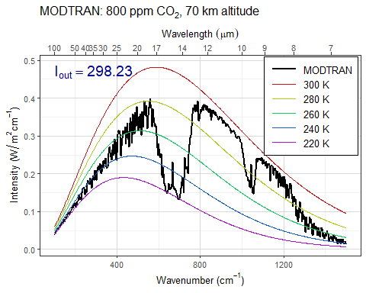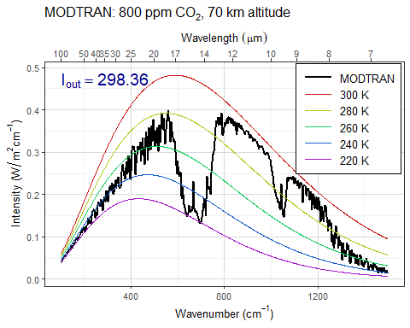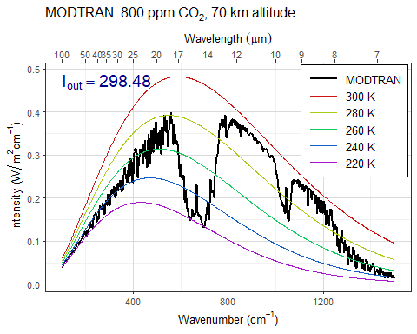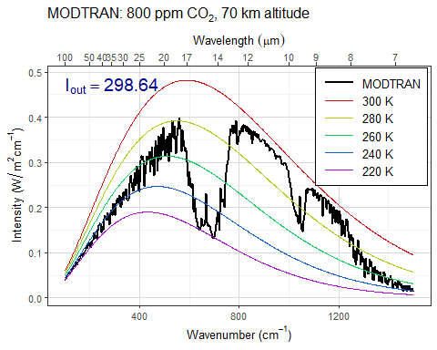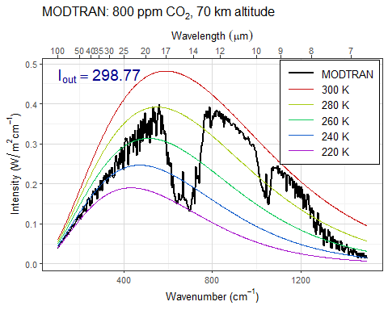

**Answer:** *Put your answer here.* Questions are answered right after they are posed.