# Working with Forms - Exercise

## Topics Covered

* Web forms are a very powerful tool for interacting with users — most commonly they are used for collecting data from users or allowing them to control a user interface.

## Resources

* **Web form building blocks**
  + https://developer.mozilla.org/en-US/docs/Learn/Forms

## Task

### Login

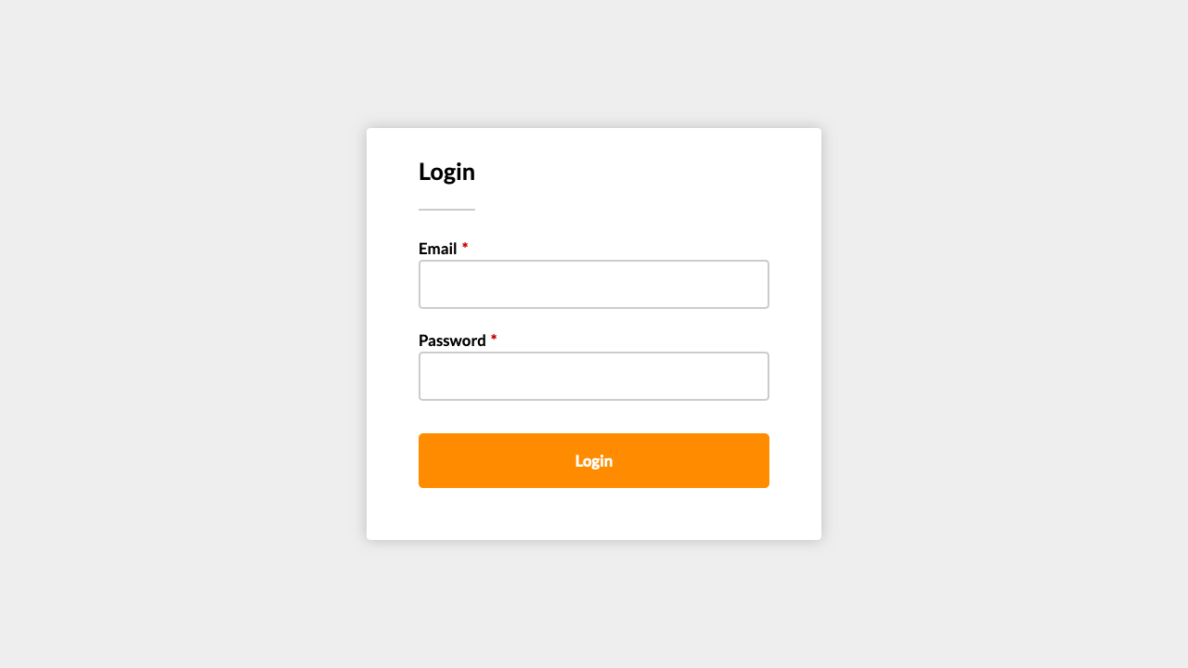

*For full screenshot check the screenshot.png file in the folder for the task*

#### Objective:

Create a webpage that looks like the screenshot above.

#### Requirements:q

1. **File Setup**:
   * Create an **HTML** document named **login.html**
   * Create a **CSS** file named **login.css**

### Icons and State

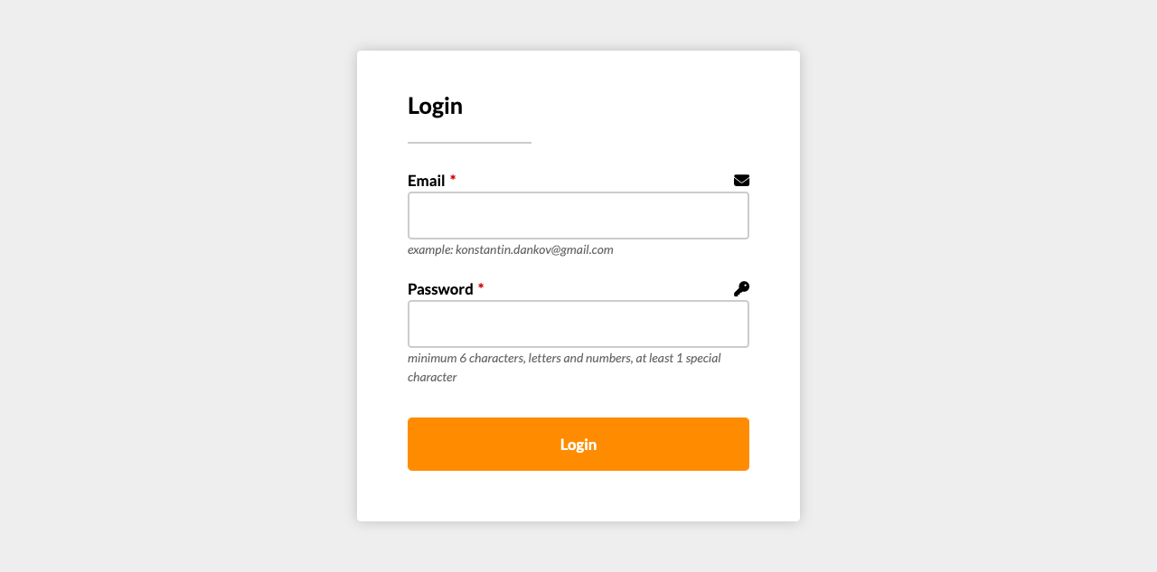

*For full screenshot check the screenshot.png file in the folder for the task*

#### Objective:

Create a webpage that looks like the screenshot above.

#### Requirements:

1. **File Setup**:
   * Create an **HTML** document named **icons-and-state.html**
   * Create a **CSS** file named **icons-and-state.css**

### Flexbox Responsive

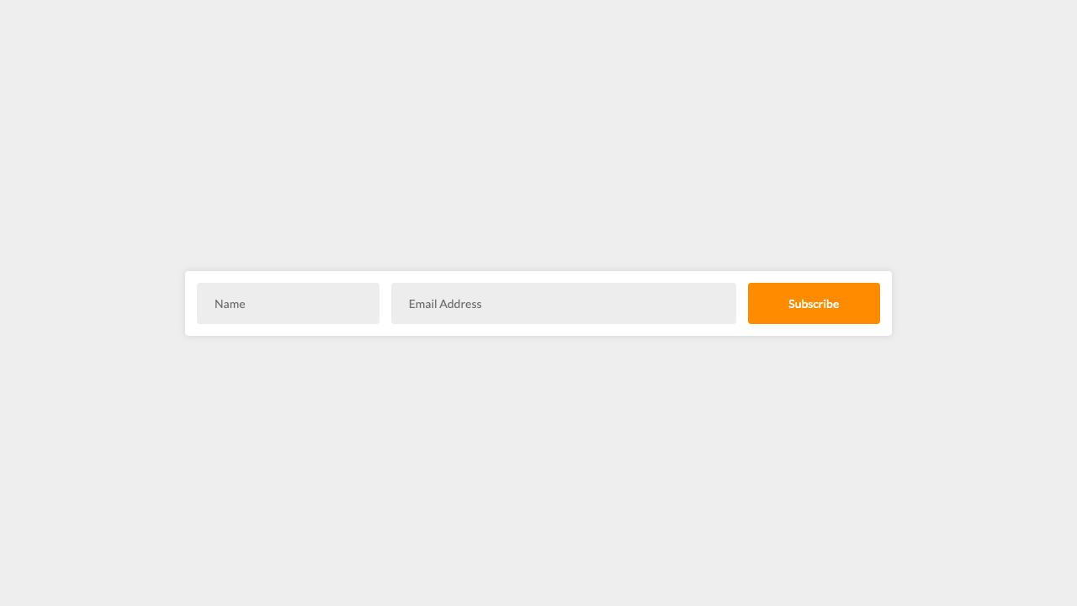

*For full screenshot check the screenshot.png file in the folder for the task*

#### Objective:

Create a webpage that looks like the screenshot above.

#### Requirements:

1. **File Setup**:
   * Create an **HTML** document named **flexbox-responsive.html**
   * Create a **CSS** file named **flexbox-responsive.css**

### Floating Labels

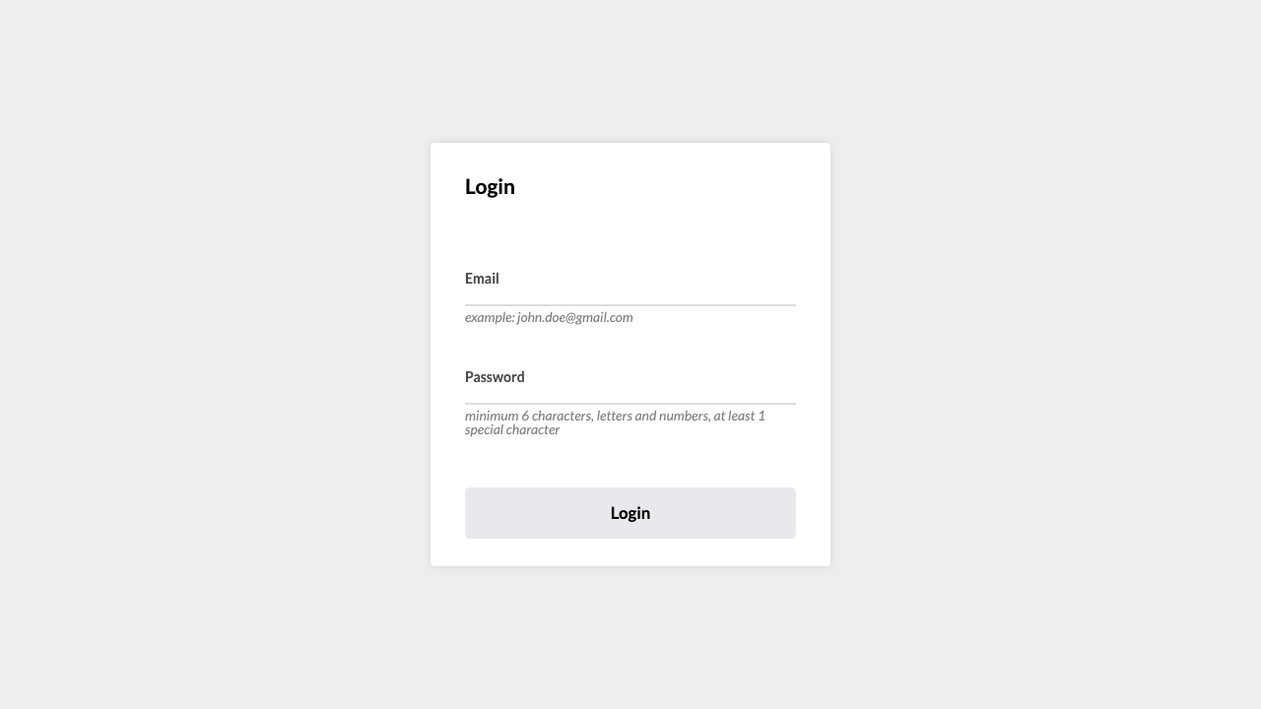

*For full screenshot check the screenshot.png file in the folder for the task*

#### Objective:

Create a webpage that looks like the screenshot above.

#### Requirements:

1. **File Setup**:
   * Create an **HTML** document named **floating-labels.html**
   * Create a **CSS** file named **floating-labels.css**

### Registration

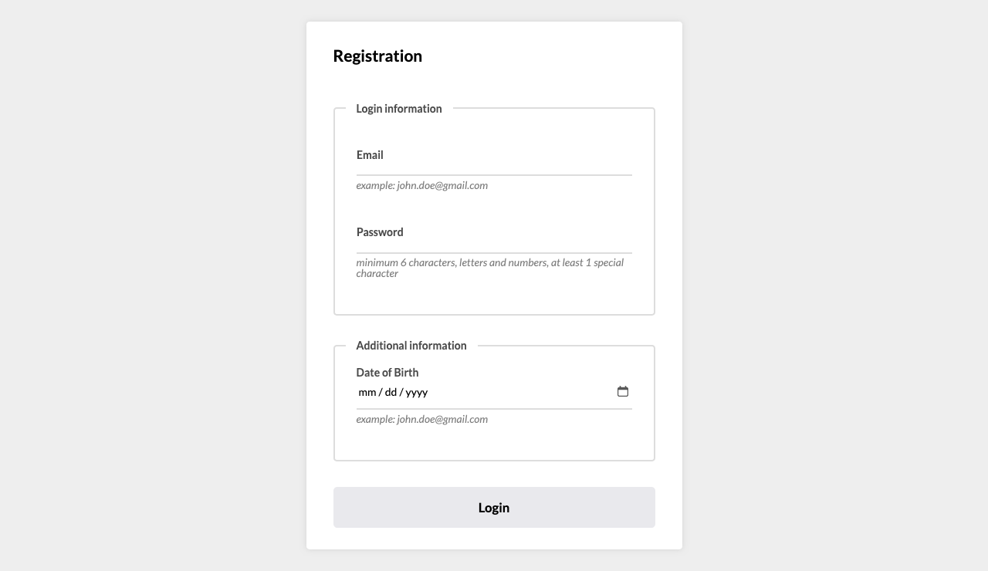

*For full screenshot check the screenshot.png file in the folder for the task*

#### Objective:

Create a webpage that looks like the screenshot above.

#### Requirements:

1. **File Setup**:
   * Create an **HTML** document named **registration.html**
   * Create a **CSS** file named **registration.css**

### Custom checkbox and radio

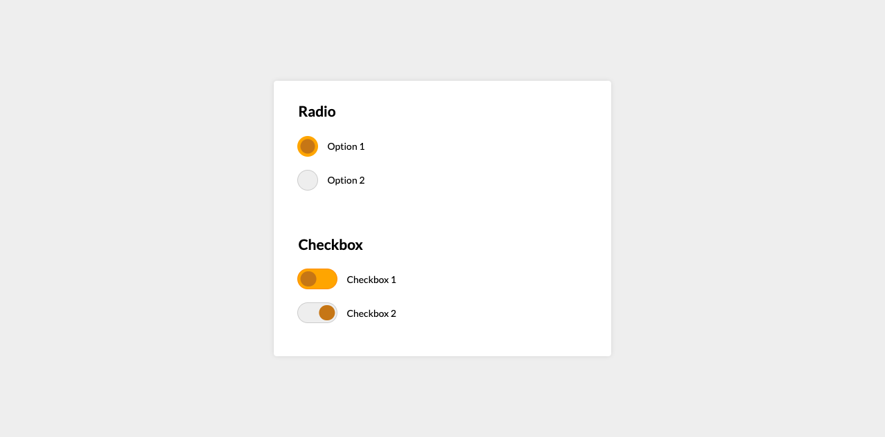

*For full screenshot check the screenshot.png file in the folder for the task*

#### Objective:

Create a webpage that looks like the screenshot above.

#### Requirements:

1. **File Setup**:
   * Create an **HTML** document named **custom-checkbox-and-radio.html**
   * Create a **CSS** file named **custom-checkbox-and-radio.css**

### Layout Horizontal Section – No wrapper

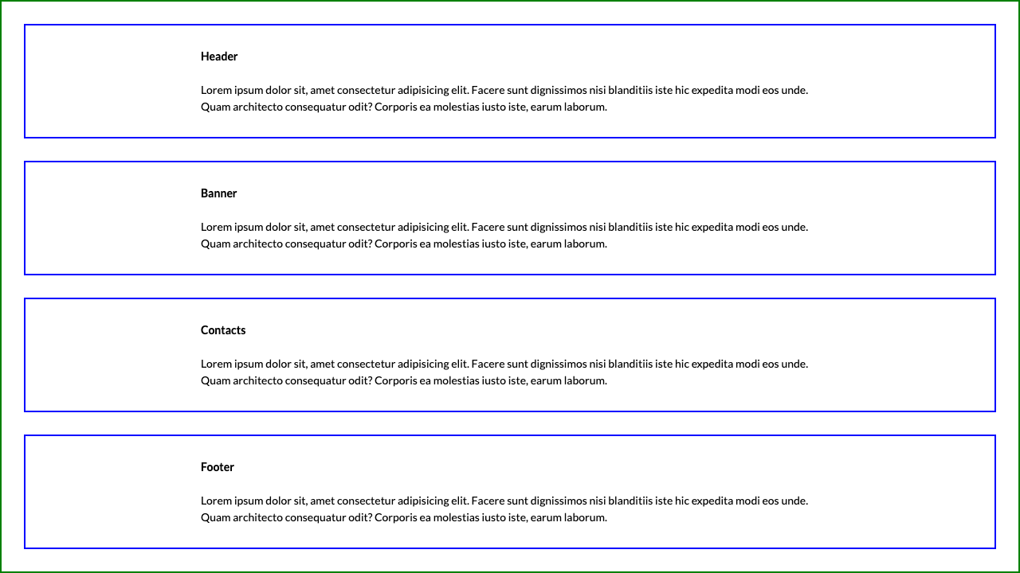

*For full screenshot check the screenshot.png file in the folder for the task*

#### Objective:

Create a webpage that looks like the screenshot above.

#### Requirements:

1. **File Setup**:
   * Create an **HTML** document named **layout-horizontal-section-no-wrapper.html**
   * Create a **CSS** file named **layout-horizontal-section-no-wrapper.css**
2. **Styling**
   * Do not use an additional HTML element to achieve the centering. Use padding, vw and calc() to get the same effect with only 1 element instead of two.

### Contact form

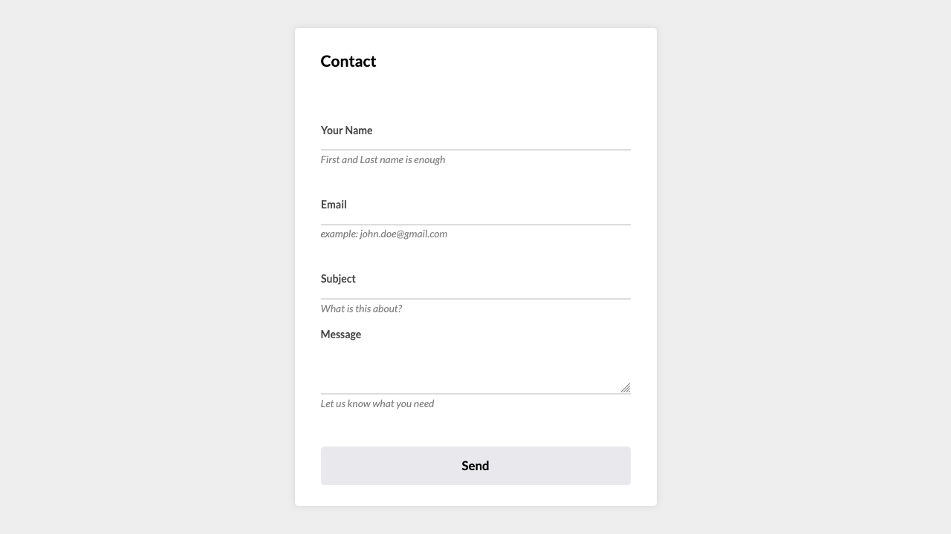

*For full screenshot check the screenshot.png file in the folder for the task*

#### Objective:

Create a webpage that looks like the screenshot above.

#### Requirements:

1. **File Setup**:
   * Create an **HTML** document named **contact.html**
   * Create a **CSS** file named **contact.css**