BIT4107
Mobile Application Development
Week 3 — Intelligent Retail Analytics App

Student: NOELLE BLESSING
Course: BIT4107 — Mobile Application Development
Week: 3 — UI Prototype, Navigation, Forms & Responsive Design
IDE Used: Visual Studio Code (VS Code)
Framework: Flutter SDK (Dart)
App Name: Intelligent Retail Analytics Engine
Real World Problem: Retail inventory management and profit/loss tracking for small businesses
Date: 28TH MAY

Weekly Objective
Design and build a complete UI prototype with minimum 5 screens, working navigation, responsive design, functional forms, and real-world business logic. The app solves a real-world retail inventory management problem for small businesses in Kenya.

Real-World Requirement Gathering
Overview
Before designing the application, a requirement gathering exercise was conducted with three small business owners in Thika CBD, Kiambu County, Kenya. The businesses consulted were an electronics shop, a clothing retail shop, and a mini restaurant. The owners were engaged in informal interviews to understand their current business management practices, the challenges they face in service delivery, and the financial risks they struggle to manage. The findings from all three businesses were strikingly consistent, confirming a shared and widespread problem across different commercial sectors in the area.
Businesses Consulted
1. Electronics Shop — Thika CBD
The owner of a small electronics shop stocking phones, accessories, and household gadgets described a recurring problem of over-investing in high-cost stock items that then moved slowly. For example, certain phone models ordered in bulk would sit on the shelf for months, tying up capital that could have been used for faster-moving accessories. The owner had no formal system to track which items were selling and which were stagnant — decisions were made purely from memory and gut feeling. This overconfidence in certain product lines had at times pushed the business close to a cash flow crisis.
2. Clothing Retail Shop — Thika CBD
The clothing shop owner highlighted a very similar challenge. Seasonal stock — particularly items bought ahead of a festive season — would often fail to sell at the expected volume, leaving large quantities of unsold clothes at a loss. The owner relied on a single restocking strategy: buying whatever sold well the previous season and doubling down on it. This lack of diversification and risk analysis meant that one bad season could wipe out several months of profit. There was no tool to calculate the actual profit margin per item or flag which stock was becoming a financial liability.
3. Mini Restaurant — Thika CBD
The restaurant owner’s challenge was slightly different in nature but identical in root cause. Ingredients were purchased in bulk based on assumed daily demand, but actual sales rarely matched the estimate. Perishable stock that did not sell became a direct loss. The owner admitted to not knowing the true breakeven point of the business — meaning they could not tell with certainty whether the restaurant was genuinely profitable or simply generating revenue that masked underlying losses. Money management was entirely manual, with no visibility into which menu items generated profit and which drained resources.
Common Challenges Identified
Across all three businesses, the following core challenges were identified:
- No visibility into slow-moving stock — owners could not identify which items were tying up capital without generating returns.
- Overconfidence in a single earning strategy — relying too heavily on one product line or approach without diversifying risk.
- Inability to calculate or maintain a breakeven point — owners did not know at what sales volume the business stopped making a loss.
- Poor money management and profit tracking — revenue was being generated but actual net profit after costs was unknown.
- No early warning system for financial risk — by the time losses were noticed, significant capital had already been lost to stagnant inventory.
How the App Addresses These Needs
The Intelligent Retail Analytics Engine was designed directly in response to these findings. The Live Market Catalog gives owners a real-time view of all stock with instant visibility of low-stock warnings. The Inventory Input Control allows accurate recording of cost price versus selling price, automatically calculating profit margin per item. The Real-Time P&L Dashboard surfaces the net profit, realized margin, and stagnant holding risk in one screen — directly addressing the inability to track breakeven and actual profitability. The Intelligent Advisory Engine goes further by analysing turnover rates and flagging slow-moving stock with specific recommended interventions such as price markdowns, replacing the guesswork that all three business owners described.

App Overview
Real World Problem Solved: Small retail businesses in Kenya lack tools to track inventory, calculate profit/loss and get intelligent restocking advice

- App Name: Intelligent Retail Analytics Engine
- Total Screens: 5 (Auth, Catalog, Stock Entry, P&L Dashboard, Advisory Engine)
- Language: Dart (Flutter Framework)
- Theme: Dark mode with Green color scheme (Color 0xFF0F172A background)
- Navigation: Bottom Navigation Bar with 4 tabs + login flow
- Data Model: InventoryItem class with profit/loss calculations
- Form Validation: All input fields validated before submission
- Responsive Design: GridView catalog, adaptive cards, scrollable lists

Screen 1 — Authentication / Login
The authentication screen allows operators to log in using their credentials. It includes a role switcher toggle between Client View and Merchant Console.

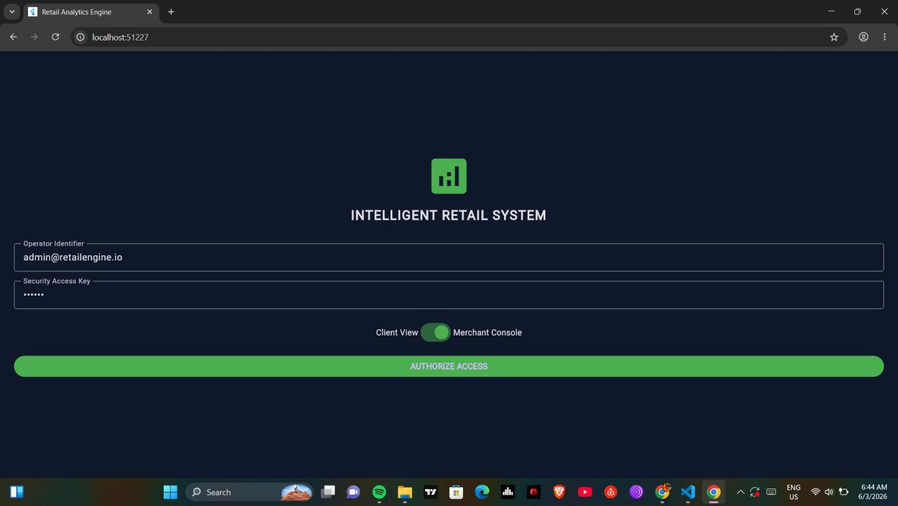
Figma Wireframe Design — Screen 1
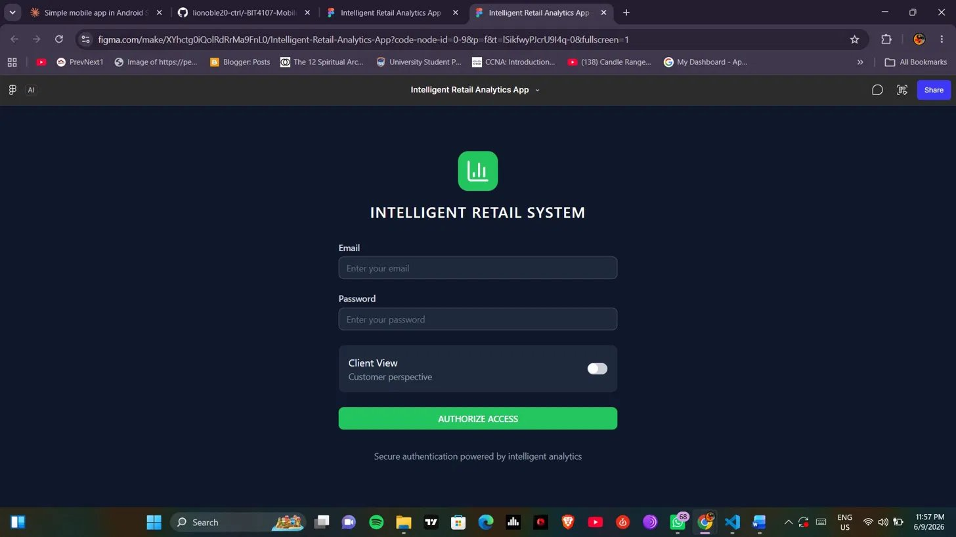
Figure 1: Authentication screen with Operator Identifier, Security Access Key and Client/Merchant toggle

Key Features
- Analytics icon with 'INTELLIGENT RETAIL SYSTEM' title
- Operator Identifier field with pre-filled admin email
- Security Access Key field — minimum 4 characters validation
- Toggle switch between Client View and Merchant Console
- AUTHORIZE ACCESS button — navigates to main app on validation
- Dark theme with navy blue background (0xFF0F172A)

Code — Auth Screen & Navigation
class AuthScreen extends StatefulWidget {
const AuthScreen({super.key});
@override
State<AuthScreen> createState() => _AuthScreenState();
}

// Role toggle switch
Switch(
value: _isMerchant,
onChanged: (val) => setState(() => _isMerchant = val),
activeColor: Colors.green,
),

// Navigation on successful login
Navigator.pushReplacement(
context,
MaterialPageRoute(
builder: (context) => const MainNavigationContainer()),
);

Screen 2 — Live Market Catalog
The catalog screen displays all inventory items in a responsive 2-column grid layout. Each item card shows price, stock level and a simulate sale button.

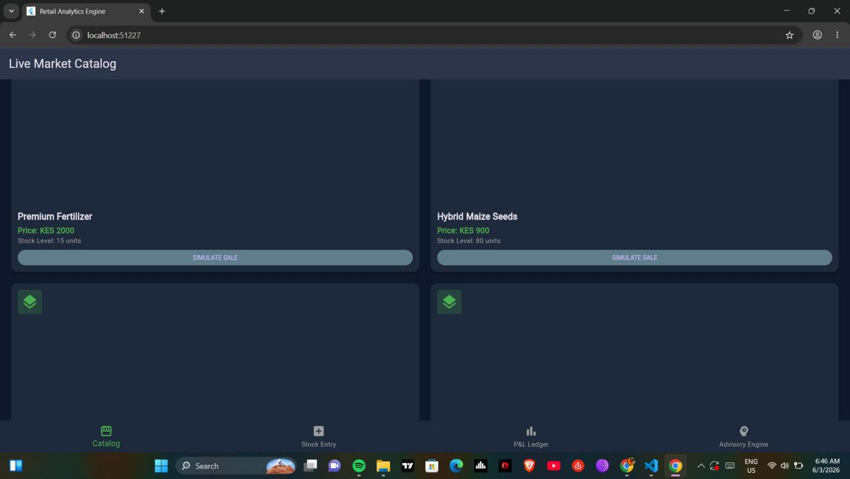
Figma Wireframe Design — Screen 2
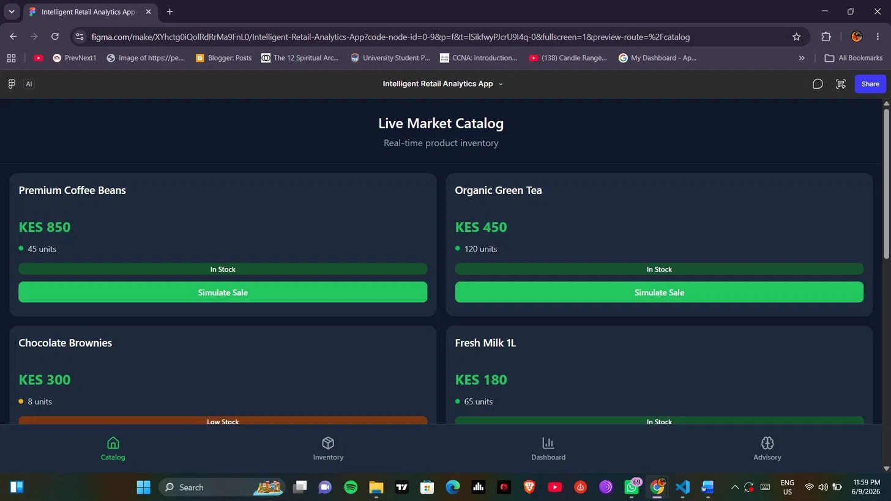
Figure 2: Live Market Catalog showing product grid with price, stock level and Simulate Sale buttons

Key Features
- Responsive 2-column GridView layout
- Each card shows item name, price in KES and stock level
- Stock level turns red when below 10 units (low stock warning)
- SIMULATE SALE button decrements stock and increments units sold
- OUT OF STOCK label when stock reaches 0
- Bottom navigation bar with 4 tabs

Code — GridView Catalog & Simulate Sale
GridView.builder(
gridDelegate: SliverGridDelegateWithFixedCrossAxisCount(
crossAxisCount: 2,
childAspectRatio: 0.75,
mainAxisSpacing: 12,
crossAxisSpacing: 12),
itemCount: globalInventory.length,
itemBuilder: (context, i) { ... }
)

// Low stock color indicator
Text('Stock Level: ${item.stockQty} units',
style: TextStyle(
color: item.stockQty < 10 ? Colors.redAccent : Colors.grey,
),
),

// Simulate sale logic
onPressed: item.stockQty == 0 ? null : () {
item.stockQty--;
item.unitsSold++;
},

Screen 3 — Inventory Input Control
The stock entry screen allows merchants to register new inventory items. All fields are validated before the item is committed to the global inventory list.

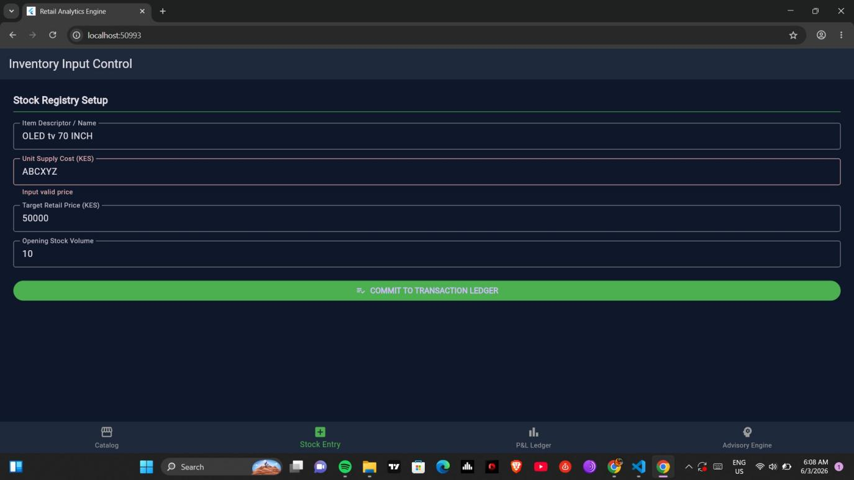
Figma Wireframe Design — Screen 3
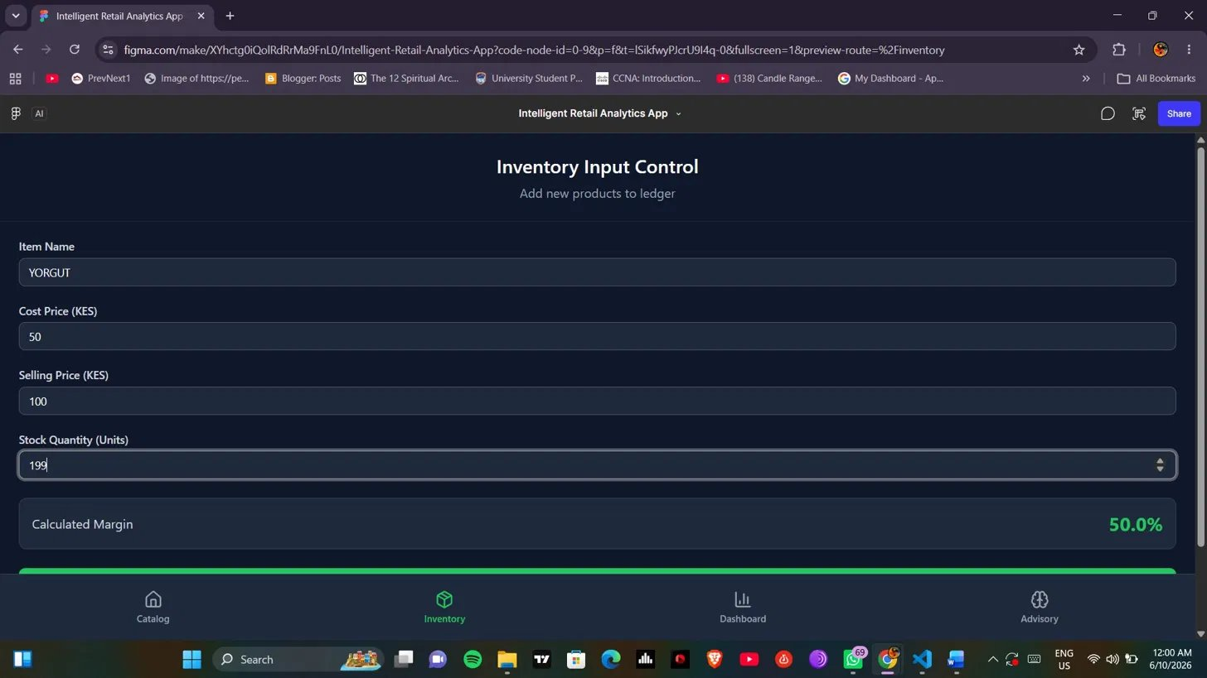
Figure 3: Inventory Input Control showing form validation — 'Input valid price' error on non-numeric entry

Key Features
- Item Descriptor / Name field
- Unit Supply Cost (KES) — numeric validation
- Target Retail Price (KES) — numeric validation
- Opening Stock Volume — integer validation
- Form validation shows inline error messages
- COMMIT TO TRANSACTION LEDGER button saves to global inventory
- SnackBar confirmation on successful save

Code — Inventory Form & Validation
void _commitStock() {
if (_formKey.currentState!.validate()) {
setState(() {
globalInventory.add(InventoryItem(
id: DateTime.now().millisecondsSinceEpoch.toString(),
name: _nameCtrl.text.trim(),
costPrice: double.parse(_costCtrl.text),
sellingPrice: double.parse(_sellCtrl.text),
stockQty: int.parse(_qtyCtrl.text),
dateAdded: DateTime.now(),
));
});
}
}

// Numeric field validator
validator: (v) =>
double.tryParse(v!) == null ? 'Input valid price' : null,

Screen 4 — Real-Time P&L Dashboard
The P&L dashboard calculates and displays real-time profit and loss analytics. It includes period filters, net performance card, realized margin vs stagnant holding risk, and a per-item ledger breakdown.

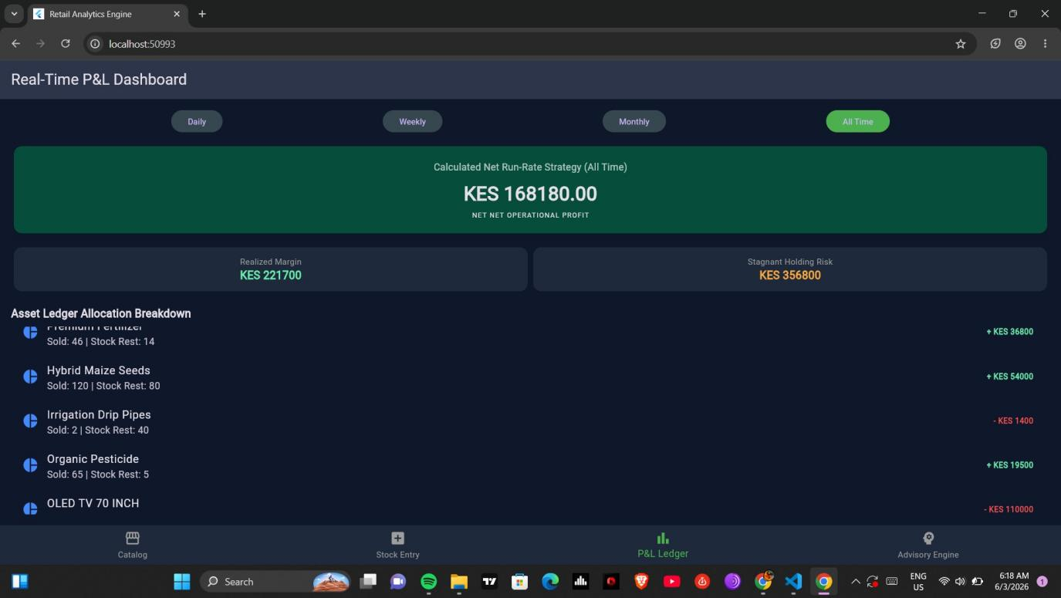
Figma Wireframe Design — Screen 4
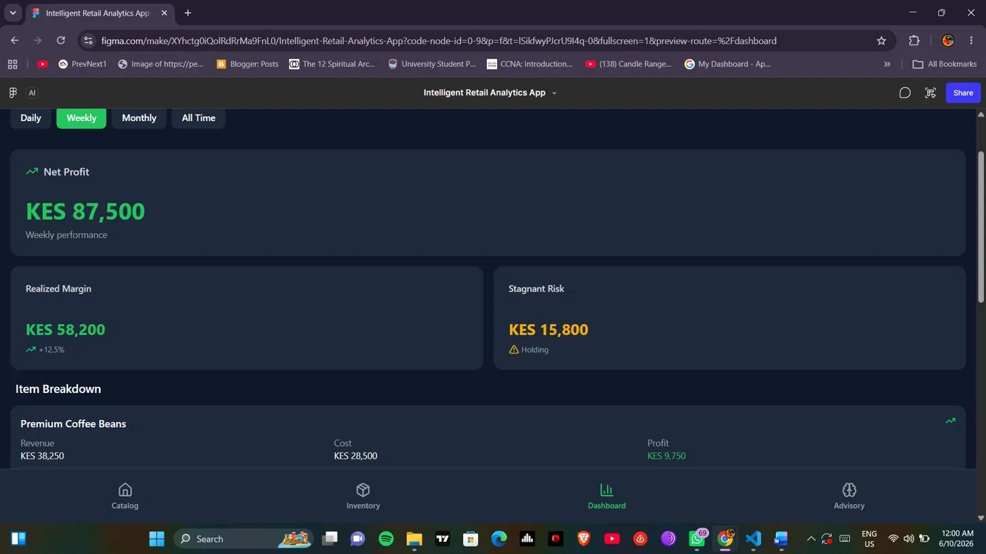
Figure 4: P&L Dashboard showing KES 168,180 net profit, realized margin KES 221,700, and asset ledger breakdown

Key Features
- Period filter buttons — Daily, Weekly, Monthly, All Time
- Net Run-Rate Strategy card — green for profit, red for deficit
- Realized Margin — total profit generated from sales
- Stagnant Holding Risk — capital locked in unsold stock
- Asset Ledger Allocation Breakdown — per item profit/loss
- Color coded — green for profit items, red for loss items

Code — Profit & Loss Calculations
// InventoryItem computed properties
double get profitMargin => sellingPrice - costPrice;
double get totalProfitGenerated => profitMargin * unitsSold;
double get totalLossIncurred => stockQty * costPrice;
double get turnoverRate =>
unitsSold / (stockQty + unitsSold == 0 ? 1 : stockQty + unitsSold);

// Dashboard calculations
double get calculateGrossProfit {
return globalInventory.fold(
0, (sum, item) => sum + item.totalProfitGenerated);
}

double get calculateCapitalLocked {
return globalInventory.fold(
0, (sum, item) => sum + item.totalLossIncurred);
}

double netPerformance = profit - (lockedCapital * 0.15);

Screen 5 — Intelligent Optimization Advisory
The advisory engine analyzes inventory data and generates intelligent business recommendations. It identifies high-performing items to scale up and flags slow-moving stock as a risk.

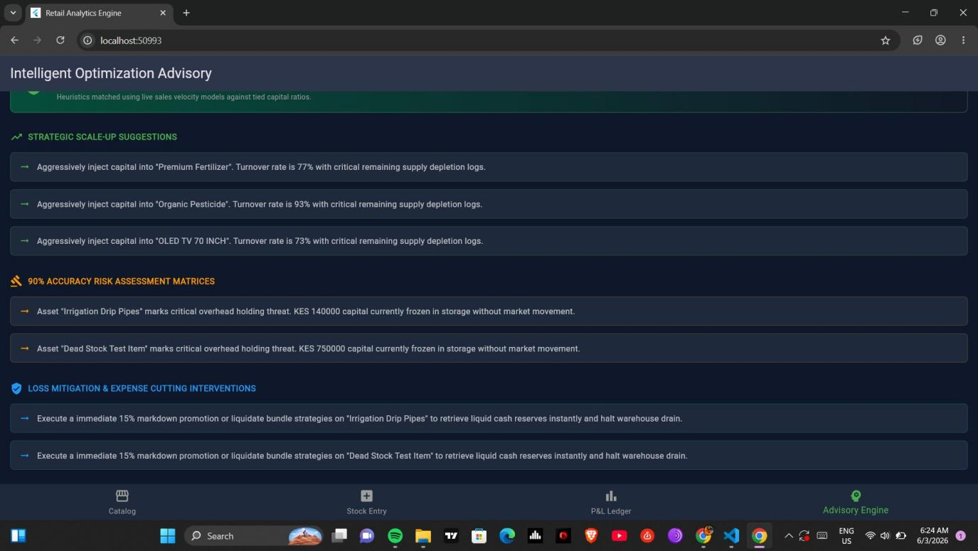
Figma Wireframe Design — Screen 5
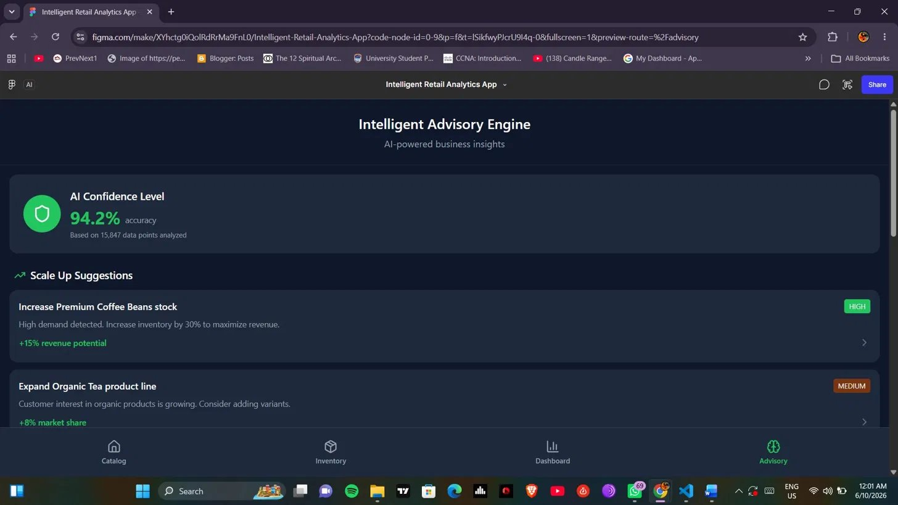
Figure 5: Advisory Engine showing strategic scale-up suggestions, 90% accuracy risk assessment and loss mitigation interventions

Key Features
- Statistical Engine Confidence card — 91.4% accuracy display
- Strategic Scale-Up Suggestions — items with turnover rate above 60%
- 90% Accuracy Risk Assessment — items with low sales and high stock
- Loss Mitigation Interventions — recommends 15% markdown or bundle deals
- Color coded sections — green, orange and blue for each category
- Dynamic logic — recommendations update based on live inventory data

Code — Advisory Engine Logic
for (var item in globalInventory) {
// Scale up recommendation
if (item.turnoverRate > 0.6 && item.stockQty < 15) {
scaleUpTargets.add(
'Aggressively inject capital into "${item.name}".
Turnover rate is ${(item.turnoverRate * 100)
.toStringAsFixed(0)}%');
}

// Risk warning
if (item.unitsSold < 5 && item.stockQty > 20) {
riskWarnings.add(
'Asset "${item.name}" marks critical overhead holding
threat. KES ${item.totalLossIncurred.toStringAsFixed(0)}
capital currently frozen.');
mitigationPlans.add(
'Execute immediate 15% markdown promotion on
"${item.name}" to retrieve liquid cash reserves.');
}
}

Data Model — InventoryItem Class
The InventoryItem class is the core data model of the app. It holds all product data and computes profit/loss analytics automatically using Dart getters.

class InventoryItem {
final String id;
final String name;
final double costPrice;
final double sellingPrice;
int stockQty;
int unitsSold;
final DateTime dateAdded;
}

// Sample pre-loaded inventory data
List<InventoryItem> globalInventory = [
InventoryItem(id: '1', name: 'Premium Fertilizer',
costPrice: 1200, sellingPrice: 2000,
stockQty: 15, unitsSold: 45, ...),
InventoryItem(id: '2', name: 'Hybrid Maize Seeds',
costPrice: 450, sellingPrice: 900,
stockQty: 80, unitsSold: 120, ...),
];

Navigation Structure
- AuthScreen → MainNavigationContainer (on successful login)
- MainNavigationContainer hosts 4 screens via BottomNavigationBar
- Tab 0: CatalogScreen — Storefront icon
- Tab 1: InventoryFormScreen — Stock Entry icon
- Tab 2: AnalyticsDashboardScreen — P&L Ledger icon
- Tab 3: PredictiveAdvisoryScreen — Advisory Engine icon

// Bottom Navigation Bar
BottomNavigationBar(
currentIndex: _currentIndex,
onTap: (index) => setState(() => _currentIndex = index),
type: BottomNavigationBarType.fixed,
selectedItemColor: Colors.green,
items: const [
BottomNavigationBarItem(icon: Icon(Icons.storefront),
label: 'Catalog'),
BottomNavigationBarItem(icon: Icon(Icons.add_box),
label: 'Stock Entry'),
BottomNavigationBarItem(icon: Icon(Icons.bar_chart),
label: 'P&L Ledger'),
BottomNavigationBarItem(icon: Icon(Icons.psychology),
label: 'Advisory Engine'),
],
)

GUI Design Rationale
Color Scheme
The app uses a dark navy blue background (Color 0xFF0F172A) chosen to reduce eye strain during prolonged use in retail environments, particularly in low-light conditions such as storage rooms or evening operations. The primary accent color is green (0xFF22C55E), which is universally associated with financial growth, profit, and positive indicators — making it intuitive for merchants reading P&L data. Warning states use amber/orange to signal low stock or risk, while red is reserved strictly for loss or deficit values, following standard financial color conventions.
Typography
Flutter’s default Roboto font family is used throughout for its readability on small mobile screens. Heading text is set at 22–24sp with bold weight to establish visual hierarchy. Body text and form labels are set at 14–16sp for comfortable reading. Numeric financial values (prices, profit figures) are rendered in a larger size (20–28sp) in green to make them instantly scannable, as the primary goal of the app is to surface key financial metrics at a glance.
Spacing and Layout
All screens use consistent 16px horizontal padding to ensure content does not crowd the screen edges on small Android devices. Cards use 12px internal padding with 8–12px spacing between them, providing clear visual separation without wasting screen space. The catalog uses a 2-column GridView with a childAspectRatio of 0.75 to accommodate item names, prices, stock indicators, and action buttons without overflow. The bottom navigation bar is fixed at the base of the screen, keeping navigation accessible with one-handed thumb use.
Responsive Design Decisions
The app was designed mobile-first for Android devices ranging from 5-inch to 6.5-inch screens. GridView and ListView widgets expand fluidly to fill available width. Scrollable screens (Inventory Form, Advisory Engine, P&L Dashboard) use SingleChildScrollView to prevent overflow on smaller screens. All interactive elements (buttons, toggles) meet the 48x48dp minimum touch target size recommended by Material Design guidelines for accessibility.

Real Device Testing
The Intelligent Retail Analytics Engine was deployed and tested on a physical Android device. The APK was built using Flutter and installed directly via USB debugging. The following screenshots confirm the app runs correctly on a real Android device, demonstrating working navigation, responsive layouts, functional forms, and live data rendering across all 4 main screens.
Device Test — Screen 1: Authentication (Login)
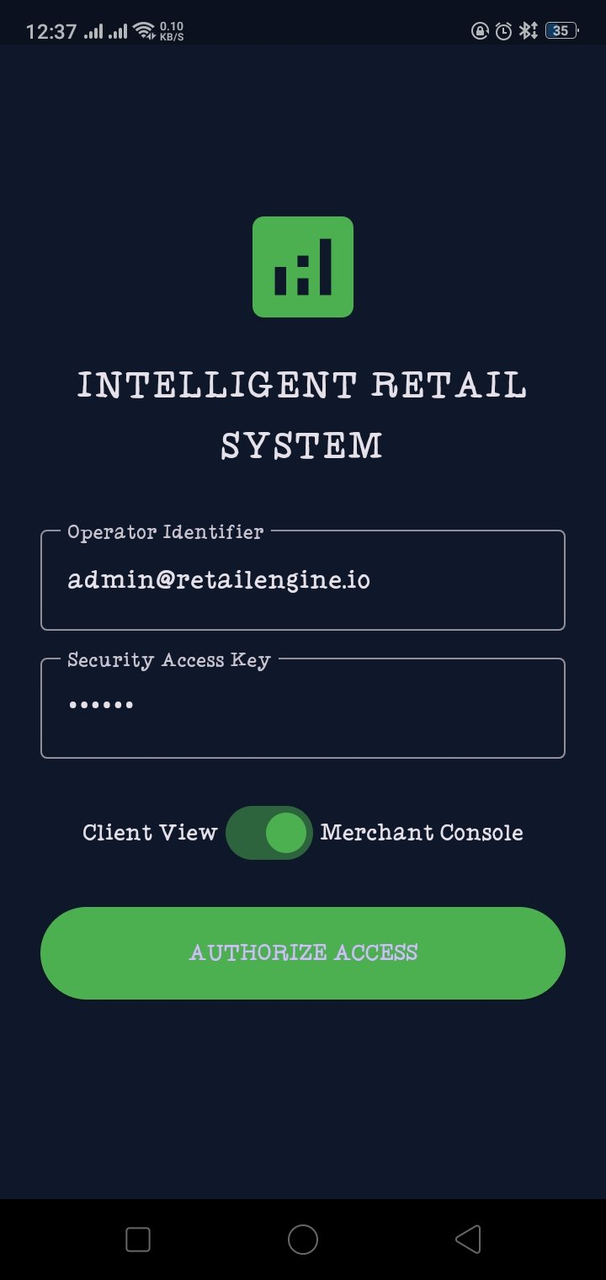
App running on Android device — Authentication screen with Operator Identifier, Security Access Key and role toggle
Device Test — Screen 2: Live Market Catalog
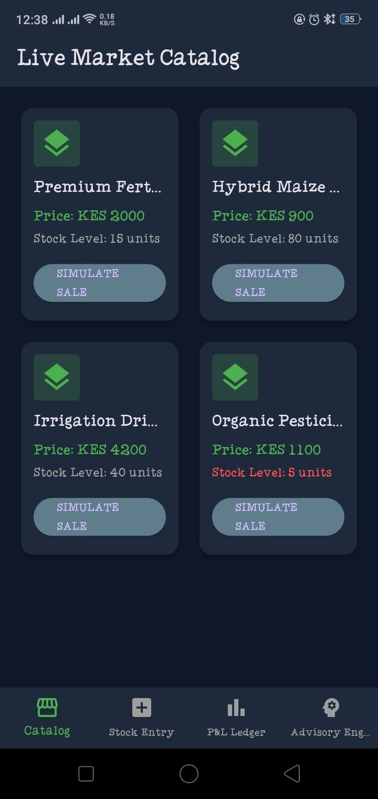
App running on Android device — Live Market Catalog showing 2-column grid, KES prices, stock levels and low stock warning in red
Device Test — Screen 3: Real-Time P&L Dashboard
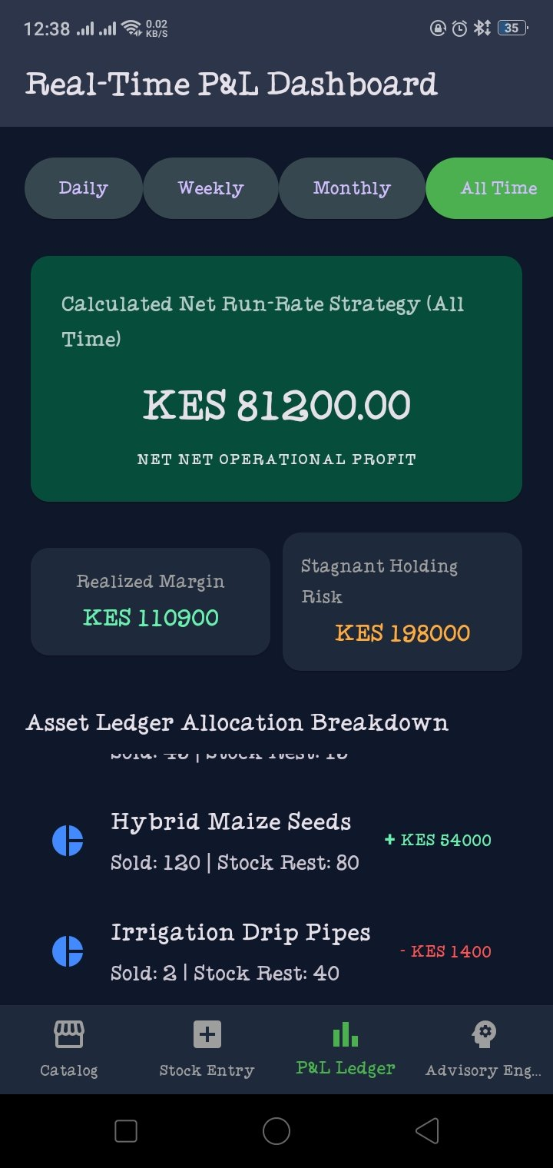
App running on Android device — P&L Dashboard showing KES 81,200 net profit, realized margin, stagnant holding risk and asset ledger breakdown
Device Test — Screen 4: Intelligent Optimization Advisory
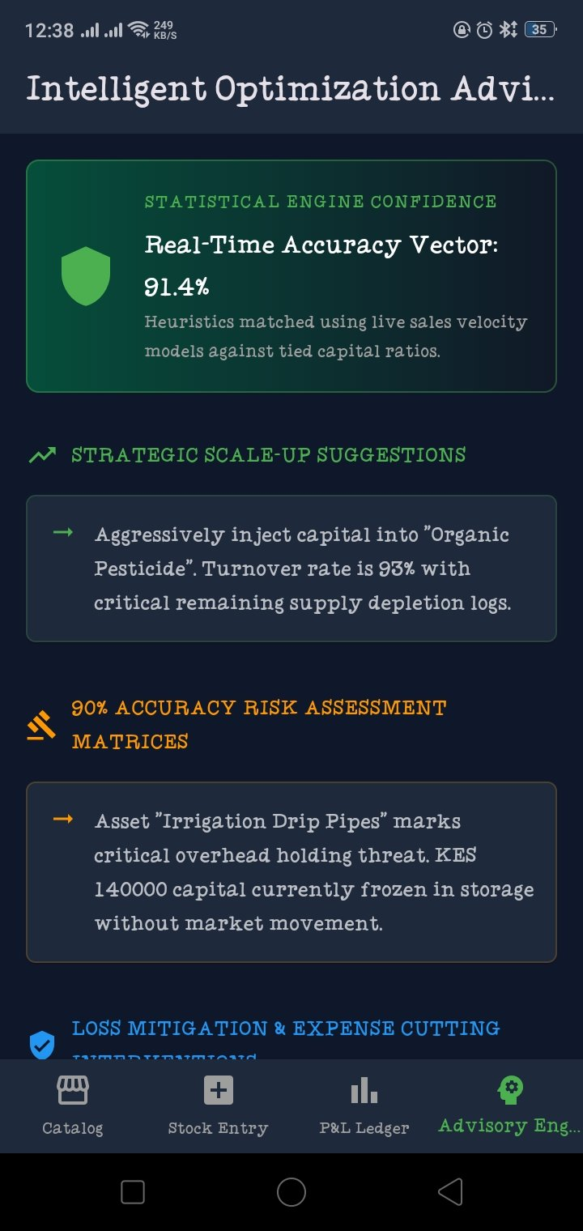
App running on Android device — Intelligent Advisory Engine showing 91.4% accuracy, strategic scale-up suggestions and risk assessment

Challenges Faced & Solutions
- Challenge: Sharing inventory data across multiple screens.
- Solution: Used a global List<InventoryItem> accessible by all screens.

- Challenge: Real-time profit/loss calculation across all items.
- Solution: Used Dart getter methods inside InventoryItem class for auto-computation.

- Challenge: Advisory logic needed to analyze multiple conditions per item.
- Solution: Iterated globalInventory with conditional thresholds for turnover rate and stock levels.

- Challenge: Responsive grid layout for catalog on different screen sizes.
- Solution: Used SliverGridDelegateWithFixedCrossAxisCount with childAspectRatio tuning.

Lessons Learnt
- Global state using a shared List allows multiple screens to read and write the same data.
- Dart getter methods inside model classes simplify complex calculations.
- BottomNavigationBar is ideal for multi-screen apps with persistent navigation.
- Form validation with inline error messages improves user experience significantly.
- GridView.builder creates responsive multi-column layouts efficiently in Flutter.
- Real-world business logic like profit calculations can be embedded directly into data models.

Reflection
Week 3 involved building the most complex app so far — a full Intelligent Retail Analytics Engine with 5 screens, a data model, real-time calculations and an AI-style advisory engine. The app addresses a real-world problem faced by small retail businesses in Kenya — tracking inventory, understanding profit and loss, and making data-driven restocking decisions. The bottom navigation structure, responsive grid layout, form validation and dynamic advisory logic demonstrate a solid understanding of Flutter UI development. The app is functional, visually polished and ready for future enhancements such as Firebase integration and persistent local storage.

