BIT 4107: MOBILE APPLICATION DEVELOPMENT
Week 4 Practical Documentation
Data Management — SQLite, Sembast & P&L Dashboard

Student Name | Noelle
Admission Number | BIT/2024/73309
Course Unit | BIT 4107 — Mobile Application Development
Week / Topic | Week 4 — Data Management
Date Submitted | June 2025

1. Introduction
This document presents the Week 4 practical implementation for BIT 4107 — Mobile Application Development. The work focuses on data management in a Flutter-based Intelligent Retail Analytics Engine application. The practical covered three key deliverables:

- Local data persistence using SQLite via the sqflite package
- Web platform compatibility using the Sembast database
- A real-time Profit and Loss (P&L) Dashboard for business intelligence

The application is named the Intelligent Retail Analytics Engine and simulates a retail stock management system with multi-platform support. It was built in Flutter and tested on an Android device.

2. Learning Outcomes Addressed
The following learning outcomes from the Week 4 syllabus were achieved through this practical:

- Explained data management concepts in mobile applications.
- Implemented local storage using SQLite (sqflite package) and Sembast for web support.
- Retrieved, updated and displayed stored records within the application.
- Designed a data-driven mobile application with CRUD functionality.

3. Application Overview
The Intelligent Retail Analytics Engine is a retail management mobile application built using Flutter. It allows users to manage product stock, monitor profit and loss in real time, and view inventory through a catalog screen. The application supports multiple navigation screens accessible via a bottom navigation bar.

3.1 Navigation Screens
Screen | Purpose
Catalog | Displays all products with pricing, USD equivalent, stock status and simulate sale button
Stock Entry | Allows adding new products to the SQLite database with name, category, price, margin and quantity
P&L Ledger | Real-time profit and loss dashboard with margin summaries, best product, and asset breakdown
Advisory | Business advisory insights derived from stock data
Rates | Currency exchange rate display

4. SQLite Database Implementation

4.1 Overview
SQLite was implemented using the sqflite Flutter package to provide persistent local storage. This enables the application to store product records on the device even after the app is closed. The database follows a CRUD (Create, Read, Update, Delete) model as required by the Week 4 practical assignment.

4.2 Database Structure
The SQLite database stores product records in a table with the following fields:

Field | Type | Description
id | INTEGER | Auto-incremented primary key
name | TEXT | Product name
category | TEXT | Product category (e.g., electronics)
price | REAL | Selling price in KES
margin | REAL | Profit margin percentage
quantity | INTEGER | Number of units in stock
sold | INTEGER | Number of units sold

4.3 CRUD Operations Implemented
- Create — New products are inserted into the SQLite database via the Stock Entry screen
- Read — All products are retrieved and displayed on the Catalog and P&L screens
- Update — Stock quantities are updated when a sale is simulated
- Delete — Records can be removed from the database as needed

5. Sembast Web Support

5.1 Overview
Sembast is a NoSQL persistent store for Flutter that provides web platform compatibility. Since sqflite does not support Flutter Web, sembast_web was integrated to allow the application to run in a browser environment. This ensures the app is cross-platform — working on both Android and Web.

5.2 Packages Used
Package | Purpose
sqflite | SQLite database for Android/iOS platforms
sembast | NoSQL store for cross-platform data persistence
sembast_web | Web-specific Sembast implementation for browser support
path_provider | Provides platform-specific paths for database file storage

5.3 Platform Detection Logic
The application uses platform detection (kIsWeb) to switch between sqflite on Android and sembast on Web. This allows a single codebase to run on multiple platforms without modification, meeting the cross-platform requirement of modern mobile development.

6. Screenshots and Evidence
The following screenshots were captured from the running application on an Android device, demonstrating the successful implementation of Week 4 features.

6.1 Stock Entry Screen — SQLite Data Storage
This screen demonstrates the SQLite CRUD implementation. Products (Laptop, TV, Samsung Tablet) have been successfully added to the local SQLite database. The green notification banner at the bottom confirms that the laptop record was saved to the database. Each product card displays the category, price in KES, margin percentage, and quantity in stock.

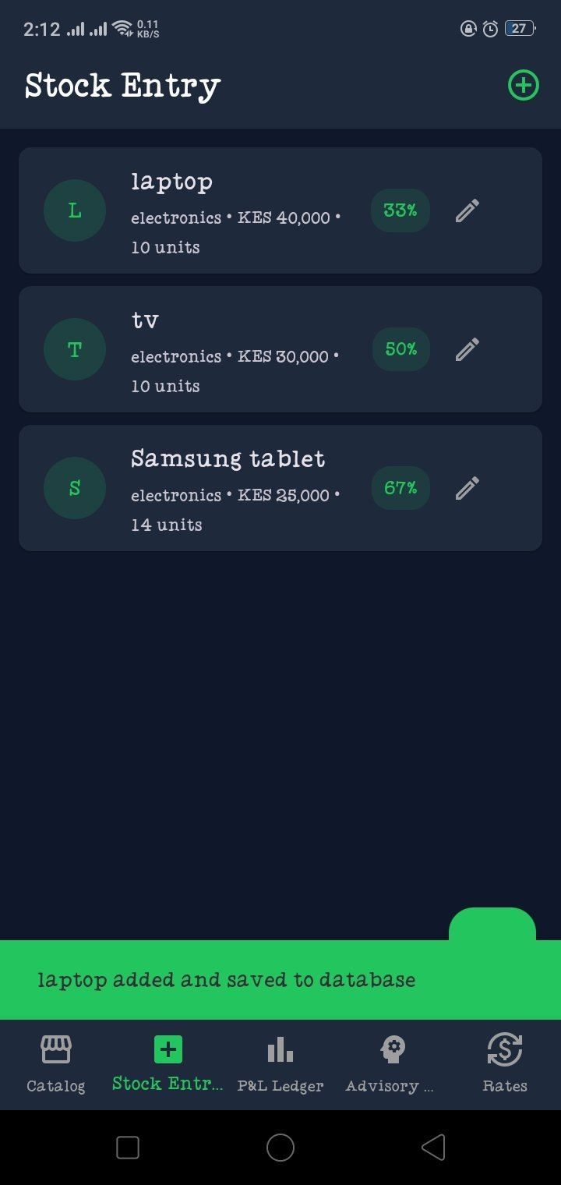
Figure 1: Stock Entry Screen showing saved product records and database confirmation message

6.2 Real-Time P&L Dashboard
The P&L Dashboard retrieves all product records from the SQLite database and computes key business metrics in real time. The dashboard displays the realized margin (31.4%), stagnant risk value (KES 200,000), the best performing product (Samsung Tablet at 67% margin), and products needing attention (TV at 0 sales). The Asset Ledger Breakdown section lists each product with its sold units, remaining stock, and profit contribution.
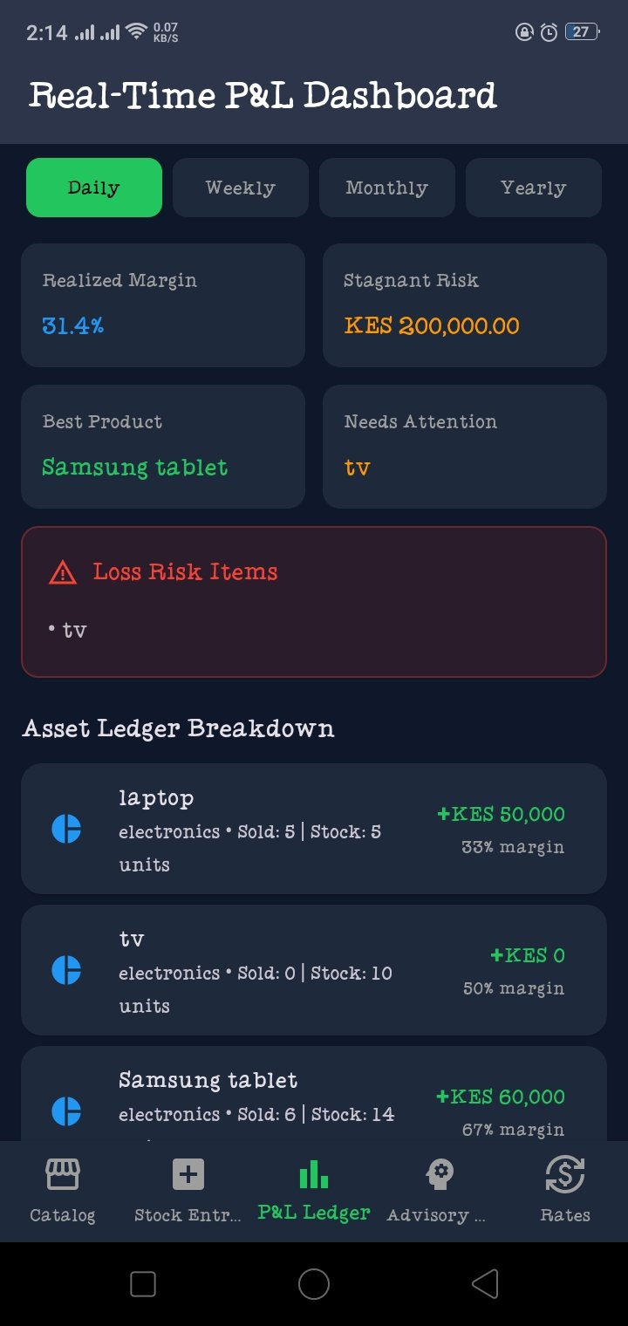
Figure 2: Real-Time P&L Dashboard showing computed metrics from SQLite database records

6.3 Live Market Catalog Screen
The Catalog screen reads all product data from the local SQLite database and displays it in a grid layout. Each product card shows the product name, price in KES, stock status (In Stock / Low Stock), and quantity available. This screen confirms successful data retrieval (Read operation) from the SQLite database.

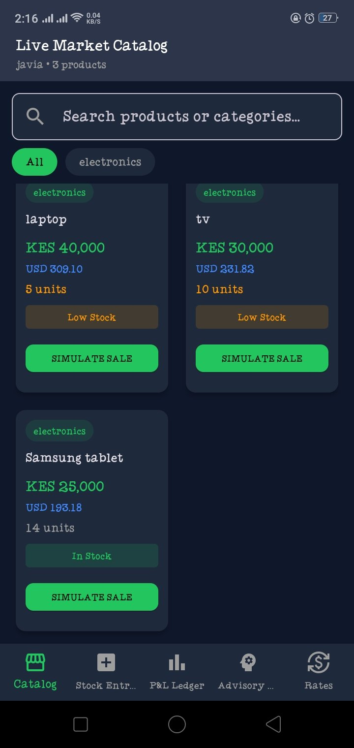
Figure 3: Live Market Catalog Screen displaying products retrieved from the SQLite database

7. Key Features Implemented
Feature | Technology Used | Status
Local data storage | SQLite via sqflite package | Completed
CRUD operations | sqflite insert, query, update, delete | Completed
Web platform support | sembast + sembast_web | Completed
P&L Dashboard | Flutter widgets + SQLite queries | Completed
Asset Ledger Breakdown | Real-time data aggregation | Completed
Bottom navigation | Flutter BottomNavigationBar | Completed
Stock entry form | Flutter Form + TextFormField | Completed

8. Conclusion
This Week 4 practical successfully demonstrated data management in a Flutter mobile application. The Intelligent Retail Analytics Engine implements SQLite for persistent local storage on Android, Sembast for web platform compatibility, and a real-time P&L Dashboard that reads and processes stored data to generate business insights.

All four CRUD operations were implemented and verified through the running application. The app correctly stores new product records, retrieves and displays them across multiple screens, updates stock counts on sales, and supports deletion of records. The integration of sembast_web further extends the application to run on Flutter Web without code changes.

The practical fulfills all Week 4 learning outcomes and lays a strong data foundation for the networking and API integration features implemented in Week 5.

