BIT4107
Mobile Application Development
Week 1 — Project Logbook

Student: NOELLE BLESSING
Course: BIT4107 — Mobile Application Development
Week: 1 — Introduction to Mobile Development
IDE Used: Visual Studio Code (VS Code)
Framework: Flutter SDK (Dart)
Date: May 2026

Weekly Objective
Set up a professional mobile development environment using VS Code and Flutter SDK, and create a first working Flutter mobile application with basic UI customizations.

Step 1 — VS Code Installation
Tool: Visual Studio Code
Source: code.visualstudio.com
Status: Already installed

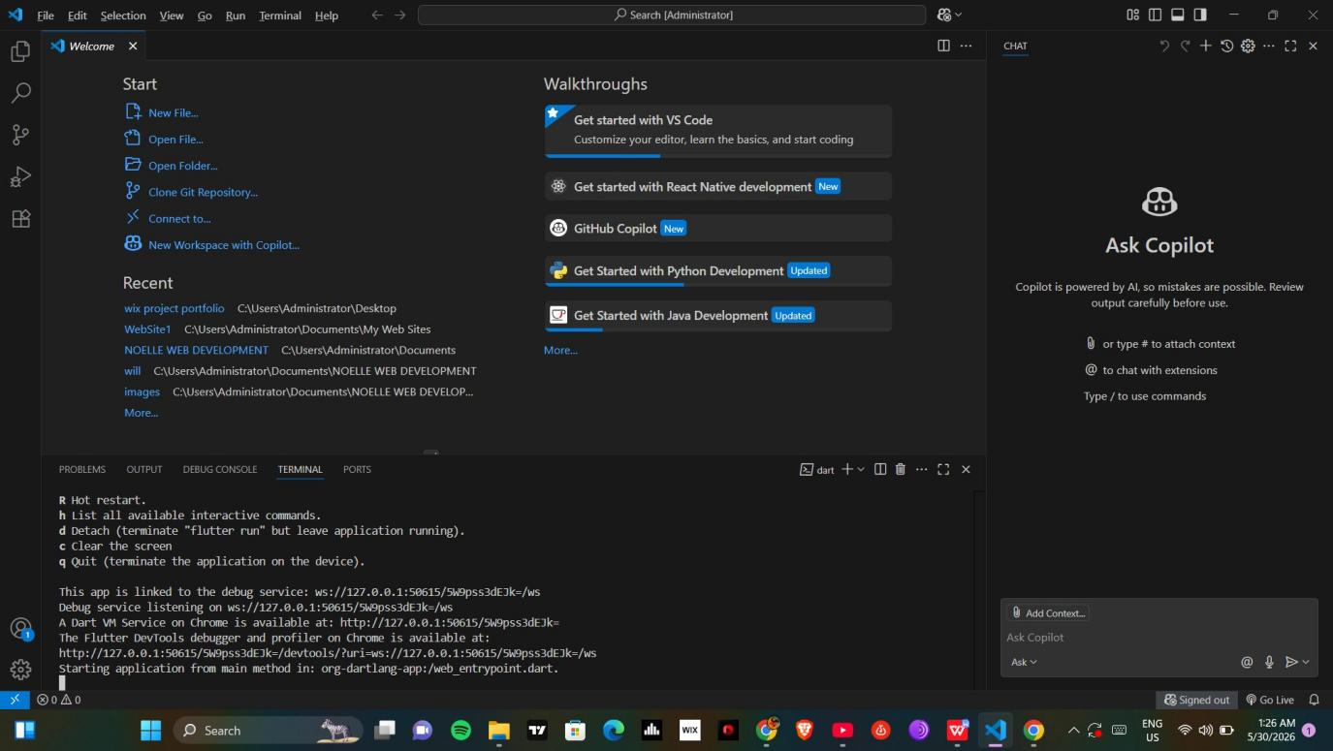
Figure 1: VS Code open showing Welcome screen and GitHub Copilot panel

Step 2 — Flutter SDK Installation
Tool: Flutter SDK v3.44.0
Source: flutter.dev
Location: C:\Users\Administrator\Downloads\flutter_windows_3.44.0-stable\flutter
Flutter SDK was downloaded and extracted. The bin folder path was added to the Windows System Environment Variables (PATH).

Code: Add Flutter to PATH
C:\Users\Administrator\Downloads\flutter_windows_3.44.0-stable\flutter\bin

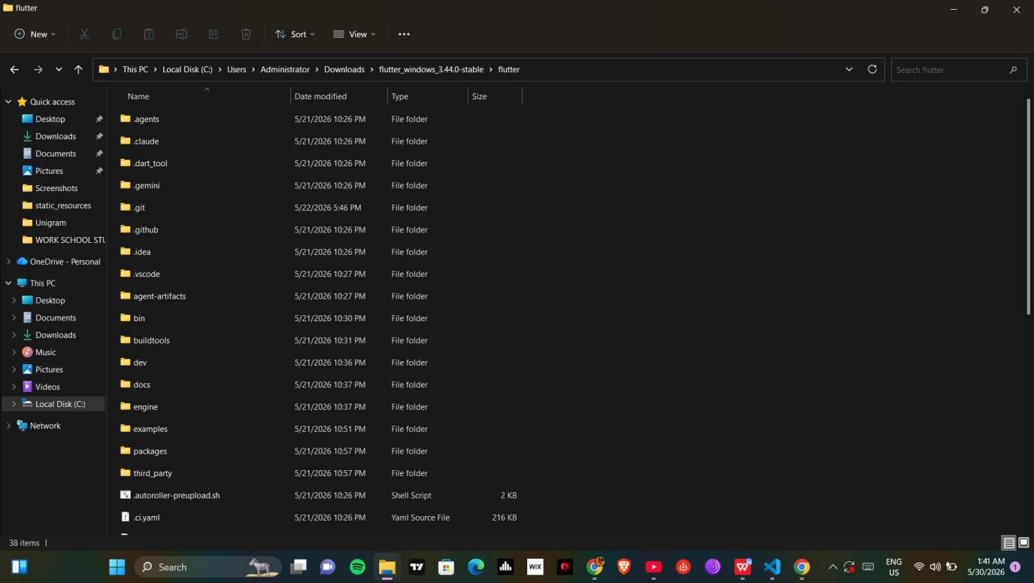
Figure 2: Flutter SDK folder structure in File Explorer

Step 3 — Environment Configuration
Ran flutter doctor to verify the environment setup. Android SDK was configured using command line tools and all licenses were accepted.

Commands Used
flutter doctor
flutter config --android-sdk "C:\android-sdk"
sdkmanager --install "platform-tools"
sdkmanager --install "platforms;android-36"
sdkmanager --install "build-tools;28.0.3"
flutter doctor --android-licenses

Flutter Doctor Results
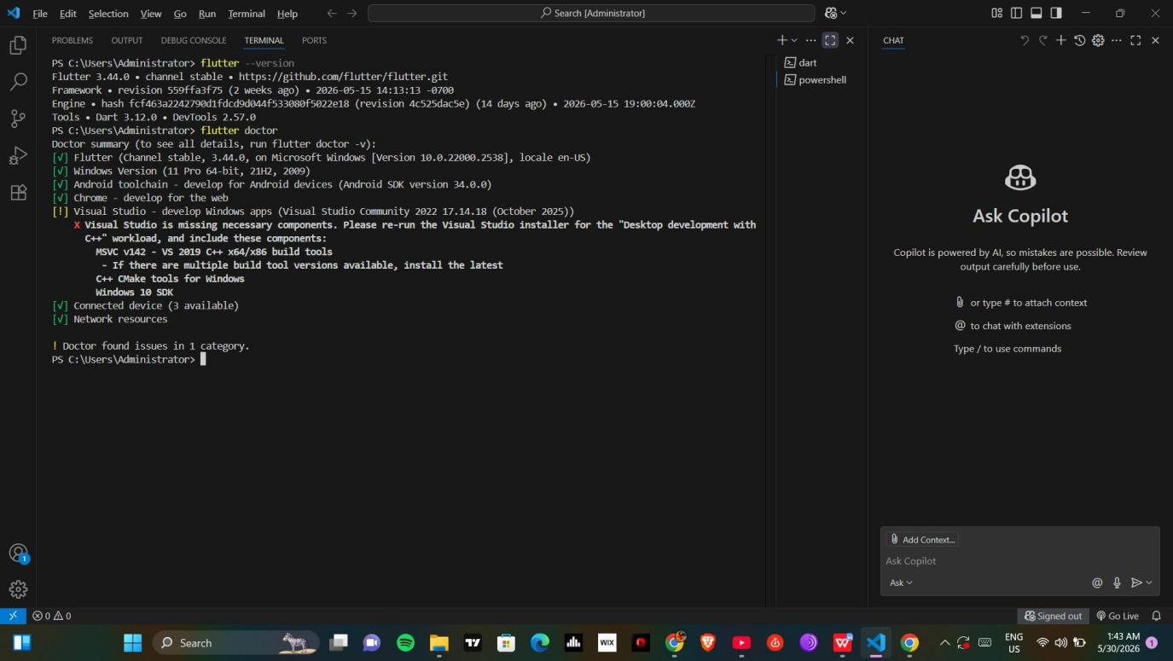
Figure 3: Flutter doctor showing green ticks — Flutter, Android toolchain, Chrome and Connected devices all working

- Flutter v3.44.0 — Channel stable
- Android SDK v34.0.0 — Configured successfully
- Chrome — Available for web testing
- Connected devices — 3 available

Step 4 — VS Code Extensions Installed
The following extensions were installed in VS Code to support mobile development:

- Flutter — by Dart Code (dart-code.flutter)
- Dart — installed automatically with Flutter
- GitHub Copilot — AI coding assistant
- React Native Tools — by Microsoft
- Python — by Microsoft

Step 5 — Creating the Flutter App
Created a new Flutter project named 'helloworld' using the flutter create command. The project was then run on Chrome browser as an emulator.

Commands Used
flutter create helloworld
cd helloworld
flutter run -d chrome

Default App Running
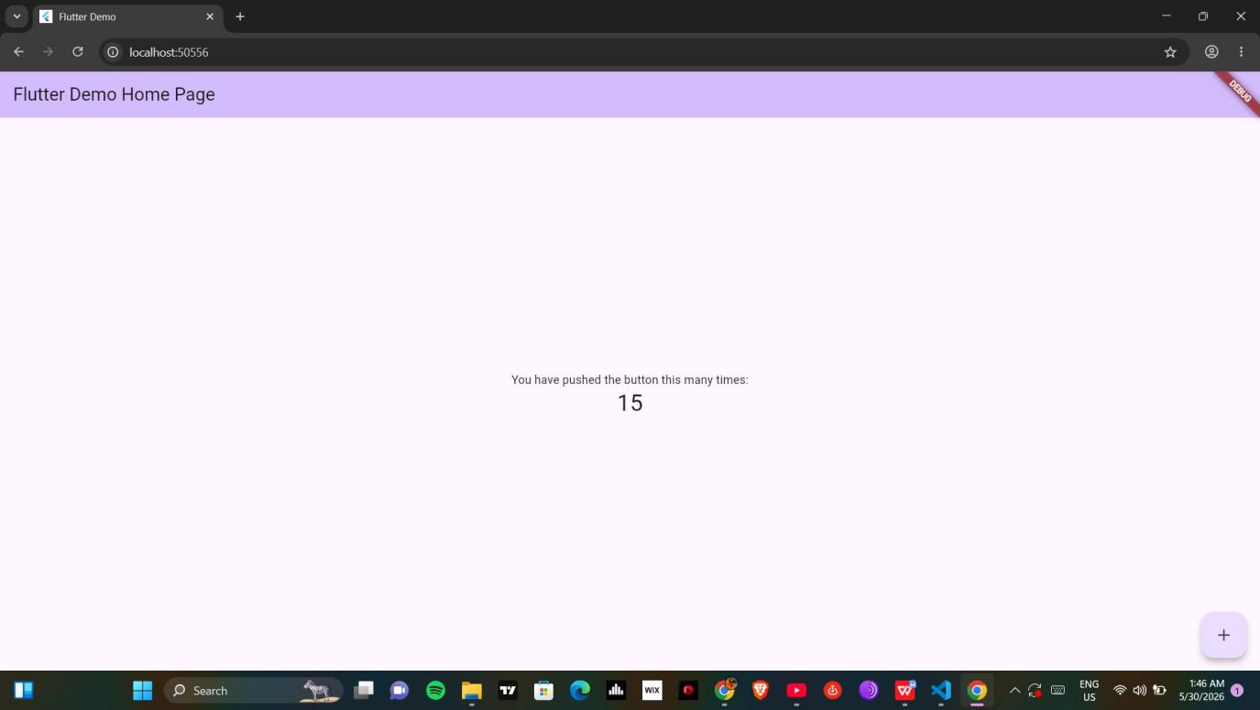
Figure 4: Default Flutter app running on Chrome — showing counter button functionality

Step 6 — App Customizations
The Flutter app was customized by editing the main.dart file. Changes included: app title, background color, font size, and the button was already included by default.

6a — App Title Changed
Original: Flutter Demo Home Page
Changed to: my first app practice scenario

Code: Change App Title
MaterialApp(
title: 'my first app practice scenario',
home: MyHomePage(title: 'my first app practice scenario'),
)

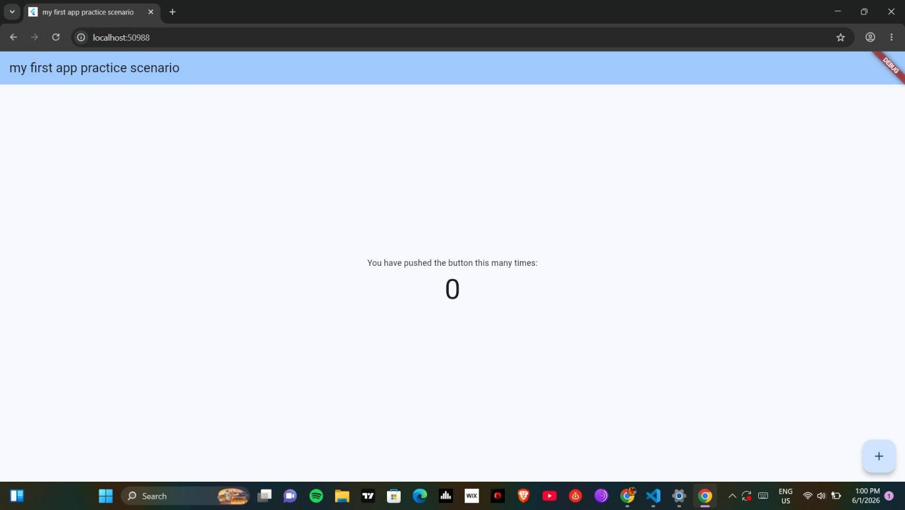
Figure 5: App title changed to 'my first app practice scenario' — visible in browser tab and app header

6b — Background Color Changed
Original: Purple/Lavender
Changed to: Blue (Colors.blue)

Code: Change Background Color
theme: ThemeData(
colorScheme: ColorScheme.fromSeed(
seedColor: Colors.blue,
),
),

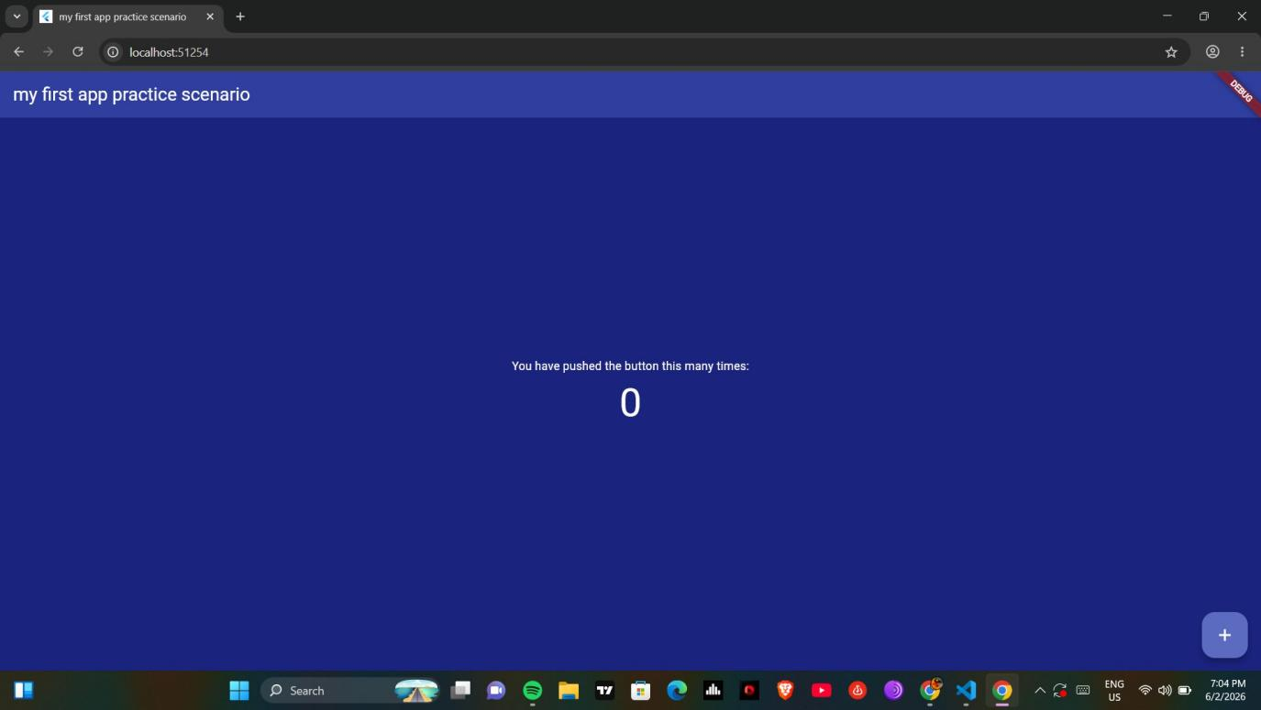
Figure 6: Background color changed to blue

6c — Font Size Changed & Button Working
Change: Counter text font size increased

Code: Change Font Size
Text(
'\$_counter',
style: Theme.of(context).textTheme.headlineMedium!.copyWith(
fontSize: 60,
color: Colors.white,
),
)

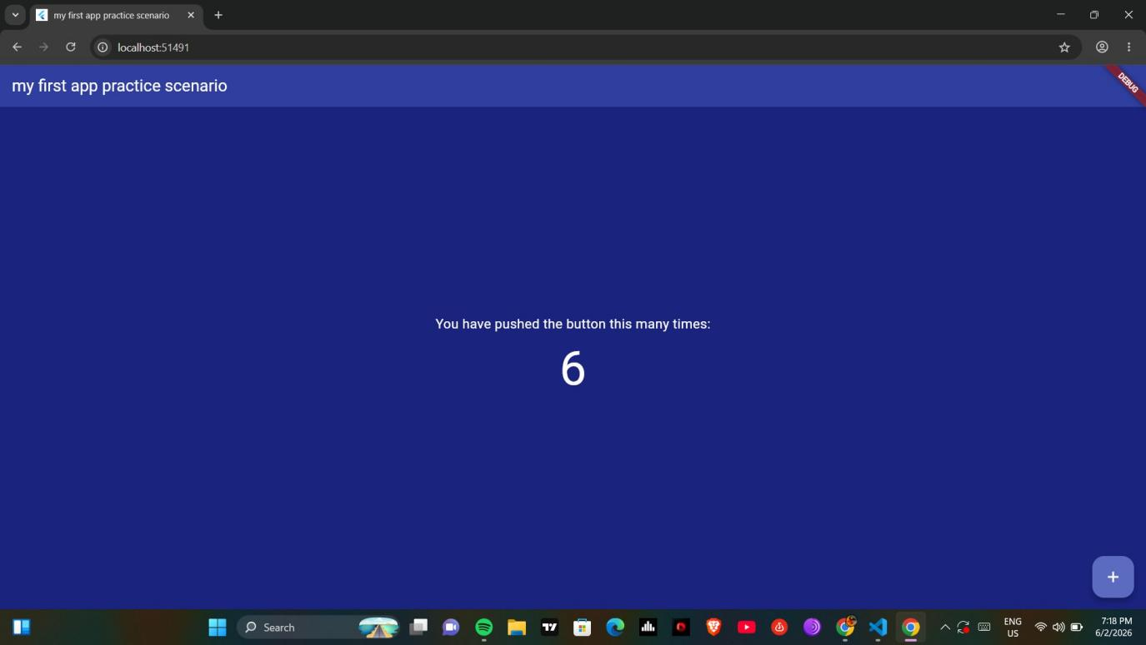
Figure 7: App showing updated font size and button working — counter showing 6 after button presses

Challenges Faced & Solutions

- Challenge: Flutter not recognized in terminal — PATH was not set correctly.
- Solution: Added Flutter bin folder path to Windows System Environment Variables.

- Challenge: sdkmanager not recognized — Android SDK command line tools not in PATH.
- Solution: Added C:\android-sdk\cmdline-tools\latest\bin to system PATH.

- Challenge: Flutter required Android SDK 36 but SDK 34 was installed.
- Solution: Installed platforms;android-36 and build-tools;28.0.3 using sdkmanager.

Lessons Learnt
- Setting up a mobile development environment requires careful PATH configuration.
- Flutter is a powerful cross-platform framework that runs on Android, iOS and Chrome.
- VS Code with Flutter extension provides a lightweight but complete mobile development environment.
- Chrome can be used as an emulator for quick Flutter app testing without a physical device.

Reflection
Week 1 involved setting up the complete mobile development environment from scratch. The process required installing and configuring multiple tools including VS Code, Flutter SDK, Android SDK, Java JDK, Git, Node.js and Python. Despite several PATH configuration challenges, all tools were successfully configured. The first Flutter app was created, run on Chrome, and customized with a new title, background color and font size. The environment is now ready for Week 2 practical work.

