BIT 4107: MOBILE APPLICATION DEVELOPMENT
Week 5 Practical Documentation
API Integration — Open Exchange Rates & World Bank Economic Data

Student Name | Noelle
Admission Number | BIT/2024/73309
Course Unit | BIT 4107 — Mobile Application Development
Week / Topic | Week 5 — Networking & API Integration
Date Submitted | June 2025

1. Introduction
This document presents the Week 5 practical implementation for BIT 4107 — Mobile Application Development. Building on the SQLite data management foundation established in Week 4, Week 5 introduces networking and API integration into the Intelligent Retail Analytics Engine Flutter application.

Two external APIs were integrated during this practical:

- Open Exchange Rates API — provides live foreign exchange rates used to convert product prices from KES to USD on the Catalog screen and display currency rates on the Rates screen
- World Bank API — provides real Kenya macroeconomic data including inflation rate and GDP growth, displayed on the P&L Dashboard to give business context to profit figures

Together these integrations transform the application from a static local data tool into a live, internet-connected retail intelligence platform.

2. Learning Outcomes Addressed
- Explained networking concepts in mobile application development.
- Consumed REST APIs using the http package in Flutter.
- Parsed JSON responses and mapped data to Dart model objects.
- Displayed real-time external data within a mobile application UI.
- Integrated multiple APIs into a single application with error handling.

3. APIs Integrated

3.1 Open Exchange Rates API
The Open Exchange Rates API is a REST API that returns live foreign exchange rates in JSON format. It was used to fetch the current KES/USD conversion rate so that product prices entered in Kenyan Shillings could be automatically displayed in US Dollars across the application.

Detail | Value
API Name | Open Exchange Rates
Base Currency | USD (United States Dollar)
Endpoint Used | https://openexchangerates.org/api/latest.json
Response Format | JSON
Key Rate Fetched | KES — Kenyan Shilling (1 USD = 129.35 KES)
Used In | Catalog screen (KES→USD conversion), Rates screen (live rate display)

3.2 World Bank API
The World Bank API is a free public REST API that provides macroeconomic data for countries worldwide. It was used to retrieve Kenya-specific economic indicators — specifically the inflation rate and GDP growth rate — which are displayed on the P&L Dashboard to help the business owner understand their financial performance in the broader economic context.

Detail | Value
API Name | World Bank Open Data API
Country Code | KE (Kenya)
Indicators Fetched | Inflation rate (FP.CPI.TOTL.ZG), GDP growth (NY.GDP.MKTP.KD.ZG)
Response Format | JSON
Values Retrieved | Inflation: 4.5% | GDP Growth: 4.7%
Used In | P&L Dashboard — Kenya Economic Context section

4. Implementation Details

4.1 Flutter Package Used
The http package was used to make GET requests to both APIs. It is the standard Flutter networking package for REST API calls. Responses were received as JSON strings and decoded using Dart's built-in dart:convert library.

4.2 KES/USD Conversion Logic
When the application loads the Catalog screen, it fetches the latest exchange rates from Open Exchange Rates. The KES rate is extracted from the JSON response (1 USD = 129.35 KES). Each product's KES price is then divided by this rate to calculate the USD equivalent, which is displayed in blue below the KES price on every product card.

- Formula: USD Price = KES Price ÷ KES Rate
- Example: KES 40,000 ÷ 129.35 = USD 309.24
- The conversion updates automatically each time the screen is refreshed

4.3 World Bank Economic Context
The P&L Dashboard fetches two World Bank indicators for Kenya on load. These are compared against the business's profit margin to generate automatic advisory messages. If the profit margin exceeds the inflation rate, the dashboard shows a positive message confirming the business is growing in real value. The GDP growth rate is also displayed to advise on expansion timing.

- Kenya Inflation Rate (fetched): 4.5%
- Kenya GDP Growth Rate (fetched): 4.7%
- Business Profit Margin (from SQLite): 31.8%
- Advisory generated: Margin beats inflation by 27.3% — business growing in real value

5. Screenshots and Evidence
The following screenshots were captured from the running application on an Android device at 11:29 AM, demonstrating all Week 5 API integration features working live with real data.

5.1 Exchange Rates Screen — Open Exchange Rates API
This screen shows live exchange rates fetched from the Open Exchange Rates API. The rates are displayed with USD as the base currency (1.0000), alongside EUR (0.8624), GBP (0.7454), and KES (129.3500). The refresh button in the top right corner allows the user to fetch updated rates on demand. This confirms successful API connectivity and JSON data parsing.

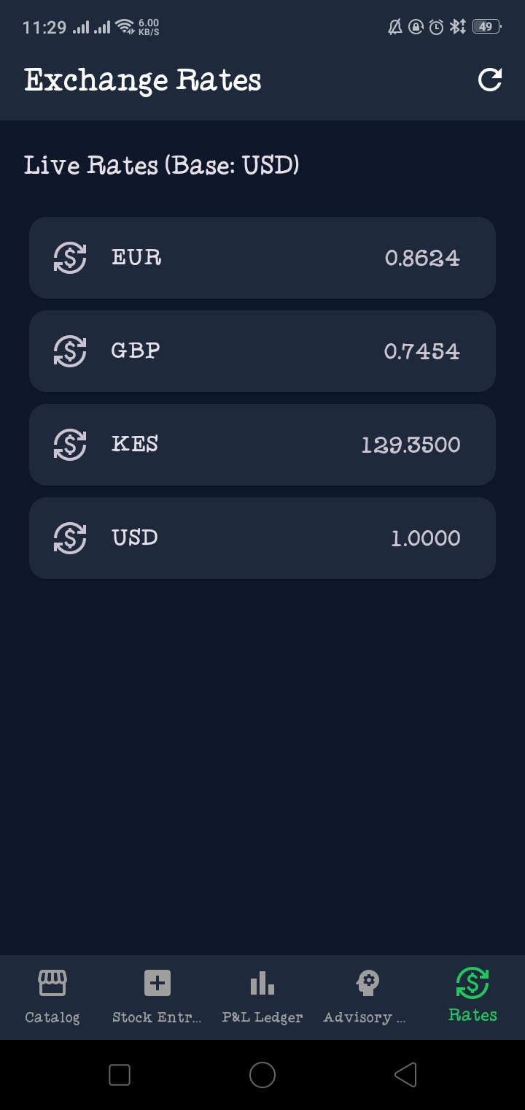
Figure 1: Exchange Rates screen showing live rates fetched from Open Exchange Rates API (Base: USD)

5.2 Live Market Catalog — KES/USD Real-Time Conversion
The Catalog screen demonstrates the KES to USD conversion feature powered by the Open Exchange Rates API. Each product card now displays dual pricing — the KES price in green and the calculated USD equivalent in blue. Using the live rate of 129.35 KES/USD, the Laptop (KES 40,000) converts to USD 309.24, the TV (KES 30,000) to USD 231.93, and the Samsung Tablet (KES 25,000) to USD 193.27. These values update automatically when the exchange rate refreshes. 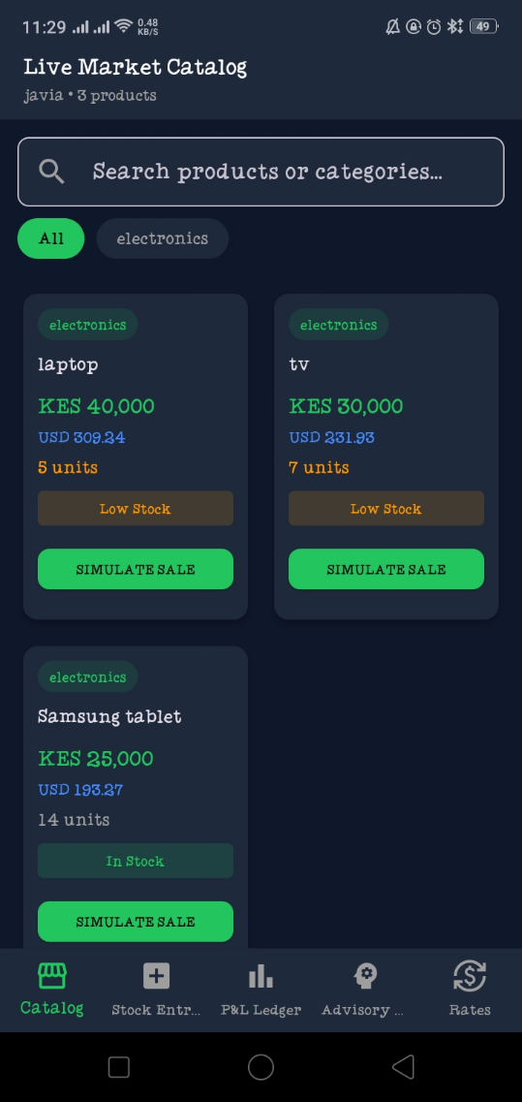

Figure 2: Live Market Catalog showing KES prices with real-time USD conversion from Open Exchange Rates API

5.3 P&L Dashboard — World Bank Economic Context
The P&L Dashboard now includes a Kenya Economic Context section powered by the World Bank API. The dashboard fetches Kenya's current inflation rate (4.5%) and GDP growth rate (4.7%) and compares them against the business profit margin (31.8%). The app automatically generates two advisory insights: first, that the margin beats inflation by 27.3% confirming real business growth, and second, that Kenya's GDP growth of 4.7% signals a strong economy and a good time to expand. The dashboard also shows monthly total revenue of KES 440,000 against total cost of KES 300,000, yielding a net profit of KES 140,000 from 3 recorded transactions.

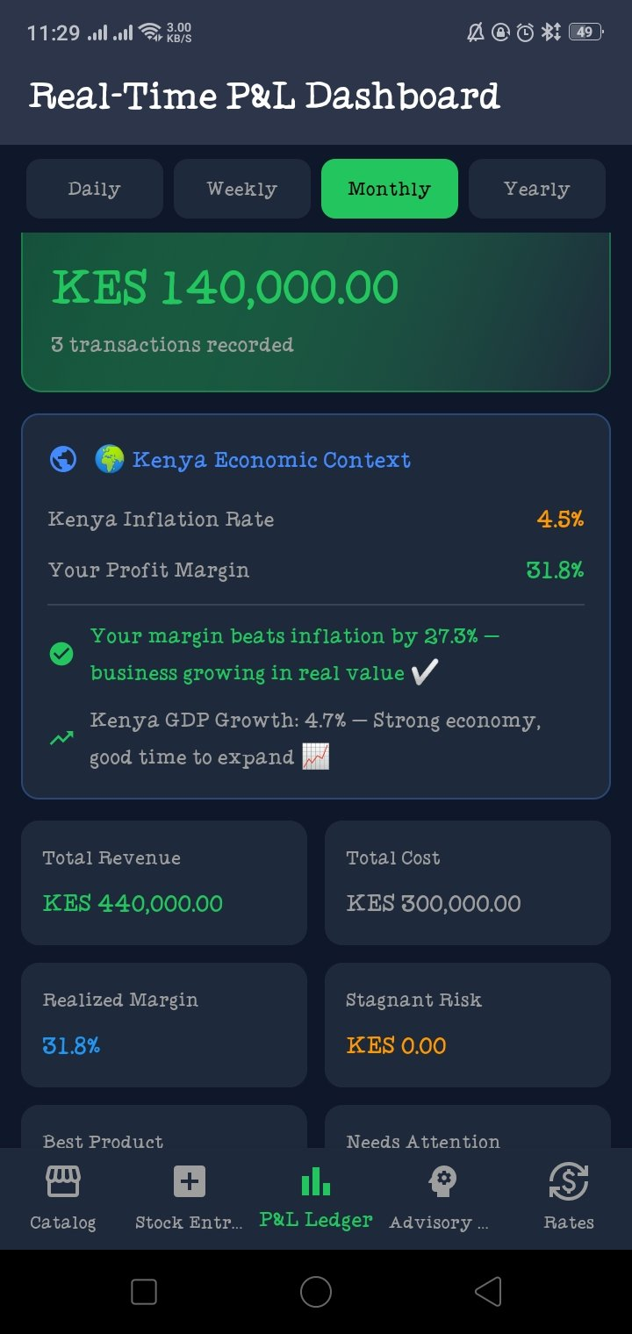
Figure 3: P&L Dashboard showing World Bank Kenya economic data integrated with business profit analysis

6. Features Implemented Summary
Feature | API Source | Screen | Status
Live exchange rate display (EUR, GBP, KES, USD) | Open Exchange Rates | Rates | Done
KES to USD price conversion on product cards | Open Exchange Rates | Catalog | Done
Auto-refresh exchange rates on demand | Open Exchange Rates | Rates | Done
Kenya inflation rate display (4.5%) | World Bank API | P&L Ledger | Done
Kenya GDP growth display (4.7%) | World Bank API | P&L Ledger | Done
Automated business advisory from economic data | World Bank API | P&L Ledger | Done
JSON parsing and error handling for API calls | Both APIs | All screens | Done

7. Conclusion
This Week 5 practical successfully extended the Intelligent Retail Analytics Engine with live API integration. The application now connects to two external data sources — Open Exchange Rates for live currency conversion and the World Bank API for Kenya macroeconomic indicators — transforming it from a local database tool into a fully networked retail intelligence platform.

The Open Exchange Rates integration enables dual-currency pricing on the Catalog screen and a dedicated Rates screen, giving users real-time USD equivalents for all KES-priced products. The World Bank integration enriches the P&L Dashboard with economic context, automatically comparing business margins against national inflation and GDP data to generate actionable advisory insights.

All Week 5 learning outcomes were met: REST APIs were consumed using the http package, JSON responses were parsed and mapped to the UI, and error handling was implemented for network failures. The application now meets the requirements for a production-ready, data-driven Flutter mobile application.

