BIT4107
Mobile Application Development
Week 2 — Mini Student Management App

Student: NOELLE BLESSING
Course: BIT4107 — Mobile Application Development
Week: 2 — UI Components, Navigation & Local Data
IDE Used: Visual Studio Code (VS Code)
Framework: Flutter SDK (Dart)
App Name: Student Management Portal
Date: 25TH MAY

Weekly Objective
Build a Mini Student Management App with a Login Screen, Registration Screen, and local record storage. The app demonstrates form validation, navigation between screens, and in-memory data management.

App Overview
- App Name: Student Management Portal
- Screens: Login Screen, Student Registry System
- Language: Dart (Flutter Framework)
- Theme: Dark mode with Teal color scheme
- Navigation: Screen-to-screen using Navigator.pushReplacement
- Data Storage: In-memory List (local array as database)
- Form Validation: Email, password, name, reg number, course fields

Screen 1 — Login / Authentication
The login screen authenticates the user before granting access to the student registry. It uses form validation to ensure valid email and password input.

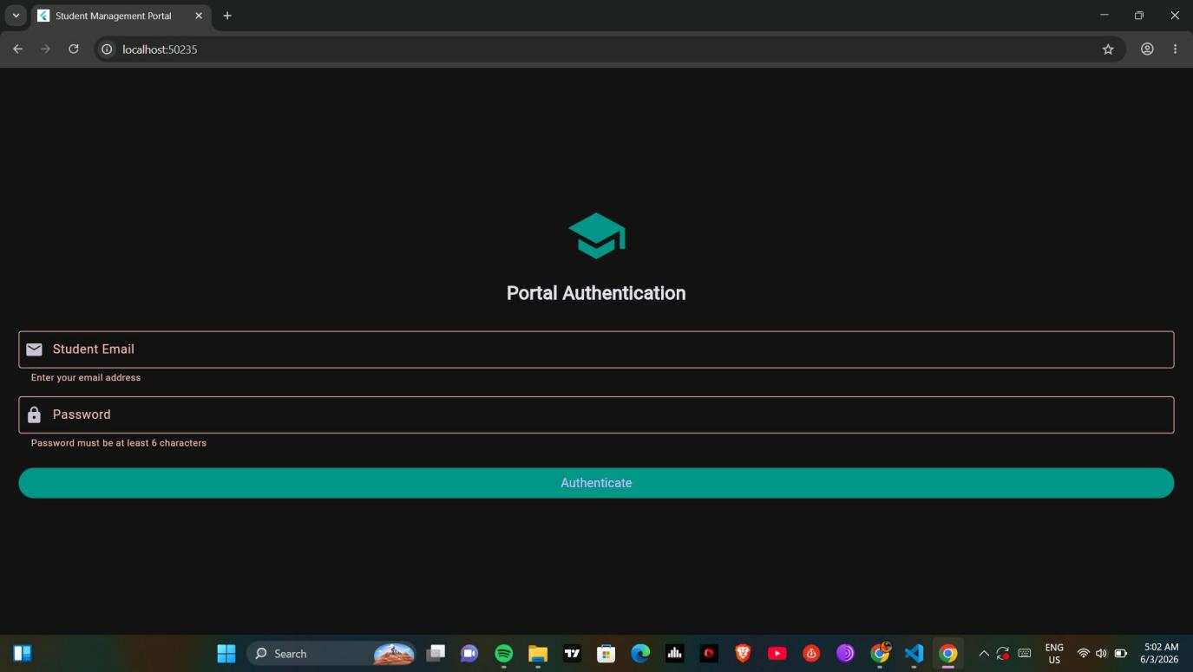
Figure 1: Login screen showing form validation errors on empty submission

Key Features
- School icon with 'Portal Authentication' title
- Student Email field with email icon and validation
- Password field with lock icon — minimum 6 characters validation
- Authenticate button navigates to Registry Screen on success
- Form validation shows error messages on invalid input

Code — Login Screen
class LoginScreen extends StatefulWidget {
const LoginScreen({super.key});
@override
State<LoginScreen> createState() => _LoginScreenState();
}

void _handleLogin() {
if (_formKey.currentState!.validate()) {
Navigator.pushReplacement(
context,
MaterialPageRoute(
builder: (context) => const RegistrationScreen()),
);
}
}

// Email field validation
validator: (value) {
if (value == null || value.trim().isEmpty) {
return 'Enter your email address';
}
return null;
},

// Password field validation
validator: (value) {
if (value == null || value.length < 6) {
return 'Password must be at least 6 characters';
}
return null;
},

Screen 2 — Student Registry System (Empty State)
After successful login, the user is directed to the Student Registry System. The registration form allows entering student details which are stored in memory.

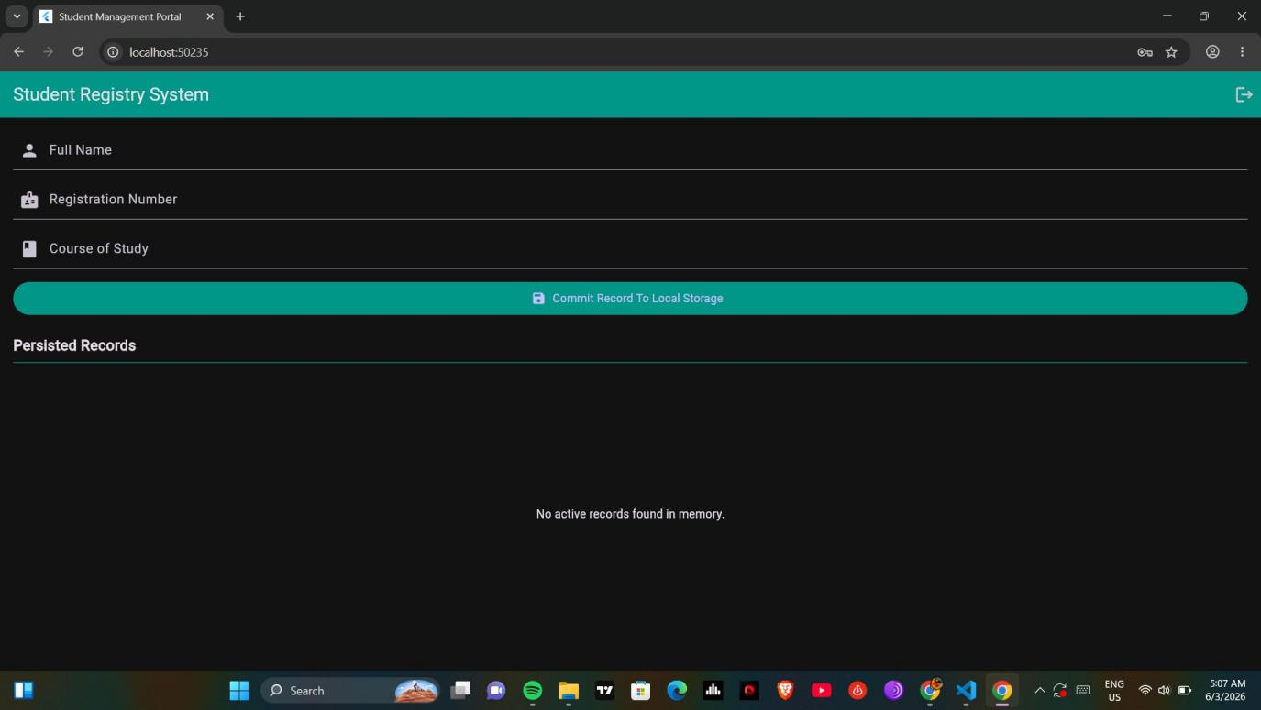
Figure 2: Student Registry screen showing empty state before any records are added

Key Features
- App bar with title 'Student Registry System' and logout button
- Full Name input field with person icon
- Registration Number input field with badge icon
- Course of Study input field with book icon
- 'Commit Record To Local Storage' button saves data to memory
- 'Persisted Records' section displays saved student cards
- Empty state message: 'No active records found in memory'

Code — Registration Screen & Local Storage
// In-memory database (local array)
final List<Map<String, String>> _studentDatabase = [];

void _saveStudentRecord() {
if (_formKey.currentState!.validate()) {
setState(() {
_studentDatabase.add({
'name': _nameController.text.trim(),
'regNum': _regNumController.text.trim(),
'course': _courseController.text.trim(),
});
});
// Clear fields after saving
_nameController.clear();
_regNumController.clear();
_courseController.clear();
ScaffoldMessenger.of(context).showSnackBar(
const SnackBar(
content: Text('Record committed successfully')),
);
}
}

Screen 3 — Student Record Saved
After filling in the student form and clicking 'Commit Record To Local Storage', the record is saved and displayed as a card in the Persisted Records section.

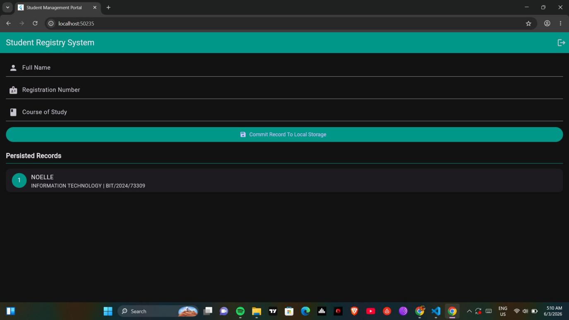
Figure 3: Student record saved — showing NOELLE, INFORMATION TECHNOLOGY | BIT/2024/73309

Key Features
- Record displays with a numbered teal circle avatar
- Student name shown as card title
- Course and Registration Number shown as subtitle
- Multiple records can be added and listed
- Logout button returns user to Login screen

Code — Displaying Records as Cards
ListView.builder(
itemCount: _studentDatabase.length,
itemBuilder: (context, index) {
final student = _studentDatabase[index];
return Card(
margin: const EdgeInsets.symmetric(vertical: 6),
child: ListTile(
leading: CircleAvatar(
backgroundColor: Colors.teal,
child: Text('${index + 1}'),
),
title: Text(student['name']!),
subtitle: Text(
'${student['course']} | ${student['regNum']}'),
),
);
},
)

App Structure & Navigation Flow
- main.dart — Entry point, runs StudentManagementApp
- StudentManagementApp — MaterialApp with dark theme and teal color
- LoginScreen — StatefulWidget with form validation
- RegistrationScreen — StatefulWidget with local data management

Code — App Entry Point & Theme
void main() {
runApp(const StudentManagementApp());
}

MaterialApp(
title: 'Student Management Portal',
theme: ThemeData(
brightness: Brightness.dark,
primaryColor: Colors.teal,
scaffoldBackgroundColor: const Color(0xFF121212),
),
home: const LoginScreen(),
debugShowCheckedModeBanner: false,
)

Navigation Flow
// Login -> Registry
Navigator.pushReplacement(
context,
MaterialPageRoute(
builder: (context) => const RegistrationScreen()),
);

// Logout -> Login
Navigator.pushReplacement(
context,
MaterialPageRoute(
builder: (context) => const LoginScreen()),
);

Challenges Faced & Solutions
- Challenge: Managing state across multiple screens.
- Solution: Used StatefulWidget with setState() for real-time UI updates.

- Challenge: Form validation for multiple fields.
- Solution: Used GlobalKey<FormState> with individual field validators.

- Challenge: Clearing fields after saving a record.
- Solution: Called .clear() on each TextEditingController after saving.

Lessons Learnt
- Flutter's StatefulWidget and setState() manage dynamic data efficiently.
- Navigator.pushReplacement is used for login/logout navigation without back button.
- In-memory List<Map> acts as a simple local database for storing records.
- Form validation using GlobalKey<FormState> ensures data integrity before saving.
- Dark theme with ColorScheme improves app visual design and user experience.

Reflection
Week 2 involved building a functional Mini Student Management App demonstrating core Flutter concepts including multi-screen navigation, form validation, stateful data management, and local in-memory storage. The app successfully implements a login authentication flow and a student registration system with real-time record display. The dark teal theme gives the app a professional appearance. The app is ready for Week 3 enhancements including Firebase integration and additional UI improvements.

